
TABLE OF CONTENTS

19CS414 – MOBILE APPLICATION DEVELOPMENT

Ex No | Date | Name of the Experiment | 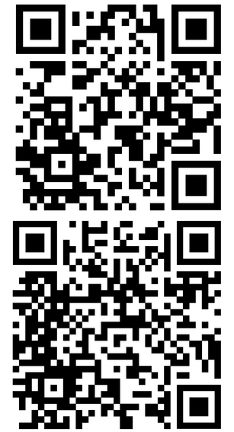  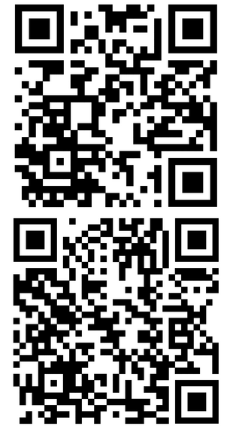  QR CODE | Mark | Signature
1 | 26.3.25 | Installing and Running Application on Android Studio  https://github.com/ANTOJESSI/MAD-Ex-1.1
2 | 26.2.25 | Develop an application to create a HelloWorld Activity using all lifecycles methods to display messages.  https://github.com/ANTOJESSI/BASIC- ANDROID-_EX_01
3 | 1.3.25 | Develop an application that uses GUI Components with Fonts and Colors.  https://github.com/ANTOJESSI/Ex.No-2-b- Font-Size | 
4 | 8.3.25 | Implementation of an application that uses Implicit Intent using Android Studio.  https://github.com/ANTOJESSI/EX_3_IMPLICIT
5 | 15.3.25 | Design an android application for Sending SMS using Intent.  https://github.com/ANTOJESSI/Ex- 4_Implicit_SMS
6 | 22.3.25 | Implement an application to display the Contact Details Using Content Provider  https://github.com/ANTOJESSI/ EX_5_CONTENT-PROVIDER | 

7 | 29.3.25 | Implementation of an application that uses Explicit Intent using Android Studio.  https://github.com/ANTOJESSI/Ex_6_Explicit- Intent |  | 
8 | 5.4.25 | Develop an android application to display the programming languages with toast message using list view in android studio.  https://github.com/ANTOJESSI/Ex_7_List-View |  | 
9 | 19.4.25 | Develop an android application to display the  images using gallery control. |  | 
9 | 19.4.25 | https://github.com/ANTOJESSI/ Ex_8_CheckBox
10 | 23.4.25 | 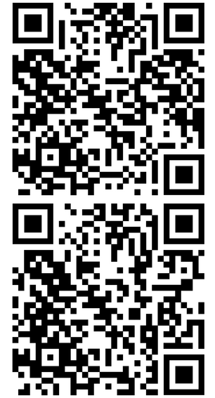  Develop a simple calculator in android studio.  https://github.com/ANTOJESSI/ Ex_9_Calculator
11 | 30.4.25 | Develop an android application to create a option menu to display menu items using android studio.  https://github.com/ANTOJESSI/Ex_10_option- menu
12 | 7.5.25 | Develop a application to add animations to ImageView,Move,blink,fade,clockwise,zoom,sli de operations are perform in android studio. |  | 
12 | 7.5.25 | https://github.com/ANTOJESSI/ Ex_11_ANIMATION
13 | 10.5.25 | Design an application that draws basic graphical primitives on the screen.  https://github.com/ANTOJESSI/ |  | 
13 | 10.5.25 | EX_12_Graphical
14 | 13.5.25 | Develop an application to perform thread Synchronization in android studio.  https://github.com/ANTOJESSI/ EX_13_THREAD |  | 

I Confirm that the experiments and GitHub links provided are entirely my own work

NAME: Anto Jessi A

DATE:
REG.NO: 212222040009

LEARNER SIGNATURE

