
TABLE OF CONTENTS

19CS414 – MOBILE APPLICATION DEVELOPMENT
Ex  No | Date | Name of the Experiment | QR CODE | Mark | Signature
1 | 26.3.25 | Installing and Running Application on  Android Studio  https://github.com/Vijisdurai/mad-1.1 | 
2 | 26.2.25 | Develop an application to create a HelloWorld Activity using all lifecycles methods to display messages.  https://github.com/Vijisdurai/BASIC-ANDROID-_EX_01 | 
3 | 1.3.25 | Develop an application that uses GUI Components with Fonts and Colors.  https://github.com/Vijisdurai/Ex.No-2-b-Font-Size | 
4 | 8.3.25 | Implementation of an application that uses Implicit Intent using Android Studio.  https://github.com/Vijisdurai/EX_3_IMPLICIT | 
5 | 15.3.25 | Design an android application for Sending SMS using Intent.  https://github.com/Vijisdurai/Ex-4_Implicit_SMS | 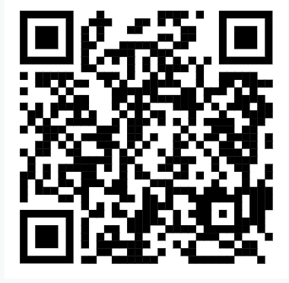
6 | 22.3.25 | Implement an application to display the Contact Details Using Content Provider https://github.com/Vijisdurai/EX_5_CONTENT-PROVIDER | 
7 | 29.3.25 | Implementation of an application that uses Explicit Intent using Android Studio.  https://github.com/Vijisdurai/Ex_6_Explicit-Intent | 
8 | 5.4.25 | Develop an android application to display the programming languages with toast message using list view in android studio.  https://github.com/Vijisdurai/Ex_7_List-View
9 | 19.4.25 | Develop an android application to display the images using gallery control. | 
9 | 19.4.25 | https://github.com/Vijisdurai/Ex_8_CheckBox
10 | 23.4.25 | Develop a simple calculator in android studio.  https://github.com/Vijisdurai/Ex_9_Calculator | 
11 | 30.4.25 | Develop an android application to create a option menu to display menu items using android studio.  https://github.com/Vijisdurai/Ex_10_option-menu | 
12 | 7.5.25 | Develop a application to add animations to ImageView, Move, blink, fade,clockwise,zoom,  slide operations are perform in android studio. | 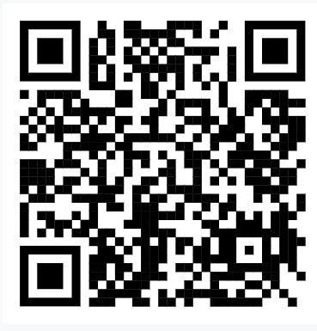
12 | 7.5.25 | https://github.com/Vijisdurai/Ex_11_ANIMATION
13 | 10.5.25 | Design an application that draws basic graphical primitives on the screen.  https://github.com/Vijisdurai/EX_12_Graphical | 
14 | 13.5.25 | Develop an application to perform thread Synchronization in android studio.  https://github.com/Vijisdurai/EX_13_THREAD | 

I Confirm that the experiments and GitHub links provided are entirely my own work
NAME: Vijis Durai R REG.NO: 212222220057

DATE: LEARNER SIGNATURE

