**EBOOKSTORE**

**WEB API**

* **Implemented All service related functionality**
* **Token based authentication**
* **Implement Swagger**

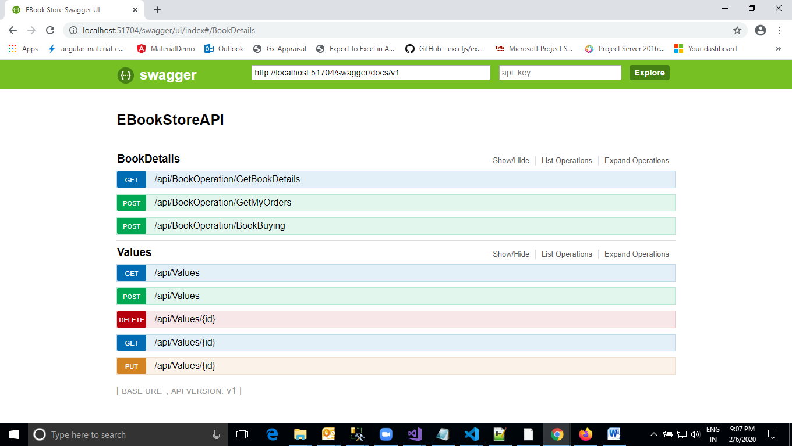

**DATA BASE**

* **Database Name – EbookStoreDB**
* **Table-User,Status,Book,Bookpurchase**
* **Total StoredProcedure- 4**
* **Total UDT- 1**

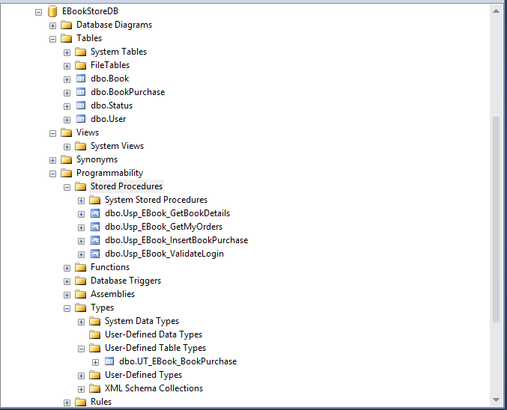

**WEB SCREEN SHOTS**

* **Angular Material**
* **Bootstrap4.0**
* **Token based authentication**
* **Toastr message.**

**Login**

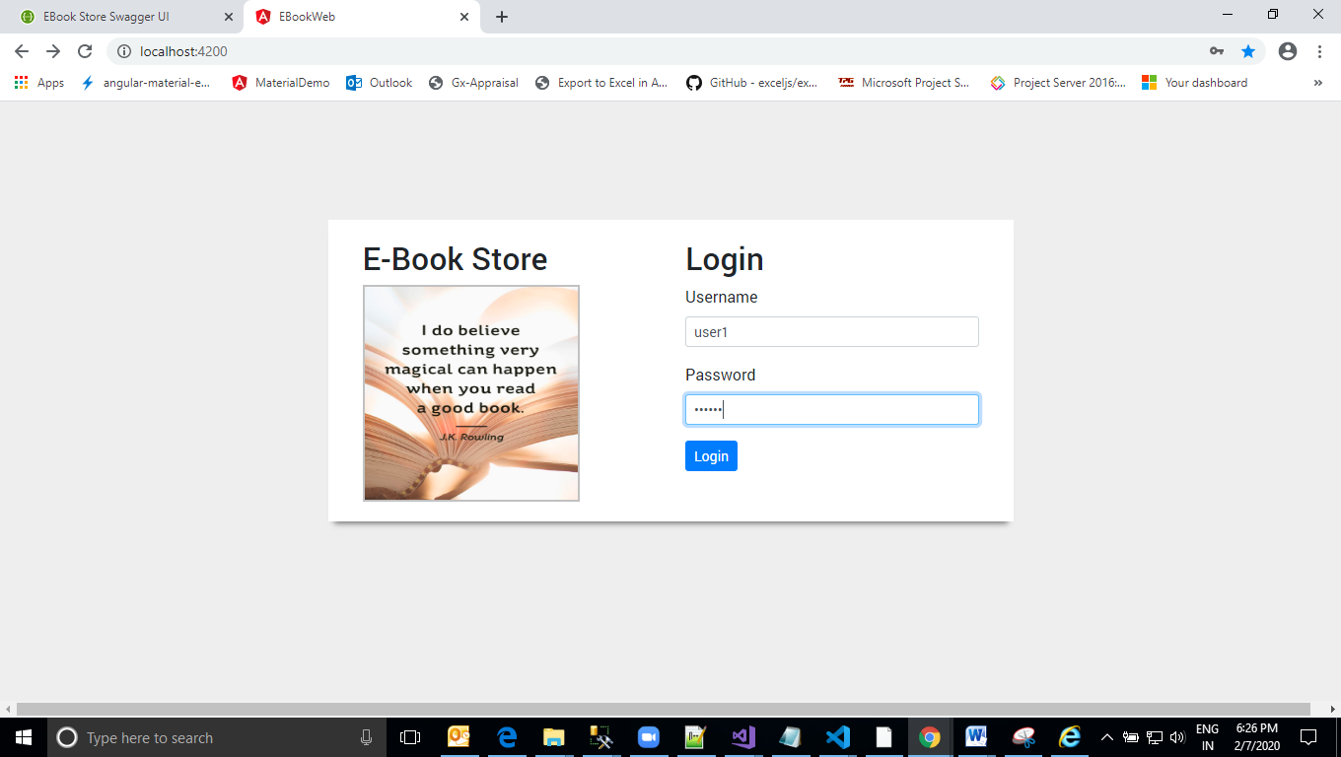

**View Books**

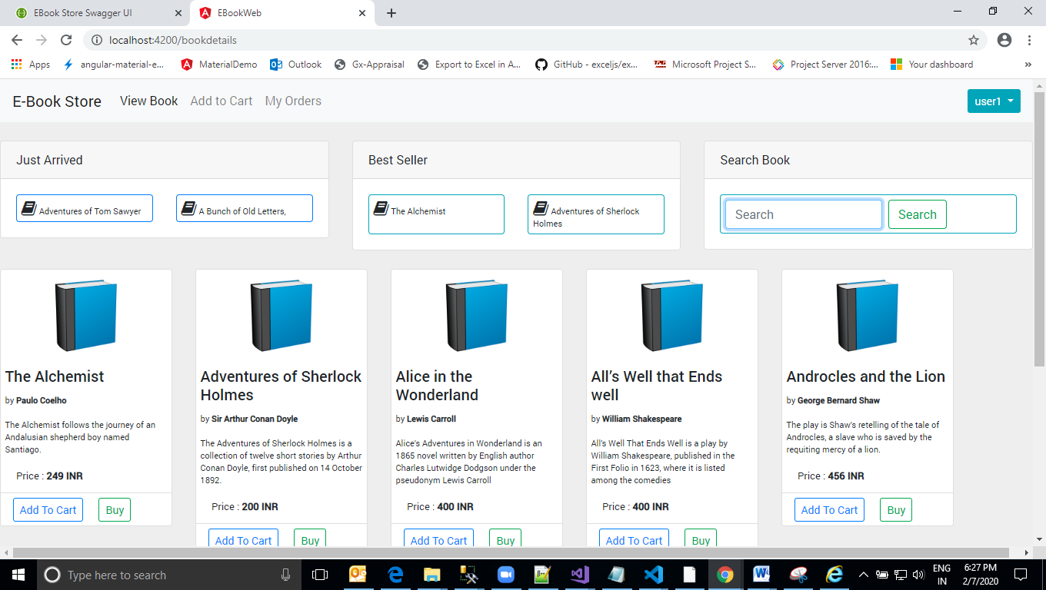

**Add To Cart Clicking**

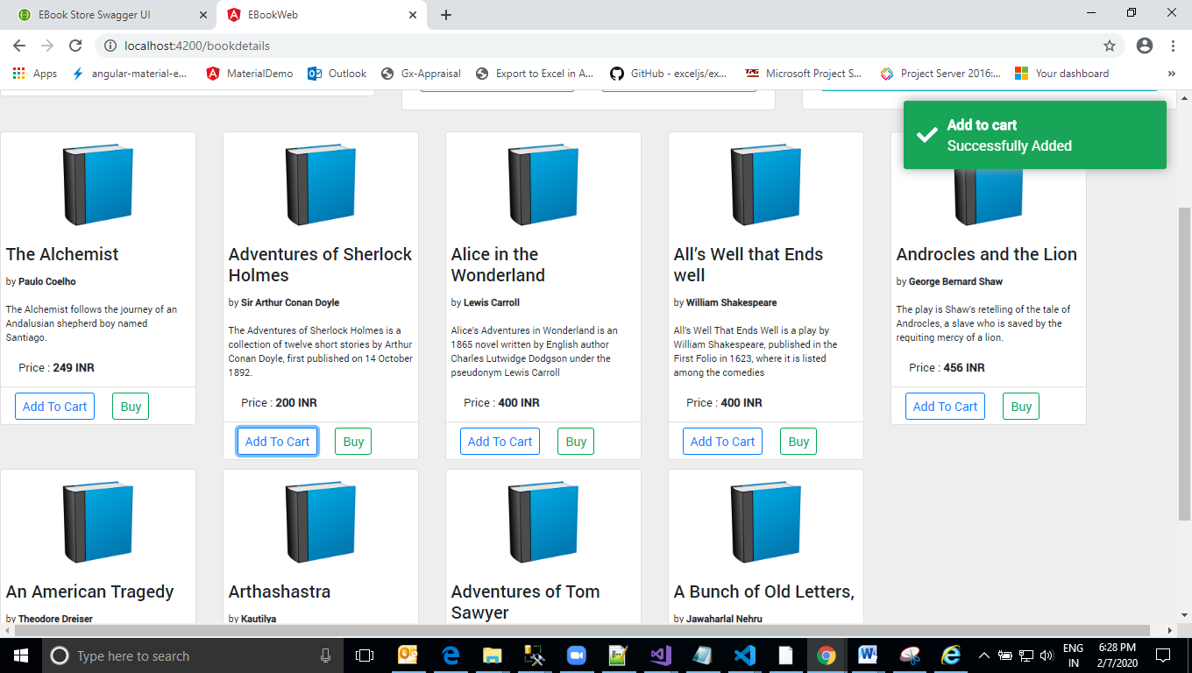

**Add to Cart Details**

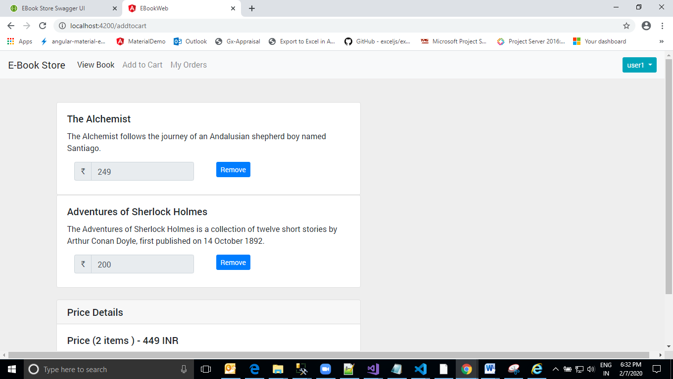

**My Order (Book List)**

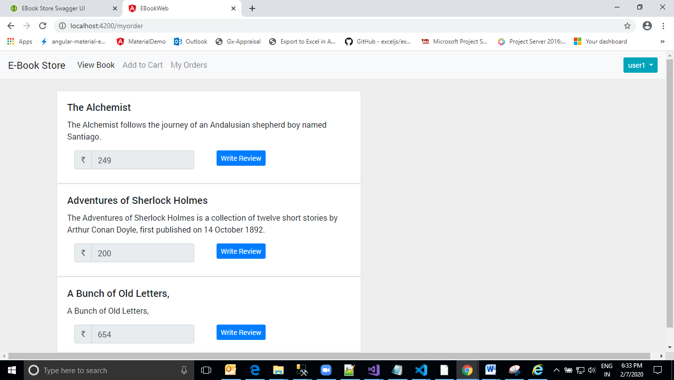

**Logout**

