Architecture Review Board (ARB)

**Use Case Context:** This artifact supports **UC07: Resolve a Data Ownership Dispute**

[G-CAF-040]
Change Driver: ARB structure, composition, or authority changes
Type: Specific
Last Updated: December 2025

Role
Strategic Authority for government digital architecture.
ARCHITECTURE REVIEW BOARD (ARB)
(Strategic Authority)
Capability Portfolio Strategy
Build/Buy/Outsource for CRITICAL PBCs
Standard Contract Version Approval
Standard Contract Migration Windows
Dispensations & Exceptions
Cross-Entity/Domain Disputes
Foundational PBC Breaking Changes

Responsibilities
Area | ARB Responsibility
Capability Portfolio | Strategic decisions on government-wide capabilities
Build/Buy/Outsource | Sourcing decisions for Critical PBCs
Standard Contract Versions | Approve new versions of standard contracts
Migration Windows | Set timelines for contract version migrations
Dispensations | Grant exceptions to G-CAF requirements
Cross-Entity Disputes | Resolve architectural disputes between entities
Foundational Changes | Approve breaking changes to Foundational Stability Tier PBCs
Technical Debt | Prioritize technical debt remediation
Vendor Partnerships | Strategic vendor relationship decisions

Technical Debt Portfolio Board
The ARB operates a Technical Debt Portfolio Board with the following responsibilities:
Function | Description
Quarterly Technical Debt Review | ARB reviews debt portfolio and prioritizes remediation
Legacy PBC Migration Planning | Formal sunset roadmap for non-compliant PBCs
Debt Scoring | Each PBC assigned debt score (0-100) based on compliance, age, consumer impact
Remediation Funding | Annual budget allocation for debt reduction initiatives
Cross-Entity Debt Coordination | ARB arbitrates when entity debt impacts shared services

Technical Debt Classification
Debt Level | Criteria | Required Action
Critical | Security vulnerabilities; EOL dependencies; blocking other PBCs | Immediate remediation plan (30 days)
High | Non-compliant with current Standard Contracts; >2 versions behind | Remediation within 6 months
Medium | 1 version behind Standard Contracts; limited test coverage | Plan in next budget cycle
Low | Code quality issues; documentation gaps | Track and address opportunistically

Relationship with DDA

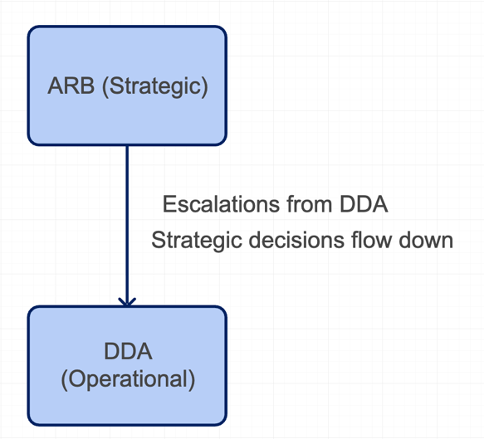

Function | ARB | DDA
Capability Strategy | ✓ Decides | Recommends
PBC Architecture | Standards approval | ✓ Reviews & approves
Standard Contracts | ✓ Version approval | Compliance enforcement
Vendor Selection | Strategic partnerships | ✓ Technical evaluation
PBC Lifecycle | — | ✓ Full governance
Exceptions | ✓ Dispensation decisions | Escalates with recommendation

Decision Authority
Decision Type | ARB Authority
New standard contract version | Required
Critical PBC sourcing | Required
Foundational PBC breaking change | Required
Cross-entity dispute | Required
DDA escalation | Required
High/Medium/Low PBC sourcing | Delegated to DDA
PBC architecture approval | Delegated to DDA

Escalation Triggers
DDA escalates to ARB when:
- Critical PBC requires sourcing decision
- Cross-entity conflict cannot be resolved
- Dispensation from G-CAF is requested
- Foundational PBC requires breaking change
- Standard contract version requires approval
- Strategic vendor partnership decision needed

Related Modules
Module | Relationship
G-CAF-041 (dda.md) | DDA reports to ARB; ARB handles escalations
G-CAF-042 (pbc-catalog.md) | ARB oversees PBC portfolio strategy
G-CAF-058 (criticality.md) | ARB handles Critical PBC sourcing decisions
G-CAF-070 (security-contract.md) | ARB approves contract versions
G-CAF-071 (data-contract.md) | ARB approves contract versions
G-CAF-072 (integration-contract.md) | ARB approves contract versions
G-CAF-073 (nfr-contract.md) | ARB approves contract versions
G-CAF-090-093 (gateways) | ARB is escalation point for gateway decisions
G-CAF-046 (Technical Debt) | ARB operates Technical Debt Portfolio Board

