PBC Catalog

**Use Case Context:** This artifact supports **UC01: Propose a New Digital Capability**

[G-CAF-042]
Change Driver: Catalog structure, fields, or registration process
Type: Specific
Last Updated: December 2025

Role
Authoritative registry of all Packaged Business Capabilities.

Catalog Fields
Field | Description
PBC ID | Unique identifier
Name | PBC name
Description | What the PBC does
Domain | GovData, GovOps, GovCitizen, etc.
PBC Type | Application, Analytics, Data, Orchestration, Digital Twin
Criticality | Critical, High, Medium, Low
Sourcing Preference | Build, Buy, Outsource
Operational Model | Centralized, Federated, Distributed
Stability Tier | Foundational, Stable, Evolving
Sourcing | Custom-Built, Vendor (product name), Outsourced
Status | Proposed, In Development, Active, Deprecated, Retired
Owner | Owning entity/team
Version | Current internal version
Interface Contract Version | Current stable interface version
Standard Contract Versions | Declared compliance versions (see _version-registry.md)
APIs | Published APIs (registered in GovDX)
Dependencies | Other PBCs this depends on
Consumers | Services/PBCs consuming this PBC
Gateway Status | Last gateway passed

Catalog Rules
Rule | Enforcement
No PBC may be deployed without Catalog registration | Go-Live Gateway requirement
Reuse assessment required before creating new PBC | Initiation Gateway requirement
Deprecated PBCs must have migration path | DDA approval for deprecation
Retired PBCs must have zero consumers | Retirement Gateway requirement
All PBCs must declare standard contract versions | Initiation Gateway requirement
Interface contract changes require consumer notification | DDA-managed process

Catalog Automation Rules
Rule | Enforcement
Catalog registration MUST be triggered through IDP pipelines | No manual entry permitted
PBC deployment pipelines MUST include automated Catalog status validation | IDP enforcement
Interface Contract changes MUST auto-update Catalog via CI/CD | Pipeline requirement
Consumer dependency tracking MUST be automated via GovDX telemetry | Automated tracking
Catalog synchronization with IDP must occur within 15 minutes of deployment | SLA monitored
Manual Catalog overrides require DDA approval with documented justification | Exception process

PBC Lifecycle States
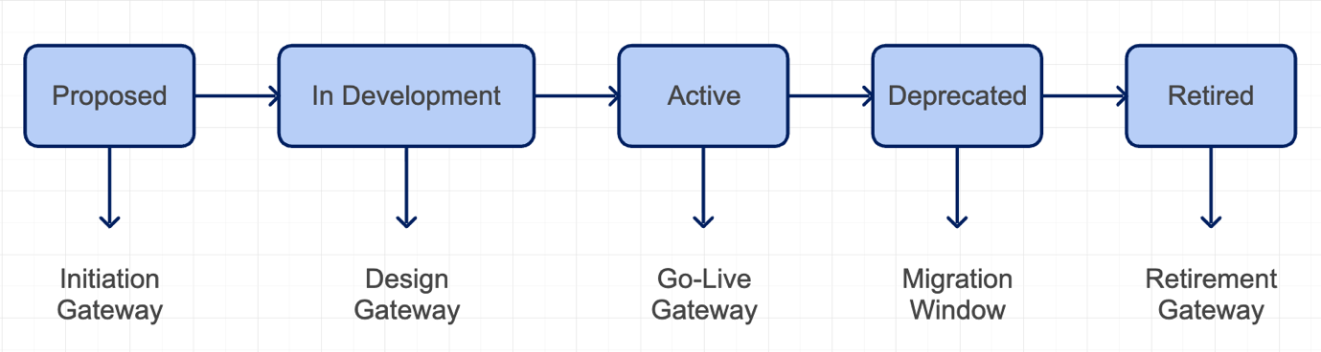

Reuse Assessment Process
Before proposing a new PBC:
- Search Catalog — Check for existing PBCs meeting the need
- Evaluate Fit — Can existing PBC be extended or configured?
- Document Gap — If no fit, document why new PBC is needed
- Initiation Gateway — Present search results and gap analysis to DDA

Consumer Tracking
The Catalog tracks:
- Which PBCs consume which other PBCs
- Consumer count per interface contract version
- Active consumers vs. deprecated version consumers
This enables:
- Impact analysis for interface changes
- Targeted consumer notifications
- Safe retirement (zero consumers verified)
**Procurement Integration:** See `procurement-governance.md` for gateway-to-procurement alignment and vendor onboarding checklist.

Related Modules
Module | Relationship
G-CAF-041 (dda.md) | DDA maintains catalog
G-CAF-058 (criticality.md) | Classification field
G-CAF-051 (sourcing.md) | Classification field
G-CAF-052 (pbc-types.md) | Classification field
G-CAF-059 (stability-tiers.md) | Classification field
G-CAF-090-093 (gateways) | Lifecycle states updated
COMPANION-001 (pbc-template.md) | PBC documentation template

