Technology Standards Catalog

**Use Case Context:** This artifact supports **UC02: Build, Buy, or Outsource Decision**

[G-CAF-043]
Change Driver: Technology strategy or approved technology lifecycle
Type: Specific
Last Updated: December 2025

Purpose
The Technology Standards Catalog provides strategic governance over technology choices across all PBCs. It defines approved technologies by category, their lifecycle status, and compliance requirements, ensuring consistency while allowing flexibility for specific business needs.
**Governance Principle:** Technology choices are governed strategically (what's allowed) while remaining separate from PBC capability definitions (what the PBC does). This maintains NS compliance by establishing separate change drivers.

Catalog Structure
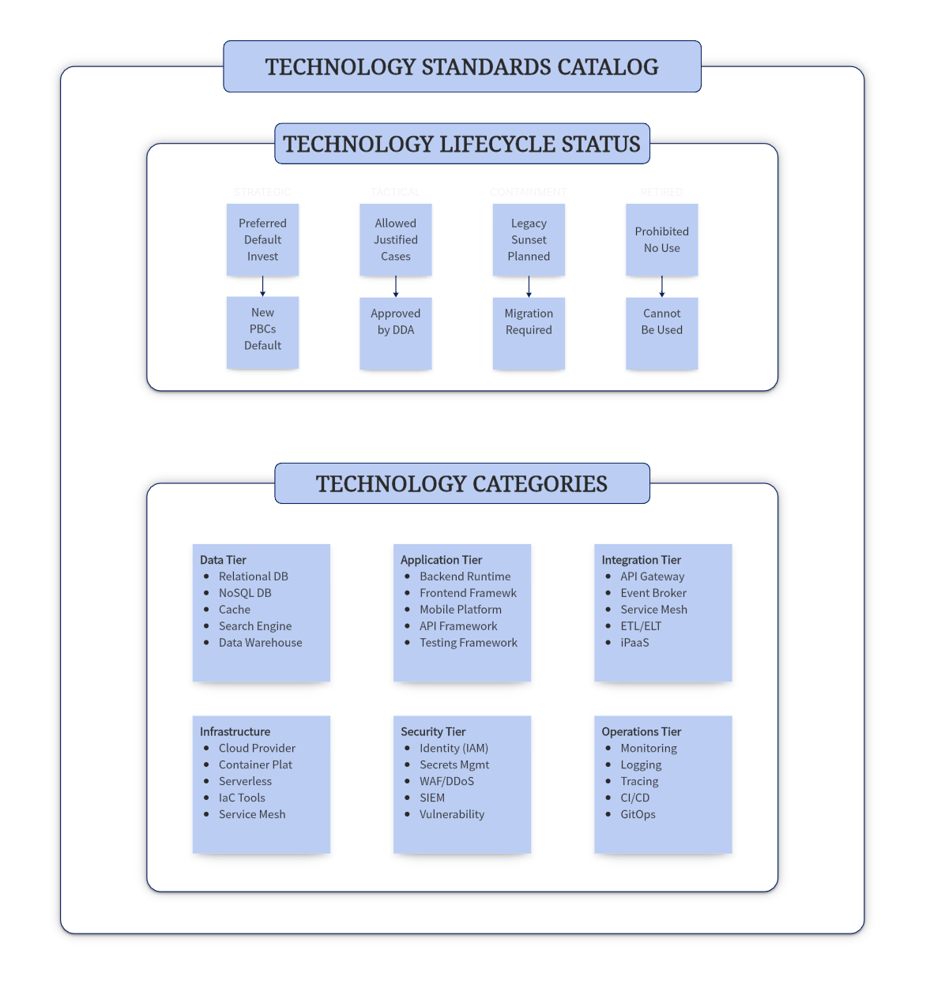

Technology Lifecycle Status Definitions
Status | Definition | Governance | PBC Usage
Strategic | Preferred technology; actively invested in; default for new PBCs | ARB approved | Default choice; no justification needed
Tactical | Approved for specific use cases; not preferred but acceptable | DDA approved | Requires documented justification
Containment | Legacy technology; sunset planned; no new adoption | DDA managed | Existing PBCs only; migration plan required
Retired | End of life; prohibited for any use | ARB enforced | Not permitted; must migrate

Lifecycle Transitions
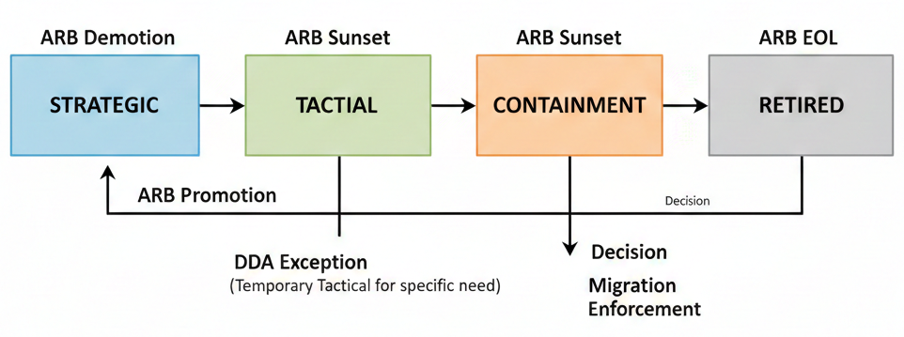

Technology Standards by Category

Data Tier
Relational Database
Technology | Version | Status | Use Case | Constraints
PostgreSQL | 15+ | Strategic | Default for all new PBCs; OLTP workloads | —
Azure SQL Database | Current | Strategic | Azure-native PBCs; managed service preference | Azure deployment only
Oracle Database | 19c+ | Tactical | Complex enterprise workloads; existing Oracle investments | Requires DDA justification; high licensing cost
MySQL | 8.0+ | Tactical | Simple workloads; open source requirement | Not for mission-critical
SQL Server | 2019+ | Containment | Existing deployments only | No new adoption; migrate to PostgreSQL/Azure SQL
SQL Server | 2016 and below | Retired | — | Must migrate immediately

NoSQL Database
Technology | Version | Status | Use Case | Constraints
Azure Cosmos DB | Current | Strategic | Multi-model; global distribution; managed service | Azure deployment only
MongoDB Atlas | 7.0+ | Strategic | Document store; flexible schema; multi-cloud | Use Atlas managed service
Redis Enterprise | 7.2+ | Strategic | Caching; session store; real-time analytics | —
Elasticsearch | 8.0+ | Tactical | Search; log analytics | Not for primary data store
Cassandra | 4.1+ | Tactical | Time-series; high write throughput | Requires specialized skills
DynamoDB | Current | Tactical | AWS-native workloads | AWS deployment only

Data Warehouse & Analytics
Technology | Version | Status | Use Case | Constraints
Azure Synapse Analytics | Current | Strategic | Enterprise data warehouse; analytics | Azure deployment
Databricks | Current | Strategic | Data engineering; ML workloads; lakehouse | —
Snowflake | Current | Tactical | Multi-cloud data warehouse | Requires cost governance
BigQuery | Current | Tactical | GCP-native analytics | GCP deployment only

Application Tier
Backend Runtime
Technology | Version | Status | Use Case | Constraints
Java (OpenJDK) | 21 LTS | Strategic | Enterprise applications; microservices | Use LTS versions only
Java (OpenJDK) | 17 LTS | Strategic | Enterprise applications; microservices | Migration to 21 recommended
.NET | 8+ | Strategic | Enterprise applications; Azure integration | Use LTS versions
Node.js | 20 LTS+ | Strategic | API services; real-time applications | Use LTS versions only
Python | 3.11+ | Tactical | Data science; scripting; ML workloads | Not for high-performance APIs
Go | 1.21+ | Tactical | High-performance services; infrastructure tools | Requires team capability
Java | 11 | Containment | Existing applications | Migrate to 17/21
.NET Framework | 4.8 | Containment | Existing Windows applications | Migrate to .NET 8+
Java | 8 | Retired | — | Must migrate
Node.js | 16 and below | Retired | — | Must migrate

Frontend Framework
Technology | Version | Status | Use Case | Constraints
React | 18+ | Strategic | Web applications; SPAs | Default choice
Angular | 17+ | Strategic | Enterprise web applications | Complex applications
Vue.js | 3+ | Tactical | Lightweight applications | Requires justification
Next.js | 14+ | Tactical | Server-side rendering; full-stack | React ecosystem only
jQuery | Any | Containment | Legacy applications only | No new development
AngularJS | 1.x | Retired | — | Must migrate to Angular 17+

Mobile Platform
Technology | Version | Status | Use Case | Constraints
Flutter | 3+ | Strategic | Cross-platform mobile apps | Default for new apps
React Native | 0.72+ | Strategic | Cross-platform; React ecosystem | React team expertise
Swift | 5.9+ | Tactical | iOS-native requirements | iOS only; requires justification
Kotlin | 1.9+ | Tactical | Android-native requirements | Android only; requires justification
Xamarin | Any | Containment | Existing apps only | Migrate to .NET MAUI

API Framework
Technology | Version | Status | Use Case | Constraints
Spring Boot | 3.2+ | Strategic | Java microservices | Java runtime
ASP.NET Core | 8+ | Strategic | .NET microservices | .NET runtime
Express.js | 4.18+ | Strategic | Node.js APIs | Node.js runtime
FastAPI | 0.100+ | Tactical | Python APIs; ML model serving | Python runtime
NestJS | 10+ | Tactical | Enterprise Node.js | Node.js runtime

Integration Tier
API Gateway
Technology | Version | Status | Use Case | Constraints
Azure API Management | Current | Strategic | Enterprise API gateway; GovDX integration | Azure deployment
Kong Enterprise | 3.4+ | Strategic | Multi-cloud; Kubernetes-native | —
AWS API Gateway | Current | Tactical | AWS-native workloads | AWS deployment only
Apigee | Current | Tactical | GCP-native; advanced analytics | GCP deployment only

Event Broker / Message Queue
Technology | Version | Status | Use Case | Constraints
Azure Event Hubs | Current | Strategic | Event streaming; high throughput | Azure deployment
Apache Kafka (Confluent) | 3.6+ | Strategic | Event streaming; multi-cloud | Use managed service
Azure Service Bus | Current | Strategic | Enterprise messaging; queues | Azure deployment
RabbitMQ | 3.12+ | Tactical | Traditional messaging; smaller scale | Not for high-volume streaming
Amazon SNS/SQS | Current | Tactical | AWS-native messaging | AWS deployment only

Integration Platform (iPaaS)
Technology | Version | Status | Use Case | Constraints
Azure Logic Apps | Current | Strategic | Workflow automation; SaaS integration | Azure deployment
Azure Data Factory | Current | Strategic | Data integration; ETL/ELT | Azure deployment
MuleSoft | Current | Tactical | Complex enterprise integration | High licensing cost
Boomi | Current | Tactical | Multi-cloud integration | Requires justification

Infrastructure Tier
Cloud Provider
Technology | Status | Use Case | Constraints
Microsoft Azure | Strategic | Primary cloud; government workloads | Default choice
Amazon Web Services (AWS) | Tactical | Specific workloads; vendor requirements | Requires DDA approval
Google Cloud Platform (GCP) | Tactical | AI/ML workloads; specific services | Requires DDA approval
Oracle Cloud Infrastructure | Tactical | Oracle workload optimization | Oracle workloads only
Private Cloud (On-premises) | Containment | Legacy; data sovereignty exceptions | Migration plan required

Container Platform
Technology | Version | Status | Use Case | Constraints
Azure Kubernetes Service (AKS) | Current | Strategic | Container orchestration; Azure | Default for Azure
Red Hat OpenShift | 4.14+ | Tactical | Enterprise Kubernetes; hybrid cloud | Requires justification
Amazon EKS | Current | Tactical | AWS container workloads | AWS deployment only
Docker Swarm | Any | Retired | — | Migrate to Kubernetes

Serverless
Technology | Version | Status | Use Case | Constraints
Azure Functions | 4.x | Strategic | Event-driven compute; Azure | Default for serverless
Azure Container Apps | Current | Strategic | Serverless containers | Azure deployment
AWS Lambda | Current | Tactical | AWS event-driven workloads | AWS deployment only
Google Cloud Functions | Current | Tactical | GCP event-driven workloads | GCP deployment only

Infrastructure as Code (IaC)
Technology | Version | Status | Use Case | Constraints
Terraform | 1.6+ | Strategic | Multi-cloud IaC | Default choice
Azure Bicep | Current | Strategic | Azure-native IaC | Azure only
Pulumi | 3+ | Tactical | Programming language IaC | Requires team capability
ARM Templates | Current | Containment | Existing Azure deployments | Migrate to Bicep
CloudFormation | Current | Tactical | AWS-native IaC | AWS only

Security Tier
Identity & Access Management
Technology | Version | Status | Use Case | Constraints
Microsoft Entra ID (Azure AD) | Current | Strategic | Enterprise identity; SSO | Default for identity
Keycloak | 22+ | Tactical | Open source; on-premises | Requires operational capability
Okta | Current | Tactical | Multi-cloud identity | SaaS preference
AWS IAM / Cognito | Current | Tactical | AWS-native identity | AWS deployment only

Secrets Management
Technology | Version | Status | Use Case | Constraints
Azure Key Vault | Current | Strategic | Secrets; keys; certificates | Azure deployment
HashiCorp Vault | 1.15+ | Strategic | Multi-cloud secrets management | —
AWS Secrets Manager | Current | Tactical | AWS-native secrets | AWS deployment only

Security Tools
Technology | Version | Status | Use Case | Constraints
Microsoft Defender for Cloud | Current | Strategic | Cloud security posture | Azure default
Azure WAF | Current | Strategic | Web application firewall | Azure deployment
Snyk | Current | Strategic | Dependency scanning; SAST | —
SonarQube | 10+ | Strategic | Code quality; SAST | —
OWASP ZAP | Current | Tactical | DAST; penetration testing | Open source
Checkmarx | Current | Tactical | Enterprise SAST/DAST | High licensing cost

Operations Tier
Monitoring & Observability
Technology | Version | Status | Use Case | Constraints
Azure Monitor | Current | Strategic | Azure-native monitoring | Azure deployment
Prometheus + Grafana | Current | Strategic | Kubernetes monitoring; multi-cloud | —
Datadog | Current | Tactical | Multi-cloud APM | SaaS; licensing cost
New Relic | Current | Tactical | APM; full-stack observability | SaaS; licensing cost
AWS CloudWatch | Current | Tactical | AWS-native monitoring | AWS deployment only

Logging
Technology | Version | Status | Use Case | Constraints
Azure Log Analytics | Current | Strategic | Centralized logging; Azure | Azure deployment
Elasticsearch + Kibana (ELK) | 8.0+ | Strategic | Log aggregation; search | Self-managed or Elastic Cloud
Splunk | Current | Tactical | Enterprise log analytics; SIEM | High licensing cost
Loki + Grafana | Current | Tactical | Kubernetes-native logging | Kubernetes only

Distributed Tracing
Technology | Version | Status | Use Case | Constraints
Azure Application Insights | Current | Strategic | APM; distributed tracing; Azure | Azure deployment
Jaeger | 1.50+ | Strategic | Open source distributed tracing | —
OpenTelemetry | Current | Strategic | Vendor-neutral telemetry | Instrumentation standard
Zipkin | Current | Tactical | Lightweight tracing | Smaller deployments

CI/CD
Technology | Version | Status | Use Case | Constraints
Azure DevOps | Current | Strategic | Enterprise CI/CD; Azure integration | Default choice
GitHub Actions | Current | Strategic | GitHub-based workflows | GitHub repositories
GitLab CI/CD | 16+ | Tactical | GitLab-based workflows | GitLab repositories
Jenkins | 2.400+ | Containment | Existing pipelines | Migrate to Azure DevOps/GitHub
ArgoCD | 2.9+ | Strategic | GitOps; Kubernetes deployments | Kubernetes only

Governance Process

Technology Addition Request

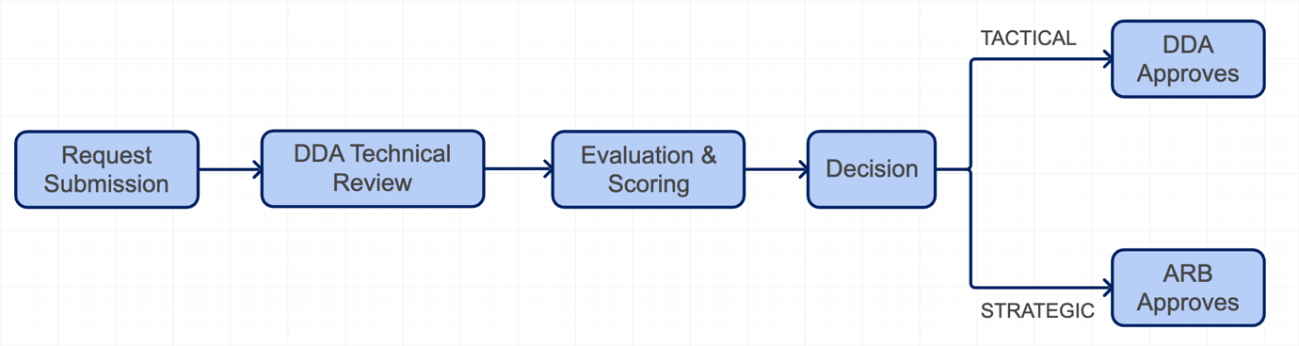

Evaluation Criteria
Criterion | Weight | Description
Strategic Alignment | 20% | Fits government cloud strategy; vendor relationships
Security & Compliance | 25% | Meets security standards; compliance certifications
Operational Maturity | 15% | Production-ready; enterprise support available
Skills Availability | 15% | Internal capability; market availability
Total Cost of Ownership | 15% | Licensing; infrastructure; operational costs
Community & Ecosystem | 10% | Active community; integration ecosystem

Decision Authority
Action | Authority | Criteria
Add as Strategic | ARB | Score ≥ 4.0; strategic importance
Add as Tactical | DDA | Score ≥ 3.5; specific use case justified
Promote Tactical → Strategic | ARB | Proven success; broad adoption
Demote Strategic → Tactical | ARB | Better alternative available; declining support
Move to Containment | ARB | Sunset decision; migration timeline set
Move to Retired | ARB | EOL reached; security risk
Exception (use Containment/Retired) | ARB | Critical business need; migration plan required

PBC Compliance Requirements

Build PBCs
Requirement | Description
Default to Strategic | New PBCs MUST use Strategic technologies unless justified
Tactical Justification | Tactical technology use requires DDA approval with documented justification
Containment Prohibition | Containment technologies CANNOT be used for new PBCs
Exception Process | ARB may grant exceptions with mandatory migration plan

Buy/Outsource PBCs
Requirement | Description
Vendor Stack Assessment | Vendor technology stack must be assessed against Catalog
Compatibility Classification | Each vendor technology classified as Compatible, ACL Required, or Incompatible
ACL Requirement | Technologies not in Catalog require Anti-Corruption Layer
Contract Clause | Vendor contracts must include technology change notification requirements

Vendor Technology Compatibility Matrix
Vendor Technology Status | G-CAF Classification | Requirement
In Catalog (Strategic/Tactical) | Compatible | Direct integration permitted
Not in Catalog but industry standard | ACL Required | Anti-Corruption Layer mandatory
Proprietary / Non-standard | ACL Required | ACL mandatory; evaluate alternatives
In Catalog (Containment/Retired) | Incompatible | Reject or require vendor upgrade

Gateway Integration

Initiation Gateway
Checklist Item | Description
[ ] Technology preferences identified | Preliminary technology choices documented
[ ] Catalog alignment checked | Technologies validated against Standards Catalog
[ ] Non-standard flagged | Any Tactical/Exception requirements identified
[ ] Vendor stack assessed (Buy) | Vendor technology compatibility evaluated

Design Gateway
Checklist Item | Description
[ ] Technology specifications documented | Full stack documented in PBC Template Section 18
[ ] Strategic technologies confirmed | Default technologies used or exceptions approved
[ ] Tactical approvals obtained | DDA approval for Tactical technologies
[ ] Exception approvals obtained | ARB approval for any exceptions
[ ] ACL designed (if required) | ACL architecture for vendor incompatibilities

Go-Live Gateway
Checklist Item | Description
[ ] Implementation matches specification | Deployed stack matches approved specification
[ ] No unapproved technologies | No Containment/Retired technologies in production
[ ] Version compliance | Technology versions meet minimum requirements
[ ] Security validation | Security tools validation passed

Catalog Maintenance

Review Cycle
Activity | Frequency | Owner | Scope
Version Updates | Quarterly | DDA | Update minimum versions; security patches
Status Review | Semi-annual | DDA | Evaluate promotions/demotions
Strategic Review | Annual | ARB | Major strategic decisions; new categories
Sunset Planning | Annual | ARB | Containment → Retired transitions
Emergency Update | As needed | DDA/ARB | Critical security vulnerabilities

Change Notification
Change Type | Notice Period | Notification Method
New Strategic technology | 30 days | Catalog update; DDA announcement
Tactical → Containment | 90 days | Direct notification to affected PBC owners
Containment → Retired | 180 days | Direct notification; migration support
Version minimum increase | 90 days | Catalog update; direct notification
Emergency security update | Immediate | Emergency notification; mandatory compliance

Reporting & Metrics

Catalog Health Metrics
Metric | Target | Measurement
Strategic technology adoption | > 80% | % of PBCs using only Strategic technologies
Tactical technology usage | < 15% | % of PBCs using Tactical technologies
Containment technology count | Decreasing | Number of PBCs on Containment technologies
Exception count | < 5 | Number of active exceptions
Average technology age | < 3 versions | Distance from current version

Compliance Dashboard
Report | Frequency | Audience
Technology Compliance Summary | Monthly | DDA
PBC Technology Debt Report | Quarterly | DDA, ARB
Catalog Health Metrics | Quarterly | ARB
Sunset Progress Report | Quarterly | ARB
Annual Technology Strategy Review | Annual | ARB, Digital Board

Companion Documents
Document ID | Document | Purpose
G-CAF-COMPANION-025 | Technology Standards Guide | Detailed evaluation criteria; exception process; migration guidance
G-CAF-COMPANION-001 | PBC Documentation Template | Section 18: Technology Specifications

Module Metadata
Field | Value
Module ID | G-CAF-043
Change Driver | Technology strategy changes; version updates
Type | Specific
Dependencies | G-CAF-040 (ARB), G-CAF-041 (DDA), G-CAF-090-093 (Gateways)
Last Updated | December 2025

NS Compliance Notes
This module follows Normalized Systems principles:
- Separation of Concerns: Technology governance (this module) is separate from PBC capability definition (Layer 2)
- Single Change Driver: Catalog updates driven by technology strategy, not PBC changes
- Version Transparency: Explicit versioning of technologies with clear lifecycle status
- Action Model: Clear governance actions (add, promote, demote, retire) with defined authority

Cross-Reference Map
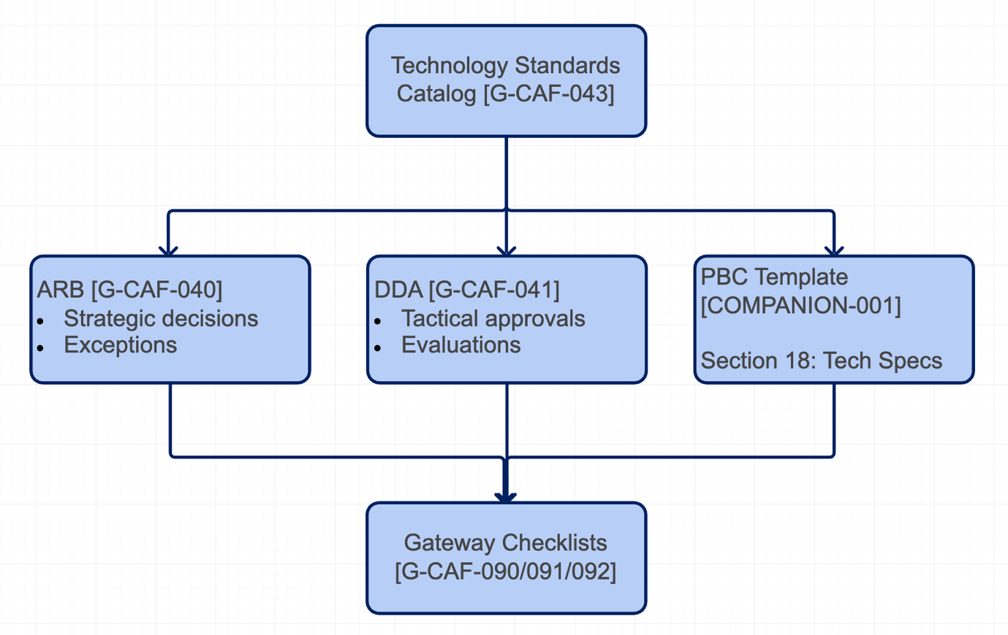

Related Modules
Module | Relationship
G-CAF-041 (dda.md) | DDA maintains catalog
G-CAF-040 (arb.md) | ARB approves Strategic
G-CAF-090-092 (gateways) | Technology validated
COMPANION-001a (Section 18) | PBC technology specs
_version-registry.md | Version tracking

