G-CAF-044: Data Asset Catalog

**Use Case Context:** This artifact supports **UC07: Resolve a Data Ownership Dispute**

[G-CAF-044]
Change Driver: Enterprise data asset governance
Type: Specific
Last Updated: December 2025

1. Purpose and Scope
[Change Driver: Strategic mandate]

1.1 Purpose
The Data Asset Catalog provides enterprise-wide governance for data entities, establishing authoritative definitions, ownership, quality standards, and lifecycle management across all PBCs in the GovDigital ecosystem.

1.2 Scope
In Scope | Out of Scope
Enterprise data entities | Technical database schema
Master data definitions | Physical data modeling
Data ownership (SoT assignment) | ETL/ELT implementation
Data quality standards | Data pipeline code
Data lifecycle governance | Operational data operations
Data domain classification | Analytics model design

1.3 Relationship to Other G-CAF Modules
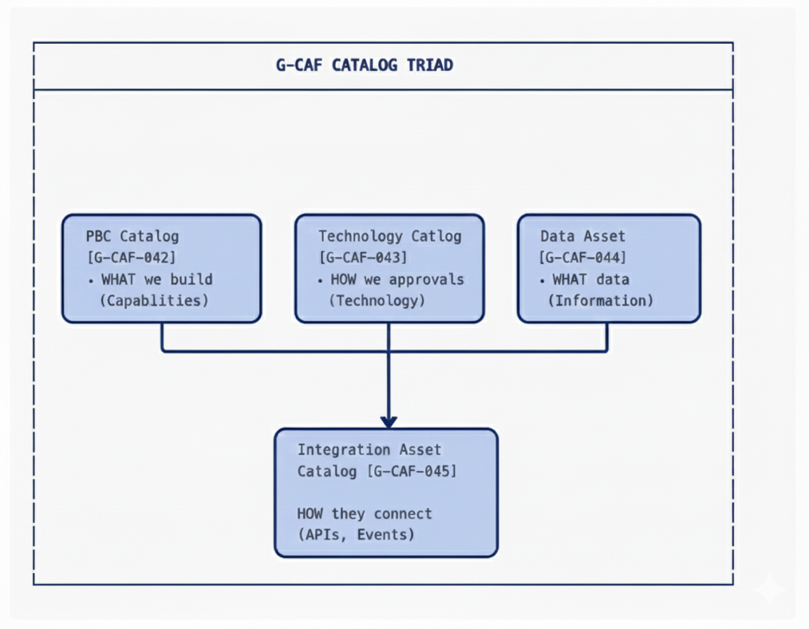

2. NS Compliance Design
[Change Driver: Architecture principles]

2.1 Module Structure
This catalog separates concerns by change driver:
Section | Change Driver | Update Trigger
§3 Data Domain Classification | Organizational restructuring | Domain boundaries change
§4 Data Entity Registry | Entity definition | New entity or attribute change
§5 Master Data Governance | Ownership policy | SoT assignment rules change
§6 Data Quality Framework | Quality standards | Measurement criteria change
§7 Data Lifecycle Status | Lifecycle governance | Status transition rules change
§8 Data Governance Process | Approval process | Governance workflow change
§9 PBC Data Specification | Per-PBC documentation | Individual PBC data changes

2.2 Separation of Concerns
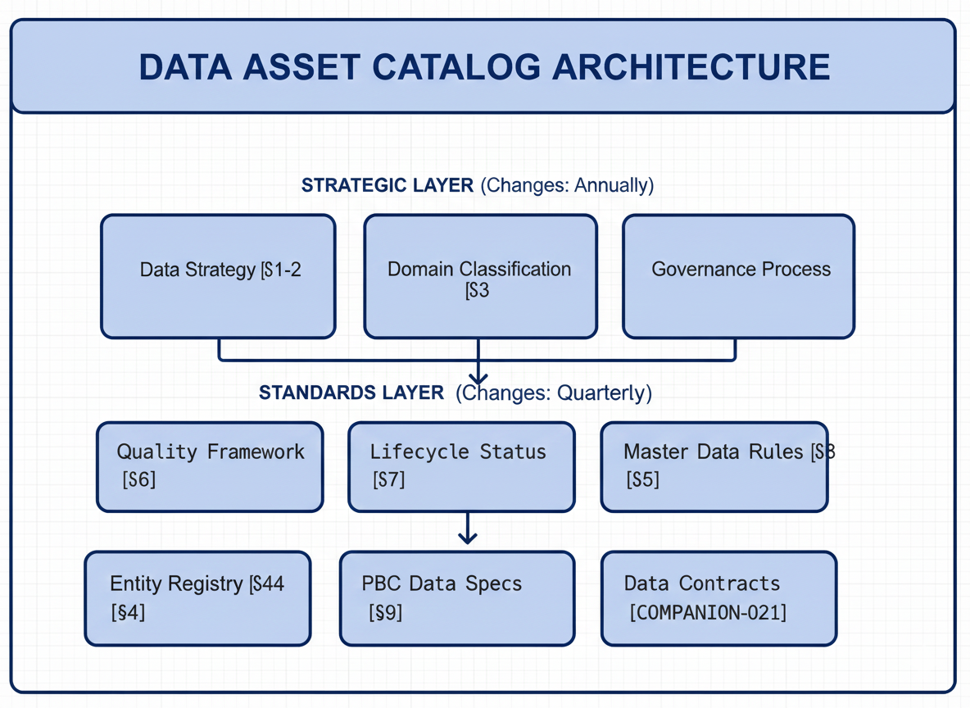

3. Data Domain Classification
[Change Driver: Organizational structure]

3.1 Domain Hierarchy
Data domains align with business capability domains but are governed separately:
Domain ID | Domain Name | Description | Domain Steward
DD-01 | Citizen | Person, identity, demographics, preferences | GovServices
DD-02 | Organization | Government entities, businesses, associations | GovOps
DD-03 | Location | Geography, addresses, spatial data | GovData
DD-04 | Asset | Physical and digital assets, inventory | GovOps
DD-05 | Finance | Transactions, budgets, accounts, payments | GovOps
DD-06 | Service | Government services, applications, requests | GovServices
DD-07 | Document | Documents, records, correspondence | GovData
DD-08 | Event | Activities, appointments, incidents, logs | GovOps
DD-09 | Reference | Codes, classifications, lookups | GovData
DD-10 | Analytics | Derived data, aggregations, metrics | GovData

3.2 Domain Governance
Responsibility | Domain Steward | Data Office | ARB
Entity definitions within domain | Approves | Reviews | —
Cross-domain entity relationships | Proposes | Approves | Arbitrates
Domain boundary changes | Proposes | Reviews | Approves
Data quality targets | Sets | Validates | —

3.3 Cross-Domain Relationships
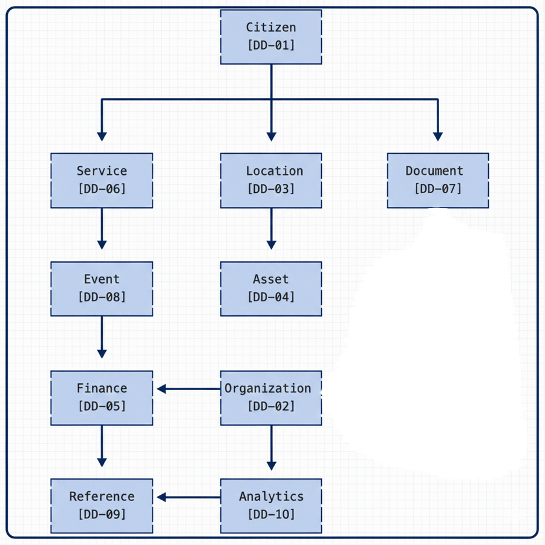

4. Data Entity Registry
[Change Driver: Entity definition changes]

4.1 Entity Classification
Classification | Definition | Example
Master Entity | Core business object; authoritative definition | Person, Organization, Address
Transactional Entity | Business events and activities | ServiceRequest, Payment, Appointment
Reference Entity | Lookup values and classifications | CountryCode, ServiceType, Status
Derived Entity | Calculated or aggregated data | CustomerScore, MonthlyMetrics

4.2 Entity Registry Structure
Each entity in the registry contains:
Attribute | Description | Example
Entity ID | Unique identifier | ENT-DD01-001
Entity Name | Canonical name | Person
Domain | Parent domain | DD-01 Citizen
Classification | Master/Transactional/Reference/Derived | Master
Definition | Business definition | A natural person who interacts with government services
Source of Truth (SoT) | Authoritative PBC | Identity Management PBC
Lifecycle Status | Current status | Authoritative
Data Steward | Accountable person | Identity Domain Lead
Quality Tier | Required quality level | Tier 1 (Critical)

4.3 Core Entity Catalog
4.3.1 Citizen Domain (DD-01)
Entity ID | Entity Name | Classification | SoT PBC | Status
ENT-DD01-001 | Person | Master | Identity Management | Authoritative
ENT-DD01-002 | Citizen | Master | Identity Management | Authoritative
ENT-DD01-003 | Resident | Master | Residency Services | Authoritative
ENT-DD01-004 | Visitor | Master | Border Services | Authoritative
ENT-DD01-005 | EmiratesID | Master | Identity Management | Authoritative
ENT-DD01-006 | ContactInfo | Master | Identity Management | Authoritative
ENT-DD01-007 | Preference | Transactional | Citizen Portal | Authoritative
ENT-DD01-008 | Consent | Transactional | Consent Management | Authoritative

4.3.2 Organization Domain (DD-02)
Entity ID | Entity Name | Classification | SoT PBC | Status
ENT-DD02-001 | Organization | Master | Entity Registry | Authoritative
ENT-DD02-002 | GovernmentEntity | Master | Entity Registry | Authoritative
ENT-DD02-003 | Business | Master | Business Licensing | Authoritative
ENT-DD02-004 | TradeLicense | Transactional | Business Licensing | Authoritative
ENT-DD02-005 | Department | Reference | Entity Registry | Authoritative
ENT-DD02-006 | Employee | Master | HR Management | Authoritative

4.3.3 Location Domain (DD-03)
Entity ID | Entity Name | Classification | SoT PBC | Status
ENT-DD03-001 | Address | Master | Address Management | Authoritative
ENT-DD03-002 | Emirate | Reference | Address Management | Authoritative
ENT-DD03-003 | Municipality | Reference | Address Management | Authoritative
ENT-DD03-004 | District | Reference | Address Management | Authoritative
ENT-DD03-005 | Building | Master | Address Management | Authoritative
ENT-DD03-006 | GeoLocation | Master | GIS Services | Authoritative
ENT-DD03-007 | Zone | Reference | Address Management | Authoritative

4.3.4 Service Domain (DD-06)
Entity ID | Entity Name | Classification | SoT PBC | Status
ENT-DD06-001 | Service | Master | Service Catalog | Authoritative
ENT-DD06-002 | ServiceRequest | Transactional | Service Request Mgmt | Authoritative
ENT-DD06-003 | Application | Transactional | Application Processing | Authoritative
ENT-DD06-004 | Certificate | Transactional | Certificate Issuance | Authoritative
ENT-DD06-005 | Permit | Transactional | Permit Management | Authoritative
ENT-DD06-006 | Appointment | Transactional | Appointment Booking | Authoritative
ENT-DD06-007 | Feedback | Transactional | Feedback Management | Authoritative

4.3.5 Reference Domain (DD-09)
Entity ID | Entity Name | Classification | SoT PBC | Status
ENT-DD09-001 | Country | Reference | Reference Data Mgmt | Authoritative
ENT-DD09-002 | Nationality | Reference | Reference Data Mgmt | Authoritative
ENT-DD09-003 | Language | Reference | Reference Data Mgmt | Authoritative
ENT-DD09-004 | Currency | Reference | Reference Data Mgmt | Authoritative
ENT-DD09-005 | ServiceType | Reference | Service Catalog | Authoritative
ENT-DD09-006 | StatusCode | Reference | Reference Data Mgmt | Authoritative
ENT-DD09-007 | DocumentType | Reference | Reference Data Mgmt | Authoritative

4.4 Entity Relationship Registry
Relationship ID | Source Entity | Target Entity | Cardinality | Ownership
REL-001 | Person | Address | 1:N | Person owns
REL-002 | Person | Organization | N:M | Association
REL-003 | Organization | Address | 1:N | Organization owns
REL-004 | ServiceRequest | Person | N:1 | ServiceRequest references
REL-005 | ServiceRequest | Service | N:1 | ServiceRequest references
REL-006 | Certificate | Person | N:1 | Certificate references
REL-007 | Business | TradeLicense | 1:N | Business owns
REL-008 | Address | GeoLocation | 1:1 | Address owns

5. Master Data Governance
[Change Driver: Ownership policy changes]

5.1 Source of Truth (SoT) Principles
Principle | Description
Single SoT | Each Master Entity has exactly ONE authoritative PBC
SoT Authority | Only SoT PBC can create/update/delete entity instances
Consumer Access | Other PBCs consume via APIs; no direct database access
Golden Record | SoT maintains canonical, reconciled version
Change Propagation | SoT publishes changes via events; consumers subscribe

5.2 SoT Assignment Criteria
Criterion | Weight | Description
Business Ownership | 30% | Which business function owns the entity lifecycle?
Data Creation | 25% | Which system creates entity instances?
Data Quality | 20% | Which system has highest quality data?
Update Frequency | 15% | Which system updates most frequently?
Integration Load | 10% | Which assignment minimizes integration complexity?

5.3 SoT Governance Process

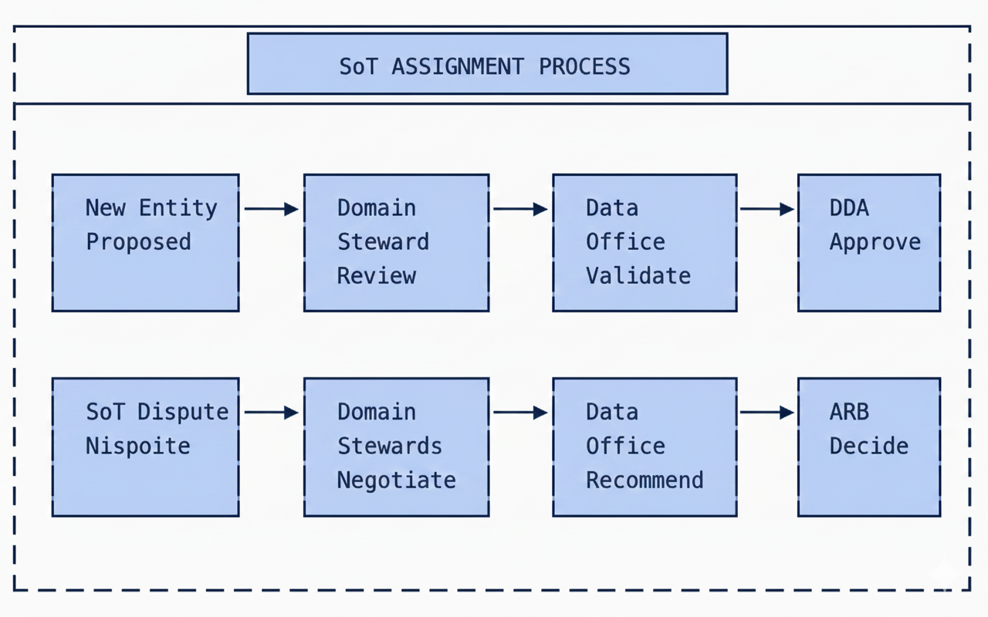

5.4 SoT Responsibilities
Responsibility | SoT PBC | Consumer PBC
Create entity instances | ✅ Required | ❌ Prohibited
Update entity instances | ✅ Required | ❌ Prohibited
Delete entity instances | ✅ Required | ❌ Prohibited
Publish change events | ✅ Required | N/A
Subscribe to events | Optional | ✅ Required
Maintain data quality | ✅ Required | N/A
Provide query APIs | ✅ Required | N/A
Cache local copy | N/A | ✅ Allowed
Transform for local use | N/A | ✅ Allowed

5.5 Data Sharing Zones
Zone | Description | Access Model
Private | PBC-internal data only | No external access
Shared-Domain | Shared within data domain | Domain APIs only
Shared-Enterprise | Available to all PBCs | GovDX APIs
Public | Open data for external consumers | Open Data Portal

6. Data Quality Framework
[Change Driver: Quality standards changes]

6.1 Quality Dimensions
Dimension | Definition | Measurement
Completeness | Required fields populated | % fields with values
Accuracy | Values match real-world | % records validated
Consistency | Same value across systems | % cross-system match
Timeliness | Data current when needed | Age of data vs. SLA
Uniqueness | No unintended duplicates | % duplicate records
Validity | Values conform to rules | % passing validation

6.2 Quality Tiers
Tier | Description | Dimensions Required | Target | Examples
Tier 1: Critical | Data supporting critical decisions | All 6 dimensions | 99.9% | Person, EmiratesID, Financial
Tier 2: High | Important operational data | Completeness, Accuracy, Validity | 99.0% | ServiceRequest, Address
Tier 3: Standard | General business data | Completeness, Validity | 95.0% | Preference, Feedback
Tier 4: Informational | Supporting data | Completeness | 90.0% | Analytics, Logs

6.3 Quality Rules by Entity Type
Entity Type | Required Rules | Optional Rules
Master | Primary key uniqueness, Required field validation, Format validation, Referential integrity | Cross-reference validation, Business rule validation
Transactional | Primary key uniqueness, Required field validation, Status transition validation | Duplicate detection, Anomaly detection
Reference | Code uniqueness, Active/Inactive status, Effective dating | Hierarchy validation
Derived | Calculation validation, Source traceability | Freshness validation

6.4 Quality Monitoring
Metric | Calculation | Frequency | Owner
Entity Completeness Score | Complete records / Total records | Daily | SoT PBC
Entity Accuracy Score | Validated records / Sampled records | Weekly | Data Office
Cross-System Consistency | Matching records / Compared records | Weekly | Data Office
Data Freshness | Records within SLA / Total records | Hourly | SoT PBC
Duplicate Rate | Duplicate records / Total records | Daily | SoT PBC

7. Data Lifecycle Status
[Change Driver: Lifecycle governance changes]

7.1 Entity Lifecycle Status
Status | Definition | Governance
Proposed | Entity identified; under definition | Domain Steward
Draft | Definition complete; under review | Data Office
Approved | Definition approved; SoT assigned | DDA
Authoritative | In production; active governance | SoT PBC
Deprecated | Sunset planned; no new usage | Data Office
Retired | End of life; historical only | Data Office

7.2 Status Transitions

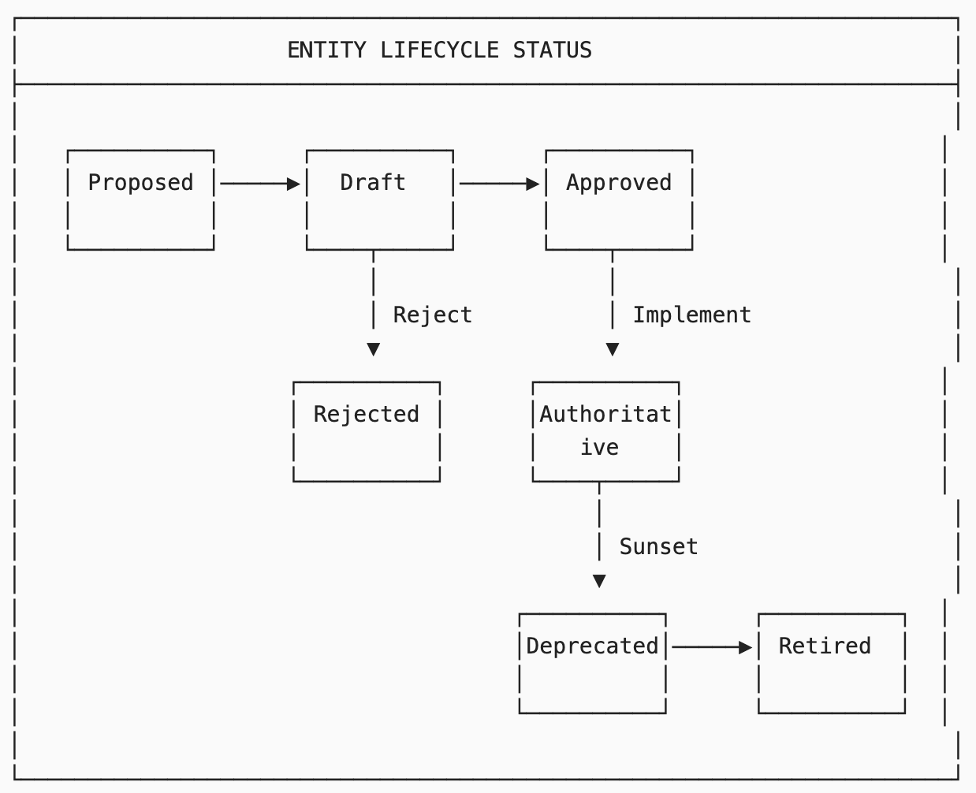

7.3 Transition Governance
Transition | Authority | Notice Period | Requirements
Proposed → Draft | Domain Steward | — | Definition complete
Draft → Approved | DDA | — | SoT assigned; quality tier set
Approved → Authoritative | SoT PBC | — | Implementation complete
Authoritative → Deprecated | Data Office | 90 days | Migration plan; consumer notification
Deprecated → Retired | Data Office | 180 days | All consumers migrated

7.4 Data Instance Lifecycle
Separate from entity definition lifecycle, data instances have their own status:
Status | Definition | Visibility
Draft | Instance created but not validated | Internal only
Active | Instance validated and current | Full visibility
Suspended | Temporarily inactive | Limited visibility
Archived | Historical; no longer current | Query only
Deleted | Logically deleted | Audit only

8. Data Governance Process
[Change Driver: Governance workflow changes]

8.1 Governance Bodies
Body | Scope | Frequency | Chair
Data Governance Council | Strategic data decisions | Monthly | Chief Data Officer
Data Office | Operational governance | Weekly | Data Office Lead
Domain Steward Forum | Cross-domain coordination | Bi-weekly | Data Office Lead
DDA Data Committee | Technical data decisions | As needed | DDA Chair

8.2 Decision Authority Matrix
Decision Type | Domain Steward | Data Office | DDA | ARB
New entity within domain | Approves | Validates | — | —
New entity cross-domain | Proposes | Reviews | Approves | —
SoT assignment | Proposes | Recommends | Approves | —
SoT dispute resolution | — | Mediates | — | Decides
Quality tier assignment | Proposes | Approves | — | —
Quality tier exception | Proposes | Reviews | Approves | —
Entity deprecation | Proposes | Approves | — | —
Domain boundary change | Proposes | Reviews | — | Approves
Data sharing agreement | Participates | Approves | — | —

8.3 Change Request Process

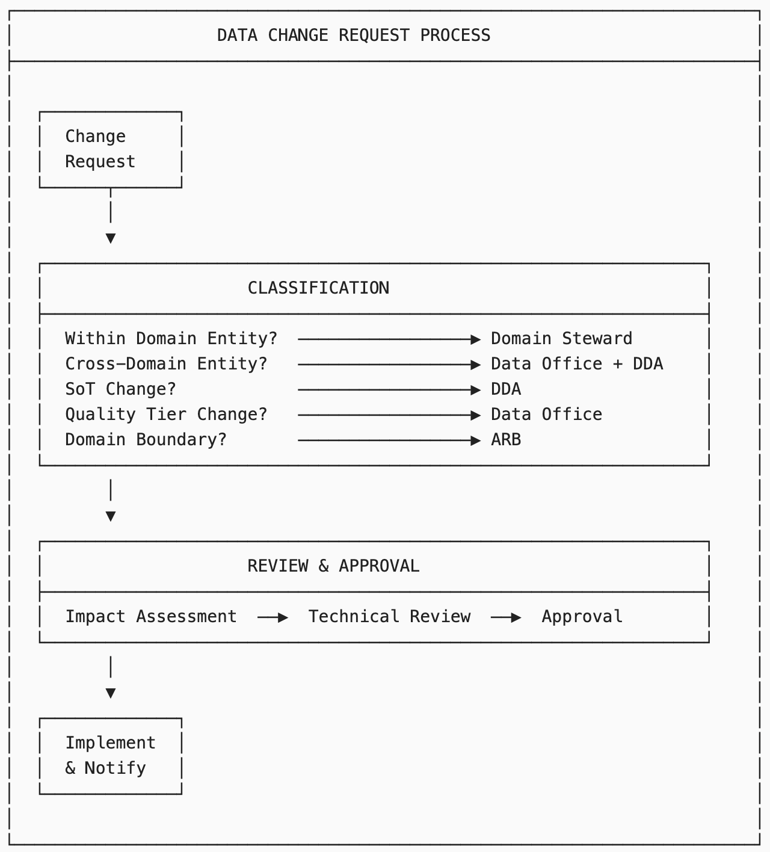

8.4 Catalog Maintenance Schedule
Activity | Frequency | Owner | Deliverable
Entity definition review | Quarterly | Domain Steward | Updated definitions
SoT validation | Quarterly | Data Office | SoT report
Quality metrics review | Monthly | SoT PBC | Quality dashboard
Cross-domain alignment | Bi-weekly | Domain Steward Forum | Alignment decisions
Catalog audit | Annual | Data Office | Audit report
Lifecycle status review | Semi-annual | Data Office | Status updates

9. PBC Data Specification
[Change Driver: Individual PBC data documentation]

9.1 PBC Template Data Section
Each PBC documents its data involvement using PBC Template Section 19: Data Specification:
Subsection | Content | Change Driver
19.1 Data Summary | Overview of data involvement | PBC scope change
19.2 Owned Entities | Entities where PBC is SoT | SoT assignment
19.3 Consumed Entities | Entities consumed from other PBCs | Integration change
19.4 Published Events | Data change events published | Event schema change
19.5 Data Quality | Quality commitments | Quality standard change
19.6 Data Lineage | Upstream/downstream flows | Integration change

9.2 Section 19.1: Data Summary

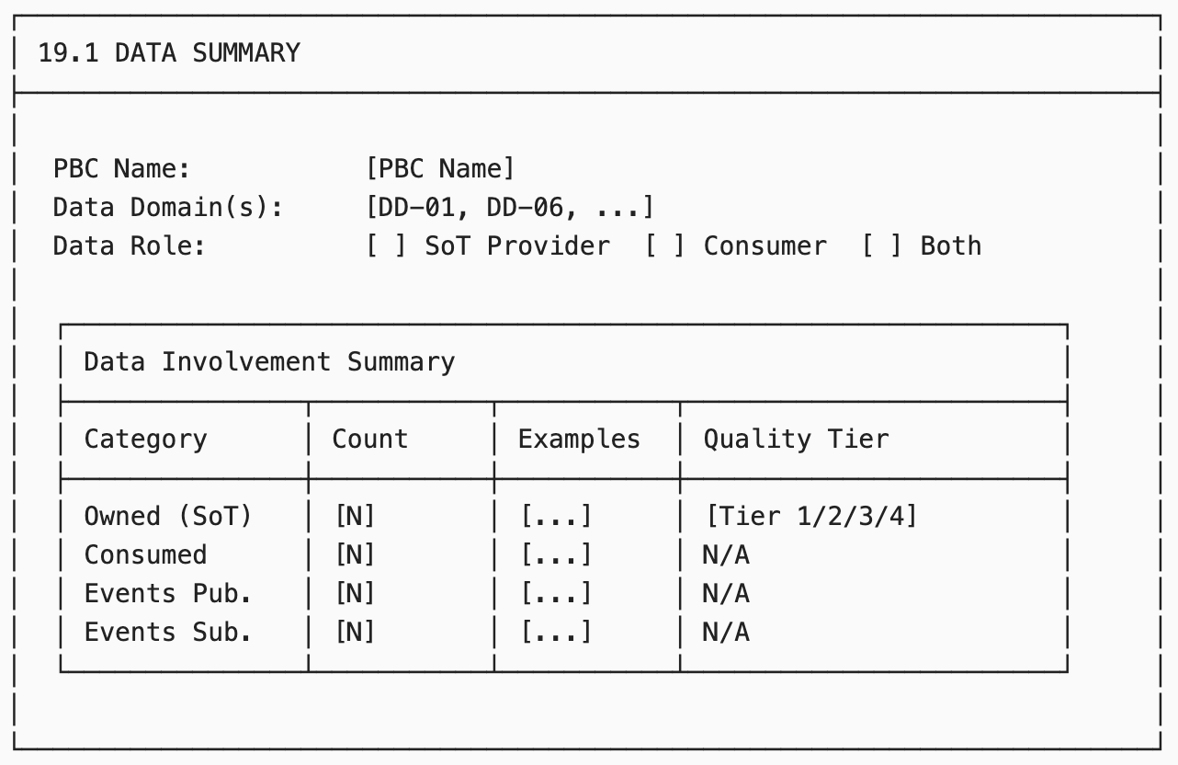

9.3 Section 19.2: Owned Entities (SoT)
Field | Description
Entity ID | Reference to Data Asset Catalog
Entity Name | Canonical name
Quality Tier | Tier 1/2/3/4
Quality Commitments | Specific targets
Retention Period | How long data is kept
Archival Policy | Archive vs. delete
Events Published | Change events emitted

Example:
Entity ID | Entity Name | Quality Tier | Retention | Events Published
ENT-DD01-001 | Person | Tier 1 | Permanent | PersonCreated, PersonUpdated
ENT-DD01-006 | ContactInfo | Tier 2 | Permanent | ContactInfoChanged

9.4 Section 19.3: Consumed Entities
Field | Description
Entity ID | Reference to Data Asset Catalog
Entity Name | Canonical name
Source PBC | SoT provider
Access Method | API / Event / Both
Caching | Yes/No; TTL
Local Transform | Any transformations applied

Example:
Entity ID | Entity Name | Source PBC | Access | Caching
ENT-DD03-001 | Address | Address Management | API + Event | Yes (1 hour)
ENT-DD09-001 | Country | Reference Data Mgmt | API | Yes (24 hours)

9.5 Section 19.4: Published Events
Field | Description
Event Type | CloudEvents type
Entity | Related entity
Trigger | What causes event
Schema | Reference to Schema Registry
Consumers | Known subscribers

Example:
Event Type | Entity | Trigger | Schema
gov.citizen.person.created.v1 | Person | New person registered | schemas/person-created-v1
gov.citizen.person.updated.v1 | Person | Person data changed | schemas/person-updated-v1
gov.citizen.contact.changed.v1 | ContactInfo | Contact info modified | schemas/contact-changed-v1

9.6 Section 19.5: Data Quality Commitments
Entity | Dimension | Target | Measurement | Reporting
Person | Completeness | 99.9% | Required fields populated | Daily
Person | Accuracy | 99.9% | Emirates ID validation | Real-time
Person | Timeliness | <1 hour | Time to reflect changes | Hourly
ContactInfo | Completeness | 99.0% | At least one contact method | Daily

9.7 Section 19.6: Data Lineage
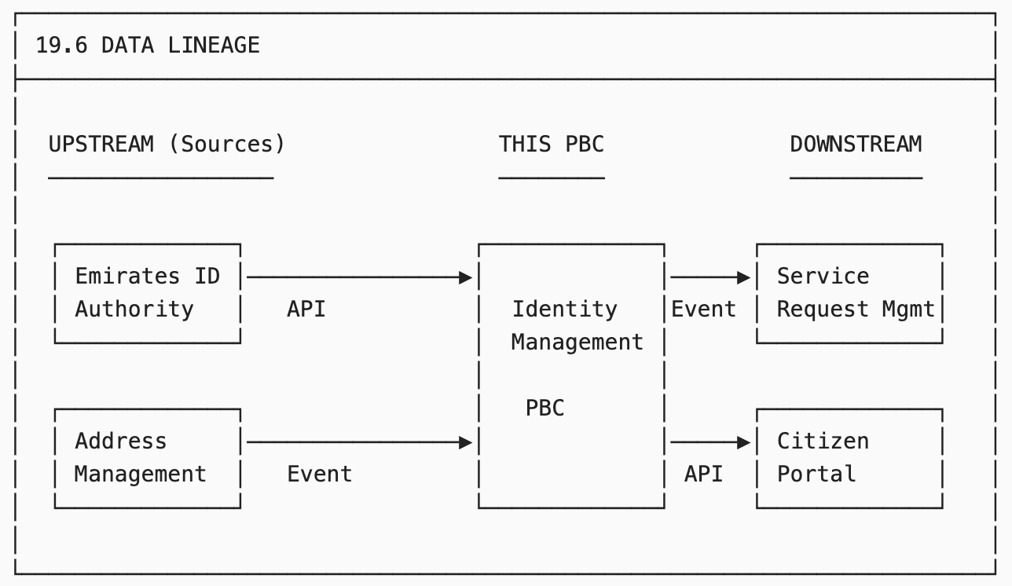

10. Integration with G-CAF Gateways
[Change Driver: Gateway process changes]

10.1 Initiation Gateway — Data Requirements
Checkpoint | Description | Evidence
Data scope identified | Entities owned/consumed listed | Data Summary (19.1)
Domain assignment | Data domain(s) confirmed | Domain Steward sign-off
SoT conflicts checked | No existing SoT for proposed entities | Data Asset Catalog query
Quality tier proposed | Tier 1/2/3/4 for owned entities | Quality requirements

10.2 Design Gateway — Data Requirements
Checkpoint | Description | Evidence
Owned entities defined | Full entity definitions | Data Asset Catalog registration
SoT approved | SoT assignment confirmed | DDA approval
Consumed entities mapped | Source PBCs identified | Section 19.3 complete
Events designed | CloudEvents schemas defined | Schema Registry entries
Quality commitments | Targets documented | Section 19.5 complete
Data lineage documented | Upstream/downstream mapped | Section 19.6 complete

10.3 Go-Live Gateway — Data Requirements
Checkpoint | Description | Evidence
Data quality operational | Quality monitoring active | Quality dashboard
Events publishing | Change events being emitted | Event logs
Consumer integrations | Downstream PBCs connected | Integration tests
Data catalog updated | Entity status = Authoritative | Data Asset Catalog
Lineage validated | Actual flows match design | Lineage verification

11. Metrics and Reporting
[Change Driver: Measurement requirements]

11.1 Catalog Health Metrics
Metric | Target | Measurement | Owner
Entity coverage | 100% | Entities in catalog / Actual entities | Data Office
SoT assignment rate | 100% | Entities with SoT / Total entities | Data Office
Definition completeness | 100% | Complete definitions / Total entities | Domain Stewards
Orphan entity rate | 0% | Entities without active PBC | Data Office

11.2 Data Quality Metrics
Metric | Target | Measurement | Owner
Tier 1 quality score | 99.9% | Aggregate quality score | SoT PBCs
Tier 2 quality score | 99.0% | Aggregate quality score | SoT PBCs
Tier 3 quality score | 95.0% | Aggregate quality score | SoT PBCs
Cross-system consistency | 99.0% | Matching records rate | Data Office
Data freshness SLA | 99.5% | Within SLA / Total | SoT PBCs

11.3 Governance Metrics
Metric | Target | Measurement | Owner
Change request cycle time | <10 days | Avg. days to resolution | Data Office
SoT dispute rate | <5% | Disputes / Total assignments | Data Office
Deprecated entity migration | 100% | Migrated before retirement | SoT PBCs
Governance compliance | 100% | Compliant PBCs / Total | Data Office

12. Module Metadata
Field | Value
Module ID | G-CAF-044
Title | Data Asset Catalog
Version | 1.0
Status | Draft
Change Driver | Enterprise data asset governance
Type | Specific
Owner | Data Office
Approved By | — (Pending ARB)
Last Updated | December 2025

13. NS Compliance Verification

13.1 Change Driver Matrix
Section | Change Driver | Independence Verified
§3 Domain Classification | Organizational structure | ✅ Can change without affecting entities
§4 Entity Registry | Entity definitions | ✅ Can add entities without changing domains
§5 Master Data Governance | Ownership policy | ✅ Can change rules without affecting entities
§6 Quality Framework | Quality standards | ✅ Can change targets without affecting entities
§7 Lifecycle Status | Lifecycle governance | ✅ Can change status rules independently
§8 Governance Process | Approval workflow | ✅ Can change process without affecting data
§9 PBC Data Spec | Per-PBC documentation | ✅ Each PBC documented independently

13.2 Module Classification
Module | Type | Reusability
Domain Classification (§3) | Specific | GovDigital only
Entity Registry Structure (§4.1-4.2) | Generic | Reusable pattern
Core Entity Catalog (§4.3) | Specific | GovDigital only
Master Data Governance (§5) | Generic | Reusable pattern
Quality Framework (§6) | Generic | Reusable pattern
Lifecycle Status (§7) | Generic | Reusable pattern
Governance Process (§8) | Specific | GovDigital only
PBC Data Spec Template (§9) | Generic | Reusable pattern

13.3 Version Transparency
- Entity definitions reference central Data Asset Catalog
- Quality tiers reference Quality Framework (§6)
- SoT assignments reference Master Data Governance (§5)
- No hardcoded values in PBC documentation

Appendix A: Entity Definition Template
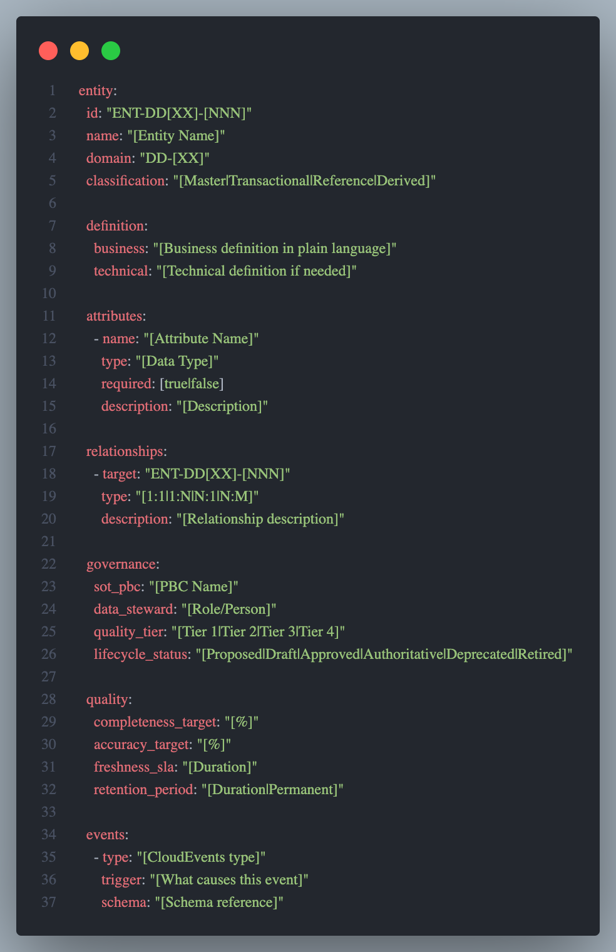

Appendix B: Cross-Reference to G-CAF Modules
G-CAF Module | Relationship to G-CAF-044
G-CAF-042 PBC Catalog | PBCs reference entities; entities reference SoT PBCs
G-CAF-043 Technology Catalog | Database technologies for data storage
G-CAF-090 Initiation Gateway | Data scope validation
G-CAF-091 Design Gateway | Data design validation
G-CAF-092 Go-Live Gateway | Data operational validation
G-CAF-100 Data Contract | Data architecture standards
G-CAF-110 Integration Contract | Event/API standards
COMPANION-021 Data Architecture Contract | Detailed data standards
COMPANION-001 PBC Template | Section 19: Data Specification

End of Document

