G-CAF-045: Integration Asset Catalog

**Use Case Context:** This artifact supports **UC06: Prepare for Go-Live**

[G-CAF-045]
Change Driver: Enterprise integration asset governance
Type: Specific
Last Updated: December 2025

1. Purpose and Scope
[Change Driver: Strategic mandate]

1.1 Purpose
The Integration Asset Catalog provides enterprise-wide governance for APIs, Events, and Schemas, establishing authoritative definitions, versioning standards, lifecycle management, and discoverability across all PBCs in the GovDigital ecosystem.

1.2 Scope
In Scope | Out of Scope
API definitions and contracts | API implementation code
Event types and schemas | Event handler implementation
Schema registry governance | Data transformation logic
API/Event versioning | Infrastructure configuration
Lifecycle management | Operational monitoring
Discoverability standards | Performance tuning
Consumer/Provider relationships | Security implementation

1.3 Relationship to G-CAF Catalog Quad

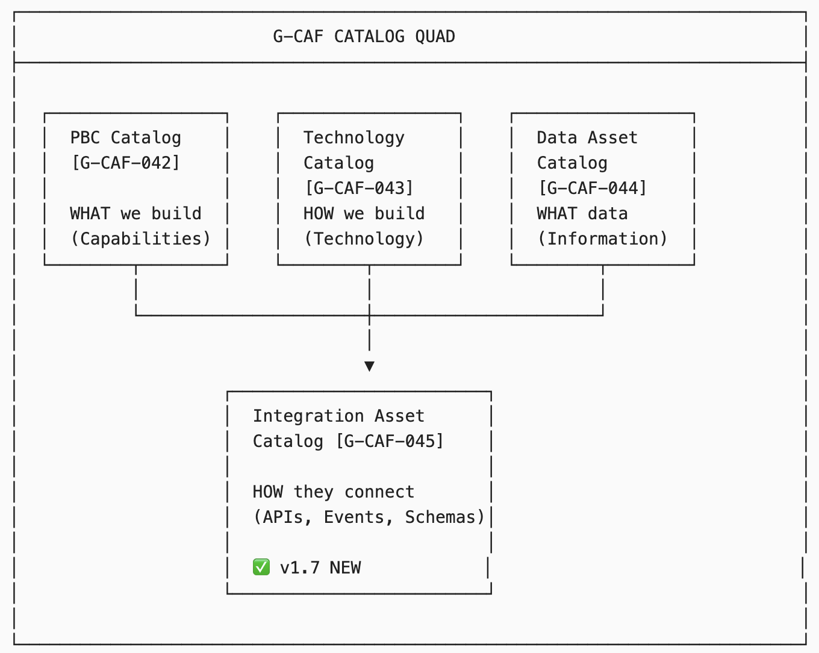

1.4 Integration with Other G-CAF Modules
Module | Integration Point
G-CAF-042 PBC Catalog | PBCs own/consume APIs and Events
G-CAF-044 Data Asset Catalog | APIs expose entities; Events propagate entity changes
G-CAF-100 Interface Contract | Technical standards for interfaces
G-CAF-110 Integration Contract | Integration patterns and ACL
COMPANION-021 Data Architecture | Data contract specifications

2. NS Compliance Design
[Change Driver: Architecture principles]

2.1 Module Structure
This catalog separates concerns by change driver:
Section | Change Driver | Update Trigger
§3 Integration Asset Classification | Asset taxonomy | New asset type or category
§4 API Registry | API definitions | New API or version change
§5 Event Registry | Event definitions | New event or schema change
§6 Schema Registry | Schema definitions | Schema evolution
§7 Versioning Standards | Version governance | Versioning policy change
§8 Lifecycle Management | Lifecycle governance | Status transition rules
§9 Governance Process | Approval workflow | Process change
§10 PBC Integration Specification | Per-PBC documentation | Individual PBC changes

2.2 Separation of Concerns
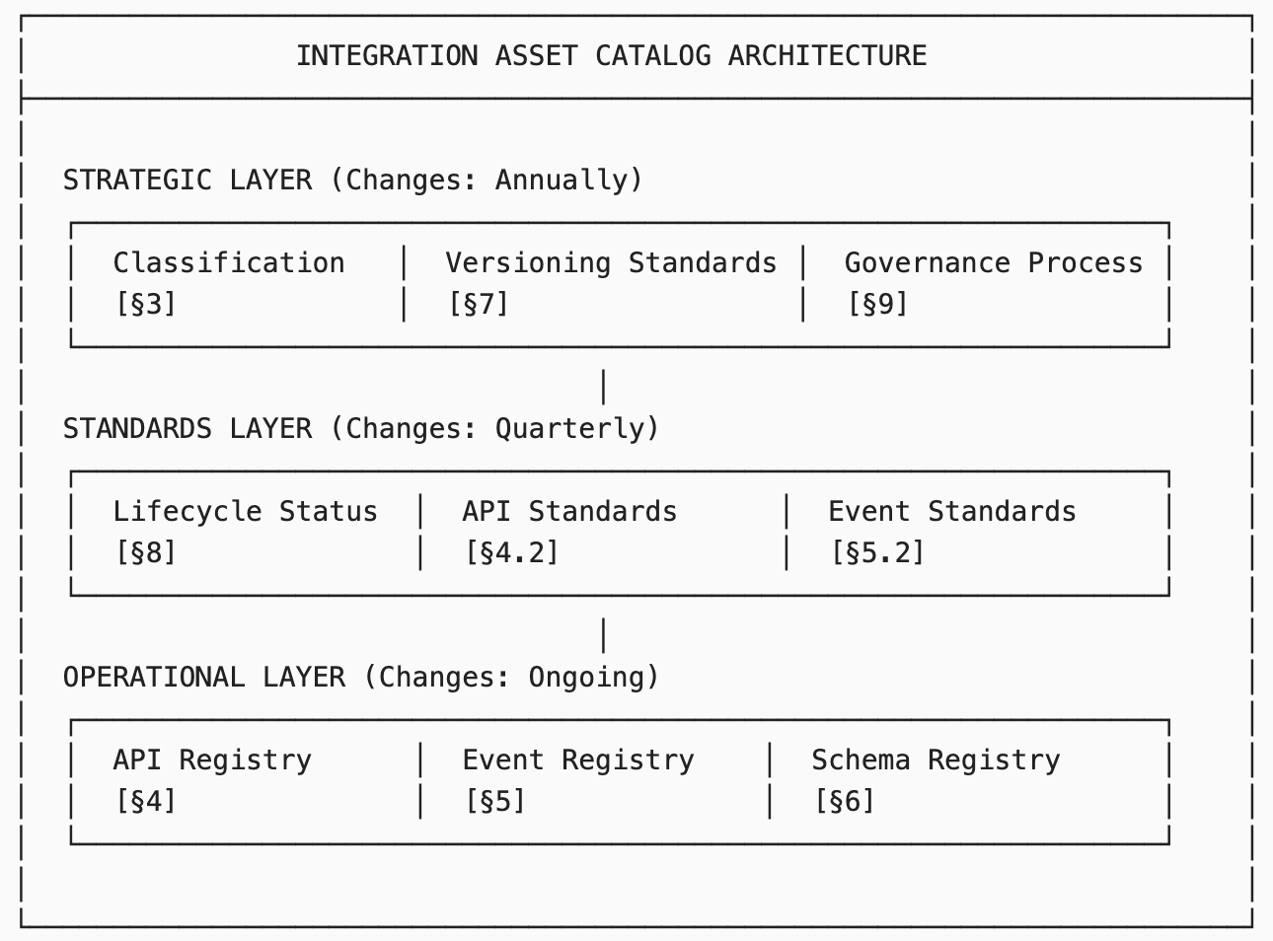

3. Integration Asset Classification
[Change Driver: Asset taxonomy changes]

3.1 Asset Types
Asset Type | Definition | Specification Format | Example
Synchronous API | Request-response interface | OpenAPI 3.1 | REST API, GraphQL
Asynchronous API | Event-driven interface | AsyncAPI 3.0 | Message queue, webhook
Event | Domain event notification | CloudEvents 1.0 | Entity changes, business events
Schema | Data structure definition | JSON Schema Draft 2020-12 | Request/response payloads

3.2 Asset Categories
Category | Description | Examples
Public API | External consumers; published to Open API Portal | Citizen services, business APIs
Partner API | Government entities and authorized partners | Inter-entity data sharing
Internal API | PBC-to-PBC within GovDigital | Service mesh communication
System API | Infrastructure and platform services | Authentication, logging

3.3 Integration Patterns
Pattern | Description | Use Case
Request-Response | Synchronous API call | Real-time queries, commands
Publish-Subscribe | Event broadcast to subscribers | Data change notifications
Event Sourcing | Event stream as source of truth | Audit trail, replay
Saga/Choreography | Distributed transaction via events | Cross-PBC workflows
CQRS | Separate read/write models | High-performance queries
ACL (Anti-Corruption Layer) | Translation between contexts | Legacy/vendor integration

4. API Registry
[Change Driver: API definition changes]

4.1 API Registry Structure
Each API in the registry contains:
Attribute | Description | Example
API ID | Unique identifier | API-PBC001-PERSON-001
API Name | Human-readable name | Person Management API
Version | Semantic version | v2.3.1
Owner PBC | Responsible PBC | Identity Management PBC
Category | Public/Partner/Internal/System | Internal
Specification | OpenAPI/AsyncAPI URL | /specs/person-api-v2.yaml
Base URL | Production endpoint | https://api.gov.ae/identity/v2
Lifecycle Status | Current status | Active
Data Entities | Exposed entities (from G-CAF-044) | Person, ContactInfo

4.2 API Standards
Standard | Requirement | Rationale
Specification | OpenAPI 3.1+ for REST; AsyncAPI 3.0+ for async | Industry standard; tooling support
Naming | {domain}.{entity}.{action} pattern | Consistency; discoverability
Versioning | URL path versioning (/v1/, /v2/) | Clear version separation
Authentication | OAuth 2.0 / OpenID Connect | Enterprise security standard
Rate Limiting | Documented in spec; enforced at gateway | Fair usage; stability
Error Format | RFC 7807 Problem Details | Consistent error handling
Pagination | Cursor-based for large datasets | Performance; consistency

4.3 Core API Catalog
4.3.1 Identity Domain APIs
API ID | API Name | Version | Owner PBC | Category | Status
API-IDM-001 | Person Management API | v2.1.0 | Identity Management | Internal | Active
API-IDM-002 | Citizen Verification API | v1.3.0 | Identity Management | Partner | Active
API-IDM-003 | Emirates ID Validation API | v1.0.0 | Identity Management | Internal | Active
API-IDM-004 | Consent Management API | v1.2.0 | Consent Management | Internal | Active

4.3.2 Service Domain APIs
API ID | API Name | Version | Owner PBC | Category | Status
API-SVC-001 | Service Catalog API | v2.0.0 | Service Catalog | Public | Active
API-SVC-002 | Service Request API | v1.5.0 | Service Request Mgmt | Internal | Active
API-SVC-003 | Appointment Booking API | v1.2.0 | Appointment Booking | Public | Active
API-SVC-004 | Certificate Issuance API | v1.1.0 | Certificate Issuance | Internal | Active

4.3.3 Reference Domain APIs
API ID | API Name | Version | Owner PBC | Category | Status
API-REF-001 | Reference Data API | v3.0.0 | Reference Data Mgmt | Internal | Active
API-REF-002 | Address Lookup API | v2.1.0 | Address Management | Internal | Active
API-REF-003 | GIS Services API | v1.0.0 | GIS Services | Partner | Active

4.3.4 Platform APIs
API ID | API Name | Version | Owner PBC | Category | Status
API-PLT-001 | Authentication API | v2.0.0 | IAM Platform | System | Active
API-PLT-002 | Authorization API | v1.5.0 | IAM Platform | System | Active
API-PLT-003 | Notification API | v1.3.0 | Notification Service | Internal | Active
API-PLT-004 | Document Storage API | v1.2.0 | Document Management | Internal | Active

4.4 API Consumer Registry
API ID | Consumer PBC | Purpose | SLA Tier | Registered
API-IDM-001 | Service Request Mgmt | Citizen lookup | Tier 1 | 2024-03-15
API-IDM-001 | Citizen Portal | Profile display | Tier 1 | 2024-02-01
API-SVC-001 | Citizen Portal | Service listing | Tier 1 | 2024-01-20
API-REF-001 | Multiple | Reference lookups | Tier 2 | Various

5. Event Registry
[Change Driver: Event definition changes]

5.1 Event Registry Structure
Each event in the registry contains:
Attribute | Description | Example
Event ID | Unique identifier | EVT-IDM-PERSON-001
Event Type | CloudEvents type | gov.identity.person.created.v1
Source PBC | Publishing PBC | Identity Management PBC
Subject Pattern | Subject identifier pattern | /persons/{personId}
Schema | JSON Schema reference | schemas/person-created-v1
Lifecycle Status | Current status | Active
Related Entity | From G-CAF-044 | Person (ENT-DD01-001)

5.2 Event Standards
Standard | Requirement | Rationale
Format | CloudEvents 1.0 specification | Industry standard; interoperability
Type Pattern | {org}.{domain}.{entity}.{action}.{version} | Namespacing; filtering
Transport | Kafka (primary); Azure Event Grid (secondary) | Scalability; reliability
Ordering | Partition by entity ID | Event ordering per entity
Idempotency | Include idempotency key | Exactly-once semantics
Schema Registry | Confluent Schema Registry | Schema evolution; validation

5.3 Event Type Patterns
Pattern | Type Format | Use Case
Entity Created | {domain}.{entity}.created.v{n} | New entity instance
Entity Updated | {domain}.{entity}.updated.v{n} | Entity modification
Entity Deleted | {domain}.{entity}.deleted.v{n} | Entity removal
Status Changed | {domain}.{entity}.status-changed.v{n} | State transition
Action Completed | {domain}.{action}.completed.v{n} | Business process
Action Failed | {domain}.{action}.failed.v{n} | Error notification

5.4 Core Event Catalog
5.4.1 Identity Domain Events
Event ID | Event Type | Source PBC | Entity | Status
EVT-IDM-001 | gov.identity.person.created.v1 | Identity Management | Person | Active
EVT-IDM-002 | gov.identity.person.updated.v1 | Identity Management | Person | Active
EVT-IDM-003 | gov.identity.contact.changed.v1 | Identity Management | ContactInfo | Active
EVT-IDM-004 | gov.identity.consent.granted.v1 | Consent Management | Consent | Active
EVT-IDM-005 | gov.identity.consent.revoked.v1 | Consent Management | Consent | Active

5.4.2 Service Domain Events
Event ID | Event Type | Source PBC | Entity | Status
EVT-SVC-001 | gov.service.request.created.v1 | Service Request Mgmt | ServiceRequest | Active
EVT-SVC-002 | gov.service.request.status-changed.v1 | Service Request Mgmt | ServiceRequest | Active
EVT-SVC-003 | gov.service.request.completed.v1 | Service Request Mgmt | ServiceRequest | Active
EVT-SVC-004 | gov.service.appointment.booked.v1 | Appointment Booking | Appointment | Active
EVT-SVC-005 | gov.service.certificate.issued.v1 | Certificate Issuance | Certificate | Active

5.4.3 Organization Domain Events
Event ID | Event Type | Source PBC | Entity | Status
EVT-ORG-001 | gov.organization.business.registered.v1 | Business Licensing | Business | Active
EVT-ORG-002 | gov.organization.license.issued.v1 | Business Licensing | TradeLicense | Active
EVT-ORG-003 | gov.organization.license.renewed.v1 | Business Licensing | TradeLicense | Active
EVT-ORG-004 | gov.organization.license.revoked.v1 | Business Licensing | TradeLicense | Active

5.5 Event Subscription Registry
Event Type | Subscriber PBC | Purpose | Consumer Group
gov.identity.person.created.v1 | Service Request Mgmt | Initialize citizen profile | srm-person-sync
gov.identity.person.updated.v1 | Citizen Portal | Update cached profile | portal-person-cache
gov.service.request.completed.v1 | Notification Service | Send completion notice | notify-request-complete
gov.organization.license.issued.v1 | Certificate Issuance | Generate license cert | cert-license-gen

6. Schema Registry
[Change Driver: Schema definition changes]

6.1 Schema Registry Structure
Each schema in the registry contains:
Attribute | Description | Example
Schema ID | Unique identifier | SCH-PERSON-CREATED-V1
Schema Name | Human-readable name | Person Created Event Schema
Version | Schema version | 1.2.0
Format | Schema format | JSON Schema Draft 2020-12
Subject | Schema subject (for registry) | gov.identity.person.created-value
Compatibility | Evolution compatibility mode | BACKWARD
Owner | Responsible PBC | Identity Management

6.2 Schema Compatibility Modes
Mode | Description | Allowed Changes | Use Case
BACKWARD | New schema can read old data | Add optional fields; remove required fields | Default for events
FORWARD | Old schema can read new data | Remove optional fields; add required fields | Controlled rollout
FULL | Both backward and forward | Only add/remove optional fields | Maximum compatibility
NONE | No compatibility checking | Any change | Development only

6.3 Schema Evolution Rules
Change Type | Backward | Forward | Full | Breaking
Add optional field | ✅ | ✅ | ✅ | No
Add required field | ❌ | ✅ | ❌ | Yes
Remove optional field | ✅ | ❌ | ❌ | Soft
Remove required field | ✅ | ❌ | ❌ | Soft
Rename field | ❌ | ❌ | ❌ | Yes
Change field type | ❌ | ❌ | ❌ | Yes
Add enum value | ✅ | ❌ | ❌ | Soft
Remove enum value | ❌ | ✅ | ❌ | Soft

6.4 Core Schema Catalog
6.4.1 Entity Schemas
Schema ID | Schema Name | Version | Compatibility | Owner
SCH-ENT-PERSON | Person Entity Schema | 2.1.0 | FULL | Identity Management
SCH-ENT-ORG | Organization Entity Schema | 1.3.0 | FULL | Entity Registry
SCH-ENT-ADDRESS | Address Entity Schema | 2.0.0 | FULL | Address Management
SCH-ENT-SERVICE | Service Entity Schema | 1.5.0 | FULL | Service Catalog
SCH-ENT-REQUEST | Service Request Schema | 1.4.0 | FULL | Service Request Mgmt

6.4.2 Event Payload Schemas
Schema ID | Schema Name | Version | Compatibility | Owner
SCH-EVT-PERSON-CREATED | Person Created Event | 1.2.0 | BACKWARD | Identity Management
SCH-EVT-PERSON-UPDATED | Person Updated Event | 1.3.0 | BACKWARD | Identity Management
SCH-EVT-REQUEST-CREATED | Request Created Event | 1.1.0 | BACKWARD | Service Request Mgmt
SCH-EVT-REQUEST-STATUS | Request Status Event | 1.2.0 | BACKWARD | Service Request Mgmt

6.4.3 API Request/Response Schemas
Schema ID | Schema Name | Version | Compatibility | Owner
SCH-API-PERSON-REQ | Person API Request | 2.0.0 | BACKWARD | Identity Management
SCH-API-PERSON-RES | Person API Response | 2.1.0 | BACKWARD | Identity Management
SCH-API-ERROR | Standard Error Response | 1.0.0 | FULL | Platform

7. Versioning Standards
[Change Driver: Version governance changes]

7.1 Semantic Versioning
All integration assets follow Semantic Versioning 2.0.0:
Version Part | Increment When | Example
MAJOR (X.0.0) | Breaking change; incompatible | 1.0.0 → 2.0.0
MINOR (0.X.0) | New feature; backward compatible | 1.2.0 → 1.3.0
PATCH (0.0.X) | Bug fix; backward compatible | 1.2.3 → 1.2.4

7.2 API Versioning Strategy
Strategy | Implementation | When Used
URL Path | /v1/persons, /v2/persons | Major version changes
Header | X-API-Version: 2.1 | Minor version selection
Query Param | ?api-version=2.1 | Testing; preview

Standard: URL path versioning for major versions; consumers specify minor via header if needed.

7.3 Event Type Versioning
Component | Format | Example
Type | {domain}.{entity}.{action}.v{major} | gov.identity.person.created.v1
Schema | {type}-value:v{major}.{minor}.{patch} | gov.identity.person.created-value:v1.2.0

Standard: Event type includes only major version; schema includes full version.

7.4 Version Lifecycle

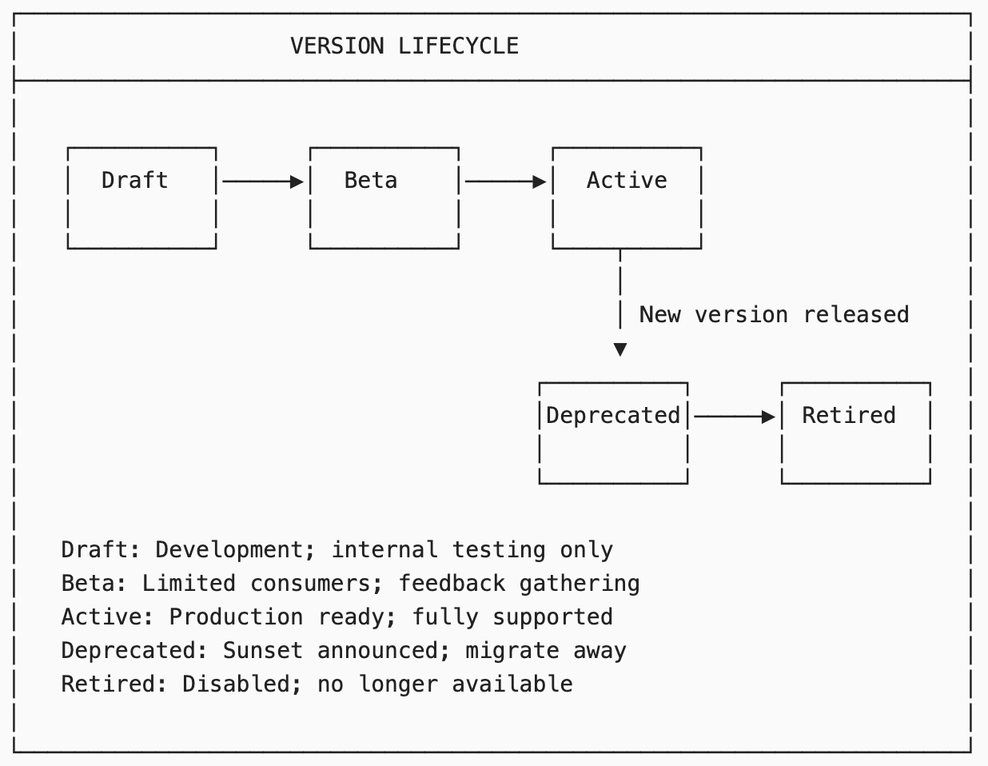

7.5 Deprecation Policy
Transition | Notice Period | Requirements
Active → Deprecated | 90 days minimum | Publish deprecation notice; notify consumers
Deprecated → Retired | 180 days minimum | All consumers migrated; provide migration guide
Emergency Deprecation | 30 days | Security/critical issue; direct notification

8. Lifecycle Management
[Change Driver: Lifecycle governance changes]

8.1 Integration Asset Lifecycle Status
Status | Definition | Governance
Draft | Under development; not published | Owner PBC
Beta | Published for testing; limited SLA | Owner PBC
Active | Production ready; full SLA | DDA
Deprecated | Sunset planned; migrate away | DDA
Retired | Disabled; historical only | DDA

8.2 Status Transitions
Transition | Authority | Requirements
Draft → Beta | Owner PBC | Specification complete; basic testing
Beta → Active | DDA | Security review; SLA defined; documentation
Active → Deprecated | DDA | New version available; migration guide
Deprecated → Retired | DDA | All consumers migrated; 180-day notice
Any → Retired (Emergency) | ARB | Critical security issue; 30-day notice

8.3 Consumer Migration
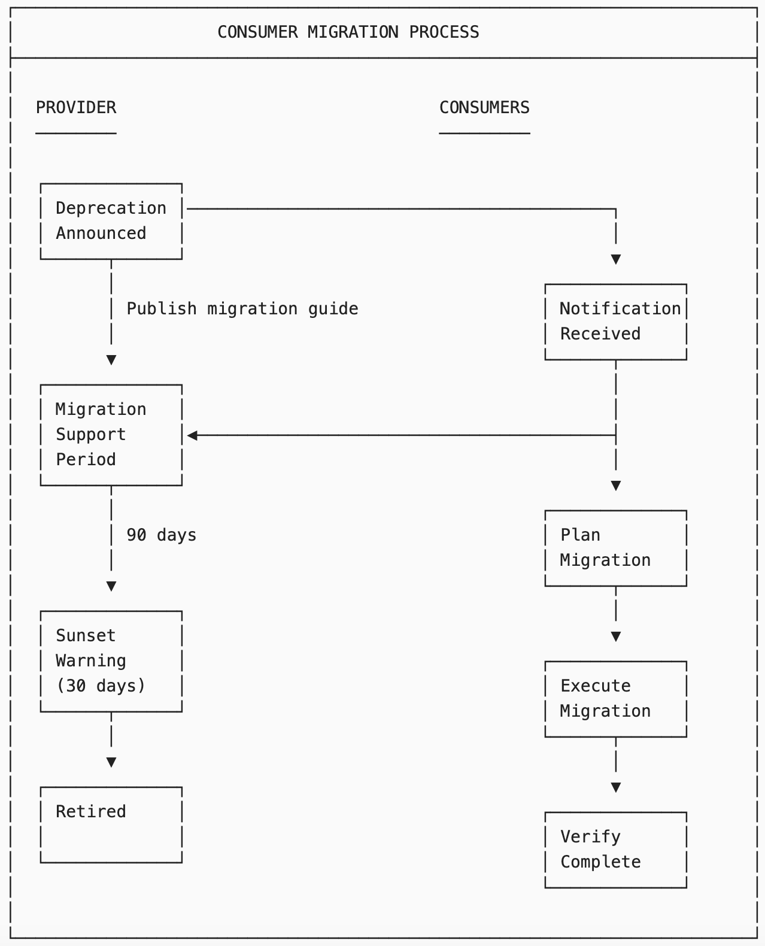

9. Governance Process
[Change Driver: Governance workflow changes]

9.1 Governance Bodies
Body | Scope | Frequency
Integration Council | Strategic integration decisions | Monthly
DDA | API/Event technical approval | As needed
Schema Review Board | Schema changes; compatibility | Weekly
API Security Review | Security assessment | Per release

9.2 Decision Authority Matrix
Decision Type | Owner PBC | DDA | ARB
New internal API | Approves | Registers | —
New public/partner API | Proposes | Approves | —
New event type | Approves | Registers | —
Breaking API change | Proposes | Approves | Arbitrates
Schema evolution (backward compatible) | Approves | — | —
Schema evolution (breaking) | Proposes | Approves | —
Emergency deprecation | Proposes | Reviews | Approves
Lifecycle status change | Proposes | Approves | —

9.3 API/Event Registration Process

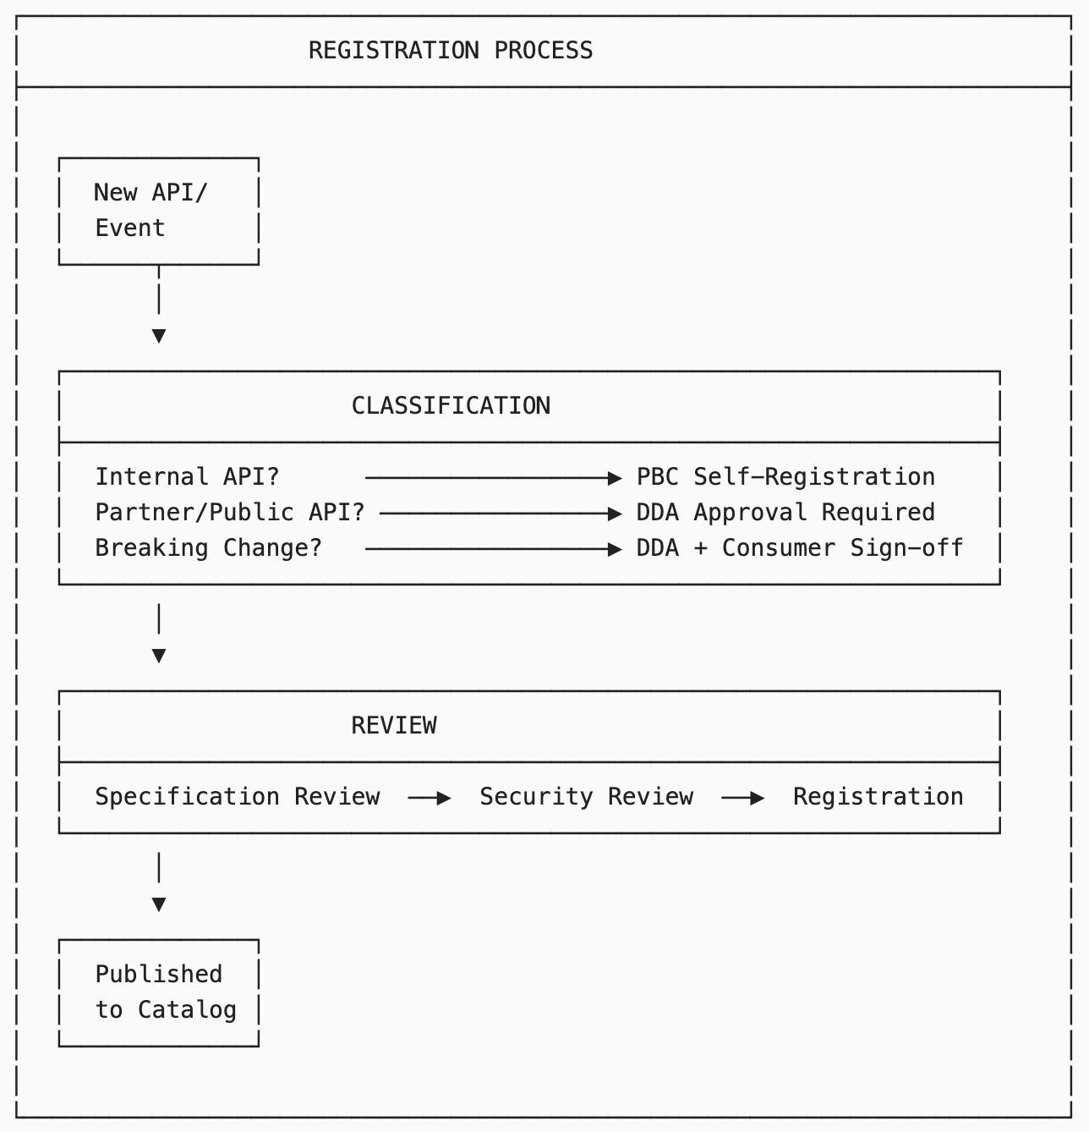

9.4 Catalog Maintenance Schedule
Activity | Frequency | Owner | Deliverable
API inventory review | Quarterly | DDA | Usage report; deprecation candidates
Event catalog audit | Quarterly | DDA | Orphan events; unused subscriptions
Schema compatibility check | Weekly | Schema Board | Compatibility report
Consumer registry validation | Monthly | Integration Team | Consumer health report
Security assessment | Semi-annual | Security Team | Vulnerability report

10. PBC Integration Specification
[Change Driver: Individual PBC integration documentation]

10.1 PBC Template Integration Section
Each PBC documents its integration involvement using PBC Template Section 20: Integration Specification:
Subsection | Content | Change Driver
20.1 Integration Summary | Overview of APIs/Events | PBC scope
20.2 Provided APIs | APIs exposed by this PBC | API changes
20.3 Consumed APIs | APIs called by this PBC | Integration changes
20.4 Published Events | Events emitted by this PBC | Event changes
20.5 Subscribed Events | Events consumed by this PBC | Integration changes
20.6 Schemas Owned | Schemas maintained by this PBC | Schema changes

10.2 Section 20.1: Integration Summary

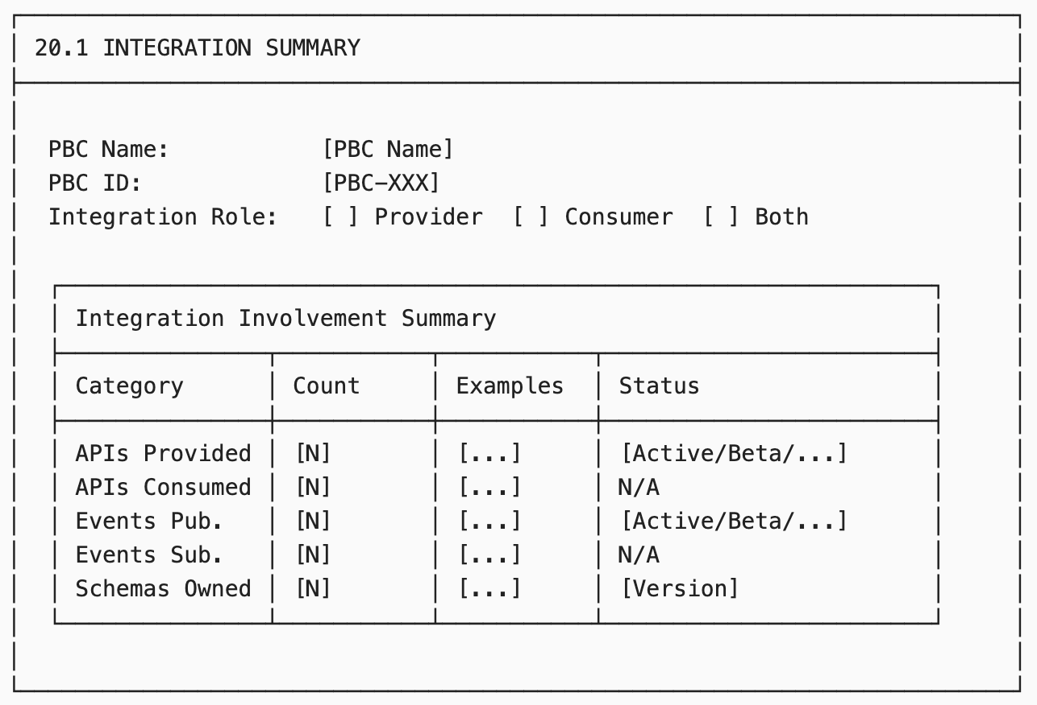

10.3 Section 20.2: Provided APIs
Field | Description
API ID | Reference to Integration Asset Catalog
API Name | Human-readable name
Version | Current version
Category | Public/Partner/Internal/System
Specification | Link to OpenAPI/AsyncAPI spec
SLA Tier | Tier 1/2/3
Consumers | Known consumer PBCs

10.4 Section 20.3: Consumed APIs
Field | Description
API ID | Reference to Integration Asset Catalog
API Name | Human-readable name
Provider PBC | API owner
Version Used | Version consumed
Purpose | Why this API is used
Fallback Strategy | Behavior if unavailable

10.5 Section 20.4: Published Events
Field | Description
Event ID | Reference to Integration Asset Catalog
Event Type | CloudEvents type
Trigger | What causes this event
Schema | Reference to Schema Registry
Subscribers | Known subscriber PBCs

10.6 Section 20.5: Subscribed Events
Field | Description
Event ID | Reference to Integration Asset Catalog
Event Type | CloudEvents type
Source PBC | Event publisher
Purpose | Why subscribed
Handler | Processing component
Idempotency | Deduplication strategy

11. Integration with G-CAF Gateways
[Change Driver: Gateway process changes]

11.1 Initiation Gateway — Integration Requirements
Checkpoint | Description | Evidence
Integration scope identified | APIs/Events needed listed | Section 20.1
Provider dependencies identified | External APIs required | Section 20.3
Event requirements identified | Events to publish/subscribe | Section 20.4/20.5

11.2 Design Gateway — Integration Requirements
Checkpoint | Description | Evidence
APIs registered in catalog | All provided APIs documented | Catalog entries
API specifications complete | OpenAPI/AsyncAPI specs | Specification files
Events registered in catalog | All events documented | Catalog entries
Schemas registered | All schemas in registry | Schema Registry
Consumer contracts established | SLA agreements | Consumer registry
Security review passed | Authentication; authorization | Security sign-off

11.3 Go-Live Gateway — Integration Requirements
Checkpoint | Description | Evidence
APIs deployed and accessible | Endpoints responding | Health checks
API documentation published | Developer portal updated | Portal verification
Events publishing verified | Events flowing to topics | Event logs
Event subscriptions operational | Handlers processing | Consumer metrics
Monitoring configured | Dashboards; alerts | Monitoring setup

12. Metrics and Reporting
[Change Driver: Measurement requirements]

12.1 Catalog Health Metrics
Metric | Target | Measurement | Owner
API coverage | 100% | APIs in catalog / Actual APIs | Integration Team
Event coverage | 100% | Events in catalog / Actual events | Integration Team
Schema coverage | 100% | Schemas in registry / Actual schemas | Schema Board
Specification completeness | 100% | Complete specs / Total specs | DDA
Documentation currency | 100% | Up-to-date docs / Total docs | Owner PBCs

12.2 API Health Metrics
Metric | Target | Measurement | Owner
API availability | 99.9% | Uptime / Total time | Owner PBCs
API latency (p95) | <500ms | 95th percentile response time | Owner PBCs
Error rate | <1% | Failed requests / Total requests | Owner PBCs
Consumer satisfaction | >4.0/5 | Survey score | Integration Team

12.3 Governance Metrics
Metric | Target | Measurement | Owner
Registration cycle time | <5 days | Avg. days to registration | DDA
Breaking change rate | <5% | Breaking changes / Total changes | DDA
Deprecation compliance | 100% | Migrations on time / Total deprecations | Consumer PBCs
Schema compatibility | 100% | Compatible changes / Total changes | Schema Board

13. Module Metadata
Field | Value
Module ID | G-CAF-045
Title | Integration Asset Catalog
Version | 1.0
Status | Draft
Change Driver | Enterprise integration asset governance
Type | Specific
Owner | Integration Office / EA Office
Approved By | — (Pending ARB)
Last Updated | December 2025

14. NS Compliance Verification

14.1 Change Driver Matrix
Section | Change Driver | Independence Verified
§3 Classification | Asset taxonomy | ✅ Can add asset types without affecting registries
§4 API Registry | API definitions | ✅ Can add APIs without changing events/schemas
§5 Event Registry | Event definitions | ✅ Can add events without changing APIs
§6 Schema Registry | Schema definitions | ✅ Can evolve schemas independently
§7 Versioning Standards | Version governance | ✅ Can change rules without affecting assets
§8 Lifecycle Management | Lifecycle governance | ✅ Can change status rules independently
§9 Governance Process | Approval workflow | ✅ Can change process without affecting assets
§10 PBC Integration Spec | Per-PBC documentation | ✅ Each PBC documented independently

14.2 Module Classification
Module | Type | Reusability
Classification (§3) | Generic | Reusable taxonomy
API Registry Structure (§4.1-4.2) | Generic | Reusable pattern
Core API Catalog (§4.3) | Specific | GovDigital only
Event Registry Structure (§5.1-5.2) | Generic | Reusable pattern
Core Event Catalog (§5.4) | Specific | GovDigital only
Schema Registry (§6) | Generic | Reusable pattern
Versioning Standards (§7) | Generic | Reusable pattern
Lifecycle Management (§8) | Generic | Reusable pattern
Governance Process (§9) | Specific | GovDigital bodies
PBC Integration Spec Template (§10) | Generic | Reusable template

14.3 Version Transparency
- API definitions reference central Integration Asset Catalog
- Event types reference Schema Registry
- Lifecycle status reference §8 definitions
- No hardcoded values in PBC documentation

Appendix A: API Definition Template
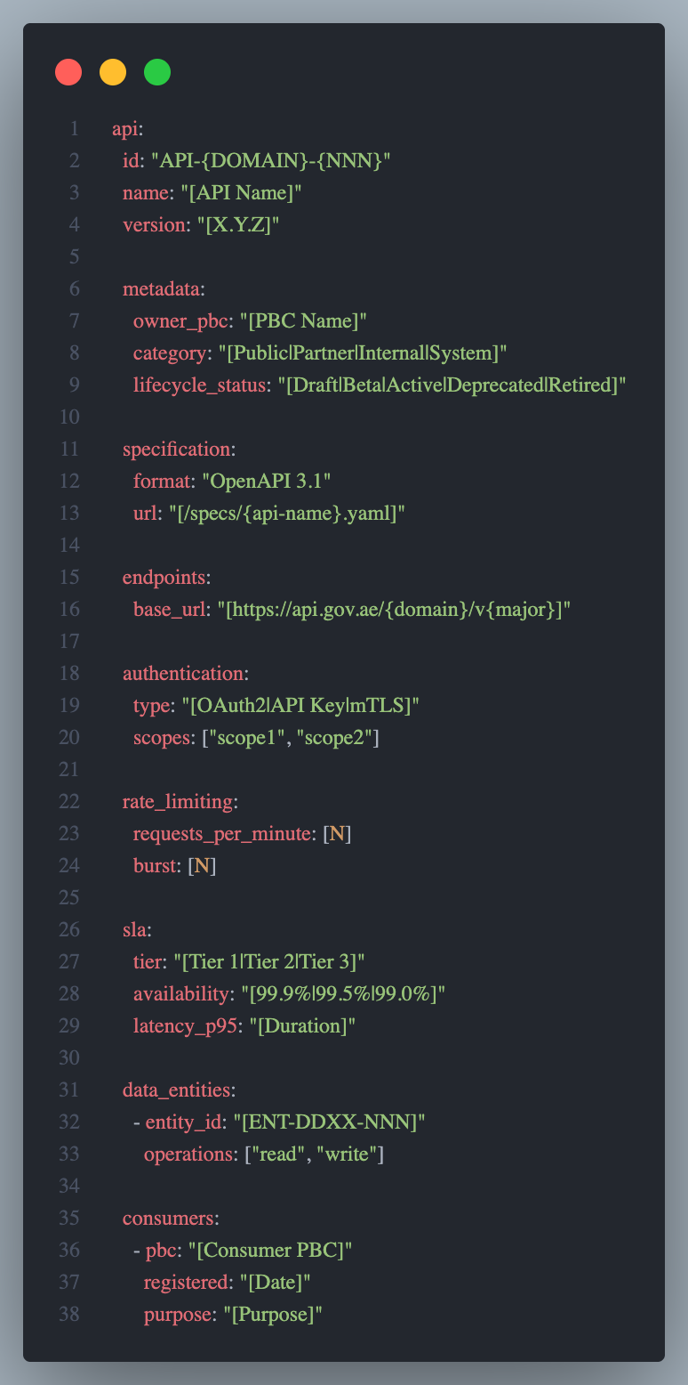

Appendix B: Event Definition Template
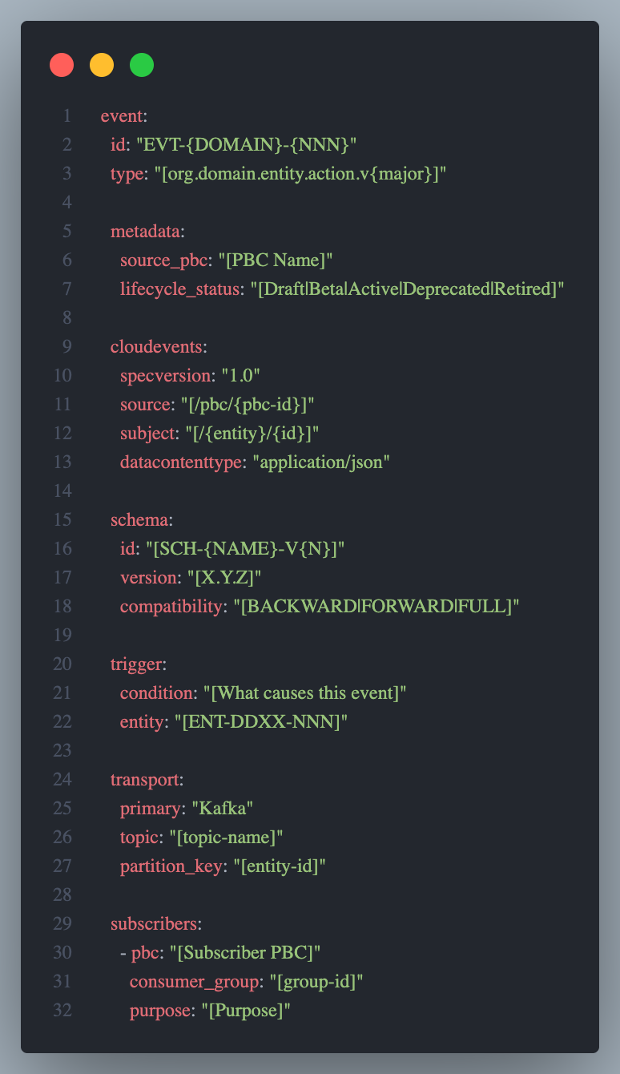

Appendix C: Cross-Reference to G-CAF Modules
G-CAF Module | Relationship to G-CAF-045
G-CAF-042 PBC Catalog | PBCs own APIs/Events; register in catalog
G-CAF-044 Data Asset Catalog | APIs expose entities; Events propagate changes
G-CAF-043 Technology Catalog | Integration technologies (Kafka, API Gateway)
G-CAF-090 Initiation Gateway | Integration scope validation
G-CAF-091 Design Gateway | API/Event registration validation
G-CAF-092 Go-Live Gateway | Integration operational validation
G-CAF-100 Interface Contract | Technical interface standards
G-CAF-110 Integration Contract | Integration patterns; ACL
COMPANION-001 PBC Template | Section 20: Integration Specification

End of Document

