G-CAF-046: Technical Debt Management

**Use Case Context:** This artifact supports **UC09: Manage Technical Debt**

[G-CAF-046]
Change Driver: Enterprise technical debt governance
Type: Specific
Last Updated: December 2025

1. Purpose and Scope
[Change Driver: Strategic mandate]

1.1 Purpose
The Technical Debt Management framework provides enterprise-wide governance for identifying, tracking, assessing, prioritizing, and remediating technical debt across all PBCs in the GovDigital ecosystem. It establishes a systematic approach to managing the long-term health and evolvability of the technology estate.

1.2 Definition
Technical Debt: The implied cost of future rework caused by choosing an easy or quick solution now instead of a better approach that would take longer. Technical debt accumulates interest over time through increased maintenance costs, reduced agility, and heightened risk.

1.3 Scope
In Scope | Out of Scope
Debt identification and classification | Business process debt
Debt registry and tracking | Organizational debt
Impact assessment methodology | Vendor contract issues
Prioritization framework | Budget allocation decisions
Remediation governance | Project delivery management
PBC lifecycle integration | Day-to-day development
Reporting and metrics | Performance optimization

1.4 Strategic Alignment

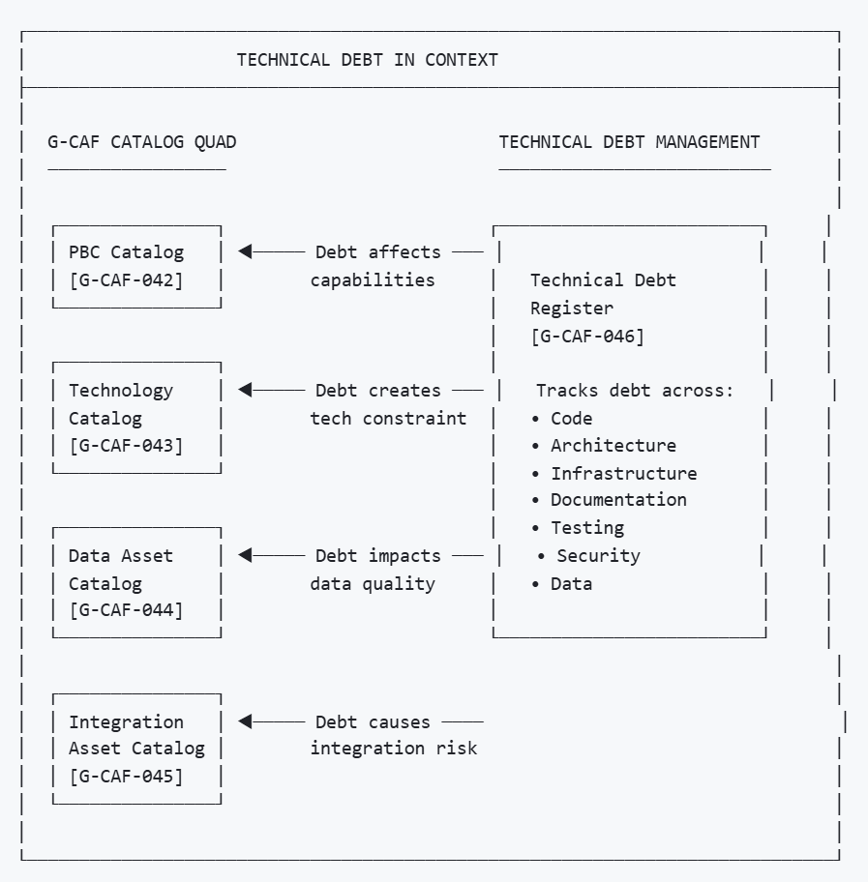

2. NS Compliance Design
[Change Driver: Architecture principles]

2.1 Module Structure
This framework separates concerns by change driver:
Section | Change Driver | Update Trigger
§3 Debt Classification | Debt taxonomy | New debt type or category
§4 Debt Registry | Debt items | New debt item or status change
§5 Impact Assessment | Assessment methodology | Scoring criteria change
§6 Prioritization Framework | Priority methodology | Priority algorithm change
§7 Remediation Governance | Remediation process | Process change
§8 Lifecycle Integration | Gateway integration | Gateway requirements change
§9 Governance Process | Approval workflow | Governance body change
§10 Metrics and Reporting | Measurement | Metric definitions change

2.2 Separation of Concerns

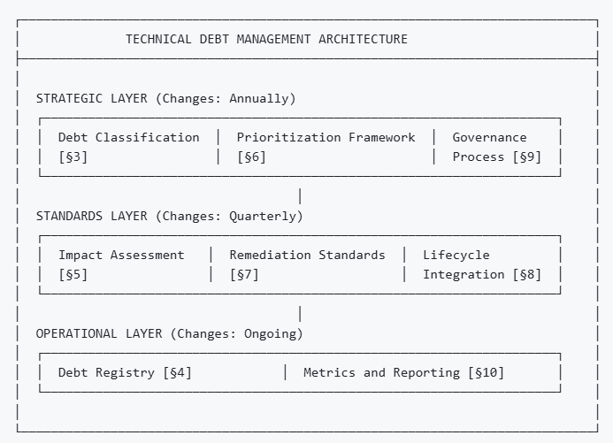

3. Debt Classification
[Change Driver: Debt taxonomy changes]

3.1 Debt Types
Debt Type | Code | Definition | Examples
Code Debt | CODE | Suboptimal code quality affecting maintainability | Code smells, complexity, duplication
Architecture Debt | ARCH | Structural compromises affecting evolvability | Tight coupling, missing abstraction, monolith
Infrastructure Debt | INFRA | Platform/environment shortcuts | Manual deployment, outdated OS, unpatched
Documentation Debt | DOC | Missing or outdated documentation | No API docs, stale runbooks, missing ADRs
Test Debt | TEST | Inadequate test coverage or quality | Low coverage, flaky tests, no integration tests
Security Debt | SEC | Known security vulnerabilities or gaps | Unpatched CVEs, weak auth, missing encryption
Data Debt | DATA | Data quality or governance issues | Schema drift, orphaned data, quality gaps
Dependency Debt | DEP | Outdated or risky dependencies | EOL libraries, version lag, license risk
Integration Debt | INT | Suboptimal integration patterns | Point-to-point, missing ACL, tight coupling
Process Debt | PROC | Development process shortcuts | No CI/CD, manual releases, no code review

3.2 Debt Categories
Category | Definition | Urgency
Deliberate-Prudent | Conscious trade-off with payback plan | Planned
Deliberate-Reckless | Conscious shortcut without plan | High
Inadvertent-Prudent | Discovered through learning | Normal
Inadvertent-Reckless | Unknown until failure | Critical

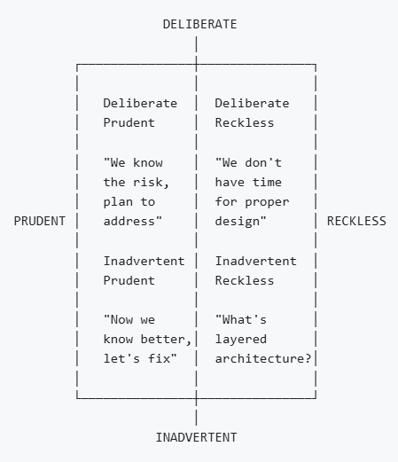

3.3 Debt Origins
Origin | Code | Description
Time Pressure | TIME | Deadline-driven shortcuts
Knowledge Gap | KNOW | Lack of expertise at creation time
Evolving Requirements | EVOL | Original design no longer fits
Technology Obsolescence | TECH | Technology aged or deprecated
Organizational Change | ORG | Team changes, lost context
Strategic Pivot | STRAT | Business direction change
Inherited | INHR | Acquired through merger/acquisition
External Dependency | EXT | Third-party library/service issue

4. Debt Registry
[Change Driver: Debt item changes]

4.1 Debt Registry Structure
Each debt item in the registry contains:
Field | Description | Example
Debt ID | Unique identifier | DEBT-PBC042-ARCH-001
Title | Short description | Missing API Gateway abstraction
Type | From §3.1 | ARCH
Category | From §3.2 | Deliberate-Prudent
Origin | From §3.3 | TIME
PBC | Affected PBC | PBC-042 Service Request
Component | Specific component | API Layer
Description | Full details | Direct service-to-service calls...
Impact Score | From §5 | 72
Priority | From §6 | High
Status | Current status | Acknowledged
Created Date | When identified | 2024-06-15
Owner | Debt owner | PBC Owner
Remediation Plan | Link to plan | REMED-042-001

4.2 Debt Status Lifecycle

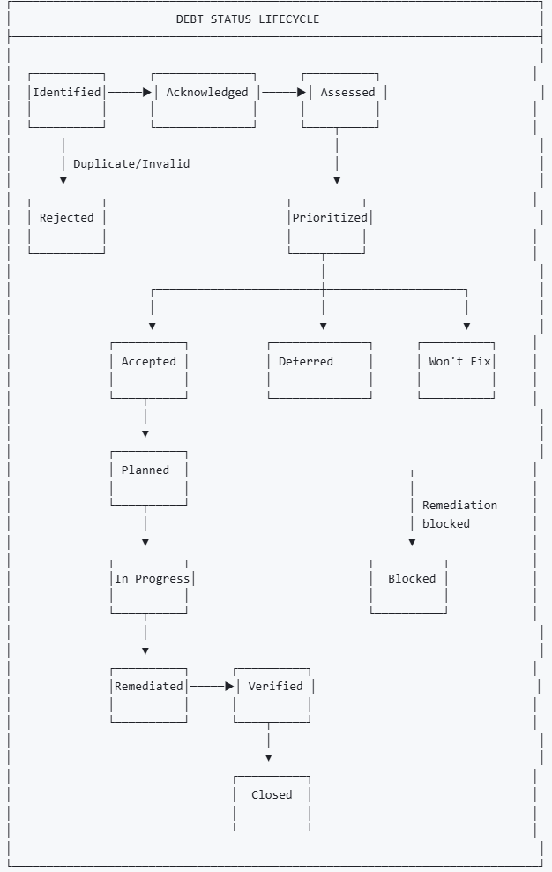

4.3 Status Definitions
Status | Definition | Owner
Identified | Debt discovered; pending review | Anyone
Acknowledged | Debt accepted as valid | PBC Owner
Assessed | Impact assessment complete | Tech Lead
Prioritized | Priority assigned | DDA
Accepted | Committed to remediate | PBC Owner
Deferred | Postponed with rationale | DDA
Won't Fix | Accepted risk; no remediation | ARB
Planned | Remediation scheduled | PBC Owner
In Progress | Remediation underway | Dev Team
Blocked | Remediation blocked | PBC Owner
Remediated | Fix implemented | Dev Team
Verified | Fix verified working | QA
Closed | Debt resolved | PBC Owner
Rejected | Invalid or duplicate | Tech Lead

4.4 Sample Debt Registry Entries
Debt ID | Title | Type | PBC | Impact | Priority | Status
DEBT-IDM-ARCH-001 | Monolithic identity service | ARCH | Identity Mgmt | 85 | Critical | Planned
DEBT-SRM-CODE-003 | High cyclomatic complexity | CODE | Service Request | 45 | Medium | Acknowledged
DEBT-PAY-SEC-001 | TLS 1.1 still supported | SEC | Payment Gateway | 92 | Critical | In Progress
DEBT-REF-DEP-002 | Spring Boot 2.x EOL | DEP | Reference Data | 68 | High | Prioritized
DEBT-CIT-TEST-001 | No integration test coverage | TEST | Citizen Portal | 55 | Medium | Deferred
DEBT-DOC-DOC-001 | Missing API documentation | DOC | Document Mgmt | 38 | Low | Accepted

5. Impact Assessment
[Change Driver: Assessment methodology changes]

5.1 Impact Dimensions
Dimension | Weight | Description
Maintainability | 20% | Effort to modify and enhance
Reliability | 20% | System stability and uptime risk
Security | 20% | Security vulnerability exposure
Performance | 15% | Response time and throughput impact
Scalability | 10% | Ability to handle growth
Compliance | 10% | Regulatory and policy risk
Cost | 5% | Direct financial impact

5.2 Scoring Matrix
Each dimension scored 1-5:
Score | Maintainability | Reliability | Security
1 - Minimal | Minor inconvenience | No impact | No exposure
2 - Low | Some extra effort | Rare issues | Limited exposure
3 - Moderate | Significant effort | Occasional failures | Known vulnerability
4 - High | Major impediment | Frequent issues | Active threat
5 - Critical | Unable to change | System unstable | Breach imminent

Score | Performance | Scalability | Compliance | Cost
1 | <10% impact | No constraint | Fully compliant | <$10K/yr
2 | 10-25% impact | Minor constraint | Minor gap | $10-50K/yr
3 | 25-50% impact | Growth limited | Audit finding | $50-100K/yr
4 | 50-75% impact | Cannot scale | Non-compliance | $100-500K/yr
5 | >75% impact | Hard ceiling | Legal risk | >$500K/yr

5.3 Impact Score Calculation

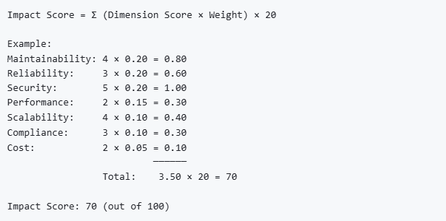

5.4 Impact Score Tiers
Tier | Score Range | Urgency | Response
Critical | 80-100 | Immediate | Emergency remediation
High | 60-79 | Urgent | Plan within 30 days
Medium | 40-59 | Normal | Plan within 90 days
Low | 20-39 | Low | Address opportunistically
Minimal | 1-19 | None | Monitor only

5.5 Spread Assessment
Beyond aggregate score, assess spread across dimensions:
Pattern | Indication | Action
Single High | Isolated issue | Target specific dimension
Multiple High | Systemic problem | Comprehensive remediation
Even Moderate | Gradual decay | Scheduled maintenance
Security Peak | Security-specific | Immediate security focus

6. Prioritization Framework
[Change Driver: Priority methodology changes]

6.1 Priority Factors
Factor | Weight | Description
Impact Score | 40% | From §5 assessment
Interest Rate | 25% | How fast debt grows
Strategic Alignment | 20% | Alignment with roadmap
Remediation Effort | 15% | Cost to fix (inverse)

6.2 Interest Rate Assessment
Technical debt accumulates "interest" over time:
Interest Rate | Definition | Examples
Compounding | Debt forces additional debt | Architecture debt causing workarounds
Linear | Steady maintenance overhead | Code complexity
Stable | Fixed impact over time | Documentation gaps
Declining | Diminishing relevance | Sunset system debt

6.3 Strategic Alignment
Alignment | Score | Description
Blocking | 5 | Prevents strategic initiative
Enabling | 4 | Required for planned work
Supporting | 3 | Improves planned work efficiency
Tangential | 2 | Minimal strategic connection
Unrelated | 1 | No strategic connection

6.4 Remediation Effort
Effort | T-Shirt | Description | Score
Trivial | XS | <1 day effort | 5
Small | S | 1-5 days effort | 4
Medium | M | 1-4 weeks effort | 3
Large | L | 1-3 months effort | 2
Extra Large | XL | >3 months effort | 1

6.5 Priority Calculation

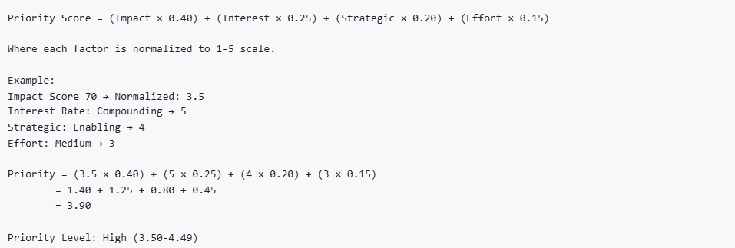

6.6 Priority Levels
Priority | Score Range | Target Resolution | Governance
Critical | 4.50-5.00 | Within 30 days | ARB oversight
High | 3.50-4.49 | Within 90 days | DDA oversight
Medium | 2.50-3.49 | Within 180 days | PBC planning
Low | 1.50-2.49 | Within 365 days | Opportunistic
Monitor | 1.00-1.49 | No action required | Track only

7. Remediation Governance
[Change Driver: Remediation process changes]

7.1 Remediation Plan Structure
Field | Description
Plan ID | Unique identifier (REMED-{PBC}-{NNN})
Debt Items | Linked debt IDs
Approach | Remediation strategy
Scope | Components affected
Dependencies | Prerequisites and blockers
Effort Estimate | Time and resources
Risk Assessment | Remediation risks
Rollback Plan | If remediation fails
Success Criteria | How to verify completion
Timeline | Start, milestones, end
Owner | Responsible person

7.2 Remediation Approaches
Approach | Description | When to Use
Refactor | Improve without changing behavior | Code debt, moderate architecture debt
Rewrite | Build new to replace old | Severe architecture debt, obsolete tech
Wrap | Isolate with abstraction layer | Integration debt, legacy isolation
Upgrade | Update dependencies/platform | Dependency debt, infrastructure debt
Patch | Targeted fix | Security debt, specific issues
Document | Add missing documentation | Documentation debt
Test | Add test coverage | Test debt
Decommission | Remove entirely | Unused/obsolete components

7.3 Remediation Planning Matrix
Priority | Planning Requirement | Review Frequency
Critical | Immediate plan; ARB approval | Weekly
High | Plan within 2 weeks; DDA approval | Bi-weekly
Medium | Plan within 30 days; PBC approval | Monthly
Low | Optional plan; track in backlog | Quarterly

7.4 Debt Budget Allocation
Organizations should allocate capacity for debt remediation:
Allocation Model | Description | Recommendation
Dedicated % | Fixed % of sprint capacity | 15-20% per sprint
Dedicated Sprint | Full sprint periodically | 1 in 6 sprints
Boy Scout Rule | Improve with every change | Continuous
Threshold-Triggered | Action when threshold breached | When Critical debt > 5

7.5 Remediation Success Criteria
Criterion | Description | Evidence
Debt Eliminated | Root cause addressed | Debt item closed
No Regression | No new debt introduced | Impact assessment
Tests Pass | Existing tests pass | CI/CD results
Coverage Improved | Test coverage maintained/improved | Coverage report
Documentation Updated | Relevant docs updated | Doc review
Stakeholders Notified | Affected parties informed | Communication log

8. Lifecycle Integration
[Change Driver: Gateway requirements changes]

8.1 PBC Lifecycle Debt Checkpoints

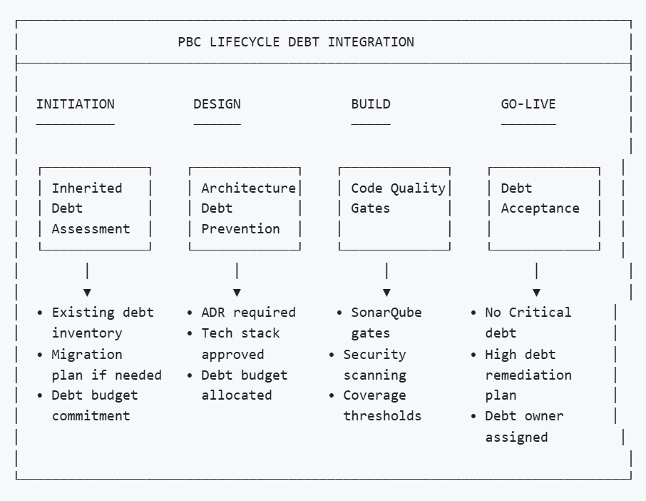

8.2 Initiation Gateway — Debt Requirements
Checkpoint | Description | Evidence
Existing debt inventory | If replacing/enhancing, document inherited debt | Debt registry entries
Debt budget commitment | Commit to debt allocation model | Sprint planning policy
Architecture review | Identify potential architecture debt early | ADR template

8.3 Design Gateway — Debt Requirements
Checkpoint | Description | Evidence
Technology compliance | Stack aligned with Technology Catalog | §18 compliance
Architecture Decision Records | Key decisions documented | ADR repository
Debt prevention measures | Quality gates defined | CI/CD configuration
No architecture debt introduced | Design reviewed for debt patterns | Design review sign-off

8.4 Build Phase — Continuous Debt Gates
Gate | Threshold | Action if Failed
Code Coverage | ≥80% | Build fails
Code Duplication | ≤3% | Build fails
Cyclomatic Complexity | ≤15 per method | Warning
Security Vulnerabilities | 0 Critical/High | Build fails
Dependency CVEs | 0 Critical | Build fails
Technical Debt Ratio | ≤5% (SonarQube) | Warning

8.5 Go-Live Gateway — Debt Requirements
Checkpoint | Description | Evidence
No Critical debt | Zero critical debt items | Debt registry
High debt remediation plan | Plan for any high debt | Remediation plans
Debt owner assigned | Each debt item has owner | Debt registry
Known debt accepted | Deliberate debt documented | ARB/DDA sign-off
Debt budget operational | Ongoing debt allocation confirmed | Sprint planning

8.6 Post-Go-Live — Ongoing Debt Management
Activity | Frequency | Owner
Debt review | Monthly | PBC Owner
Debt reporting | Quarterly | EA Office
Debt retrospective | Per release | Dev Team
Debt threshold review | Annually | DDA

9. Governance Process
[Change Driver: Governance workflow changes]

9.1 Governance Bodies
Body | Scope | Frequency
Technical Debt Board | Enterprise debt oversight | Monthly
DDA | PBC-level debt decisions | As needed
ARB | Cross-PBC debt, strategic debt | Quarterly
Security Council | Security debt prioritization | Bi-weekly

9.2 Decision Authority Matrix
Decision | PBC Owner | DDA | ARB
Identify debt | ✓ | — | —
Assess impact | ✓ | Validates | —
Prioritize (within PBC) | Proposes | Approves | —
Prioritize (cross-PBC) | Proposes | Reviews | Approves
Accept debt (Medium/Low) | Proposes | Approves | —
Accept debt (High/Critical) | Proposes | Reviews | Approves
Defer debt | Proposes | Approves | —
Won't Fix decision | Proposes | Reviews | Approves
Set debt budget | Proposes | Approves | —
Change debt thresholds | — | Proposes | Approves

9.3 Debt Review Process

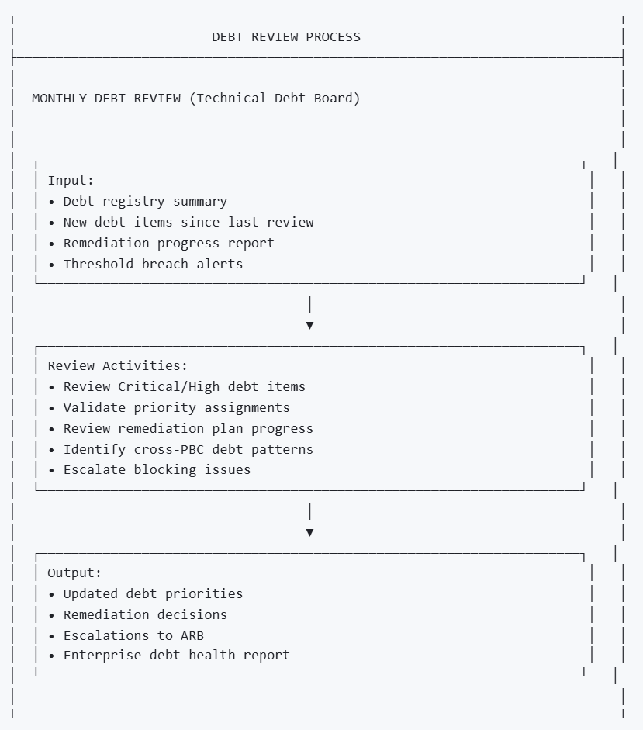

9.4 Escalation Triggers
Trigger | Escalation To | Response
Critical debt unaddressed >14 days | ARB | Emergency review
High debt unaddressed >60 days | DDA | Priority review
Debt threshold breached | Technical Debt Board | Process review
Cross-PBC debt identified | ARB | Strategic decision
Security debt with active threat | Security Council | Immediate action
Debt budget not allocated | DDA | PBC review

10. Metrics and Reporting
[Change Driver: Measurement requirements changes]

10.1 Debt Health Metrics
Metric | Definition | Target | Alert
Total Debt Count | Number of open debt items | Trending down | Increase >10%
Critical Debt Count | Items with Critical priority | 0 | Any >0
High Debt Count | Items with High priority | <10 | >15
Debt Age (Avg) | Average days open | <90 days | >120 days
Oldest Debt | Days since oldest item | <365 days | >400 days
Debt per PBC | Average items per PBC | <5 | >10

10.2 Debt Flow Metrics
Metric | Definition | Target | Alert
Debt Inflow | New items per month | Stable/declining | Spike >2× avg
Debt Outflow | Closed items per month | ≥ Inflow | < Inflow for 3 months
Resolution Rate | Closed / (Opened + Carried) | >30% | <20%
Mean Time to Resolve | Avg days from Identified to Closed | <60 days | >90 days
Remediation Velocity | Story points closed per sprint | Increasing | Declining 3 sprints

10.3 Quality Gate Metrics
Metric | Definition | Target | Alert
Build Pass Rate | Builds passing debt gates | >95% | <90%
Coverage Trend | Code coverage direction | Stable/improving | Declining
Security Scan Pass | Scans with 0 critical | 100% | <95%
Dependency Health | Dependencies without CVEs | >95% | <90%

10.4 Debt Distribution Analysis
Analysis | Purpose | Frequency
By Type | Identify systemic issues | Monthly
By PBC | Identify struggling teams | Monthly
By Age | Identify stale debt | Weekly
By Origin | Identify root causes | Quarterly
By Category | Identify reckless patterns | Quarterly

10.5 Reporting Cadence
Report | Audience | Frequency | Content
Debt Dashboard | All | Real-time | Key metrics, trends
PBC Debt Report | PBC Owners | Weekly | PBC-specific debt
Enterprise Debt Report | DDA, ARB | Monthly | Enterprise summary
Executive Summary | Leadership | Quarterly | Strategic overview
Annual Debt Review | All | Annually | Year-over-year analysis

10.6 Sample Dashboard Layout

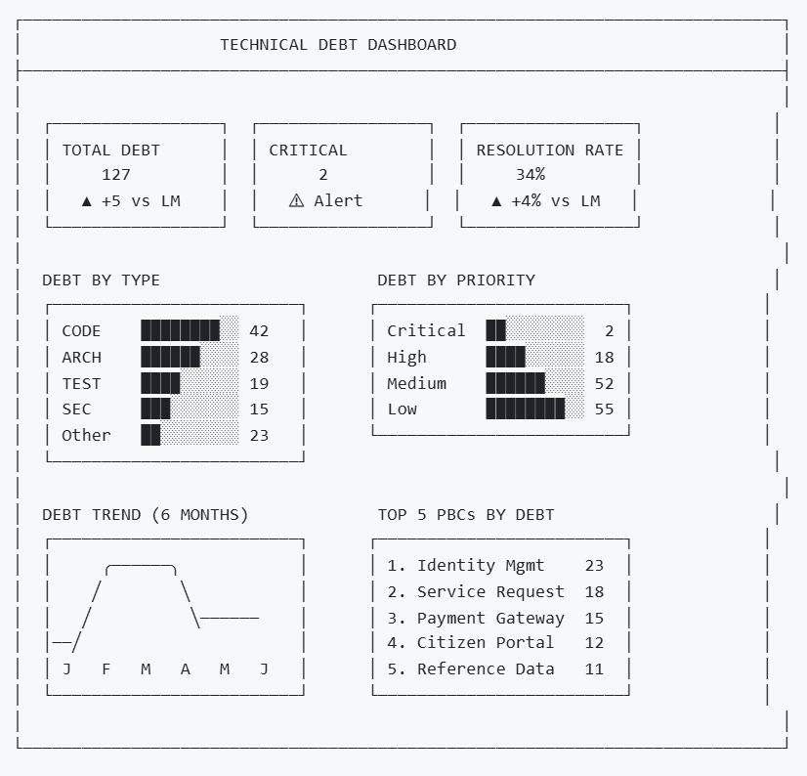

11. PBC Debt Specification Template
[Change Driver: Per-PBC documentation]

11.1 PBC Template Section 21: Technical Debt
Each PBC documents its debt position using this structure:
Subsection | Content
21.1 Debt Summary | Overview, count by type/priority
21.2 Known Debt Items | Link to debt registry entries
21.3 Debt Budget | Allocation model and commitment
21.4 Remediation Plans | Active remediation plans
21.5 Debt Thresholds | PBC-specific thresholds
21.6 Quality Gates | CI/CD gate configuration

11.2 Section 21 Template

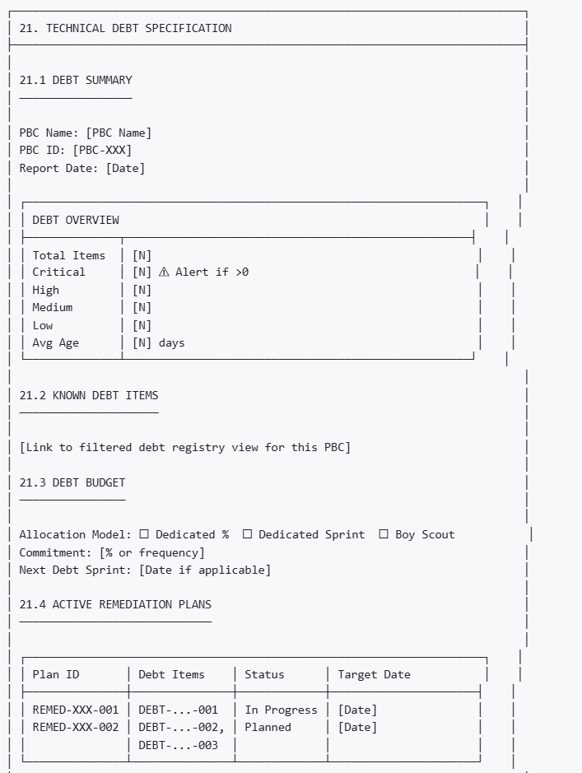

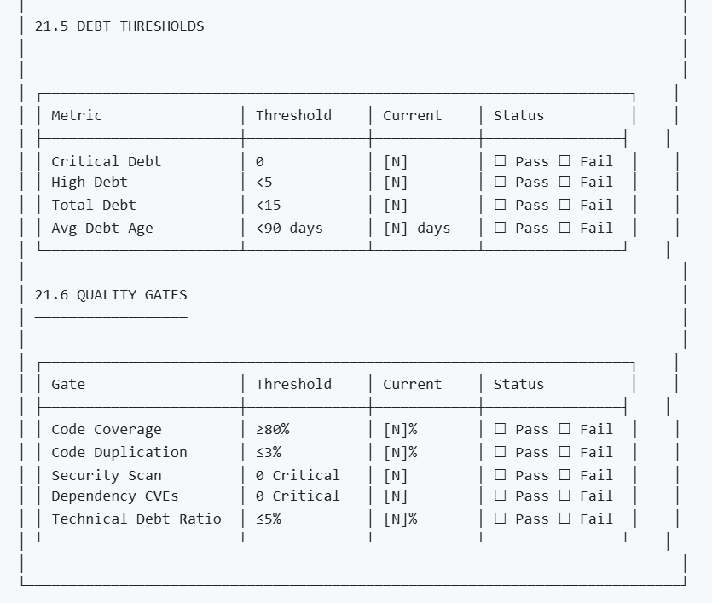

12. Module Metadata
Field | Value
Module ID | G-CAF-046
Title | Technical Debt Management
Version | 1.0
Status | Draft
Change Driver | Enterprise technical debt governance
Type | Mixed (Generic patterns + Specific thresholds)
Owner | EA Office / Quality Office
Approved By | — (Pending ARB)
Last Updated | December 2025

13. NS Compliance Verification

13.1 Change Driver Matrix
Section | Change Driver | Independence Verified
§3 Debt Classification | Debt taxonomy | ✅ Can add debt types without affecting registry
§4 Debt Registry | Debt items | ✅ Can add items without changing classification
§5 Impact Assessment | Assessment methodology | ✅ Can change scoring without affecting prioritization
§6 Prioritization Framework | Priority methodology | ✅ Can change algorithm independently
§7 Remediation Governance | Remediation process | ✅ Can change process without affecting registry
§8 Lifecycle Integration | Gateway requirements | ✅ Can change gates without affecting assessment
§9 Governance Process | Approval workflow | ✅ Can change governance without affecting remediation
§10 Metrics and Reporting | Measurement | ✅ Can change metrics without affecting governance
§11 PBC Debt Specification | Per-PBC documentation | ✅ Each PBC documented independently

13.2 Module Classification
Module | Type | Reusability
Debt Classification (§3) | Generic | Reusable taxonomy
Debt Registry Structure (§4.1-4.3) | Generic | Reusable pattern
Sample Debt Registry (§4.4) | Specific | GovDigital examples
Impact Assessment (§5) | Generic | Reusable methodology
Prioritization Framework (§6) | Generic | Reusable algorithm
Remediation Governance (§7) | Generic | Reusable process
Lifecycle Integration (§8) | Specific | G-CAF gateway integration
Governance Process (§9) | Specific | GovDigital bodies
Metrics and Reporting (§10) | Generic | Reusable metrics
PBC Debt Specification (§11) | Generic | Reusable template

13.3 Combinatorial Effects Prevention
Scenario | Without G-CAF-046 | With G-CAF-046
Add debt type | Hunt through PBC docs | §3 update only
Change scoring | Update N assessment docs | §5 update only
Change priority algorithm | Recalculate manually | §6 update; auto-recalc
Add quality gate | Configure N pipelines | §8 update; propagate
Change governance | Notify teams manually | §9 update; clear process

Appendix A: Debt Item Template
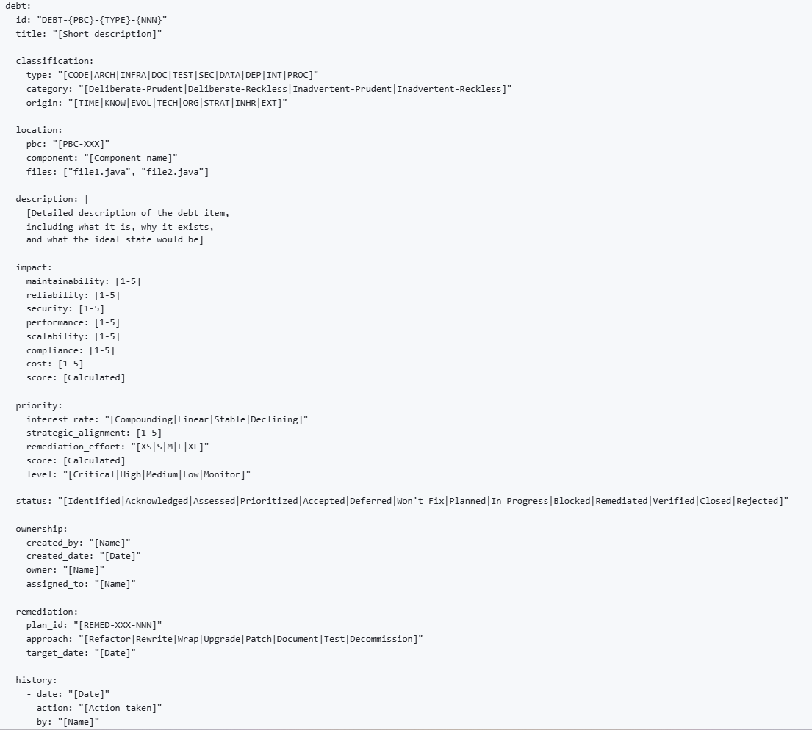

Appendix B: Remediation Plan Template
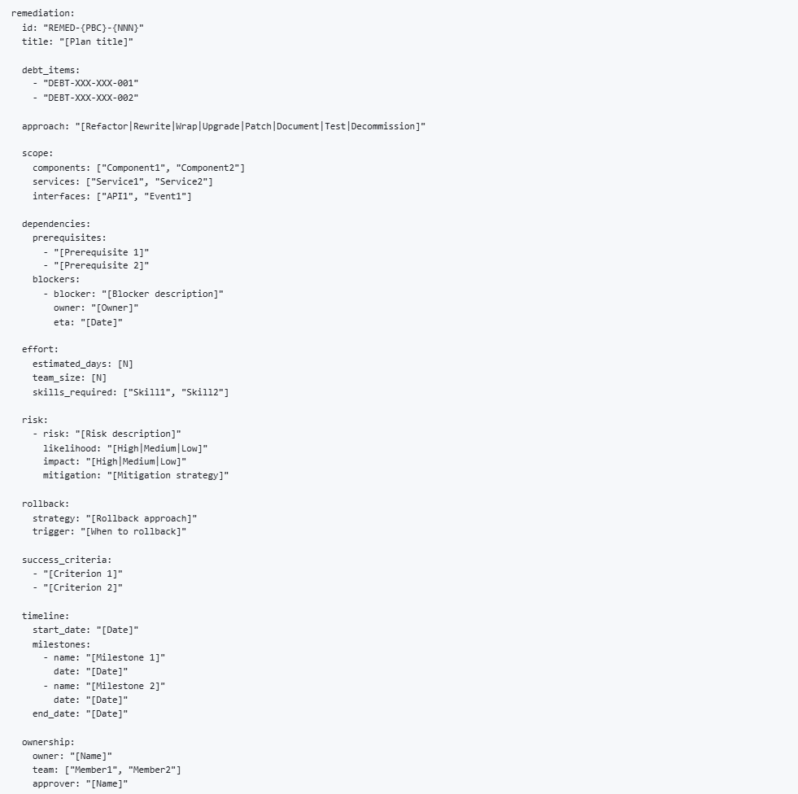

Appendix C: Cross-Reference to G-CAF Modules
G-CAF Module | Relationship to G-CAF-046
G-CAF-042 PBC Catalog | Debt items linked to PBCs
G-CAF-043 Technology Catalog | Dependency debt references tech stack
G-CAF-044 Data Asset Catalog | Data debt references entities
G-CAF-045 Integration Asset Catalog | Integration debt references APIs/Events
G-CAF-090 Initiation Gateway | Inherited debt assessment
G-CAF-091 Design Gateway | Architecture debt prevention
G-CAF-092 Go-Live Gateway | Debt acceptance criteria
COMPANION-001 PBC Template | Section 21: Technical Debt

End of Document

