G-CAF-048: Environment Standards

**Use Case Context:** This artifact supports **UC10: Retire a PBC**

[G-CAF-048]
Change Driver: Enterprise environment governance
Type: Specific
Last Updated: December 2025

1. Purpose and Scope
[Change Driver: Strategic mandate]

1.1 Purpose
The Environment Standards framework provides enterprise-wide governance for the definition, provisioning, configuration, and management of deployment environments across all PBCs. This ensures consistency, security, and operational excellence throughout the software delivery lifecycle.

1.2 Definition
Environment: A configured infrastructure context where software components are deployed, tested, and executed. Each environment provides isolation, specific configurations, and appropriate access controls aligned with its purpose in the delivery lifecycle.

1.3 Scope
In Scope | Out of Scope
Environment type definitions | Vendor-specific provisioning scripts
Environment configuration standards | Application-specific configurations
Provisioning governance | Infrastructure cost management
Promotion pipeline standards | Network architecture design
Environmental security controls | Physical data center operations
Monitoring requirements | Capacity planning details
PBC environment documentation | Incident management procedures

1.4 Strategic Alignment
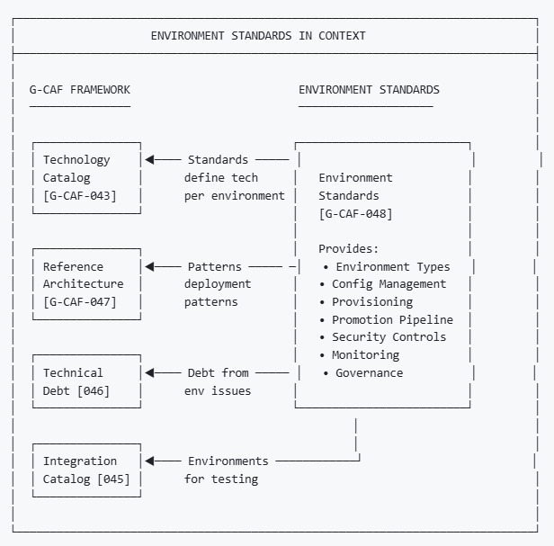

2. NS Compliance Design
[Change Driver: Architecture principles]

2.1 Module Structure
This framework separates concerns by change driver:
Section | Change Driver | Update Trigger
§3 Environment Classification | Environment taxonomy | New type or tier
§4 Environment Registry | Environment definitions | New environment instance
§5 Configuration Management | Configuration standards | Config pattern change
§6 Provisioning Standards | Provisioning methodology | Infrastructure evolution
§7 Promotion Pipeline | Deployment flow | Pipeline requirements
§8 Security Controls | Security requirements | Security policy change
§9 Monitoring Standards | Observability requirements | Monitoring evolution
§10 Governance Process | Approval workflow | Governance body change
§11 PBC Specification | Per-PBC documentation | Template evolution

2.2 Separation of Concerns
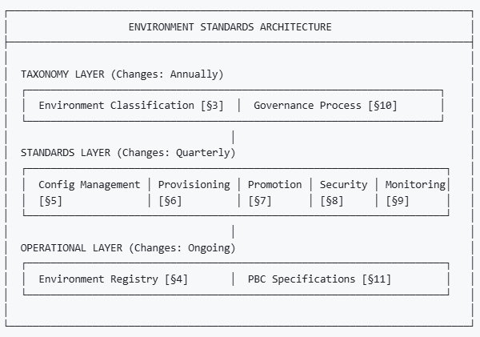

3. Environment Classification
[Change Driver: Environment taxonomy changes]

3.1 Environment Types
Type | Code | Purpose | Stability | Data
Development | DEV | Active development and unit testing | Unstable | Synthetic
Integration | INT | Component integration testing | Semi-stable | Synthetic
Quality Assurance | QA | Functional and regression testing | Stable | Synthetic/Masked
Performance | PERF | Load and performance testing | Stable | Production-like
User Acceptance | UAT | Business validation and sign-off | Stable | Masked production
Staging | STG | Pre-production validation | Stable | Masked production
Production | PROD | Live business operations | Highly stable | Production
Disaster Recovery | DR | Business continuity | Mirror of PROD | Replicated
Sandbox | SBX | Experimentation and POC | Unstable | Synthetic

3.2 Environment Tiers
Tier | Environments | SLA | Support
Tier 1 (Critical) | PROD, DR | 99.9% uptime | 24/7
Tier 2 (Business) | UAT, STG | 99.5% uptime | Business hours + on-call
Tier 3 (Development) | DEV, INT, QA, PERF, SBX | 95% uptime | Business hours

3.3 Environment Lifecycle States

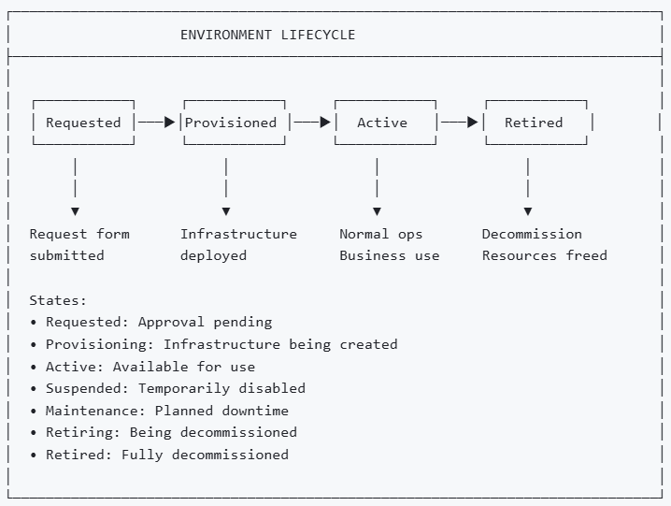

3.4 Environment Sizing Profiles
Profile | Code | CPU | Memory | Storage | Use Case
Minimal | XS | 1 vCPU | 2 GB | 20 GB | Sandbox, POC
Small | S | 2 vCPU | 4 GB | 50 GB | Dev, simple services
Medium | M | 4 vCPU | 8 GB | 100 GB | INT, QA, most PBCs
Large | L | 8 vCPU | 16 GB | 250 GB | PERF, complex PBCs
X-Large | XL | 16 vCPU | 32 GB | 500 GB | STG, high-load PBCs
Production | P | Auto-scale | Auto-scale | As needed | PROD, DR

4. Environment Registry
[Change Driver: Environment instances]

4.1 Environment Registry Structure
Each environment instance contains:
Field | Description
Environment ID | Unique identifier (ENV-{PBC}-{TYPE}-{NNN})
Environment Name | Descriptive name
Type | From §3.1
Tier | From §3.2
Status | From §3.3
PBC | Owning PBC
Sizing Profile | From §3.4
Region | Deployment region
Cloud Provider | Azure / AWS / GCP / On-Premises
Created Date | Provisioning date
Owner | Responsible team/person
Config Version | Current configuration version
Last Updated | Last modification date

4.2 Standard Environment Set
Each PBC should have the following minimum environments

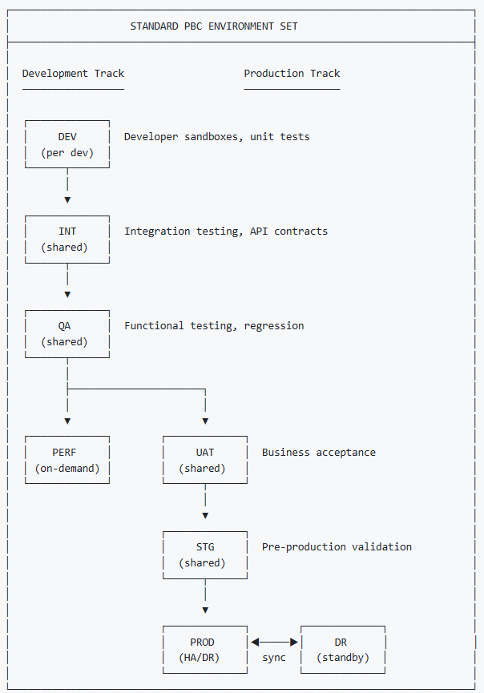

4.3 Environment Naming Convention
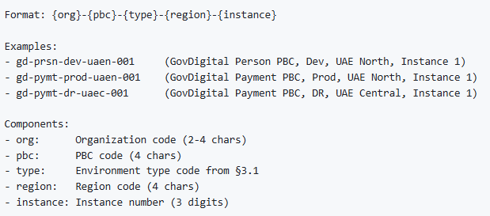

5. Configuration Management
[Change Driver: Configuration standards]

5.1 Configuration Principles
Principle | Description
Infrastructure as Code (IaC) | All infrastructure defined in version-controlled code
Configuration as Code | All configurations in version-controlled files
Immutable Infrastructure | Replace, don't modify running infrastructure
Secret Separation | Secrets stored separately from configuration
Environment Parity | Minimize differences between environments

5.2 Configuration Layers

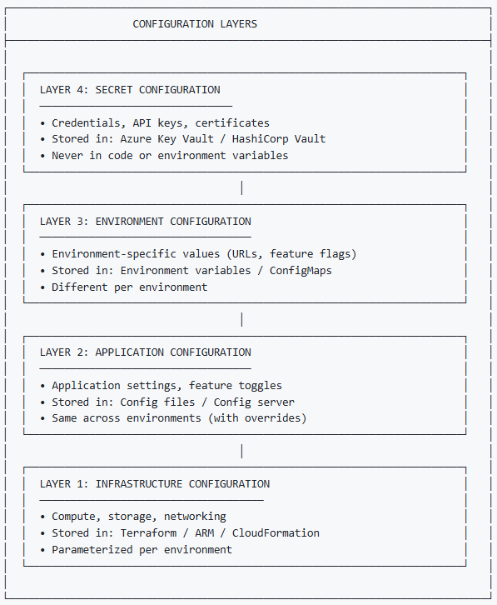

5.3 Configuration File Structure

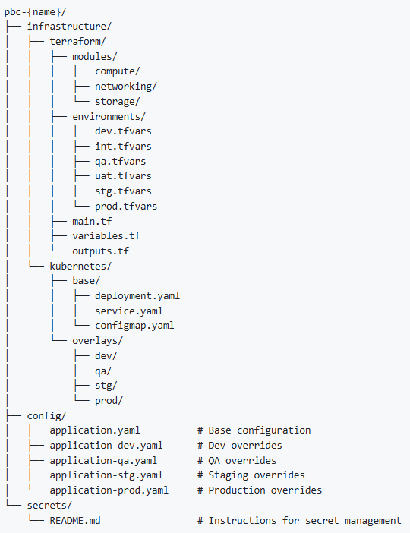

5.4 Configuration Drift Prevention
Control | Description | Frequency
IaC Validation | Terraform plan/apply only via pipeline | Every deployment
Config Audit | Compare running config vs. source | Daily
Drift Detection | Automated scanning for changes | Hourly
Reconciliation | Auto-revert unauthorized changes | On detection
Change Log | All config changes logged | Continuous

5.5 Environment Variable Standards
Category | Prefix | Example
Application | APP_ | APP_LOG_LEVEL=INFO
Database | DB_ | DB_HOST=postgres.prod
Cache | CACHE_ | CACHE_HOST=redis.prod
Message Queue | MQ_ | MQ_HOST=kafka.prod
External Service | SVC_ | SVC_PAYMENT_URL=https://...
Feature Flag | FF_ | FF_NEW_UI=true
Environment Meta | ENV_ | ENV_NAME=production

6. Provisioning Standards
[Change Driver: Infrastructure provisioning methodology]

6.1 Provisioning Approach
Environment | Provisioning Method | Automation Level
DEV | Self-service + IaC | Fully automated
INT | IaC via pipeline | Fully automated
QA | IaC via pipeline | Fully automated
PERF | IaC on-demand | Automated with approval
UAT | IaC via pipeline | Automated with approval
STG | IaC via pipeline | Automated with approval
PROD | IaC via pipeline | Automated with approval
DR | IaC synchronized | Automated

6.2 Provisioning Pipeline

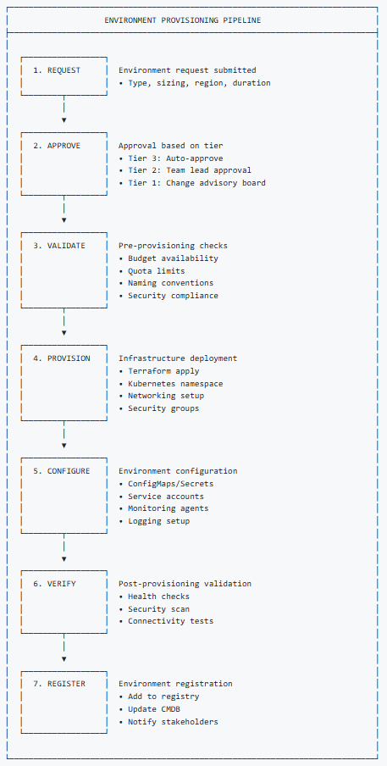

6.3 Provisioning Templates
Template | Description | Target Environments
pbc-basic | Single container, basic networking | DEV, SBX
pbc-standard | Multi-container, load balancer | INT, QA
pbc-ha | High availability, auto-scaling | UAT, STG
pbc-production | Full HA, multi-zone, DR ready | PROD
pbc-dr | DR replica configuration | DR

6.4 Resource Quotas
Environment Type | CPU Quota | Memory Quota | Storage Quota | Pod Limit
DEV | 4 vCPU | 8 GB | 50 GB | 20
INT | 8 vCPU | 16 GB | 100 GB | 30
QA | 8 vCPU | 16 GB | 100 GB | 30
PERF | 32 vCPU | 64 GB | 500 GB | 100
UAT | 16 vCPU | 32 GB | 200 GB | 50
STG | 32 vCPU | 64 GB | 500 GB | 100
PROD | Unlimited* | Unlimited* | Unlimited* | 500

*Subject to budget and capacity review

7. Promotion Pipeline
[Change Driver: Deployment flow requirements]

7.1 Promotion Path

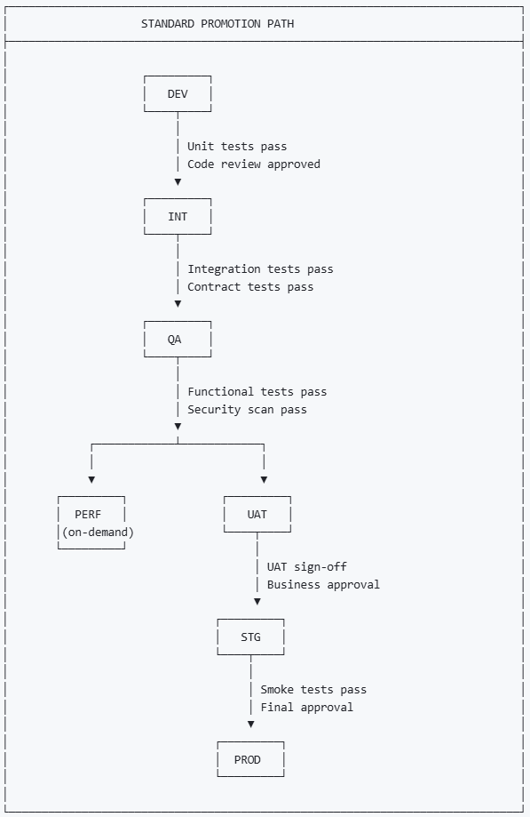

7.2 Promotion Gates
Gate | From → To | Automated Checks | Manual Approvals
G1 | DEV → INT | Unit tests, code coverage, linting | Code review
G2 | INT → QA | Integration tests, contract tests | —
G3 | QA → UAT | Functional tests, security scan, performance baseline | QA lead
G4 | UAT → STG | Regression tests | Business owner, UAT sign-off
G5 | STG → PROD | Smoke tests, health checks | Change advisory board

7.3 Promotion Checklist
Stage | Checklist Item | Required
All | Version tagged in source control | ✓
All | Release notes documented | ✓
All | Configuration validated | ✓
QA → UAT | Test report attached | ✓
QA → UAT | Known issues documented | ✓
UAT → STG | UAT sign-off obtained | ✓
UAT → STG | Rollback plan documented | ✓
STG → PROD | Change request approved | ✓
STG → PROD | Deployment window scheduled | ✓
STG → PROD | On-call team notified | ✓

7.4 Rollback Procedures
Environment | Rollback Method | Target Time
DEV, INT | Redeploy previous version | < 5 minutes
QA, UAT | Redeploy previous version | < 15 minutes
STG | Blue-green switch | < 5 minutes
PROD | Blue-green switch or canary abort | < 5 minutes

8. Security Controls
[Change Driver: Security requirements]

8.1 Security by Environment Tier
Control | Tier 3 (DEV) | Tier 2 (UAT/STG) | Tier 1 (PROD/DR)
Network isolation | Basic | Enhanced | Maximum
Access control | Team-based | Role-based | Strict RBAC
Data encryption at rest | Optional | Required | Required
Data encryption in transit | TLS | TLS 1.2+ | TLS 1.3
Secret management | Team vault | Shared vault | Production vault
Audit logging | Basic | Enhanced | Comprehensive
Vulnerability scanning | Weekly | Daily | Continuous
Penetration testing | — | Quarterly | Monthly

8.2 Network Security

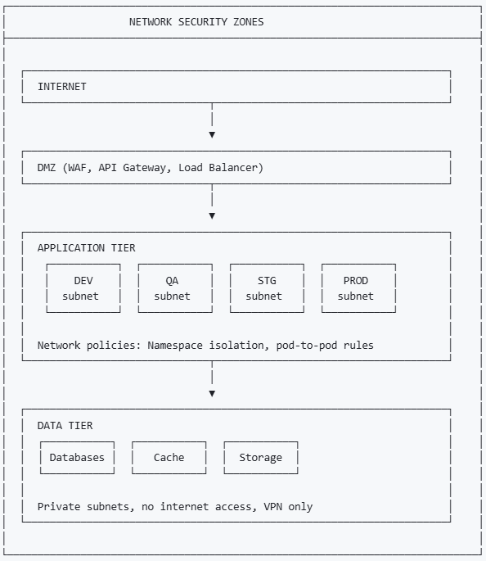

8.3 Access Control Matrix
Role | DEV | INT | QA | UAT | STG | PROD | DR
Developer | Full | Deploy | Read | Read | — | — | —
QA Engineer | Read | Read | Full | Read | Read | — | —
Tech Lead | Full | Full | Full | Read | Read | Read | Read
DevOps | Full | Full | Full | Full | Full | Deploy | Deploy
SRE | Read | Read | Read | Full | Full | Full | Full
PBC Owner | Read | Read | Read | Full | Read | Read | Read

8.4 Secret Management
Environment | Secret Store | Rotation | Access
DEV | Azure Key Vault (Dev) | Manual | Team
INT, QA | Azure Key Vault (Non-Prod) | 90 days | Service account
UAT, STG | Azure Key Vault (Non-Prod) | 90 days | Service account
PROD, DR | Azure Key Vault (Prod) | 30 days | Service account + MFA

9. Monitoring Standards
[Change Driver: Observability requirements]

9.1 Monitoring Requirements by Tier
Capability | Tier 3 | Tier 2 | Tier 1
Health checks | 5 min | 1 min | 30 sec
Metrics collection | 1 min | 30 sec | 15 sec
Log aggregation | Basic | Enhanced | Comprehensive
Alerting | Email | Email + Slack | PagerDuty + SMS
Dashboards | Basic | Standard | Executive + Detailed
Tracing | Optional | Sampling | Full
Retention | 7 days | 30 days | 1 year

9.2 Standard Metrics
Category | Metrics | Alert Threshold
Availability | Uptime %, health check status | < 99.9% (Prod)
Performance | Response time (p50, p95, p99) | p99 > 2s
Throughput | Requests/sec, transactions/sec | < baseline - 20%
Errors | Error rate, 5xx rate | > 1%
Resources | CPU, memory, disk, network | > 80%
Business | Custom PBC metrics | PBC-defined

9.3 Logging Standards
Field | Description | Required
timestamp | ISO 8601 format | ✓
level | TRACE, DEBUG, INFO, WARN, ERROR, FATAL | ✓
service | PBC/service name | ✓
environment | Environment name | ✓
correlation_id | Request correlation ID | ✓
message | Log message | ✓
user_id | User identifier (if applicable) | When available
error | Error details (if applicable) | When error

9.4 Alerting Matrix
Severity | Response Time | Notification | Examples
P1 Critical | 15 min | PagerDuty + Phone | Prod down, data loss
P2 High | 1 hour | PagerDuty + Slack | Major degradation
P3 Medium | 4 hours | Slack + Email | Minor issues
P4 Low | Next business day | Email | Warnings, thresholds

10. Governance Process
[Change Driver: Approval workflow]

10.1 Governance Bodies
Body | Scope | Frequency
Change Advisory Board (CAB) | Production changes | Weekly
Infrastructure Council | Standards, capacity | Monthly
Security Council | Security controls | Bi-weekly
DDA | PBC environment decisions | As needed

10.2 Decision Authority Matrix
Decision | PBC Owner | DevOps | DDA | CAB
Create DEV/INT environment | ✓ | — | — | —
Create QA environment | ✓ | Provisions | — | —
Create UAT environment | Proposes | Provisions | Approves | —
Create STG environment | Proposes | Provisions | Approves | —
Create PROD environment | Proposes | Provisions | Reviews | Approves
Modify PROD environment | Proposes | Provisions | Reviews | Approves
Decommission environment | Proposes | Executes | Approves | — (Tier 1: CAB)
Change security controls | Proposes | Reviews | Reviews | Security Council
Exception request | Proposes | Reviews | Reviews | Approves

10.3 Change Management
Environment Tier | Change Window | Lead Time | Approval
Tier 3 | Anytime | None | Auto
Tier 2 | Business hours | 24 hours | Team lead
Tier 1 | Scheduled | 5 business days | CAB
Tier 1 (Emergency) | Anytime | Immediate | CAB chair

10.4 Environment Review Process
Review Type | Frequency | Participants | Output
Security Review | Quarterly | Security, DevOps | Compliance report
Cost Review | Monthly | Finance, DevOps, PBC Owner | Optimization actions
Capacity Review | Monthly | DevOps, SRE | Scaling recommendations
Configuration Audit | Weekly | DevOps | Drift report

11. PBC Environment Specification
[Change Driver: Per-PBC documentation]

11.1 PBC Template Section 23
Each PBC documents its environment specifications using this structure:
Subsection | Content
23.1 Environment Overview | Summary of all environments
23.2 Environment Details | Per-environment specifications
23.3 Configuration Management | Config approach and structure
23.4 Promotion Pipeline | PBC-specific promotion flow
23.5 Security Configuration | Environment security settings
23.6 Monitoring Setup | Environment monitoring config
23.7 Section Approval | Sign-off table

12. Module Metadata
Field | Value
Module ID | G-CAF-048
Title | Environment Standards
Version | 1.0
Status | Draft
Change Driver | Enterprise environment governance
Type | Mixed (Generic standards + Specific processes)
Owner | Platform Engineering
Approved By | — (Pending ARB)
Last Updated | December 2025

13. NS Compliance Verification

13.1 Change Driver Matrix
Section | Change Driver | Independence Verified
§3 Environment Classification | Environment taxonomy | ✅ Can add types without affecting registry
§4 Environment Registry | Environment instances | ✅ Can add environments without changing classification
§5 Configuration Management | Configuration standards | ✅ Can change config approach independently
§6 Provisioning Standards | Provisioning methodology | ✅ Can update provisioning independently
§7 Promotion Pipeline | Deployment flow | ✅ Can change pipeline without affecting security
§8 Security Controls | Security requirements | ✅ Can change security without affecting monitoring
§9 Monitoring Standards | Observability requirements | ✅ Can change monitoring independently
§10 Governance Process | Approval workflow | ✅ Can change governance independently
§11 PBC Specification | Per-PBC documentation | ✅ Each PBC documented independently

13.2 Module Classification
Module | Type | Reusability
Environment Classification (§3) | Generic | Reusable taxonomy
Environment Registry Structure (§4) | Generic | Reusable template
Configuration Management (§5) | Generic | Industry patterns
Provisioning Standards (§6) | Generic | Reusable methodology
Promotion Pipeline (§7) | Generic | Reusable flow
Security Controls (§8) | Mixed | Generic controls + specific thresholds
Monitoring Standards (§9) | Generic | Reusable requirements
Governance Process (§10) | Specific | GovDigital bodies
PBC Specification (§11) | Generic | Reusable template

Appendix A: Environment Request Form Template
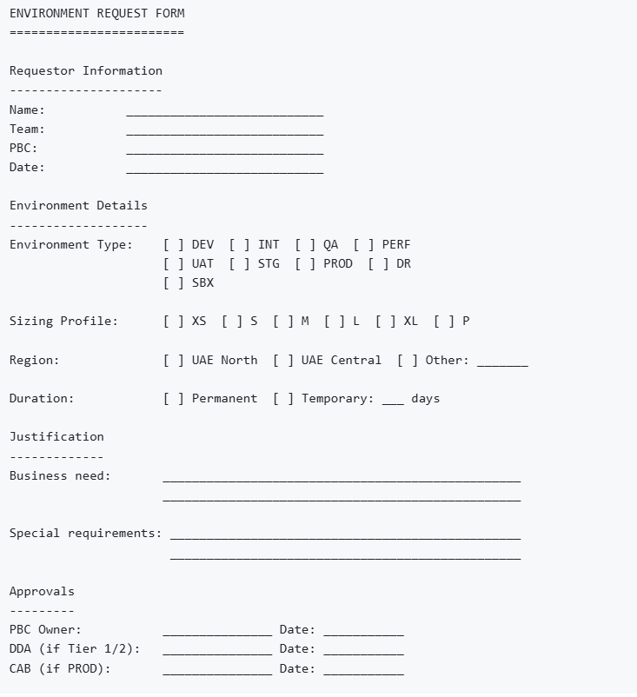

Appendix B: Cross-Reference to G-CAF Modules
G-CAF Module | Relationship to G-CAF-048
G-CAF-042 PBC Catalog | PBCs have environments
G-CAF-043 Technology Catalog | Technologies approved per environment
G-CAF-044 Data Asset Catalog | Data classification affects environment security
G-CAF-045 Integration Asset Catalog | Integrations tested in environments
G-CAF-046 Technical Debt | Environment issues create debt
G-CAF-047 Reference Architecture | Deployment patterns used
G-CAF-090 Initiation Gateway | Environment needs identified
G-CAF-091 Design Gateway | Environment architecture approved
G-CAF-092 Go-Live Gateway | Production readiness verified
COMPANION-001 PBC Template | Section 23: Environment Specification

End of Document

