PBC Maturity Classification

**Use Case Context:** This artifact supports **UC10: Retire a PBC**

[G-CAF-055]
Change Driver: Maturity level definitions or assessment criteria
Type: Generic
Last Updated: December 2025

Purpose
Maturity classification categorizes PBCs by their level of autonomy and data ownership completeness. Based on Gartner's Reference Model for Intelligent Composable Business Applications. Used for legacy modernization planning and roadmap prioritization.

Gartner Maturity Types
Maturity Type | Data Ownership | Autonomy Level | Complexity | Primary Use Case
Fully Expressed | Complete | High | High | Core business entities; greenfield
Orchestration | Process state only | Medium | Medium-High | Workflow coordination
Basic Business Function | Partial | Low | Low-Medium | Legacy modernization; incremental extraction
Pseudo PBC | None (facade) | None | Low | Transitional; legacy wrapping

**Note:** This maturity classification is **orthogonal** to G-CAF's five PBC Types (Application, Analytics, Data, Orchestration, Digital Twin). Maturity describes *how complete* a PBC is; Type describes *what function* it performs.

Type 1: Fully Expressed (Autonomous) PBC

Definition
Wholly and exclusively encapsulates the function and data of its designated business object. The PBC is the exclusive source of truth for that entity.

Characteristics
Aspect | Requirement
Data Ownership | Complete entity state from creation to closure
Transaction History | All transactions associated with entity
Data Mastery | Data may be copied to Data Fabric but PBC remains master
Write Access | No external system has write access to entity data
Lifecycle | Manages complete entity lifecycle
Autonomy | Minimal external dependencies; operates independently

When to Target
- Core business entities that define competitive advantage
- Entities requiring complete audit trails
- High-value objects needing data sovereignty
- Greenfield implementations

Example
A Savings Account PBC containing: account state, all transactions (deposits, withdrawals, credits, debits), state changes, analysis findings, and closure.

Type 2: Orchestration PBC

Definition
Encapsulates a process. Most action is invocation of other PBCs. Manages process state when applicable.

Characteristics
Aspect | Requirement
Data Ownership | Process state only; no entity data
Function | Invokes multiple PBCs; contains summarization logic
Composition | Building block for application composition
Saga Support | Manages distributed transaction coordination

When to Target
- Multi-step business processes
- Cross-PBC transactions requiring coordination
- Approval workflows
- Long-running processes needing state persistence

Example
An Account Overdraft Approval PBC invoking: Customer Credit Rating, Customer History Analytics, Compliance Analytics, Policy Lookup, and Summarization Logic.

Type 3: Basic Business Function PBC

Definition
Represents a software-encapsulated business capability but does not attempt completeness of data domain modeling. Easier to design but lacks full autonomy.

Characteristics
Aspect | Characteristic
Data Ownership | Partial; may share data with other components
Implementation | No comprehensive data domain modeling
Origin | Common when modernizing older applications
Trade-off | Lower autonomy; simpler implementation

When to Use
- Modernizing legacy applications incrementally
- Functions that naturally depend on other systems
- Read-heavy operations
- Utility functions across domains

Example
A Bank Deposit PBC (vs. a fully expressed Bank Account PBC) — handles deposit transactions but doesn't own complete account lifecycle.

Type 4: Pseudo PBC

Definition
APIs of a business nature placed in front of monolithic applications. Allows older applications to participate in composition but has none of the dynamics of true PBCs.

Characteristics
Aspect | Limitation
Architecture | API facade over monolith
Deployment | Cannot be independently deployed
Scaling | Cannot be independently scaled
Replacement | Cannot be replaced without monolith changes
Autonomy | No data autonomy

When to Use
- Immediate integration need with legacy systems
- Budget/time constraints prevent full extraction
- Proving composability value before investment
- Transitional state (plan for evolution)

Example
Order API facade over monolithic ERP — enables composition participation while planning eventual extraction to Fully Expressed Order PBC.

Maturity Evolution Path
Organizations typically evolve PBCs through these stages:

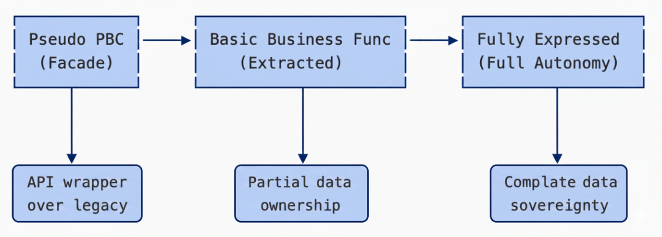

Evolution Triggers
From | To | Trigger
Pseudo | Basic Business Function | Legacy system replacement begins; data extraction planned
Basic Business Function | Fully Expressed | Need for complete data sovereignty; audit requirements
Any | Orchestration | Multi-PBC process coordination needed

Evolution Planning
At Initiation Gateway, document:
Field | Requirement
Current Maturity | Which type is this PBC today?
Target Maturity | Which type should it become?
Evolution Timeline | When will transition occur?
Migration Dependencies | What else must change?

Maturity and G-CAF Classification
Maturity type informs but does not determine other G-CAF classifications:
Maturity | Typical Criticality | Typical Sourcing | Notes
Fully Expressed | Critical/High | Build | Strategic; differentiation
Orchestration | High/Medium | Build | Process-specific
Basic Business Function | Medium | Buy/Build | Commodity functions
Pseudo PBC | Low | Outsource | Transitional; minimize investment

Classification Decision Tree
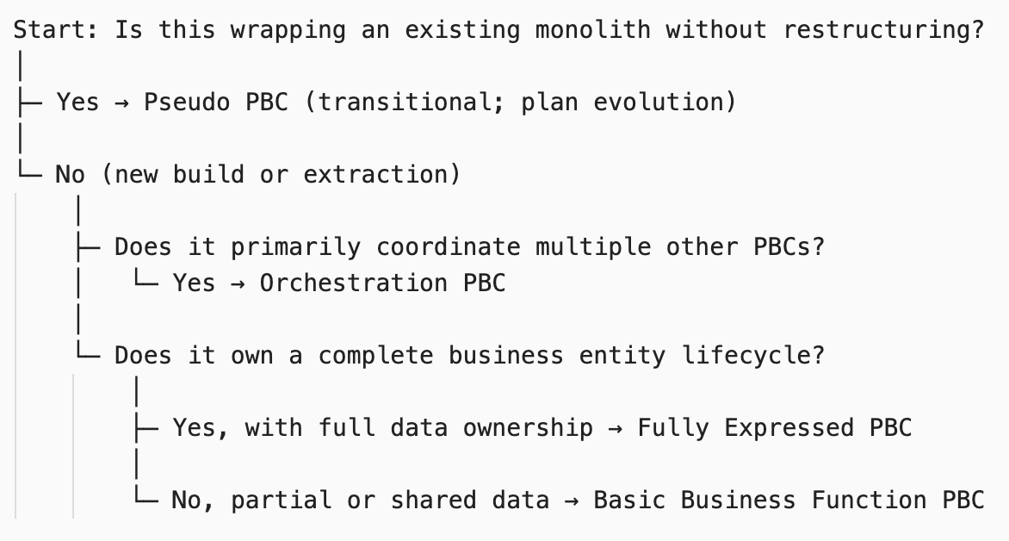

Data Fabric Relationship by Maturity
Maturity Type | Relationship to Data Fabric
Fully Expressed | Contributes data; remains master
Orchestration | Consumes reference data; no contribution
Basic Business Function | May consume or contribute partially
Pseudo PBC | Typically contributes via extraction jobs

Gateway Implications
Gateway | Maturity Requirement
Initiation | Declare current and target maturity; document evolution plan if Pseudo/Basic
Design | Architecture must support target maturity
Go-Live | Current maturity documented in Catalog
Quarterly Review | Track progress toward target maturity

Technical Debt Correlation
Maturity Type | Typical Debt Profile
Pseudo PBC | High debt by definition; temporary state
Basic Business Function | Medium debt; incomplete autonomy
Orchestration | Low-Medium; process-focused
Fully Expressed | Low; target state

**Note:** Pseudo PBCs that remain pseudo for >2 years should be flagged for ARB review.

Module Metadata
Field | Value
Module ID | G-CAF-055
Change Driver | Maturity classification and evolution paths
Type | Generic
Last Updated | December 2025

Related Modules
Module | Relationship
G-CAF-042 (pbc-catalog.md) | Maturity tracked in catalog
G-CAF-055a (agent-maturity.md) | Agent-specific maturity
G-CAF-052 (pbc-types.md) | Maturity applies to all types
G-CAF-046 (Technical Debt) | Low maturity creates debt

