Agent Governance Contract

**Use Case Context:** This artifact supports **UC05: Design an Agent PBC**

[G-CAF-COMPANION-024]
Change Driver: Agent governance framework or sub-contract structure
Type: Specific
Last Updated: December 2025

Purpose
Master governance contract for Agent PBCs, composed of modular sub-contracts. Each sub-contract has a single change driver, enabling bounded updates. This contract is mandatory for all Agent PBCs at Maturity Level 2 and above.

Contract Composition
Sub-Contract | Module ID | Change Driver
Agent Identity Contract | [G-CAF-COMPANION-024a] | Identity/authentication standards
Agent Autonomy Contract | [G-CAF-COMPANION-024b] | Autonomy policy updates
Agent Guardrails Contract | [G-CAF-COMPANION-024c] | Safety/compliance requirements
Agent Memory Contract | [G-CAF-COMPANION-024d] | Data retention policies
Agent Interoperability Contract | [G-CAF-COMPANION-024e] | Protocol versions (MCP, A2A)
Agent Human Oversight Contract | [G-CAF-COMPANION-024f] | Oversight model changes
Agent Observability Contract | [G-CAF-COMPANION-024g] | Audit requirements
Agent Security Contract | [G-CAF-COMPANION-024h] | Security standards

Contract Architecture
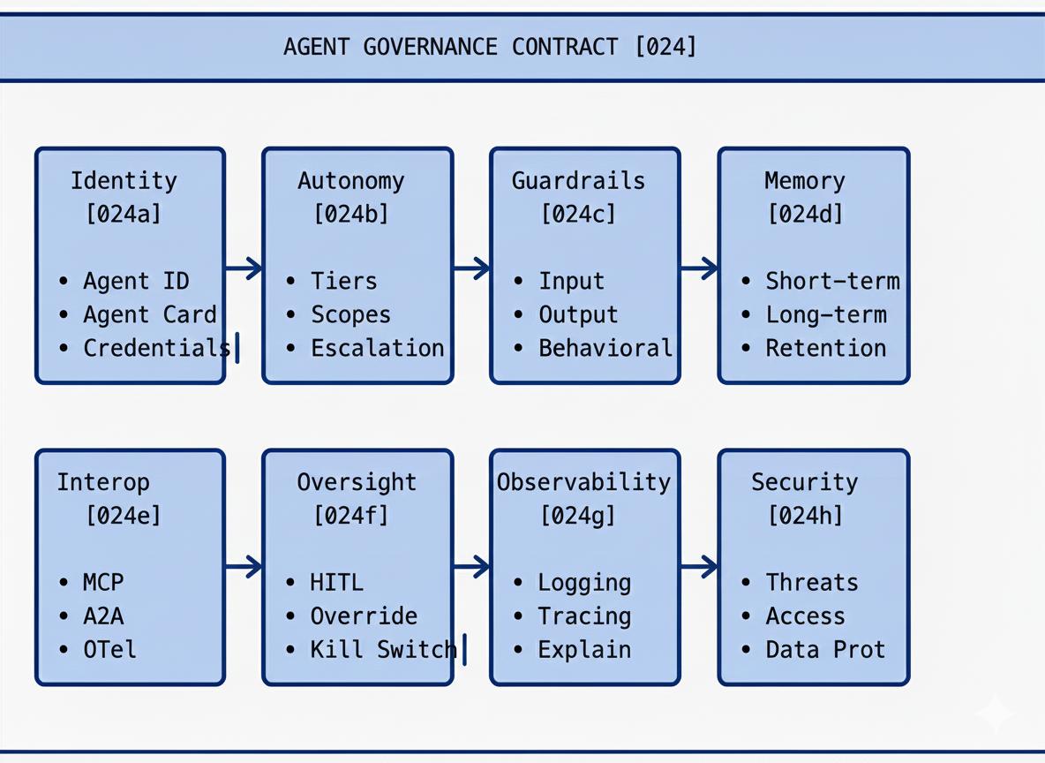

Applicability by Maturity Level
Sub-Contract | L0 | L1 | L2 | L3 | L4
Identity [024a] | — | — | Required | Required | Required
Autonomy [024b] | — | — | Required | Required | Required
Guardrails [024c] | — | — | Required | Required | Required
Memory [024d] | — | — | Optional | Required | Required
Interoperability [024e] | — | — | MCP only | Full | Full
Human Oversight [024f] | — | — | Required | Required | Required
Observability [024g] | — | — | Required | Required | Required
Security [024h] | — | — | Required | Required | Required

Compliance Summary Checklist

For L2 Agent PBCs
Sub-Contract | Key Requirements
Identity | Agent ID registered; Agent Card in registry; credentials provisioned
Autonomy | Tier declared; scopes defined; escalation rules configured
Guardrails | Input + output + action guardrails implemented
Memory | Architecture documented; security configured
Interoperability | MCP compliance; tool access scoped; OpenTelemetry integrated
Human Oversight | Configuration defined; override mechanisms tested
Observability | Logging + tracing + explainability operational
Security | Authentication + authorization + data protection configured

Additional for L3+ Agent PBCs
Sub-Contract | Additional Requirements
Identity | A2A Agent Card compliance
Autonomy | Cross-agent escalation paths
Guardrails | Guardian agent integration
Memory | Cross-agent memory policies
Interoperability | Full A2A compliance; mutual authentication
Human Oversight | Multi-agent oversight model
Observability | Cross-agent lineage tracking
Security | Mutual TLS; cross-agent security monitoring

Version Management
Each sub-contract is versioned independently. See _version-registry.md for current versions.
Sub-Contract | Initial Version
G-CAF-COMPANION-024a | 1.0.0
G-CAF-COMPANION-024b | 1.0.0
G-CAF-COMPANION-024c | 1.0.0
G-CAF-COMPANION-024d | 1.0.0
G-CAF-COMPANION-024e | 1.0.0
G-CAF-COMPANION-024f | 1.0.0
G-CAF-COMPANION-024g | 1.0.0
G-CAF-COMPANION-024h | 1.0.0

NS Compliance
This contract structure follows Normalized Systems principles:
Principle | Implementation
Separation of Concerns | Each sub-contract has ONE change driver
Version Transparency | Sub-contracts versioned independently
Data Version Transparency | Contract schema stable; content evolves per sub-contract
Bounded Change | Policy change affects only relevant sub-contract

Module Metadata
Field | Value
Document ID | G-CAF-COMPANION-024
Type | Master Contract (composition)
Sub-Contracts | 024a, 024b, 024c, 024d, 024e, 024f, 024g, 024h
Owner | EA Office / AI Governance
Versioned | Yes — see _version-registry.md
Added | v1.4
Last Updated | December 2025

Related Modules
Module | Relationship
G-CAF-057 (agent-pbc-type.md) | Agent PBC definition
COMPANION-024a-h (sub-contracts) | 8 sub-contracts
G-CAF-071a (agent-gateway-extensions.md) | Gateway compliance
G-CAF-070 (security-contract.md) | Security foundation

