Agent Interoperability Contract

**Use Case Context:** This artifact supports **UC05: Design an Agent PBC**

[G-CAF-COMPANION-024e]
Change Driver: MCP/A2A protocol standards or agent communication patterns
Type: Specific
Parent: G-CAF-COMPANION-024 (Agent Governance Contract)
Last Updated: December 2025

Purpose
Defines interoperability requirements for Agent PBCs, covering protocol compliance, tool access, and agent collaboration standards.
Change Driver: Protocol version updates (MCP, A2A)

Protocol Compliance
Protocol | Purpose | Requirement
MCP | Tool access | Required for L2+
A2A | Agent collaboration | Required for L3+
OpenTelemetry | Observability | Required for L2+

MCP (Model Context Protocol) Requirements

Tool Registration
Requirement | Specification
Tool Registration | All tools registered in Tool Registry
Schema Compliance | Tools follow MCP input/output schemas
Capability Advertisement | Tools declare capabilities accurately
Version Management | Tool versions tracked

Tool Access
Requirement | Specification
Least Privilege | Agent granted minimum required tools
Access Logging | All tool invocations logged
Error Handling | Graceful handling of tool failures
Timeout Handling | Appropriate timeouts configured

A2A (Agent-to-Agent) Requirements

Agent Card Compliance
Field | Required | Description
agent_id | Yes | Unique identifier
capabilities | Yes | Advertised capabilities
supported_protocols | Yes | Protocol versions
endpoint | Yes | Communication endpoint

Task Lifecycle Compliance
State | Transition From | Description
submitted | (initial) | Task received
working | submitted | Task in progress
input-required | working | Awaiting additional input
completed | working | Task finished successfully
failed | working | Task failed
cancelled | any | Task cancelled

Agent Collaboration Requirements (L3+)
Requirement | Specification
A2A Compliance | Agent Card and task lifecycle compliance
Mutual Authentication | Agents authenticate each other
Capability Verification | Verify target agent capabilities
Context Passing | Secure context transfer between agents
Error Propagation | Proper error handling across agents

Cross-Protocol Integration
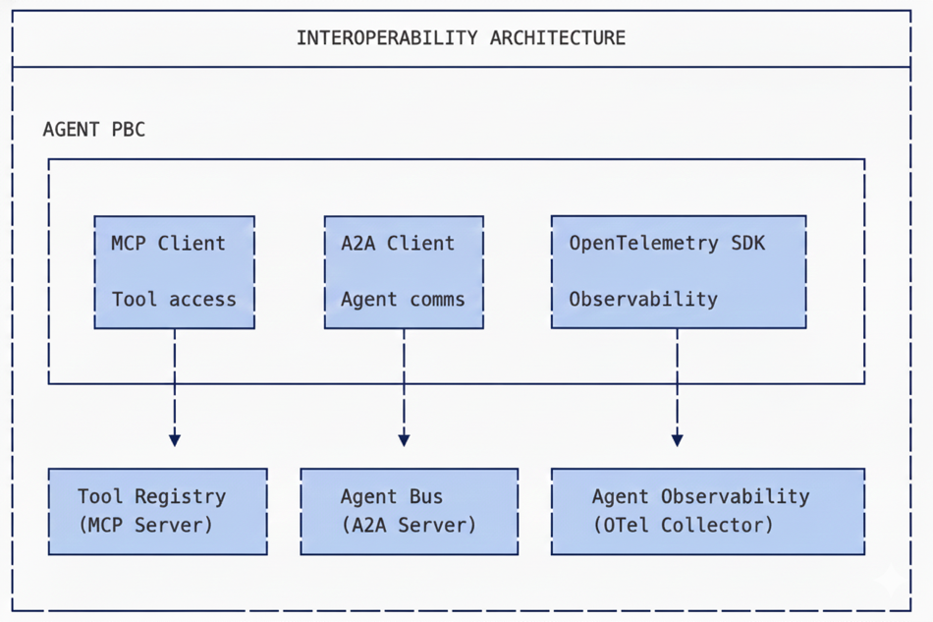

Protocol Version Management
Protocol | Version | Compliance Requirement
MCP | 1.0+ | Strict compliance
A2A | 1.0+ | Strict compliance
OpenTelemetry | 1.0+ | Semantic conventions

Compliance Checklist
Requirement | L2 | L3+
MCP compliance verified | ☐ | ☐
Tools registered in Tool Registry | ☐ | ☐
Tool access scoped to minimum | ☐ | ☐
OpenTelemetry integrated | ☐ | ☐
A2A compliance verified | — | ☐
Agent Card registered | — | ☐
Mutual authentication configured | — | ☐

Module Metadata
Field | Value
Document ID | G-CAF-COMPANION-024e
Parent | G-CAF-COMPANION-024 (Agent Governance Contract)
Change Driver | Protocol version updates (MCP, A2A)
Owner | EA Office / AI Governance
Added | v1.4

Related Modules
Module | Relationship
COMPANION-024 (agent-governance-contract.md) | Parent contract
G-CAF-105a (agent-integration.md) | MCP/A2A implementation
G-CAF-072 (integration-contract.md) | Integration standards

