Agent PBC Type

**Use Case Context:** This artifact supports **UC05: Design an Agent PBC**

[G-CAF-057]
Change Driver: Agent capability patterns or AI/ML integration standards
Type: Specific
Last Updated: December 2025

Purpose
Defines Agent PBC as the sixth PBC type within G-CAF, enabling governance of autonomous AI capabilities that reason, plan, take actions, and collaborate with other agents or humans.

Agent PBC Definition
Attribute | Specification
Primary Function | Autonomous AI capability that perceives context, reasons about goals, plans actions, executes tasks, and learns from outcomes
Data Relationship | Consumes context (tools, memory, knowledge); produces actions, decisions, and artifacts; may maintain persistent memory state
Distinguishing Characteristic | Has identity, invokes tools autonomously, supports orchestration patterns, requires embedded governance guardrails
Autonomy Spectrum | Ranges from human-supervised to fully autonomous within defined boundaries

Agent PBC vs. Other PBC Types
PBC Type | Key Distinction from Agent PBC
Application PBC | Manages entity lifecycle (CRUD); Agent PBC manages autonomous decision-making and action execution
Analytics PBC | Produces predictions/insights for human consumption; Agent PBC acts on insights autonomously
Data PBC | Provides reference data and lookups; Agent PBC consumes data to inform autonomous decisions
Orchestration PBC | Coordinates workflows via static/rule-based logic; Agent PBC uses AI reasoning for dynamic routing
Digital Twin PBC | Represents physical assets; Agent PBC may interact with Digital Twins but focuses on autonomous reasoning

Agent PBC Characteristics
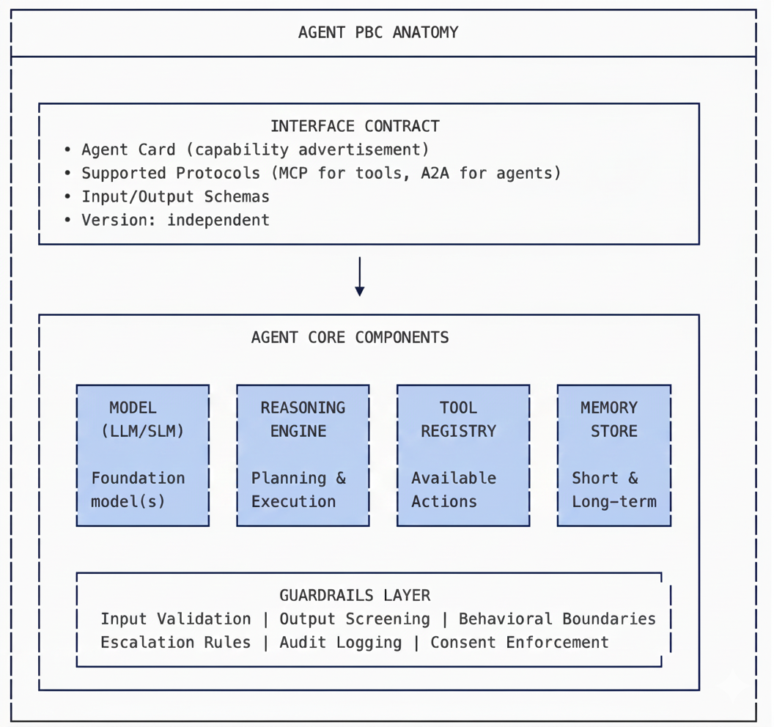

Agent PBC Core Components
Component | Purpose | Requirements
Model | Foundation LLM/SLM providing reasoning capability | Model selection criteria; version pinning; failover model
Reasoning Engine | Planning, decomposition, execution loop | ReAct, CoT, or custom reasoning pattern documented
Tool Registry | Available actions the agent can invoke | MCP-compliant tool definitions; tool access scopes
Memory Store | Context persistence across interactions | Short-term (session) + Long-term (persistent) architecture
Guardrails Layer | Safety, compliance, and behavioral boundaries | Mandatory; see Agent Governance Contract

Agent PBC Subtypes
Subtype | Description | Examples
Task Agent | Executes specific, bounded tasks autonomously | Document Processor, Form Filler, Data Extractor
Conversational Agent | Maintains dialogue with humans; may take actions | Customer Service Agent, Citizen Inquiry Agent
Orchestrator Agent | Coordinates other agents; decomposes and routes tasks | Supervisor Agent, Workflow Coordinator
Guardian Agent | Monitors, validates, and enforces compliance on other agents | Compliance Reviewer, Output Validator, Security Monitor
Research Agent | Gathers, synthesizes, and reports information | Policy Analyst, Market Research Agent

Agent PBC Data Relationships
Relationship | Description
Context Consumption | Retrieves context from tools, knowledge bases, and other PBCs
Memory Persistence | Maintains session state (short-term) and learned patterns (long-term)
Action Execution | Invokes tools and APIs to take actions in external systems
Artifact Production | Generates documents, decisions, recommendations, or data outputs
Agent Collaboration | Communicates with other Agent PBCs via A2A protocol

Data Fabric Relationship
Agent PBC Role | Data Fabric Interaction
Consumes | Knowledge graphs, reference data, entity data for context
Produces | Decision logs, action records, generated artifacts
Memory Layer | May use Data Fabric for persistent memory storage
Observability | Agent actions and decisions logged for lineage and audit

Selecting Agent PBC
If the capability... | Then PBC Type is...
Autonomously reasons and takes actions based on goals | Agent PBC
Requires AI-driven dynamic routing across multiple steps | Agent PBC
Must collaborate with other AI agents | Agent PBC
Needs persistent memory across sessions | Agent PBC
Only provides predictions without autonomous action | Analytics PBC
Coordinates workflows via static rules | Orchestration PBC

Agent PBC Requirements
Requirement | Specification
Identity | Unique agent identity registered in Agent Registry
Agent Card | Capability advertisement following A2A Agent Card schema
Tool Access | Declared tool scopes with least-privilege principle
Guardrails | Mandatory guardrails layer per Agent Governance Contract
Autonomy Declaration | Declared autonomy tier with human-in-loop configuration
Memory Architecture | Documented short-term and long-term memory approach
Observability | Real-time action logging; audit trail; lineage tracking
Interoperability | MCP compliance for tools; A2A compliance for agent collaboration

Agent PBC Lifecycle States
State | Description | Agent-Specific Considerations
Proposed | Passed Initiation Gateway | Agent Card drafted; autonomy tier proposed
In Development | Passed Design Gateway | Guardrails implemented; sandbox testing
Pilot | Limited production deployment | Restricted scope; enhanced monitoring
Active | Full production deployment | All guardrails enforced; audit active
Deprecated | Retirement planned | Agent handoff procedures; memory migration
Retired | Decommissioned | Identity revoked; memory archived

Module Metadata
Field | Value
Module ID | G-CAF-057
Change Driver | Agent capability governance
Type | Specific
Added | v1.4
Last Updated | December 2025

Related Modules
Module | Relationship
G-CAF-052 (pbc-types.md) | Agent extends PBC Types
G-CAF-055a (agent-maturity.md) | Agent maturity classification
G-CAF-057a (agent-orchestration-patterns.md) | Multi-agent patterns
G-CAF-105a (agent-integration.md) | Agent integration layer
COMPANION-024 (agent-governance-contract.md) | Governance contracts

