Agent Guardrails Contract

**Use Case Context:** This artifact supports **UC05: Design an Agent PBC**

[G-CAF-COMPANION-024c]
Change Driver: Safety boundaries, compliance rules, or operational limits
Type: Specific
Parent: G-CAF-COMPANION-024 (Agent Governance Contract)
Last Updated: December 2025

Purpose
Defines guardrail requirements for Agent PBCs, covering input/output controls and behavioral boundaries to ensure safe, compliant agent operations.
Change Driver: Safety/compliance requirements

Guardrail Architecture
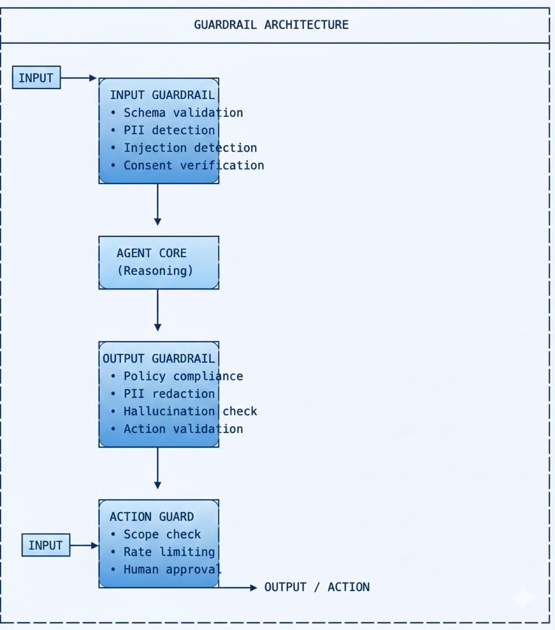

Input Guardrail Requirements
Check | Description | Action on Failure
Schema Validation | Input matches expected schema | Reject with error
PII Detection | Identify and flag PII | Tag for handling policy
Injection Detection | Detect prompt injection attempts | Block and log
Consent Verification | Verify data access consent | Block if no consent
Rate Limiting | Enforce request rate limits | Throttle or reject

Output Guardrail Requirements
Check | Description | Action on Failure
Policy Compliance | Output meets policy requirements | Block and retry/escalate
PII Handling | PII redacted per policy | Redact before output
Hallucination Check | Cross-reference with sources | Flag low confidence
Toxicity Screening | No harmful content | Block and log
Format Validation | Output matches expected format | Reformat or retry

Action Guardrail Requirements
Check | Description | Action on Failure
Scope Check | Action within declared scope | Block and log
Rate Limiting | Action rate within limits | Queue or reject
Human Approval | Human approval if required by tier | Hold pending approval
Resource Limits | Within resource quotas | Throttle or reject

Behavioral Boundaries
Boundary | Description
Topic Scope | Agent only addresses topics in its domain
Action Scope | Agent only performs actions in its scope
Data Access | Agent only accesses data it's authorized for
Communication | Agent identifies itself as AI in user interactions
Escalation | Agent escalates when uncertain or out of scope

Guardrail Service Integration
Service | Purpose | Location
Input Validator | Schema + injection detection | Agent Integration Layer
Output Screener | Policy + PII + toxicity | Agent Integration Layer
PII Detector | Identify PII in text | Agent Integration Layer
Consent Checker | Verify consent status | GovDX Core
Rate Limiter | Enforce rate limits | Agent Integration Layer

Compliance Checklist
Requirement | L2 | L3+
Input guardrails implemented | ☐ | ☐
Output guardrails implemented | ☐ | ☐
Action guardrails configured | ☐ | ☐
Behavioral boundaries defined | ☐ | ☐
Guardrail bypass prevented | ☐ | ☐

Module Metadata
Field | Value
Document ID | G-CAF-COMPANION-024c
Parent | G-CAF-COMPANION-024 (Agent Governance Contract)
Change Driver | Safety/compliance requirements
Owner | EA Office / AI Governance
Added | v1.4

Related Modules
Module | Relationship
COMPANION-024 (agent-governance-contract.md) | Parent contract
G-CAF-070 (security-contract.md) | Security guardrails
COMPANION-024b (agent-contract-autonomy.md) | Autonomy limits

