Vendor PBC Evaluation Criteria

**Use Case Context:** This artifact supports **UC02: Build, Buy, or Outsource Decision**

[G-CAF-056]
Change Driver: Vendor evaluation criteria or assessment methodology
Type: Generic
Last Updated: December 2025

Purpose
Evaluation criteria for assessing vendor applications' suitability as PBCs in a composable architecture. Used at Initiation Gateway for Buy/Outsource sourcing decisions.
**Cross-Reference:** This module extends `procurement-governance.md` [G-CAF-120] with technical evaluation criteria.

Evaluation Framework

Mandatory Requirements (Must Pass)
A vendor application must meet ALL of the following to be considered:
Requirement | Verification
API Completeness | Full API access to all functionality; no UI-only features
Composition Support | Can participate in composition with non-vendor PBCs
Standard Protocols | REST/GraphQL APIs; supports CloudEvents for async
Authentication Standards | OAuth 2.0/OIDC; supports service-to-service auth
Data Portability | Documented data export; no proprietary lock-in

Scored Criteria
Criterion | Weight | Scoring
Business-Centric Modularity | 20% | 0-5: How well does design reflect business capabilities?
Component Autonomy | 20% | 0-5: Can components operate independently?
API Surface Quality | 15% | 0-5: Complete, well-documented, versioned APIs?
Schema Stability History | 15% | 0-5: Track record of backward compatibility?
Composition Flexibility | 15% | 0-5: Ease of integration with other vendors' PBCs?
Operational Transparency | 15% | 0-5: Monitoring, logging, health APIs available?

Minimum Score: 3.5/5.0 weighted average to proceed.

Desirable Characteristics
Give preference to vendor applications that demonstrate:
Characteristic | Evidence
Business-centric software modularity | Product architecture maps to business capabilities
Autonomy in component design | Components deployable/scalable independently
Full API access | No functionality restricted to UI
Documented schema stability | Published API changelog; SemVer compliance
Multi-vendor composition | Customer references using vendor with other vendors
CloudEvents support | Native event publishing; webhook support
OpenTelemetry support | Distributed tracing; standard observability

Rejection Criteria
Reject vendor applications that:
Criterion | Rationale
Do not expose complete API access | Cannot participate in composition
Require tight coupling with vendor's other components | Limits architectural flexibility
Cannot integrate with external PBCs | Vendor lock-in
Have history of unannounced breaking API changes | Unstable; high integration risk
Require proprietary protocols | Standards compliance failure
Cannot provide data export | Data sovereignty risk

Schema Stability Assessment

Historical Analysis
Request from vendor:
Information | Purpose
API changelog for past 3 years | Assess breaking change frequency
Deprecation policy documentation | Understand notice periods
Customer impact reports for major versions | Real-world disruption evidence
Roadmap for next 2 years | Anticipate future changes

Stability Scoring
History | Score | Implication
No breaking changes in 3 years; 12+ month deprecation notices | 5 | Low risk; standard integration
<2 breaking changes in 3 years; 6+ month notices | 4 | Acceptable; monitor closely
2-4 breaking changes in 3 years; 3+ month notices | 3 | Elevated risk; ACL recommended
>4 breaking changes in 3 years; <3 month notices | 2 | High risk; ACL required
Unannounced breaking changes; no deprecation policy | 1 | Reject or ACL mandatory with ARB approval

Anti-Corruption Layer (ACL) Requirements

When ACL is Required
Condition | ACL Requirement
Schema stability score ≤3 | ACL required
Vendor uses non-standard protocols | ACL required
Vendor's roadmap includes major restructuring | ACL recommended
Vendor acquired/merger pending | ACL recommended
First engagement with vendor | ACL recommended

ACL Implementation
When ACL is required:
- Register ACL as separate PBC in Catalog
- ACL owns the interface contract exposed to consumers
- Vendor changes absorbed by ACL, not propagated
- Version ACL independently from vendor product
- Include ACL maintenance in TCO calculation
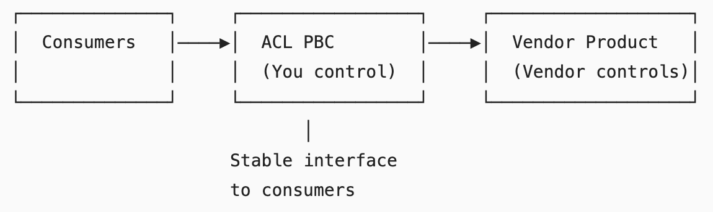

Contractual Requirements
Include in vendor contracts:
Clause | Requirement
Breaking Change Notice | Minimum 90 days for breaking changes; 180 days for deprecation
Deprecation Windows | Align with G-CAF Stability Tiers (see stability-tiers.md)
API Versioning | SemVer compliance; parallel version support
Change Notification | Automated notification to registered contacts
Rollback Support | Ability to rollback to previous version for 30 days post-upgrade
Data Export SLA | Full data export available within 48 hours of request

Evaluation Process

Step 1: Initial Screening (Mandatory Requirements)

All mandatory requirements met?

├─ No → Reject vendor

└─ Yes → Proceed to scoring

Step 2: Scored Evaluation

Complete scoring matrix

├─ Score <3.5 → Reject vendor

└─ Score ≥3.5 → Proceed to stability assessment

Step 3: Schema Stability Assessment

Stability score

├─ Score ≤2 → Reject (or ARB exception with mandatory ACL)

├─ Score 3 → Accept with mandatory ACL

└─ Score ≥4 → Accept; ACL optional

Step 4: Contract Negotiation
- Include all contractual requirements
- Document any exceptions with ARB approval
- Record in PBC Catalog vendor details section

Documentation Requirements
At Initiation Gateway for Buy/Outsource PBCs:
Document | Content
Vendor Evaluation Scorecard | Completed scoring matrix
Schema Stability Assessment | Historical analysis and score
ACL Decision | Required/Not Required with rationale
Contract Clause Checklist | All required clauses included
Risk Register Entry | Identified risks and mitigations

Gateway Integration
Gateway | Vendor Evaluation Activity
Initiation | Complete evaluation; ACL decision; contract requirements
Design | ACL architecture (if required); integration design
Go-Live | Vendor onboarding checklist complete (see pbc-catalog.md)

Module Metadata
Field | Value
Module ID | G-CAF-056
Change Driver | Vendor assessment criteria for PBC readiness
Type | Generic
Last Updated | December 2025

Related Modules
Module | Relationship
G-CAF-051 (sourcing.md) | Buy/Outsource sourcing
G-CAF-042a (procurement-governance.md) | Procurement process
G-CAF-090 (gateway-initiation.md) | Vendor assessment

