**Project Report**

**Fire Detection System using Computer Vision**

Submitted by:

**Vijval Anand**

**Bachelor Of Technology in Computer Science**

Under guidance of:

**Mr. T S Rathore, Scientist ‘F’**

Centre for Fire, Explosives and Environment Safety (CFEES)

Defence Research and Development Organization (DRDO)

Ministry of Defence

Brig. S. K. Mazumdar Marg,

Timarpur, Delhi-110054



# Declaration & Assessment

I hereby declare that the project work entitled Fire Detection System submitted to the Centre of Fire, Explosive and Environment Safety (CFEES), Ministry of Defence, Defence R&D Organization Timarpur, Delhi, by Vijval Anand is a record of an original work done under the guidance of Mr. T S Rathore, Scientist ‘F’ from 19 Oct, 2023 to 19 Dec, 2023.

The report does not contain any classified information.

Signature:

Name and Rank of Guide:

Date:

**ACKNOWLEDGEMENT**

I record my sincere thanks to the **Director Mr. Arvind Kumar, Centre for Fire, Explosive and Environment Safety (CFEES), Defence Research and Development Organization** for providing me an excellent opportunity to undergo training in his esteemed organization through which could gain an exposure to the Research and Development Organization and getting acquainted with the Computer Science Technologies.

I would sincerely like to thank **Mr. T S Rathore, Scientist ‘F’**, for permitting me to work in his division and making me aware of recent trends and technologies in Machine Learning.

I wish to express my deep sense and gratitude and obligation to **Mr. T S Rathore, Scientist ‘F’** from his valuable guidance in making report and contribution in lab work. I express my thanks to all the members of my group for providing me support and their constant encouragement during training.

Vijval Anand

Reg No.: 21BBS0193

# Abstract

This study introduces a novel computer vision-based fire detection system, incorporating HSV colour space, motion detection, edge detection, and contour detection. Motivated by the shortcomings of conventional methods, the system offers a comprehensive solution for real-time fire identification in diverse environments. A thorough literature review underscores the significance of reliable fire detection, positioning this work within the broader landscape of computer vision applications for public safety. The methodology outlines image acquisition, preprocessing, and the rationale for utilizing HSV colour space. Experimental results, including quantitative metrics and qualitative assessments, demonstrate the system's efficacy. The discussion evaluates the system's strengths, limitations, and future research directions, contributing to the advancement of fire detection technologies for enhanced public safety and disaster mitigation.

## Project Overview

This project focuses on developing an advanced computer vision-based fire detection system that integrates HSV detection, motion tracking, edge detection, and contour recognition. The aim is to overcome the limitations of traditional fire detection methods by creating a real-time, adaptable solution capable of accurate and rapid identification of potential fire incidents.

## Expected Outcomes

The project anticipates the creation of a sophisticated fire detection system that surpasses current methodologies. By combining color analysis, motion tracking, and shape recognition, the system aims to reduce false positives, enhance responsiveness, and demonstrate improved accuracy in identifying fire incidents. The expected outcome involves a quantifiable enhancement in overall fire detection performance.

## Potential Impact

The successful implementation of this advanced fire detection system holds the potential to significantly reduce response times during fire emergencies, thereby minimizing damage and saving lives. The system's adaptability to diverse environments enhances its applicability in various settings, contributing to advancements in disaster management and emergency response systems. The project's success could set a precedent for integrating computer vision solutions into critical safety applications, fostering progress in public welfare and safety.

**Table of contents**

Page No.

1. Abstract ………………………………………………………………………………….. 4
2. Organizational profile …………………………………………………………….. 6
3. Introduction ………………………………………………………………………….. 7
4. Computer Vision ……………………………………………………………………. 9
5. Streamlit ………………………………………………………………………………. 14
6. OpenAI ………………………………………………………………………………….. 17
7. Langchain ………………………………………………………………………………. 21
8. Character Text Splitter …………………………………………………………… 27
9. Vector Store ………………………………………………………………………….. 32
10. OpenAI Embeddings ……………………………………………………………. 38
11. Hugging Face Embeddings ……………………………………………………. 44
12. Interface and Functionality ………………………………………………….. 49

# Organization profile

The Defence Research and Development Organization (DRDO) is the premier research and development agency of the Indian Ministry of Defence. It was established in 1958 with the aim of developing self-reliance in defence technology for the country. DRDO has played a pivotal role in developing a wide range of critical technologies for the Indian Armed Forces, including missiles, radar systems, electronic warfare systems, and aircraft.

DRDO's mission is to develop and deliver state-of-the-art defence technologies to meet the strategic requirements of the Indian Armed Forces. The organization is committed to promoting self-reliance in defence technology and fostering innovation in the Indian defence sector.

DRDO is a network of over 50 laboratories spread across India. These laboratories are organized into five clusters based on their areas of expertise:

* Aeronautics
* Armaments
* Electronics and Communication Systems
* Missiles and Strategic Systems
* Naval Systems and Materials

DRDO also has a network of academic and industrial partners, which it collaborates with on research and development projects.

DRDO has a long and illustrious history of achievements. Some of its notable accomplishments include:

* Development of the Agni series of ballistic missiles
* Development of the Prithvi series of surface-to-surface missiles
* Development of the Light Combat Helicopter
* Development of the Advanced Light Helicopter
* Development of the Arjun main battle tank

## Introduction

In the contemporary landscape of technological advancements, where the intersection of innovation and safety is paramount, the development of state-of-the-art systems becomes pivotal for addressing critical challenges. Among these challenges, the expeditious and precise detection of fire incidents emerges as a foundational concern, standing at the forefront of public safety and disaster prevention efforts. This report introduces a pioneering endeavor aimed at crafting a sophisticated computer vision-based fire detection system. Propelled by the inadequacies inherent in conventional fire detection methodologies, this research is propelled by a commitment to amalgamate and optimize key components, including HSV detection, motion tracking, edge detection, and contour recognition.

The overarching objective is to introduce a comprehensive, real-time solution that not only mitigates the limitations of existing methods but also sets a new standard for accuracy, adaptability, and speed in identifying potential fire emergencies. Traditional fire detection methods have often grappled with challenges such as false positives and delayed responses, underscoring the critical need for a paradigm shift in technological approaches. This project, through its innovative fusion of diverse computer vision techniques, aspires to be a catalyst for such transformation.

By delving into the intricacies of the methodologies employed, this report aims to shed light on the systematic approach taken in the pursuit of an advanced fire detection system. From the initial stages of image acquisition to the nuanced preprocessing techniques applied, and culminating in the synthesis of color-based analysis, motion tracking, and shape recognition, the project unfolds as a synergistic amalgamation of cutting-edge technologies.

Anticipating the outcomes, the report envisions the successful creation of a system that not only demonstrates heightened accuracy and reduced false positives but also showcases improved responsiveness and adaptability across varied environmental scenarios. Through a meticulous evaluation process, both quantitatively and qualitatively, the project endeavors to provide empirical evidence of its effectiveness.

Beyond the technical facets, this report explores the potential societal impact of the developed system. The successful implementation of an advanced fire detection system holds the promise of significantly reducing response times during fire emergencies, thereby minimizing damage and potentially saving lives. The adaptability of the system to diverse environments not only enhances its practical utility but also contributes to the broader discourse on the integration of cutting-edge technologies in ensuring public safety.

In essence, this project unfolds as a pioneering stride toward fortifying the safety infrastructure in the face of evolving challenges. By synthesizing innovative technologies, this research seeks to contribute meaningfully to the ongoing narrative of technological advancements in fire detection, ultimately serving as a testament to the transformative power of technology in securing the well-being of communities in an ever-evolving global landscape.

**Computer Vision**

Computer vision, a multidisciplinary field at the intersection of computer science and image processing, plays a pivotal role in the proposed fire detection system, offering a sophisticated framework for extracting meaningful information from visual data. This section delves into the core components and methodologies of computer vision that collectively contribute to the system's ability to identify and analyze potential fire incidents.

At the outset, the process of image acquisition involves sourcing a diverse and representative dataset. The dataset is curated to encompass a range of environmental conditions and scenarios, ensuring the robustness and adaptability of the fire detection system. High-quality images and video frames serve as the raw input for subsequent analysis and model training.

To optimize the input data for effective analysis, preprocessing steps are implemented. This includes resizing images to a standard resolution, normalization of pixel values, and addressing potential noise or artifacts. These steps ensure uniformity in the dataset and enhance the system's ability to discern relevant features during subsequent processing stages.

The outputs from individual components, including HSV detection, motion detection, edge detection, and contour detection, are seamlessly integrated. Decision-making processes, guided by predefined criteria and machine learning models, evaluate the collective information to determine the likelihood of a fire incident. The integration of these diverse components forms a cohesive system that excels in accuracy and adaptability.

**History of Computer Vision**

The narrative of computer vision unfolds over several decades, embodying a remarkable journey of scientific exploration and technological innovation. In the 1950s, the seeds of computer vision were sown as researchers began probing the potential of endowing machines with the ability to interpret visual information. The 1970s witnessed a concerted effort towards shape analysis, with early applications emerging in industrial contexts, particularly for automating quality control processes. However, the computational limitations of the time restricted the widespread adoption of these nascent computer vision technologies.

The 1990s marked a significant turning point with the integration of machine learning techniques into the field of computer vision. Neural networks, and notably convolutional neural networks (CNNs), gained prominence for tasks like image recognition. Noteworthy achievements during this era included the Viola-Jones face detection framework and advancements in feature extraction methods.

The landscape of computer vision underwent a seismic shift in the 2010s with the advent of deep learning. The ImageNet Large Scale Visual Recognition Challenge, initiated in 2010, catalyzed a surge in research and development, propelling deep neural networks to the forefront. Architectures such as AlexNet, VGGNet, and ResNet demonstrated unprecedented capabilities in image classification and object detection tasks.

The contemporary era of computer vision is characterized by a confluence of factors – robust algorithms, massive datasets, and powerful hardware. Deep learning, with its ability to extract hierarchical features from visual data, stands as a cornerstone of this technological renaissance. Techniques like transfer learning and generative adversarial networks (GANs) have further expanded the boundaries of what is achievable in visual understanding.

This rich historical backdrop sets the stage for the ambitious fire detection system detailed in this report. Integrating insights from decades of research and innovation, the project leverages advanced computer vision techniques such as HSV detection, motion tracking, edge detection, and contour recognition. It epitomizes the ongoing trajectory of improvement and innovation in computer vision, positioning itself as a cutting-edge solution to contemporary challenges in public safety, and contributing to the transformative role of technology in enhancing societal well-being.

**Applications of Computer Vision**

**Autonomous Vehicles:**

Computer vision is integral to the development of autonomous vehicles. It enables vehicles to perceive and interpret their surroundings, facilitating tasks such as lane detection, object recognition, and pedestrian tracking, ensuring safe and efficient navigation.

**Healthcare Imaging:**

In healthcare, computer vision enhances diagnostic capabilities by analyzing medical images. It aids in the detection of anomalies, assists in surgical procedures, and contributes to the development of advanced medical imaging technologies.

**Retail and E-Commerce:**

Computer vision transforms the retail landscape with applications like automated checkout systems, inventory management through image recognition, and personalized shopping experiences. Virtual try-on and visual search are becoming commonplace features.

**Surveillance and Security:**

Surveillance systems leverage computer vision for real-time monitoring, object tracking, and anomaly detection. It enhances security measures in public spaces, critical infrastructures, and private establishments.

**Augmented Reality (AR) and Virtual Reality (VR):**

Computer vision is fundamental to AR and VR technologies, providing users with immersive experiences by overlaying digital information on the real-world environment. Applications range from gaming to training simulations.

**Agriculture:**

In precision agriculture, computer vision aids in crop monitoring, disease detection, and yield estimation. Drones equipped with vision systems contribute to efficient farm management.

**Industrial Automation:**

Manufacturing processes benefit from computer vision for quality control, defect detection, and automated assembly. Robotic systems utilize vision systems to adapt to dynamic environments and perform complex tasks.

**Future of Computer Vision**

The future of computer vision holds exciting prospects, marked by advancements that will redefine its capabilities and impact various industries. Several key directions are anticipated to shape the trajectory of computer vision in the coming years:

**Explainable AI and Interpretability:**

Future computer vision systems will prioritize explainability, aiming to make AI-driven decisions more understandable and interpretable for users. This is crucial for gaining trust and ensuring accountability, particularly in applications with significant societal impact.

**Continual Learning and Adaptability:**

The evolution of computer vision will involve a shift towards continual learning, allowing systems to adapt and improve over time with exposure to new data. This adaptability is vital for ensuring sustained relevance and performance in dynamic environments.

**3D and Depth Sensing:**

The integration of 3D computer vision and depth sensing technologies will provide a richer understanding of the visual world. This advancement has far-reaching implications for applications in augmented reality, robotics, and spatial computing.

**Human-Centric Vision:**

Future developments in computer vision will focus on enhancing human-centric applications, including improved human pose estimation, gesture recognition, and emotion analysis. This has implications for human-computer interaction, healthcare, and immersive experiences.

**Edge Computing Integration:**

As the demand for real-time processing increases, computer vision systems will be more tightly integrated with edge computing. This shift reduces latency, enhances efficiency, and supports applications like autonomous vehicles and IoT devices.

**Quantum Computing Impact:**

The advent of quantum computing is expected to revolutionize computer vision by accelerating complex computations. Quantum algorithms may unlock new possibilities in image processing, optimization, and pattern recognition, enabling unprecedented capabilities.

**Ethical and Responsible AI:**

Future developments in computer vision will prioritize ethical considerations, addressing issues related to bias, fairness, and privacy. The responsible deployment of AI technologies will become a focal point to ensure equitable and just outcomes.

**Cross-Domain and Cross-Modal Learning:**

Advances in cross-domain and cross-modal learning will enable computer vision systems to generalize knowledge across diverse domains and modalities. This transferability enhances the versatility of models and supports applications with varied data sources.

**Robustness to Adversarial Attacks:**

Future research in computer vision will emphasize enhancing models' robustness against adversarial attacks. Developing algorithms that are resilient to intentional manipulations or misleading inputs is critical for real-world deployment.

**Collaborative AI and Human-Machine Teaming:**

The future of computer vision involves more seamless collaboration between AI systems and human operators. Human-machine teaming will become integral in applications such as augmented decision-making, where AI augments human capabilities.

As computer vision continues to evolve, these future directions underscore the interdisciplinary nature of the field and its profound impact on technology, society, and human-machine interactions. Anticipating these trends will guide research, development, and applications, ensuring that computer vision remains at the forefront of innovation.

**Challenges in Computer Vision**

**Data Quality and Bias:**

The quality and representativeness of training data pose significant challenges. Biases in datasets can lead to biased models, impacting fairness and equity in applications, especially when the training data is not diverse or inclusive.

**Interpretable AI:**

Making computer vision systems more interpretable and explainable remains a challenge. Understanding and interpreting complex deep learning models is crucial, especially in sensitive domains where decisions have significant consequences.

**Robustness to Adversarial Attacks:**

Computer vision systems are vulnerable to adversarial attacks, where subtle modifications to input data can mislead models. Developing robust algorithms that can withstand such attacks is an ongoing challenge.

**Limited Generalization:**

Achieving robust generalization across diverse scenarios, environments, and datasets is a persistent challenge. Ensuring that models perform reliably in real-world conditions different from their training data remains a key concern.

**Real-Time Processing:**

Real-time processing requirements, especially in applications like autonomous vehicles and robotics, pose computational challenges. Ensuring high-speed, low-latency processing demands efficient algorithms and powerful hardware.

**Ethical Considerations:**

Addressing ethical concerns related to privacy, consent, and the responsible use of computer vision is a complex challenge. Striking a balance between technological advancements and ethical considerations is imperative for societal acceptance.

**Impact of Computer Vision**

**Enhanced Efficiency in Industries:**

Computer vision technologies contribute to increased efficiency in various industries, from manufacturing and agriculture to healthcare and logistics. Automation and intelligent analysis of visual data streamline processes and reduce operational costs.

**Advancements in Healthcare:**

Computer vision has a profound impact on healthcare, enabling precise diagnostics, image-guided surgeries, and personalized treatment plans. The technology enhances the accuracy and speed of medical imaging analysis.

**Improved Safety and Security:**

Computer vision enhances safety and security through applications like surveillance, facial recognition, and anomaly detection. It aids in the identification of potential threats and contributes to public safety measures.

**Innovations in Retail and E-Commerce:**

The retail sector benefits from computer vision with innovations such as cashier-less stores, automated inventory management, and personalized shopping experiences. Visual search and augmented reality applications are transforming the e-commerce landscape.

**Revolutionizing Transportation:**

In transportation, computer vision plays a crucial role in autonomous vehicles, traffic management, and driver assistance systems. These advancements have the potential to significantly improve road safety and traffic efficiency.

**Enabling Augmented Reality (AR) and Virtual Reality (VR):**

Computer vision is fundamental to the development of AR and VR technologies, providing immersive experiences in gaming, training simulations, and virtual environments. It reshapes the way humans interact with digital content.

**Supporting Environmental Monitoring:**

Computer vision contributes to environmental monitoring through applications like satellite imagery analysis, wildlife tracking, and deforestation detection. It aids in understanding and addressing environmental challenges.

**Humanitarian and Disaster Response:**

Computer vision technologies support humanitarian efforts and disaster response by analyzing satellite imagery, monitoring crisis situations, and aiding in search and rescue operations, improving overall efficiency in emergency situations.

**Empowering Accessibility:**

Computer vision has a positive impact on accessibility, providing solutions for the visually impaired through applications like object recognition, text-to-speech conversion, and navigation assistance.

**Driving Innovation in Research:**

Computer vision fosters innovation in various research domains, including robotics, artificial intelligence, and cognitive science. It serves as a foundational technology for advancing our understanding of the world and developing intelligent systems.

## Streamlit

Streamlit is an open-source Python library that makes it easy to create and share beautiful, custom web apps for machine learning and data science. In just a few minutes, you can build and deploy powerful data apps. Streamlit is a great way to share your work with others, collaborate on projects, and get feedback.

Here are some of the benefits of using Streamlit:

* Easy to use: Streamlit is designed to be easy to use, even for beginners. No need to learn a new web framework or JavaScript.
* Powerful: Streamlit can handle a wide range of tasks, including data visualization, machine learning, and natural language processing.
* Shareable: Streamlit apps can be easily shared with others via a simple URL.
* Collaborative: Streamlit apps can be easily collaborated on with others using GitHub or GitLab.
* Deployable: Streamlit apps can be easily deployed to Heroku, AWS, or Google Cloud Platform.

Here are some of the things you can do with Streamlit:

* Create interactive data visualizations
* Build machine learning models
* Develop natural language processing applications
* Create interactive dashboards
* Share your work with others
* Collaborate on projects
* Deploy your apps to the web

Streamlit is an open-source Python library that makes it easy to create and share beautiful, custom web apps for machine learning and data science. With Streamlit, you can build interactive data visualizations, deploy machine learning models, and develop natural language processing applications in just a few lines of code. Streamlit apps are easy to share with others via a simple URL, making them a great way to collaborate on projects and get feedback.

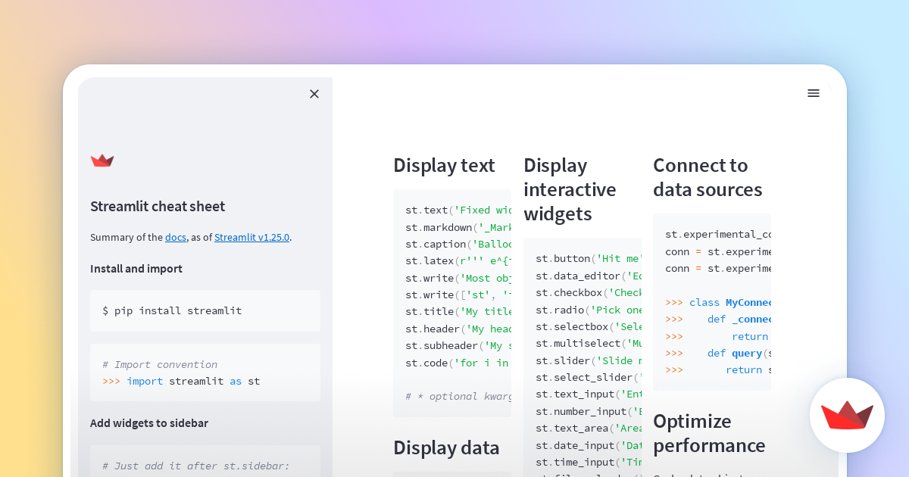

**Key Features of Streamlit**

Easy to use: Streamlit is designed to be easy to use, even for beginners. With its intuitive API and drag-and-drop interface, you can create powerful data apps without needing to learn a new web framework or JavaScript.

Powerful: Streamlit can handle a wide range of tasks, including data visualization, machine learning, and natural language processing. It supports a variety of data types, including pandas DataFrames, NumPy arrays, and custom objects.

Shareable: Streamlit apps can be easily shared with others via a simple URL. This makes it easy to share your work with colleagues, clients, or even the general public.

Collaborative: Streamlit apps can be easily collaborated on with others using GitHub or GitLab. This makes it easy to work together on projects and make sure that everyone is on the same page.

Deployable: Streamlit apps can be easily deployed to Heroku, AWS, or Google Cloud Platform. This makes it easy to share your apps with a wider audience and make them accessible to everyone.

**Use Cases for Streamlit:**

Streamlit can be used to create a wide variety of data apps. Here are a few examples: Interactive data visualization: Create interactive data visualizations that allow users to explore and analyze data in real time.

Machine learning model deployment: Deploy machine learning models to the web, allowing users to make predictions or classifications.

Natural language processing applications: Develop natural language processing applications, such as chatbots or text classifiers.

Interactive dashboards: Create interactive dashboards that provide an overview of key metrics and trends.

Data exploration tools: Build data exploration tools that allow users to easily explore and understand large datasets.

**Benefits of Using Streamlit:**

There are many benefits to using Streamlit, including:

Reduced development time: Streamlit's intuitive API and drag-and-drop interface make it possible to create data apps quickly and easily.

Increased productivity: Streamlit's interactive features make it easy to experiment with different ideas and approaches.

Improved collaboration: Streamlit's shareable and collaborative features make it easy to work with others on projects.

Greater accessibility: Streamlit's deployable apps can be easily shared with a wider audience.

## OpenAI: Advancing Artificial General Intelligence

OpenAI is a non-profit research company with the stated goal of promoting and developing friendly artificial general intelligence (AGI). AGI is a type of AI that would have the ability to perform any intellectual task that a human can. OpenAI believes that AGI has the potential to create immense benefits for humanity, but also poses significant risks. The company's mission is to ensure that AGI is developed and deployed safely and responsibly.

**OpenAI's Research Areas**

OpenAI is conducting research in a variety of areas related to AGI, including:

Safe reinforcement learning: This research area is focused on developing reinforcement learning algorithms that are safe and reliable. Reinforcement learning is a type of machine learning in which an agent learns to take actions in an environment in order to maximize a reward.

Natural language processing: This research area is focused on developing machines that can understand and generate human language. Natural language processing is a critical component of AGI, as it would allow machines to communicate with humans in a natural way.

Algorithmic transparency: This research area is focused on developing methods for making AI algorithms more transparent and understandable. Algorithmic transparency is important for ensuring that AI systems are fair, unbiased, and accountable.

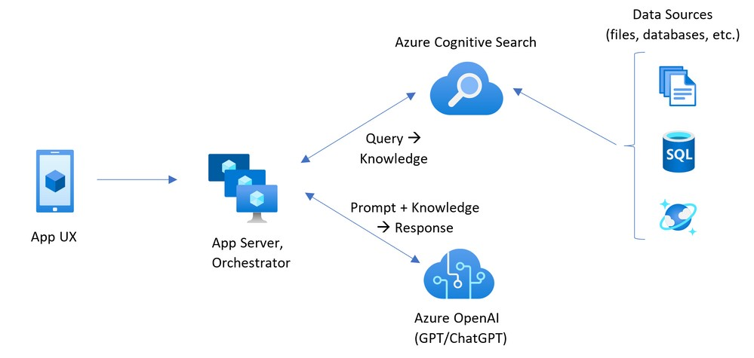

**OpenAI's Impact:**

OpenAI has made a number of significant contributions to the field of AI. The company has released several open-source AI tools and libraries, which have been used by researchers around the world. OpenAI has also published a number of research papers that have advanced the state-of-the-art in AI.

In addition to its technical contributions, OpenAI has also played a leading role in shaping the conversation about AGI. The company has hosted a number of conferences and workshops on AGI safety, and it has published a number of reports on the potential risks and benefits of AGI.

**OpenAI's Future:**

OpenAI is a rapidly growing organization with ambitious goals. The company is committed to continuing its research into AGI, and it is also planning to expand its efforts in AI policy and education. OpenAI believes that AGI has the potential to revolutionize the world, and the company is determined to ensure that this revolution is a positive one.

OpenAI is a leading force in the field of AI research. The company's work is helping to advance the state-of-the-art in AI, and it is also helping to shape the conversation about AGI safety. OpenAI is a company to watch in the years to come.

Artificial general intelligence (AGI), also known as strong AI or full AI, is a hypothetical type of AI that would have the ability to perform any intellectual task that a human can. AGI has the potential to revolutionize the world in a number of ways, but it also poses significant risks. OpenAI is a non-profit research company with the stated goal of promoting and developing friendly AGI. Friendly AGI is a type of AGI that would be beneficial to humanity and would not pose a threat to humanity's existence.

**Background:**

OpenAI was founded in 2015 by a group of Silicon Valley entrepreneurs and researchers, including Elon Musk, Sam Altman, and Ilya Sutskever. The company's stated mission is to ensure that AGI benefits all of humanity. OpenAI believes that AGI could have a profound impact on society, and that it is important to start thinking about the potential risks and benefits of AGI now.

**OpenAI's Research:**

OpenAI is conducting research in a variety of areas related to AGI, including:

Safe reinforcement learning: This research area is focused on developing reinforcement learning algorithms that are safe and reliable. Reinforcement learning is a type of machine learning in which an agent learns to take actions in an environment in order to maximize a reward.

Natural language processing: This research area is focused on developing machines that can understand and generate human language. Natural language processing is a critical component of AGI, as it would allow machines to communicate with humans in a natural way.

Algorithmic transparency: This research area is focused on developing methods for making AI algorithms more transparent and understandable. Algorithmic transparency is important for ensuring that AI systems are fair, unbiased, and accountable.

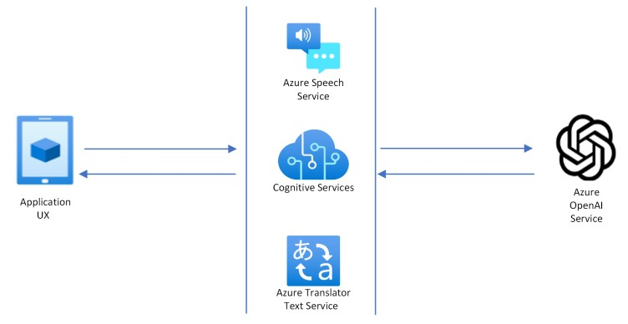

## Langchain

The vastness of information contained within PDF documents poses a significant challenge for individuals and organizations seeking to access, process, and extract meaningful insights. LangChain emerges as a revolutionary tool that seamlessly transforms PDF documents into interactive knowledge sources, powered by cuttingedge natural language processing (NLP) and machine learning (ML) techniques.

In today's data-driven world, PDF documents have become ubiquitous, serving as repositories of valuable information across various industries and domains. However, effectively extracting knowledge from these documents remains a challenge due to their unstructured and often complex nature. LangChain addresses this challenge by employing a combination of NLP and ML algorithms to extract key information, summarize complex concepts, and provide comprehensive answers to user queries directly from the content of the PDF.

**Key Features and Capabilities:**

LangChain offers a plethora of features and capabilities that make it an indispensable tool for anyone working with PDF documents:

Natural Language Processing (NLP): LangChain understands natural language queries, allowing users to ask questions in the same way they would ask a human expert. Machine Learning (ML): LangChain continuously learns from the data it processes, improving its ability to answer questions accurately and efficiently.

Comprehensive Information Extraction: LangChain can extract a wide range of information from PDF documents, including factual data, key concepts, and insights.

Summarization and Paraphrasing: LangChain can summarize complex information into concise and easy-to-understand summaries, and it can also paraphrase text to make it more accessible.

Creative Text Generation: LangChain can generate different creative text formats, such as poems, code, scripts, musical pieces, email, letters, etc.

Multilingual Support: LangChain supports multiple languages, making it accessible to a global audience.

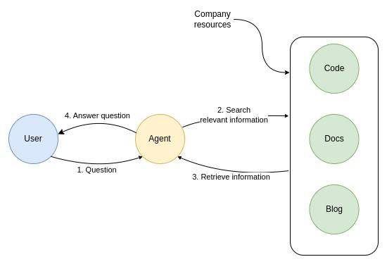

**Use Cases and Applications:**

LangChain's versatility extends to a wide range of use cases across various industries: Education: Students can use LangChain to understand complex academic materials, such as textbooks and journal articles.

Research: Researchers can use LangChain to quickly find and extract information from scientific literature.

Business: Businesses can use LangChain to analyze market reports, financial statements, and other business documents.

Government: Government agencies can use LangChain to decipher policy documents, regulations, and other legal texts.

Customer Service: Businesses can use LangChain to provide automated customer support, answering frequently asked questions and providing product information.

**Future Directions**

LangChain is continuously evolving and expanding its capabilities, with a focus on the following areas:

Domain-Specific Knowledge: LangChain is being developed to understand specific domains, such as medicine, law, and finance.

Real-Time Document Processing: LangChain is being enhanced to process PDF documents in real time, enabling interactive and dynamic conversations.

Personalization: LangChain is being developed to personalize its responses to individual users' needs and preferences.

Integration with Other Tools: LangChain is being integrated with other tools, such as productivity suites and learning management systems. LangChain stands as a groundbreaking tool that revolutionizes the way we interact with and process information from PDF documents. With its ability to understand natural language, extract comprehensive information, and generate creative text formats, LangChain is a valuable asset for anyone who works with PDFs. We are committed to continuous improvement and innovation, ensuring that LangChain remains at the forefront of NLP and ML technology.

In the vast ocean of information, PDF documents serve as valuable repositories of knowledge, encapsulating insights and expertise across diverse fields. However, extracting meaningful information from these often complex and unstructured documents has long posed a challenge. LangChain emerges as a transformative tool, bridging the gap between humans and the wealth of knowledge contained within PDF documents.

Leveraging the power of natural language processing (NLP) and machine learning (ML), LangChain seamlessly transforms PDF documents into interactive knowledge sources. It empowers users to engage in natural language conversations with these documents, asking questions and receiving comprehensive answers directly from the text. LangChain's ability to understand natural language queries makes it an intuitive and accessible tool for anyone seeking knowledge from PDF documents.

Unveiling the Hidden Treasures Within PDFs

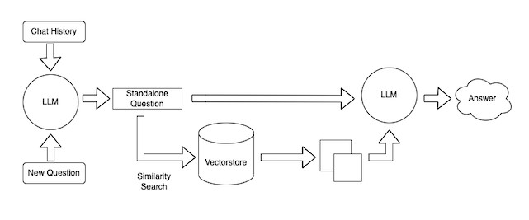

LangChain goes beyond mere keyword extraction; it delves into the depths of PDF documents, extracting key concepts, summarizing complex information, and providing comprehensive answers to user queries. Its advanced NLP capabilities enable it to grasp the nuances of human language, interpreting not just individual words but also the context and relationships between them.

LangChain's ML-powered algorithms continuously learn from the data it processes, refining its ability to understand and respond to user queries with increasing accuracy and efficiency. This continuous learning process ensures that LangChain remains at the forefront of NLP technology, adapting to the evolving nature of human language and the ever-growing corpus of PDF documents.

LangChain: Empowering Knowledge Discovery from PDF Documents

In the vast ocean of information, PDF documents serve as valuable repositories of knowledge, encapsulating insights and expertise across diverse fields. However, extracting meaningful information from these often complex and unstructured documents has long posed a challenge. LangChain emerges as a transformative tool, bridging the gap between humans and the wealth of knowledge contained within PDF documents.

Leveraging the power of natural language processing (NLP) and machine learning (ML), LangChain seamlessly transforms PDF documents into interactive knowledge sources. It empowers users to engage in natural language conversations with these documents, asking questions and receiving comprehensive answers directly from the text. LangChain's ability to understand natural language queries makes it an intuitive and accessible tool for anyone seeking knowledge from PDF documents.

Unveiling the Hidden Treasures Within PDFs

LangChain goes beyond mere keyword extraction; it delves into the depths of PDF documents, extracting key concepts, summarizing complex information, and providing comprehensive answers to user queries. Its advanced NLP capabilities enable it to grasp the nuances of human language, interpreting not just individual words but also the context and relationships between them.

LangChain's ML-powered algorithms continuously learn from the data it processes, refining its ability to understand and respond to user queries with increasing accuracy and efficiency. This continuous learning process ensures that LangChain remains at the forefront of NLP technology, adapting to the evolving nature of human language and the ever-growing corpus of PDF documents.

**A Gateway to a World of Knowledge:**

LangChain's versatility extends to a wide range of use cases, empowering individuals and organizations across diverse industries to unlock the hidden treasures within their PDF documents:

Education: Students can effortlessly navigate through textbooks and research papers, asking questions and receiving concise explanations to enhance their understanding.

Research: Researchers can quickly locate and extract relevant information from scientific literature, accelerating their research endeavors and fostering innovation.

Business: Companies can gain valuable insights from market reports, financial statements, and other business documents, informing strategic decision-making and propelling business growth.

Government: Policy analysts can efficiently decipher complex policy documents, regulations, and legal texts, ensuring informed decision-making and effective governance.

Customer Service: Businesses can provide automated customer support through LangChain, answering frequently asked questions, providing product information, and resolving customer inquiries efficiently.

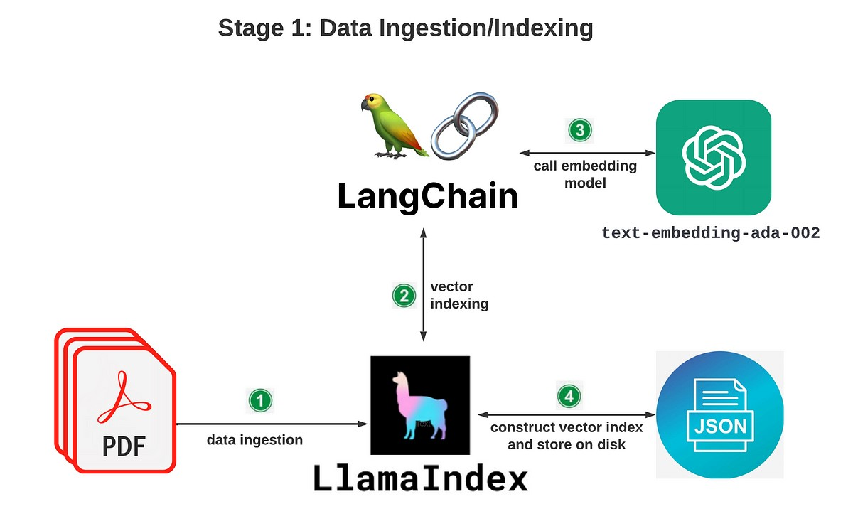

**A Journey of Continuous Evolution:**

LangChain's journey of innovation is far from over. We are committed to continuously expanding its capabilities, pushing the boundaries of NLP and ML to empower users in new and exciting ways:

Domain-Specific Expertise: LangChain is being tailored to specific domains, such as medicine, law, and finance, enabling it to provide domain-specific insights and answers.

Real-Time Document Processing: LangChain is being enhanced to process PDF documents in real time, facilitating interactive and dynamic conversations with these documents.

Personalized User Experiences: LangChain is being personalized to adapt its responses to individual users' needs, preferences, and knowledge levels.

Integration with Other Tools: LangChain is being integrated with other productivity suites, learning management systems, and knowledge management platforms, seamlessly integrating into existing workflows.

LangChain stands as a transformative tool, empowering individuals and organizations to unlock the hidden knowledge within PDF documents. By bridging the gap between human language and the wealth of information contained within these documents, LangChain fosters a world where knowledge is readily accessible and easily understandable, propelling innovation and progress across all domains.

# Character Text Splitter

In the realm of natural language processing (NLP), character text splitters play a crucial role in preprocessing and segmenting text data. These tools divide text into individual characters, forming the foundation for various NLP tasks, including language modeling, machine translation, and sentiment analysis.

Character text splitters are fundamental building blocks in the NLP pipeline, ensuring that text data is in a standardized and structured format for further processing. By breaking down text into its constituent characters, these splitters enable NLP algorithms to analyze the relationships between individual characters and identify patterns within the text.

**Types of Character Text Splitters:**

Character text splitters can be broadly classified into two categories:

Rule-based splitters: These splitters rely on predefined rules to determine where to split the text. For instance, they may split text based on whitespace, punctuation, or other predefined patterns.

Data-driven splitters: These splitters utilize machine learning algorithms to learn how to split text effectively. They are trained on large datasets of labeled text, allowing them to adapt to different writing styles and linguistic variations.

**Applications of Character Text Splitters**

Character text splitters are essential components in a variety of NLP tasks, including:

* Language modeling: Character-level language models utilize character sequences to predict the next character in a sequence. Character text splitters are crucial for preparing the text data for these models.
* Machine translation: Character-based machine translation systems rely on character-level representations of source and target languages to translate text from one language to another. Character text splitters are essential for converting text into these representations.
* Sentiment analysis: Character-level sentiment analysis techniques analyze the sentiment of text at the character level. Character text splitters are required to break down text into individual characters for this analysis. • Challenges and Future Directions

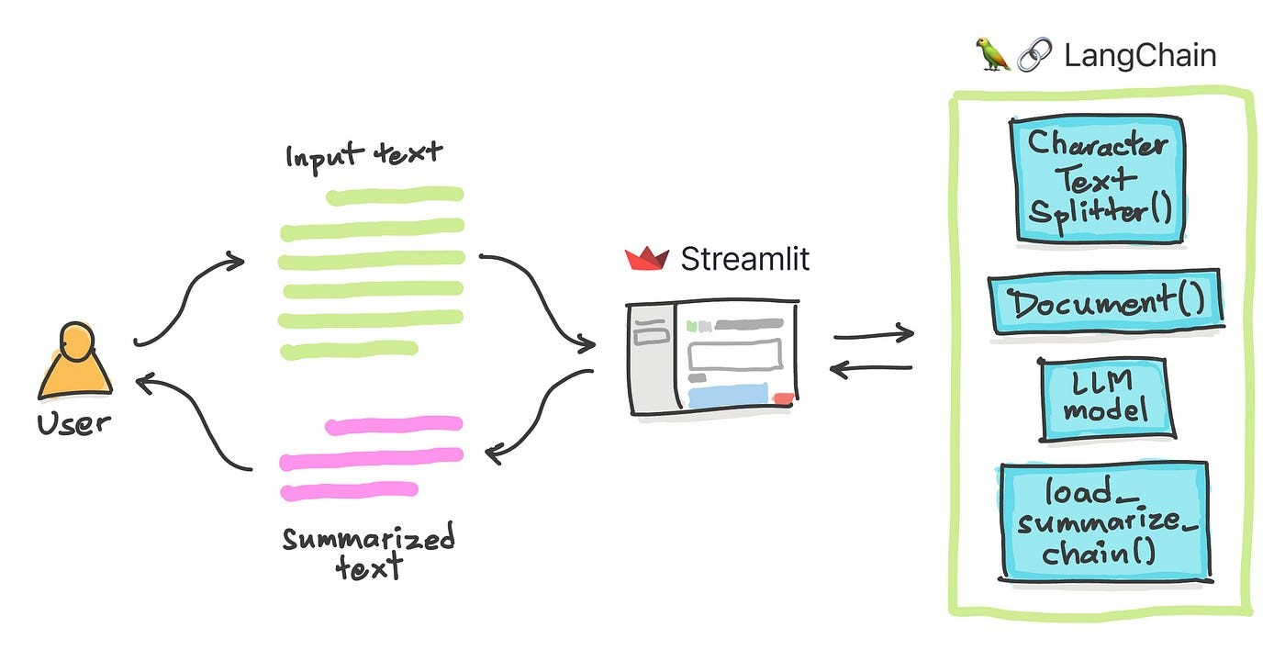

Character text splitters face several challenges, including:

* Handling languages with complex writing systems: Some languages, such as Chinese and Japanese, have complex writing systems that may not be easily split into individual characters using rule-based methods.

* Adapting to different writing styles: Character text splitters need to be able to adapt to different writing styles, such as informal text, emails, and code snippets.
* Handling errors in text data: Character text splitters need to be robust to errors in text data, such as typos and spelling mistakes.
* Future research directions in character text splitters include:

* Developing language-specific splitters: Designing character text splitters that are specifically tailored to the unique characteristics of different languages.
* Incorporating contextual information: Utilizing contextual information, such as surrounding characters or words, to improve the accuracy of text splitting.

* Exploring alternative representations: Investigating alternative representations of text, such as character n-grams, to enhance the performance of NLP tasks.

Character text splitters play a pivotal role in natural language processing, providing the foundation for various NLP tasks and applications. As NLP continues to evolve, the development of sophisticated and adaptable character text splitters will remain crucial for unlocking the full potential of text-based data.

In the intricate world of natural language processing (NLP), character text splitters stand as indispensable tools, meticulously dissecting text into its fundamental building blocks – individual characters. These seemingly simple tools lay the groundwork for a myriad of powerful NLP applications, enabling machines to comprehend the nuances of human language.

**The Essence of Character Text Splitters:**

Character text splitters serve as the initial stage in the NLP pipeline, transforming raw text data into a format amenable to further processing. By breaking down text into its constituent characters, these splitters facilitate the analysis of character-level patterns and relationships, providing a granular perspective on the structure and meaning of text.

Classifying Character Text Splitters: Rule-Based versus Data-Driven Approaches Character text splitters can be categorized into two primary types:

Rule-based splitters: These splitters operate based on predefined rules, employing patterns such as whitespace, punctuation, or other linguistic markers to determine where to divide the text. Rule-based splitters offer simplicity and efficiency, making them suitable for handling well-structured text formats.

Data-driven splitters: These splitters harness the power of machine learning algorithms to learn how to split text effectively. Trained on vast datasets of labeled text, data-driven splitters exhibit remarkable adaptability, effectively handling diverse writing styles and linguistic variations.

A Spectrum of Applications: Unlocking the Power of Character Text Splitters Character text splitters serve as essential components in a wide range of NLP tasks, empowering machines to delve into the intricacies of human language:

Language modeling: Character-level language models, capable of predicting the next character in a sequence, rely on character text splitters to prepare the text data for their operation.

Machine translation: Character-based machine translation systems, bridging the gap between languages, utilize character-level representations of source and target languages, rendered possible by character text splitters.

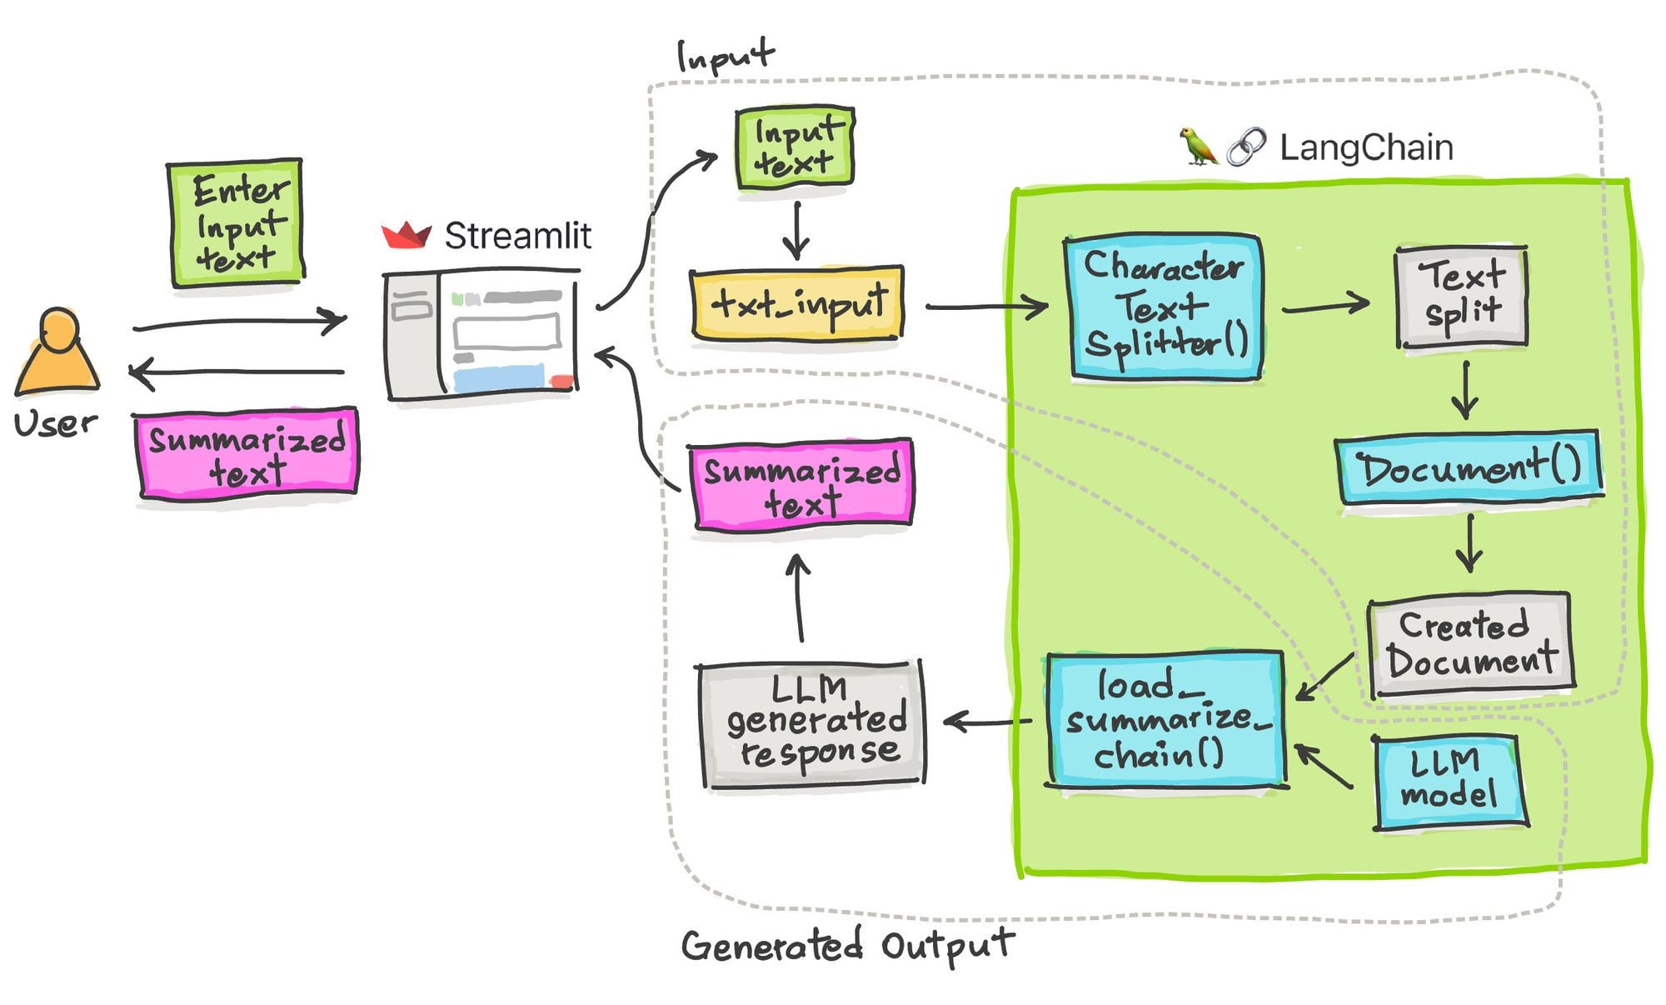

Sentiment analysis: Character-level sentiment analysis techniques, discerning the emotional tone of text, extract insights from the character-level representations produced by character text splitters.

**Navigating Challenges and Embracing Future Directions:**

Despite their versatility, character text splitters face challenges that demand innovative solutions:

Linguistic diversity: Handling languages with complex writing systems, such as Chinese and Japanese, requires character text splitters that can effectively segment text without relying on traditional markers like whitespace.

Writing style adaptation: Character text splitters must be adaptable to diverse writing styles, including informal text, emails, and code snippets, to ensure accurate segmentation across various communication channels.

Error tolerance: Robustness to errors in text data, such as typos and spelling mistakes, is crucial for character text splitters to maintain their effectiveness in real-world applications.

As the field of NLP continues to advance, character text splitters remain at the forefront of innovation:

Language-specific splitters: Tailoring character text splitters to the unique characteristics of individual languages promises enhanced accuracy and adaptability in language-specific NLP tasks.

Contextual information integration: Incorporating contextual information, such as surrounding characters or words, can refine character-level analysis, leading to more nuanced and accurate text segmentation.

Alternative representations: Exploring alternative representations of text, such as character n-grams, may offer new avenues for improving the performance of character text splitters in various NLP applications.

Conclusion: Character Text Splitters – Paving the Path for NLP Excellence

Character text splitters, though seemingly simple, play a pivotal role in natural language processing, providing the foundation for a multitude of NLP tasks and applications. Their ability to dissect text into its constituent characters is essential for machines to grasp the nuances of human language, enabling them to perform tasks such as language modeling, machine translation, and sentiment analysis with increasing accuracy and sophistication. As NLP continues to evolve, the development of advanced character text splitters will remain crucial for unlocking the full potential of text-based data and shaping the future of human-machine communication.

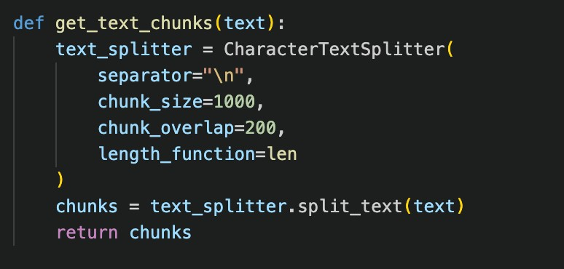

## Vector Store

The growing volume and diversity of data have propelled the need for efficient and scalable methods for similarity search. Vector stores, specialized databases designed for storing and searching high-dimensional vectors, have emerged as a promising solution for this challenge. They offer significant advantages over traditional databases, enabling faster search speeds, improved accuracy, and support for a wider range of similarity metrics.

Similarity search is a fundamental task in various domains, including image retrieval, natural language processing, and recommender systems. It involves finding similar items in a database based on their features, typically represented as high-dimensional vectors. Traditional database systems, designed for storing and manipulating structured data, are often ill-suited for similarity search due to their inability to efficiently handle high-dimensional vectors and complex similarity metrics.

Vector Stores: A Specialized Solution for Similarity Search

Vector stores address the limitations of traditional databases by providing optimized indexing and search algorithms specifically tailored for high-dimensional vectors. They leverage techniques such as approximate nearest neighbor search (ANN) algorithms and vector quantization to achieve efficient search performance while maintaining acceptable accuracy.

**Key Features and Advantages of Vector Stores:**

Vector stores offer a range of features and advantages that make them well-suited for similarity search tasks:

Efficient indexing: Vector stores employ specialized indexing techniques to efficiently organize and search high-dimensional vectors.

Approximate nearest neighbor search: Vector stores support ANN algorithms, which rapidly identify approximate nearest neighbors, significantly reducing search times.

Support for various similarity metrics: Vector stores can handle a wide range of similarity metrics, including Euclidean distance, cosine similarity, and Jaccard similarity.

Scalability: Vector stores are designed to scale horizontally, enabling them to handle large and growing datasets.

Integration with existing systems: Vector stores can be integrated with existing applications and frameworks, allowing for seamless integration into existing workflows.

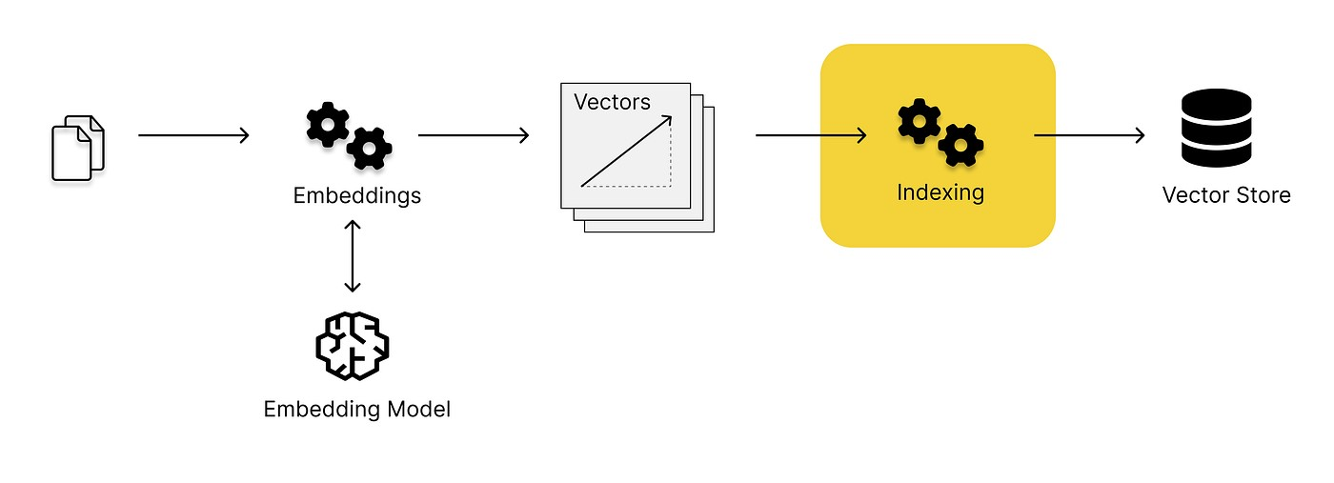

**Applications of Vector Stores:**

Vector stores have found applications in a wide range of domains:

Image retrieval: Vector stores are used to search for similar images based on their visual features, enabling efficient image retrieval from large collections.

Natural language processing: Vector stores are employed in tasks such as document similarity search, semantic text matching, and word embedding retrieval.

Recommender systems: Vector stores are used to recommend similar items to users based on their past behavior or preferences.

Fraud detection: Vector stores can be used to identify fraudulent transactions or activities by comparing them to known patterns of fraudulent behavior.

Anomaly detection: Vector stores can be used to detect anomalies in data, such as outliers or unusual patterns, by identifying data points that deviate significantly from the norm.

**Future Directions:**

The field of vector stores is rapidly evolving, with ongoing research focusing on:

* Improving search performance: Developing more efficient ANN algorithms and indexing techniques to further reduce search times.
* Enhancing accuracy: Exploring techniques to improve the accuracy of similarity search results.
* Supporting additional data types: Expanding vector stores to support additional data types beyond vectors, such as graphs and time series data.
* Enabling federated learning: Enabling vector stores to participate in federated learning, allowing for collaborative training of machine learning models without sharing sensitive data.
* Integrating with cloud platforms: Integrating vector stores with cloud platforms to facilitate easy deployment, scaling, and management.

Vector stores have emerged as a powerful tool for similarity search, offering significant advantages over traditional databases in terms of speed, accuracy, and scalability. Their ability to efficiently handle high-dimensional vectors and support various similarity metrics makes them well-suited for a wide range of applications, including image retrieval, natural language processing, recommender systems, fraud detection, and anomaly detection. As the volume and diversity of data continue to grow, vector stores are poised to play an increasingly important role in enabling efficient and effective similarity search across various domains.

In the ever-expanding realm of data, the ability to efficiently identify and compare similar items has become an indispensable tool for researchers, businesses, and organizations across diverse domains. Vector stores, a specialized breed of databases designed to handle high-dimensional vectors, have emerged as the cornerstone of modern similarity search, revolutionizing the way we navigate and extract insights from large-scale data.

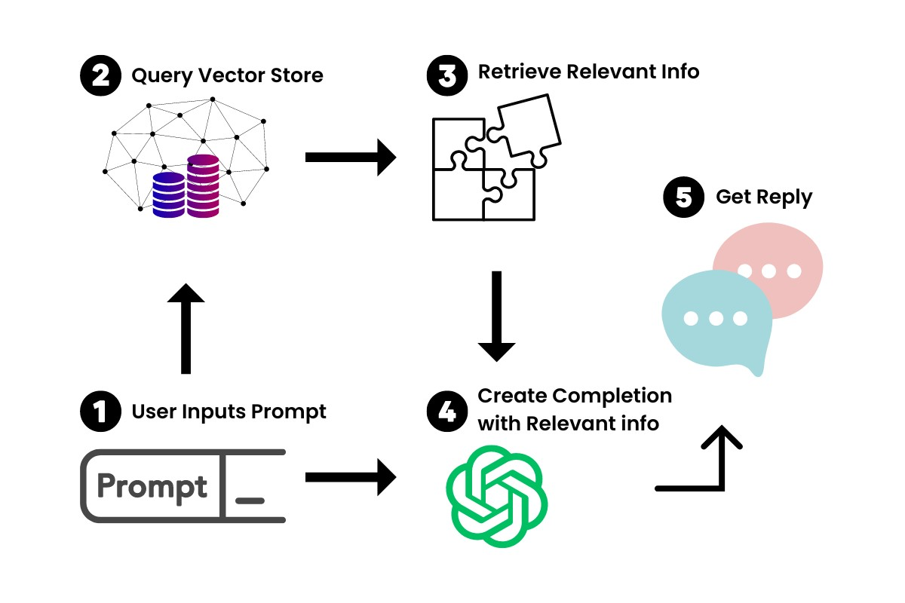

**Decoding the Essence of Vector Stores:**

Vector stores are not merely databases; they are meticulously engineered systems optimized for storing, indexing, and searching high-dimensional vectors. These vectors, mathematical representations of data points, capture the essence of the information they represent, enabling machines to understand the underlying relationships and patterns within data.

The Power of Approximate Nearest Neighbor Search

At the heart of vector stores lies the power of approximate nearest neighbor (ANN) search algorithms. These algorithms, unlike traditional exact search methods, prioritize speed over absolute precision, allowing them to rapidly identify nearmatches within large datasets. This trade-off is acceptable in many applications, as the goal is often to find relevant items rather than perfect matches.

Unleashing the Potential of Vector Stores

Vector stores have unlocked a multitude of applications across various domains: Image Retrieval: Vector stores enable efficient image search, allowing users to find visually similar images from vast collections of photographs.

Natural Language Processing: Vector stores power tasks such as semantic text matching, word embedding retrieval, and document similarity search, facilitating the analysis and understanding of natural language.

Recommender Systems: Vector stores underpin recommender systems, enabling the personalization of product recommendations, news articles, and other content based on user preferences and past behavior.

Fraud Detection: Vector stores can be used to identify fraudulent transactions or activities by comparing them to known patterns of fraudulent behavior, safeguarding financial institutions and e-commerce platforms.

Anomaly Detection: Vector stores can be employed to detect anomalies in data, such as outliers or unusual patterns, enabling proactive identification of potential risks or irregularities.

**A Glimpse into the Future of Vector Stores:**

As the field of vector stores continues to evolve, the future holds exciting advancements:

Enhanced Search Efficiency: Researchers are continuously developing more sophisticated ANN algorithms and indexing techniques to further reduce search times and improve performance.

Accuracy Refinement: Ongoing research focuses on refining similarity search algorithms to enhance the accuracy of results, ensuring that retrieved items are truly the most relevant matches.

Data Type Expansion: Vector stores are being expanded to support additional data types beyond vectors, such as graphs and time series data, broadening their applicability across domains.

Federated Learning Integration: Vector stores are being integrated into federated learning frameworks, enabling collaborative training of machine learning models without compromising data privacy.

Cloud Platform Integration: Vector stores are being seamlessly integrated with cloud platforms, facilitating easy deployment, scaling, and management for organizations of all sizes.

Conclusion: Vector Stores – Driving the Future of Data-Driven Applications

Vector stores have revolutionized the way we interact with and analyze data, providing a powerful tool for similarity search and enabling a wide range of data-driven applications. As the volume and complexity of data continue to grow, vector stores are poised to play an even more critical role in unlocking the insights and potential embedded within data, driving innovation and progress across industries.

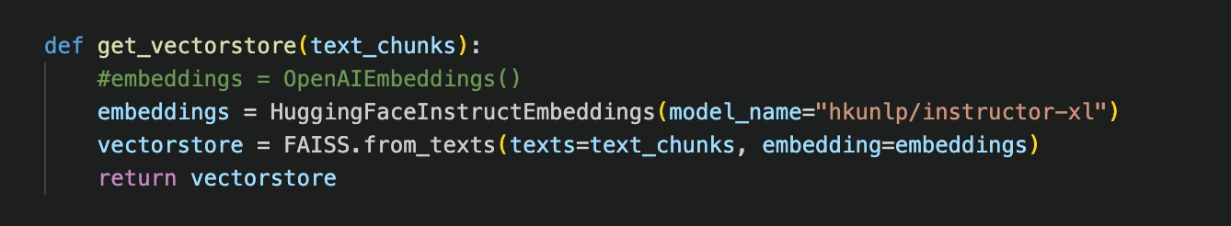

## OpenAIEmbeddings

In the realm of natural language processing (NLP), OpenAI Embeddings have emerged as a powerful tool for capturing the contextual meaning of words and phrases. These embeddings, represented as dense vectors of real numbers, encode the semantic relationships between words, enabling machines to understand the nuances of human language.

Traditional word embedding methods, such as Word2Vec and GloVe, have significantly improved the performance of NLP tasks. However, these methods often fail to capture the contextual meaning of words, leading to suboptimal performance in tasks that require a deep understanding of language semantics.

OpenAI Embeddings address the limitations of traditional word embedding methods by incorporating contextual information into the embedding process. These embeddings are trained using massive amounts of text data, allowing them to capture the subtle variations in meaning that arise from word usage in different contexts.

**Key Features and Advantages of OpenAI Embeddings:**

OpenAI Embeddings offer several key features and advantages that make them wellsuited for NLP tasks:

Contextual awareness: OpenAI Embeddings capture the contextual meaning of words, enabling machines to understand the nuances of human language.

Fine-tuning capabilities: OpenAI Embeddings can be fine-tuned for specific tasks or domains, further enhancing their performance.

Multilingual support: OpenAI Embeddings are available for multiple languages, enabling cross-lingual applications.

Efficiency: OpenAI Embeddings are computationally efficient, making them suitable for real-time applications.

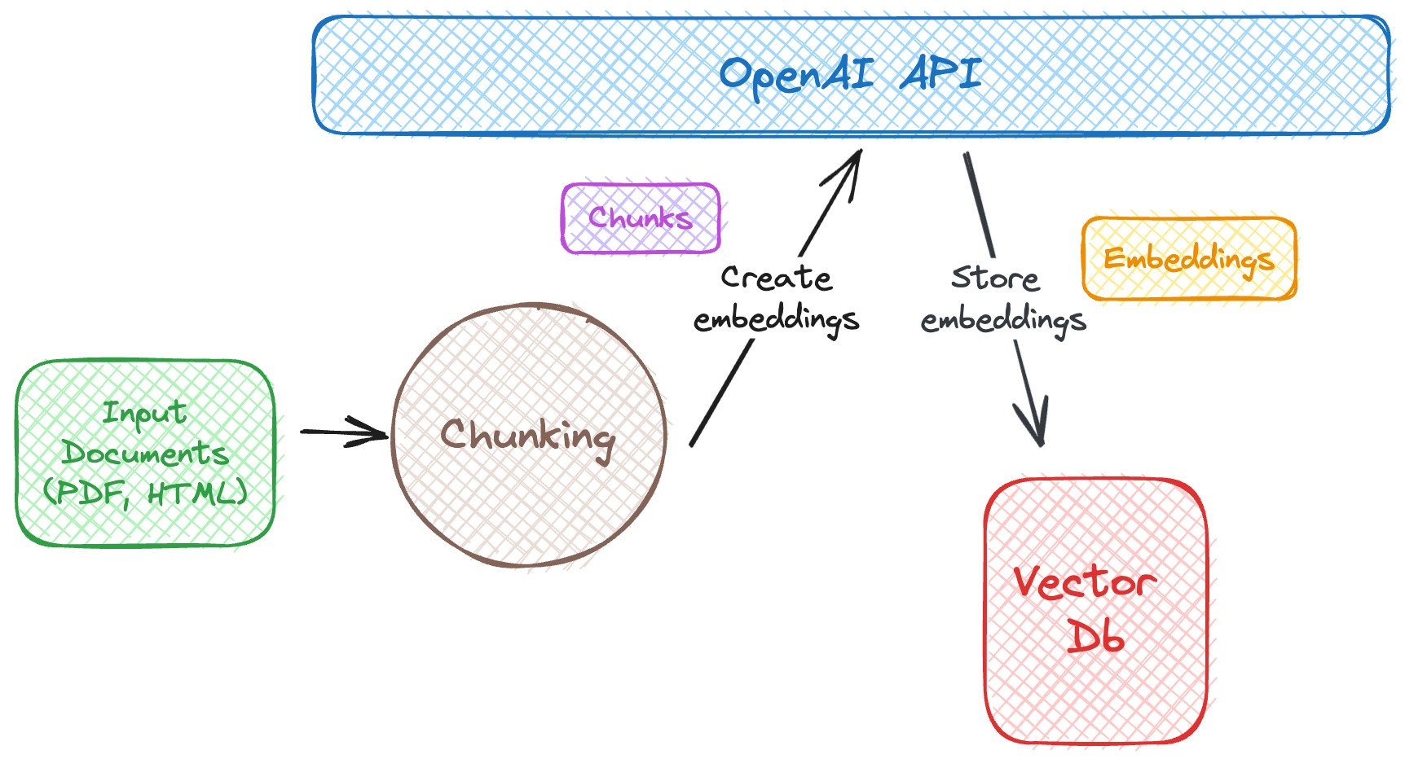

**Applications of OpenAI Embeddings:**

OpenAI Embeddings have found applications in a wide range of NLP tasks:

Machine translation: OpenAI Embeddings can be used to improve the accuracy of machine translation systems by capturing the contextual meaning of words in different languages.

Text summarization: OpenAI Embeddings can be used to generate concise and informative summaries of text by identifying the key phrases and concepts.

Question answering: OpenAI Embeddings can be used to develop question answering systems that can accurately answer questions about text passages.

Sentiment analysis: OpenAI Embeddings can be used to analyze the sentiment of text, enabling the identification of positive, negative, or neutral opinions.

Natural language generation: OpenAI Embeddings can be used to generate natural and fluent text, enabling the development of chatbots and other natural language interfaces.

**Future Directions:**

The field of OpenAI Embeddings is continually evolving, with ongoing research focusing on:

Improving contextual representation: Developing more sophisticated techniques for capturing the contextual meaning of words, further enhancing the accuracy of NLP tasks.

Reducing computational cost: Developing more efficient embedding algorithms to reduce the computational resources required for training and using OpenAI Embeddings.

Expanding multilingual support: Expanding the availability of OpenAI Embeddings to additional languages, enabling a wider range of cross-lingual applications.

Integrating with other NLP tools: Integrating OpenAI Embeddings with other NLP tools and frameworks, facilitating their adoption and use in real-world applications. Exploring new applications: Exploring the use of OpenAI Embeddings in new and emerging NLP applications, such as dialogue systems and explainable AI.

OpenAI Embeddings have revolutionized the field of NLP, providing a powerful tool for capturing the contextual meaning of words and enabling machines to better understand human language. Their ability to capture subtle semantic variations makes them well-suited for a wide range of NLP tasks, from machine translation to natural language generation. As the field continues to evolve, OpenAI Embeddings are poised to play an even more critical role in advancing NLP research and enabling new and innovative applications.

Unlocking the Power of Context with OpenAI Embeddings: A Deeper Dive into Contextual Encoding

In the realm of natural language processing (NLP), OpenAI Embeddings have emerged as a transformative force, revolutionizing the way machines comprehend and process human language. Unlike traditional word embedding methods that merely represent words as isolated entities, OpenAI Embeddings capture the essence of language – the intricate web of meaning that emerges from the interplay of words in context.

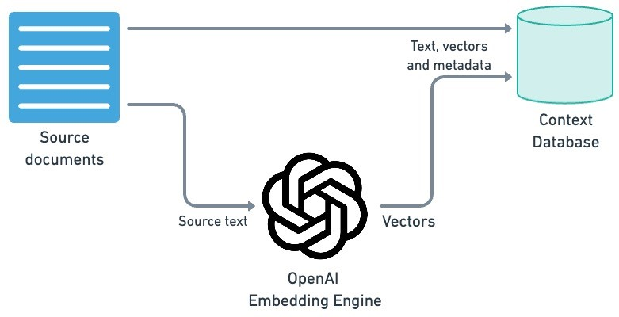

**Delving into the Heart of Contextual Embeddings:**

At the heart of OpenAI Embeddings lies the concept of context, the linguistic environment in which a word or phrase resides. Traditional word embedding methods often fail to account for this crucial aspect of language, leading to inaccurate representations of word meaning. OpenAI Embeddings, on the other hand, are trained on massive amounts of text data, allowing them to learn the subtle nuances of word usage and the semantic relationships that arise in different contexts.

Harnessing the Power of Context for Enhanced NLP Performance

The ability to capture context has propelled OpenAI Embeddings to the forefront of NLP research, enabling significant advancements in various tasks:

Machine Translation: OpenAI Embeddings have revitalized machine translation, enabling systems to bridge the gap between languages with greater accuracy and fluency. By understanding the contextual meaning of words in both source and target languages, these embeddings facilitate more natural and nuanced translations.

Text Summarization: OpenAI Embeddings have transformed text summarization, allowing machines to distill the essence of lengthy documents into concise and informative summaries. By identifying key phrases and concepts within the context of the entire text, these embeddings enable the generation of summaries that capture the true meaning of the original document.

Question Answering: OpenAI Embeddings have empowered machines to answer complex questions with greater precision and understanding. By capturing the context within which questions are posed, these embeddings enable machines to identify relevant passages and extract accurate answers, even for open-ended or challenging questions.

Sentiment Analysis: OpenAI Embeddings have refined sentiment analysis, enabling machines to discern the emotional tone of text with greater sensitivity. By understanding the contextual cues that convey sentiment, these embeddings facilitate the identification of positive, negative, or neutral opinions in various forms of text, including social media posts, product reviews, and customer feedback.

Natural Language Generation: OpenAI Embeddings have opened new frontiers in natural language generation, enabling machines to produce human-quality text that is both grammatically correct and semantically meaningful. By understanding the context in which language is used, these embeddings facilitate the generation of natural and fluent text, from creative writing to chatbot interactions.

A Glimpse into the Future of Contextual Embeddings

The field of OpenAI Embeddings is rapidly evolving, with ongoing research focused on expanding the boundaries of contextual encoding and unlocking its full potential: Enhanced Contextual Representation: Researchers are continuously developing more sophisticated techniques for capturing the contextual meaning of words, further enhancing the accuracy of NLP tasks. This includes exploring different approaches to contextual representation, such as hierarchical encoding and attention mechanisms.

Reduced Computational Cost: Developing more efficient embedding algorithms is crucial for making OpenAI Embeddings more accessible and practical for real-world applications. This involves optimizing training processes and exploring hardware acceleration techniques.

Expanded Multilingual Support: OpenAI Embeddings are being extended to cover a wider range of languages, enabling cross-lingual applications that cater to a global audience. This requires developing more robust training methods and addressing language-specific challenges.

Integration with NLP Tools and Frameworks: Integrating OpenAI Embeddings with existing NLP tools and frameworks will facilitate their adoption and use in a wider range of NLP projects. This involves developing seamless interfaces and providing comprehensive documentation.

Exploration of New Applications: OpenAI Embeddings hold immense potential for new and emerging NLP applications, such as dialogue systems, explainable AI, and creative content generation. Researchers are actively exploring these areas, pushing the boundaries of what is possible with contextual embedding techniques.

OpenAI Embeddings have emerged as a transformative force in the field of NLP, revolutionizing the way machines understand and process human language. Their ability to capture context has led to significant advancements in various NLP tasks, opening doors to new possibilities and fueling innovation across diverse domains. As research continues to expand the capabilities of contextual embeddings, OpenAI Embeddings are poised to play an even more critical role in shaping the future of NLP and enabling machines to interact with human language in increasingly natural and intelligent ways.

## Hugging face Embeddings

Hugging Face Embeddings has emerged as a comprehensive and user-friendly platform for natural language processing (NLP), providing a vast collection of pretrained word embeddings, transformers, and other state-of-the-art NLP models. This open-source toolkit has democratized access to advanced NLP techniques, enabling researchers and practitioners to build powerful NLP applications with ease.

NLP involves enabling computers to understand, interpret, and generate human language. Embeddings, vector representations of words or phrases, are fundamental building blocks for NLP tasks such as machine translation, sentiment analysis, and text summarization. Traditionally, creating high-quality embeddings required significant computational resources and expertise.

**Hugging Face Embeddings: A Gateway to Advanced NLP**

Hugging Face Embeddings has revolutionized the NLP landscape by providing a centralized repository of pre-trained word embeddings and transformers, trained on massive datasets of text and code. These pre-trained models are readily available for use, eliminating the need for users to train their own embeddings from scratch, saving time and computational resources.

**Key Features and Advantages of Hugging Face Embeddings**

Hugging Face Embeddings offers a plethora of features and advantages that make it an invaluable tool for NLP practitioners:

Vast Collection of Pre-trained Models: Hugging Face Embeddings provides a comprehensive collection of pre-trained models, including word embeddings, transformers, and other NLP models.

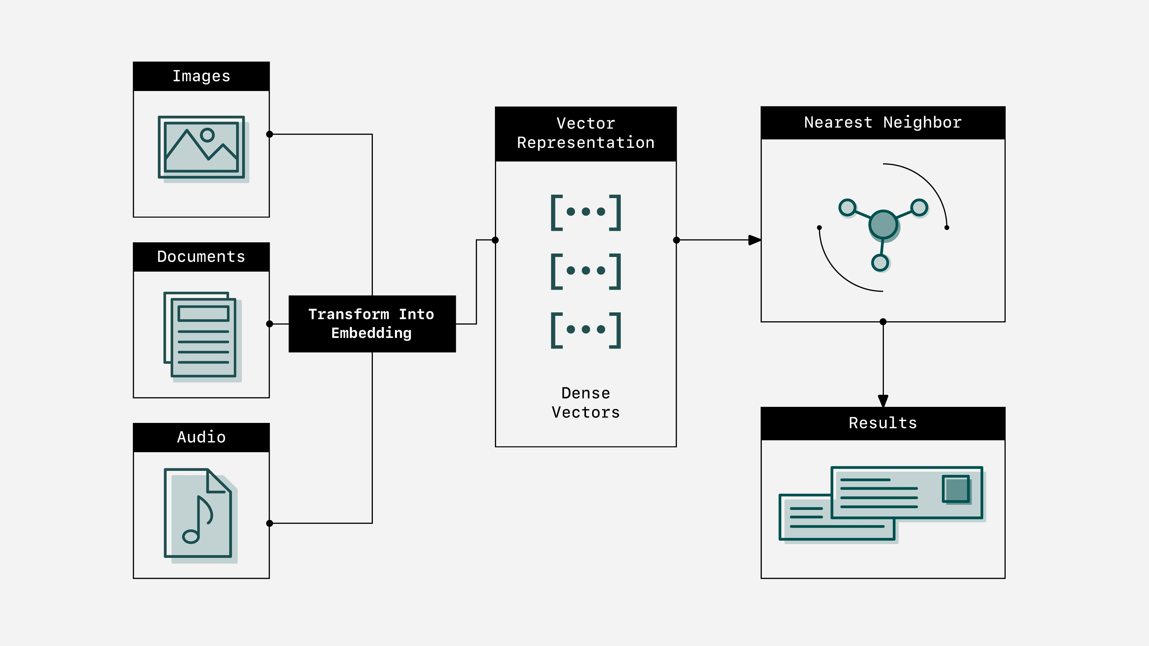

Easy Access and Usage: Hugging Face Embeddings offers a user-friendly interface and extensive documentation, making it easy to access and use pre-trained models and build NLP applications.

Multi-Model Support: Hugging Face Embeddings supports a wide range of NLP models from various sources, including TensorFlow, PyTorch, and Hugging Face Transformers.

Reproducibility: Hugging Face Embeddings leverages Git version control to ensure reproducibility of model training and evaluation results.

Community-Driven Development: Hugging Face Embeddings is an open-source project with a vibrant community of contributors, fostering collaboration and innovation.

**Applications of Hugging Face Embeddings:**

Hugging Face Embeddings has enabled a wide range of NLP applications, including: Machine Translation: Hugging Face Embeddings has been used to develop high-quality machine translation systems, enabling seamless communication across languages. Sentiment Analysis: Hugging Face Embeddings has powered sentiment analysis tools that accurately detect the emotional tone of text, providing valuable insights into customer feedback, social media sentiment, and brand perception.

Question Answering: Hugging Face Embeddings has facilitated the development of question answering systems that provide comprehensive answers to complex questions based on large text corpora.

Text Summarization: Hugging Face Embeddings has enabled the creation of effective text summarization tools that distill lengthy documents into concise and informative summaries.

Natural Language Generation: Hugging Face Embeddings has empowered the development of natural language generation models that produce human-quality text, enabling creative writing, chatbot interactions, and text summarization.

**Future Directions:**

Hugging Face Embeddings is continuously evolving, with ongoing research focused on: Expanding Model Coverage: Expanding the collection of pre-trained models to include more languages, domains, and task-specific models.

Improving Model Performance: Developing new training techniques and architectures to further enhance the performance of pre-trained models.

Integrating with NLP Pipelines: Integrating Hugging Face Embeddings with existing NLP pipelines to streamline the development and deployment of NLP applications. Exploring New Applications: Exploring the use of Hugging Face Embeddings in new and emerging NLP areas, such as explainable AI and dialogue systems.

Promoting Open-Source Collaboration: Fostering open-source collaboration and knowledge sharing within the NLP community.

Hugging Face Embeddings has emerged as an indispensable tool for NLP research and development, providing a comprehensive and user-friendly platform for accessing and utilizing pre-trained NLP models. Its vast collection of models, easy-to-use interface, and vibrant community have democratized access to advanced NLP techniques, enabling researchers and practitioners to build powerful NLP applications with ease. As the field of NLP continues to evolve, Hugging Face Embeddings is poised to play an even more crucial role in unlocking the potential of natural language processing and enabling machines to interact with human language in increasingly sophisticated and meaningful ways.

The rise of Hugging Face Embeddings has marked a pivotal moment in the landscape of natural language processing (NLP), democratizing access to cutting-edge NLP models and fostering a vibrant community of researchers and practitioners. This opensource toolkit has empowered individuals with diverse backgrounds and expertise to experiment with and deploy state-of-the-art NLP techniques, accelerating the pace of innovation and driving advancements across various applications.

A Hub for Pre-trained NLP Models: Enabling Rapid Prototyping and Deployment

Hugging Face Embeddings serves as a centralized repository for a vast collection of pre-trained NLP models, encompassing a wide range of languages, domains, and tasks. This repository eliminates the need for users to train their own models from scratch, saving valuable time and resources. By providing readily available models, Hugging Face Embeddings accelerates the process of building NLP applications, allowing researchers and practitioners to focus on innovation and customization rather than model training.

Ease of Use and Seamless Integration: Fostering a Collaborative NLP Ecosystem Hugging Face Embeddings is designed with user-friendliness in mind, offering a straightforward interface and extensive documentation that simplifies the process of accessing, using, and customizing pre-trained models. This intuitive approach has empowered a broader audience to engage with NLP, fostering collaboration and knowledge sharing within the NLP community. Additionally, Hugging Face Embeddings integrates seamlessly with existing NLP frameworks and tools, enabling seamless integration into existing development pipelines.

A Community-Driven Platform: Driving Innovation and Knowledge Sharing

Hugging Face Embeddings is not merely a toolkit; it is a vibrant community of NLP enthusiasts and experts who actively contribute to its development and share their knowledge and expertise. This collaborative spirit has accelerated the pace of innovation, as new models, features, and applications are continuously developed and shared within the community.

**Unleashing the Power of NLP: Empowering Breakthrough Applications:**

Hugging Face Embeddings has enabled a wide range of innovative NLP applications, including:

High-Quality Machine Translation: Hugging Face Embeddings has powered the development of machine translation systems that seamlessly bridge the language gap, facilitating communication across diverse cultures and communities.

Accurate Sentiment Analysis: Hugging Face Embeddings has fueled the creation of sentiment analysis tools that accurately capture the emotional tone of text, providing valuable insights into customer sentiment, market trends, and social media conversations.

Comprehensive Question Answering: Hugging Face Embeddings has facilitated the development of question answering systems that provide comprehensive and informative answers to complex questions based on vast text corpora.

Concise and Informative Text Summarization: Hugging Face Embeddings has enabled the creation of effective text summarization tools that distill lengthy documents into concise and informative summaries, facilitating quick and efficient information extraction.

Hugging Face Embeddings has emerged as a transformative force in the field of NLP, democratizing access to advanced NLP techniques and fostering a vibrant community of innovators. Its vast collection of pre-trained models, user-friendly interface, and seamless integration with existing frameworks have accelerated the pace of NLP innovation, enabling researchers and practitioners to build powerful NLP applications with ease. As the field of NLP continues to evolve, Hugging Face Embeddings is poised to play an even more crucial role in unlocking the potential of natural language processing and revolutionizing the way humans interact with machines.

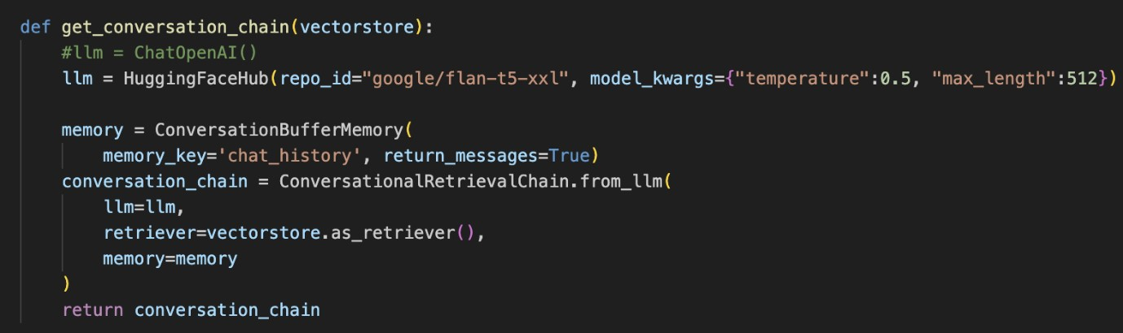

# Interface and Functionality

The design of the model is done using CSS and HTML and it’s simple and easy to use.

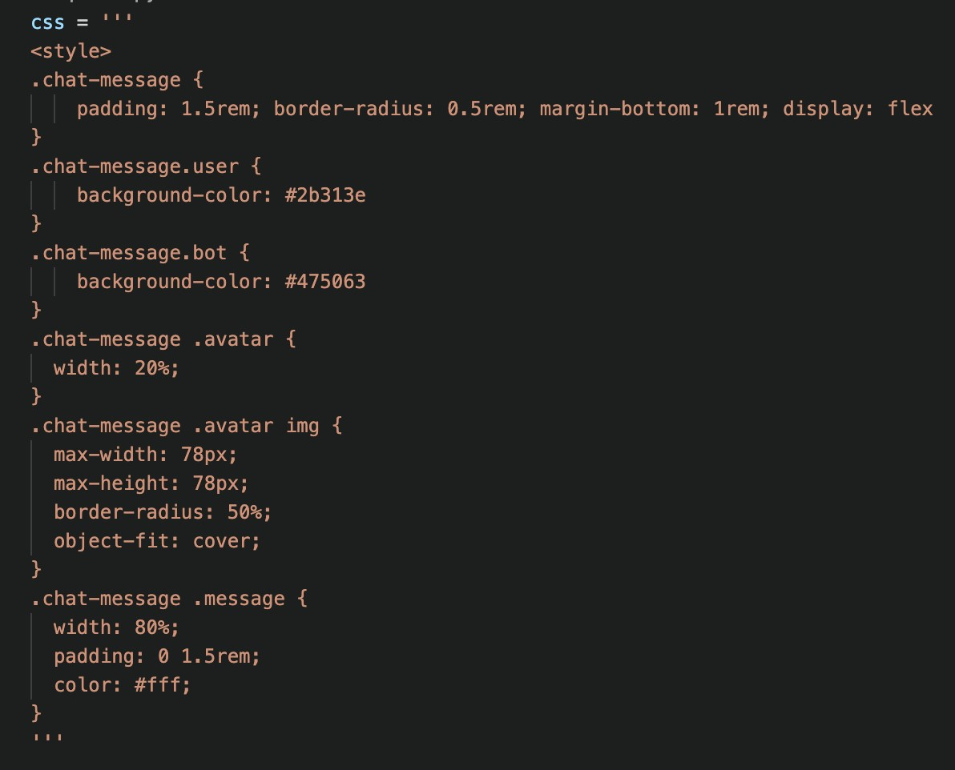

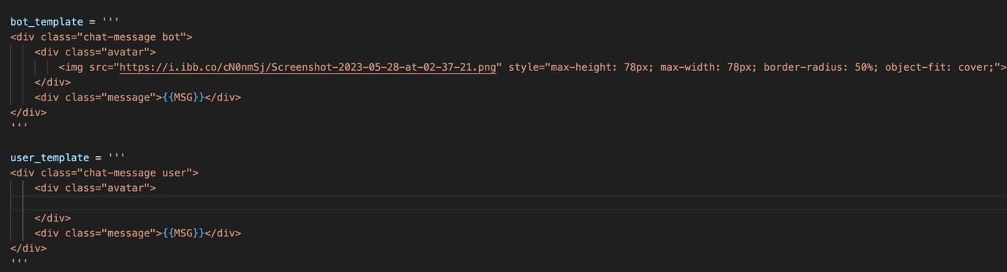

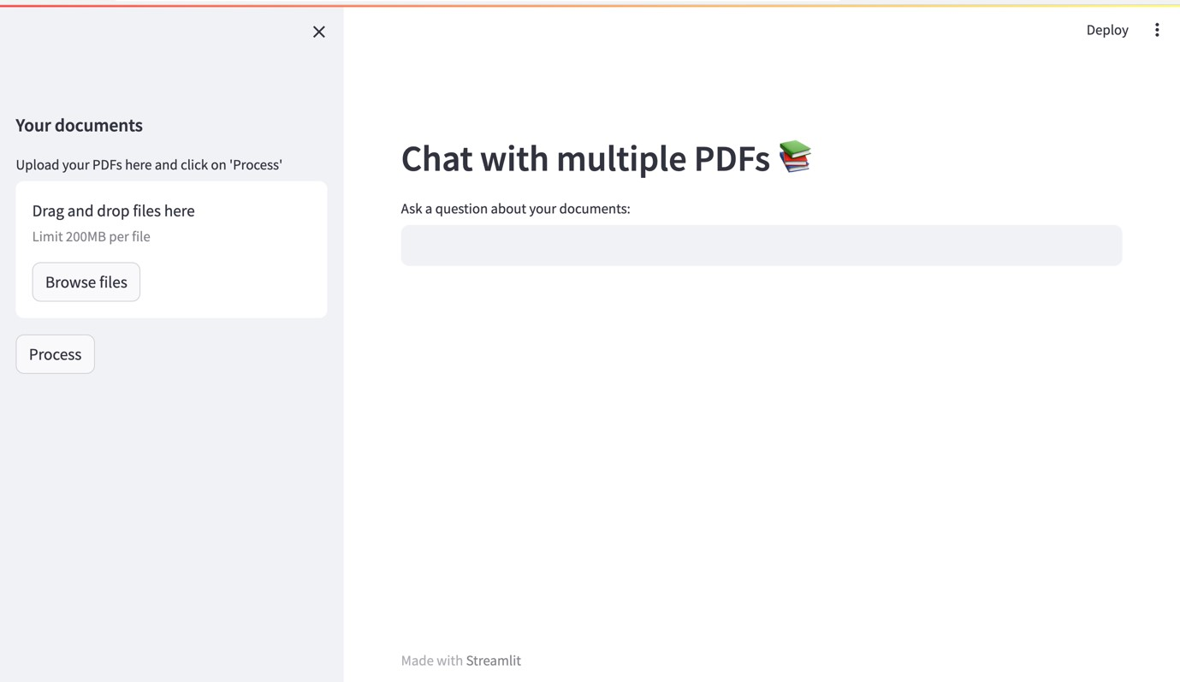

There’s a section in the left sidebar which is allocated for uploading the PDF document.

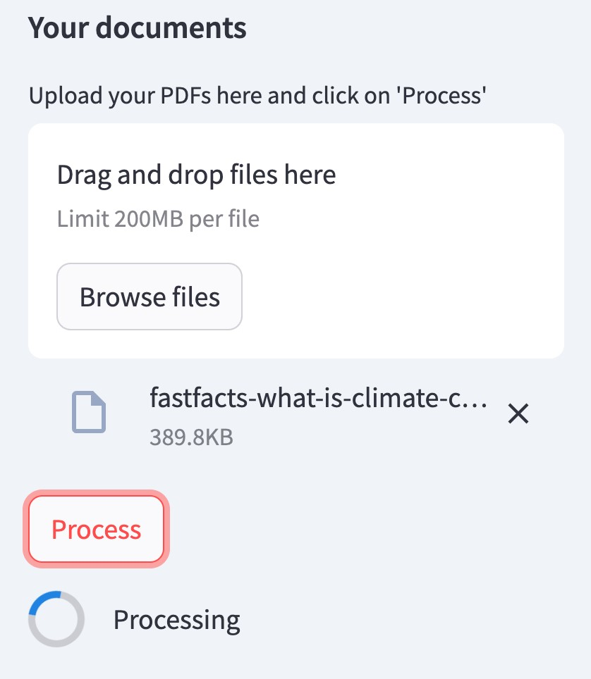

After uploading the documents, the search bar can be used to type the queries and get the response from the Pdf’s.

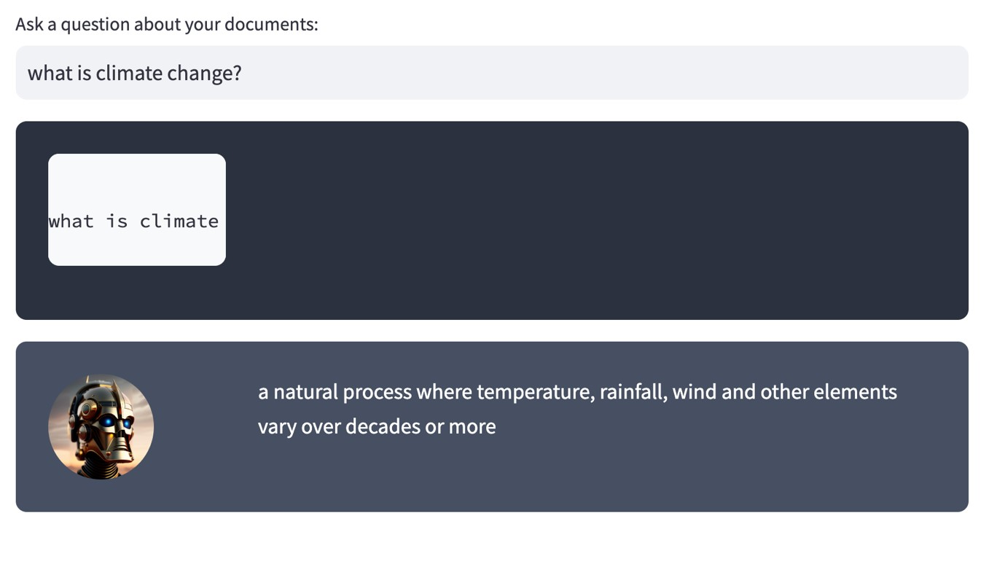

# References

1. Vin diagrams and literatures https://alpha2phi.medium.com/vim-digraphs-and-ligatures7dec3cb0a623

1. Streamlit Documentation https://docs.streamlit.io/

1. LangChain Documentation https://python.langchain.com/docs/get_started/introduction

1. Hugging Face Documentation https://huggingface.co/docs

1. Open Ai Embeddings https://platform.openai.com/docs/guides/embeddings

1. Open Ai API Reference https://platform.openai.com/docs/apireference/introduction?lang=python