PHASE 1 DELIVERABLE
Professional UI Kit and Design System
Reusable visual standards derived from the Stitch Novessa Foundation Impact Portal designs.
Project | Phase | Status | Basis
Novessa Foundation | Phase 1 | Handoff | Stitch designs + contract

Design Direction
The visual system balances trust, warmth, and operational clarity. Navy provides institutional reliability, emerald signals growth and positive outcomes, gold marks moments of action, and light surfaces keep content calm and readable.
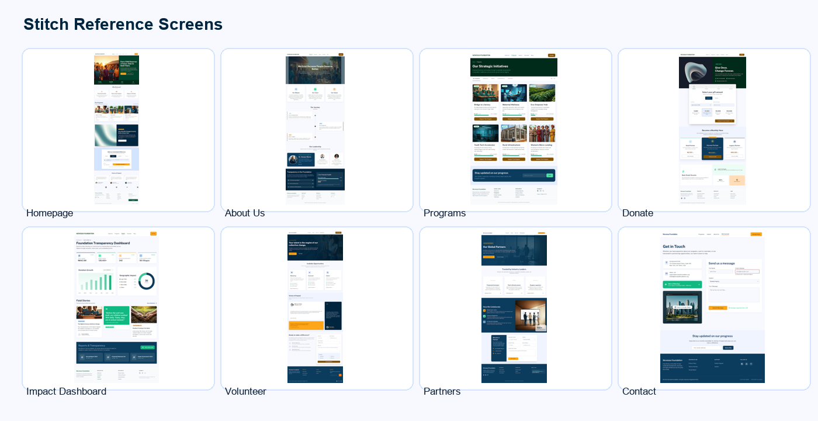

Core Tokens
Token | Value | Use
Primary navy | #00263f | Headers, primary buttons, navigation emphasis
Emerald accent | #10b981 | Positive status, impact emphasis, hover states
Gold secondary | #fea619 | Donation/payment highlights and secondary accents
Light surface | #f8f9ff | Page background and low-contrast panels
Ink | #0b1c30 | Primary copy and high-legibility labels
Border | #d3e4fe | Quiet separators and diagram boundaries

Component Guidance
Component | Design rule | Accessibility note
Navigation | Use restrained text links with a strong donate action. | Keep focus states visible and maintain keyboard order.
Cards | Use compact radius, clear image crops, and a single dominant action. | Avoid text over busy images unless contrast is guaranteed.
Forms | Group fields by user intent and keep success states explicit. | Labels must remain visible; errors should be text plus color.
Impact dashboard | Lead with metrics, then stories and reports. | Charts require labels, not color-only meaning.
Donation flow | Make amount, method, and confirmation states unmistakable. | Payment failure and success pages must be clear at first glance.

Responsive Standards
- Desktop layouts prioritize scanning, comparison, and confident next actions.
- Mobile layouts collapse into single-column flows with obvious navigation recovery.
- Buttons, form controls, and payment choices must remain large enough for touch.
- Every page should preserve the nonprofit tone: human, trustworthy, and practical.

