PHASE 1 DELIVERABLE
Sitemap and User Flow Documentation
Formal sign-off artifact for public navigation, donor conversion, volunteer onboarding, and operational handoff flows.
Project | Phase | Status | Basis
Novessa Foundation | Phase 1 | Handoff | Stitch designs + contract

Purpose
This document validates the website information architecture and core journeys promised in Phase 1. It is based on the approved Stitch visual references and the implemented Novessa web/API surface.

Public Sitemap
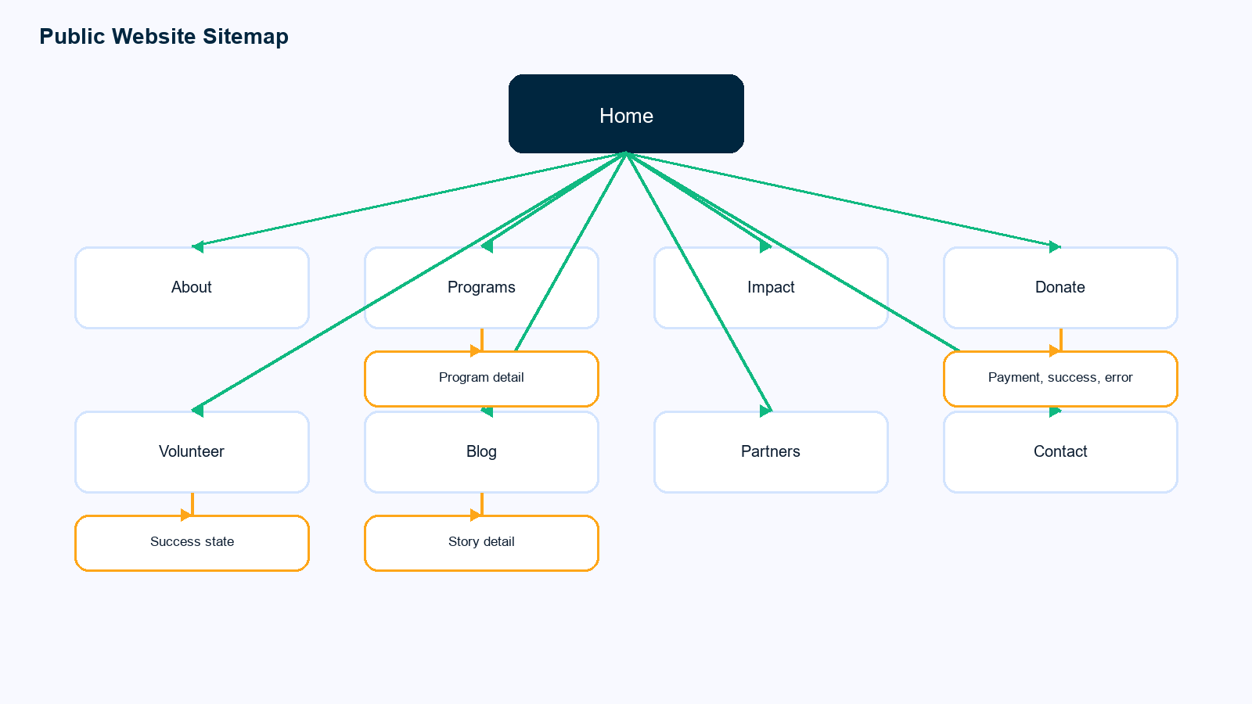
Area | Primary user intent | Success signal
Home | Understand mission and choose a next action | Visitor reaches programs, impact, donate, or volunteer paths
Programs | Browse initiatives and read program detail | Visitor can connect mission areas to concrete work
Donate | Contribute securely through Paystack | Donation checkout starts and completes with receipt
Volunteer | Offer time and skills | Application is stored with availability and confirmation email
Impact/Reports | Evaluate transparency and outcomes | Visitor can review stories, stats, and reports
Contact/Partners | Start a relationship with Novessa | Inquiry is stored for staff follow-up

Core User Flows
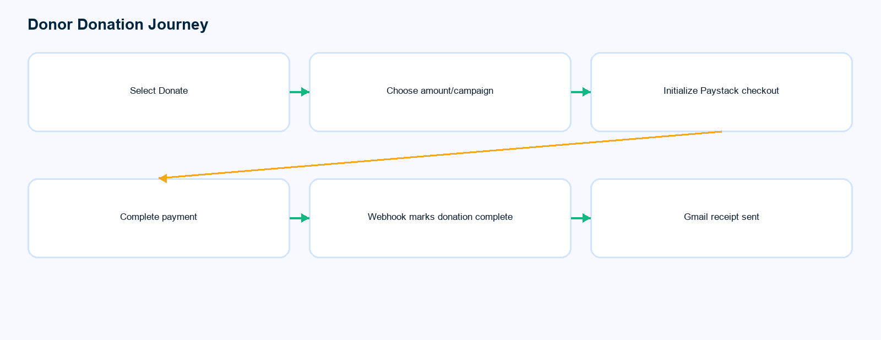
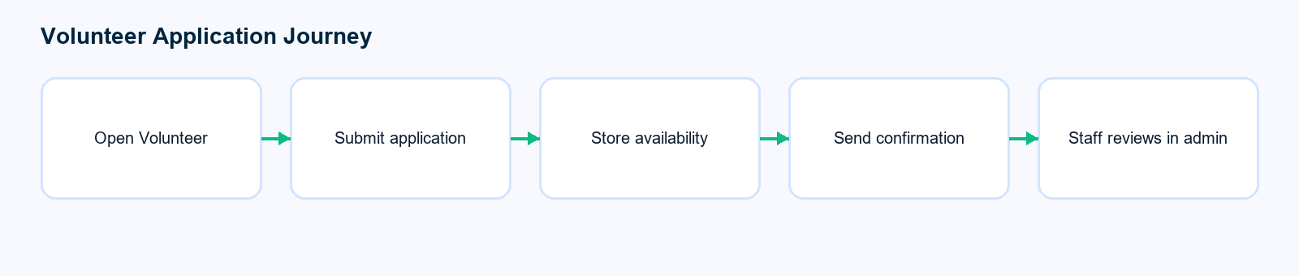
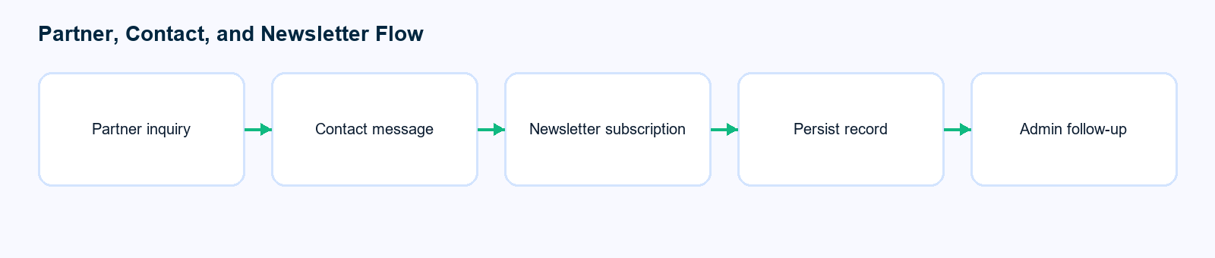
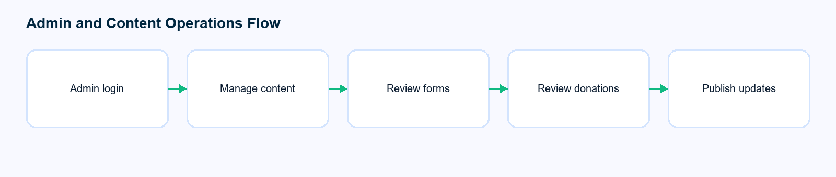

Sign-off Checklist
- Navigation covers every Phase 1 public screen promised in the contract.
- Donation, volunteer, partner, contact, and newsletter journeys each end in a clear system outcome.
- Admin operations can review content, donations, and submitted community records.
- Mobile and desktop references are represented in the handoff package.

