PHASE 1 DELIVERABLE
Technical Foundation and Architecture Report
Backend architecture, data model, payment, email, deployment, and security baseline for the Phase 1 foundation.
Project | Phase | Status | Basis
Novessa Foundation | Phase 1 | Handoff | Stitch designs + contract

Architecture Overview
Novessa uses a Next.js public web app and a Django API/admin backend. The architecture separates public engagement from operational records while keeping content, donations, forms, audit history, and outbound notifications in clear service boundaries.
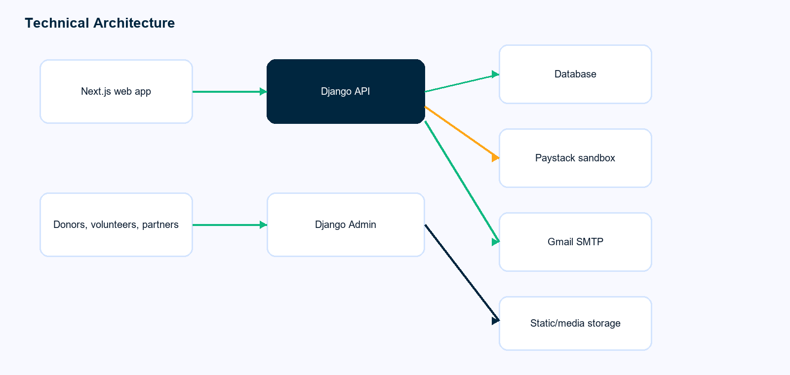

Data Model Overview
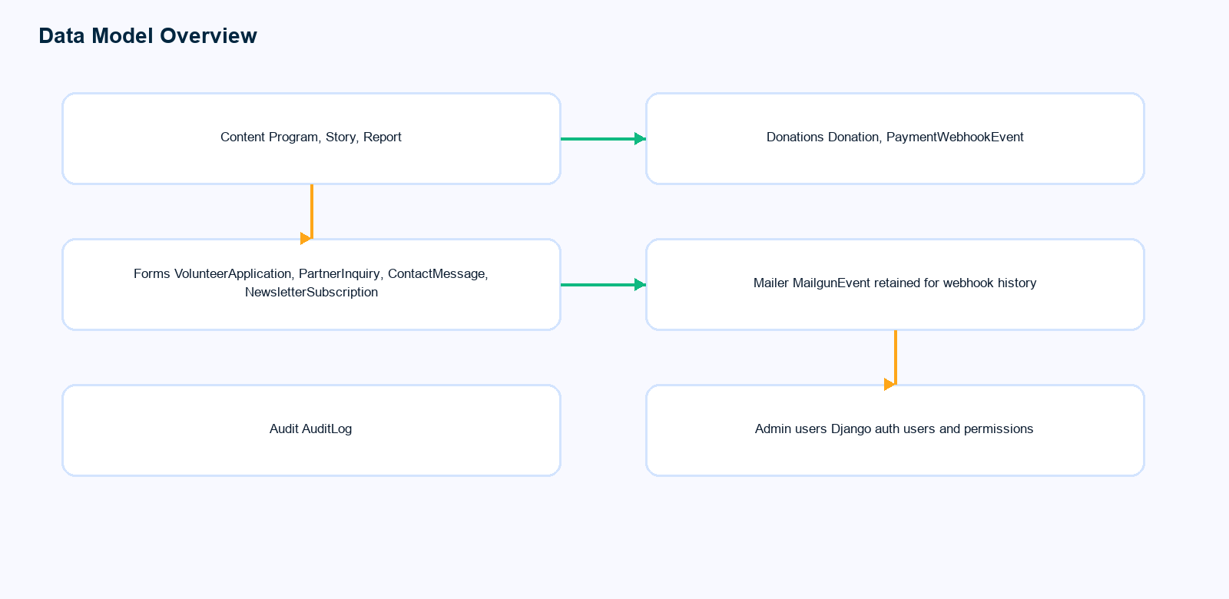
Domain | Records | Operational purpose
Content | Programs, stories, reports | Power public pages and transparency content
Donations | Donation, payment webhook event | Track donor intent, payment status, and provider references
Forms | Volunteer, partner, contact, newsletter | Capture community engagement and staff follow-up queues
Mailer | Email service plus retained Mailgun events | Send Gmail SMTP notifications while preserving webhook history if needed
Audit | AuditLog | Support operational accountability for admin activity

Payment and Email Flows
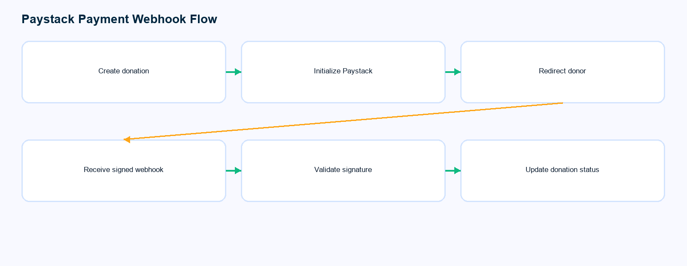
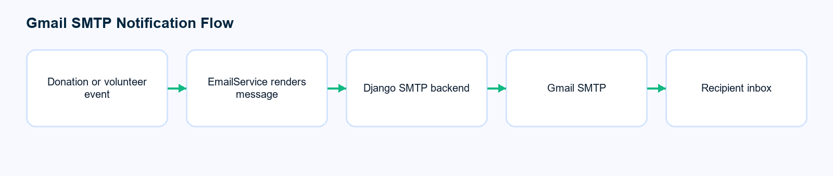

Deployment and Security Baseline
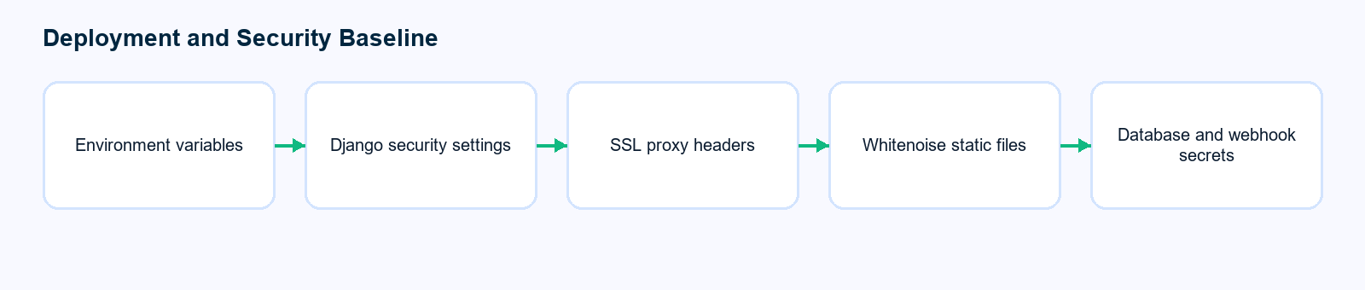
- Environment-specific secrets remain outside source control.
- Django production settings enforce SSL redirect, secure cookies, HSTS, and proxy SSL headers.
- Paystack webhook validation uses HMAC signatures before donation state changes.
- Gmail SMTP credentials are read from environment variables through Django settings.
- Whitenoise serves collected static assets for the Django admin/API deployment.

