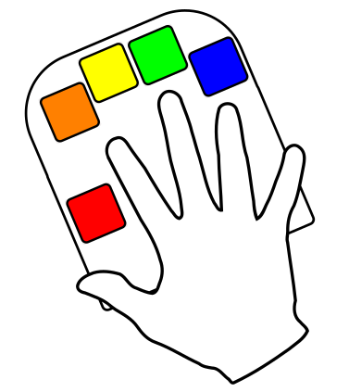
Using International Characters On The

Foreword
International characters are a complex topic, so compared to the other user documentation this document is rather dense. Development is easier on the CircuitPython-based Quirkey, so the majority of international character work is being done on that platform, and will be ported to the Arduino in due course.

What Makes It Complex?
The root of the problem is that keyboards do not return characters. They return key numbers which are then interpreted by the host computer into characters. There are three basic ways that a Quirkey can be used to enter international characters: Do nothing and let the users transpose keys or use “dead” keys, redefine the key numbers in the Quirkey’s key table to match a specific country’s keyboard layout, or get the Quirkey to provide a key sequence that tells the host computer to generate an international character using the UTF standard. All of these approaches have problems, some of which are cultural rather than technical.

How International Characters Currently Work
The Quirkey emulates a standard US USB keyboard. Characters not on the keyboard are created by simulating a series of keystrokes that enter the UTF code for that character. For this to work the Quirkey needs to be configured to match the UTF entry method the user’s operating system uses, and the operating system needs to have UTF character entry enabled. We’ll get to that in a bit, but you need to do it before international characters will work.
The Quirkey was originally designed to cater for the largest user base: the Chinese. The author is not Chinese, and had to learn how the Pīnyīn system worked. As a side-effect Pīnyīn produces a large proportion of the accents used in European languages.
To enter language mode, the Cmd-’ chord is typed. The next vowel (or letter V) typed will cause the Quirkey to wait for a single key to be clicked, and that key will determine the type of accent applied to the vowel – thumb key is “no accent.” The letter V is not used in Pīnyīn, and produces the Ü character.

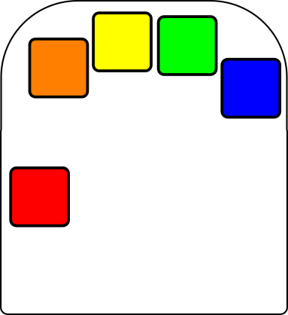
The accent keys are arranged as follows (using ‘a’ as an example):
a
ā
á
ǎ
à

Cmd-’ and a then

Characters specific to Spanish are mapped into Function Shift:
Function-N ñ
Function-Y Ñ
Function-- ¡
Function-Q ¿

Selecting The Operating System On The Quirkey
To select your operating system, you will need to edit the code.py file on the Quirkey’s file system with a text editor. This should mount just like any other file system, and code.py is in the top level directory. Find the line that says one of
systemType='linux' systemType='windows'
and change it to match your host PC. Mac is not yet supported (though perhaps we can fix that), and Android cannot be supported as it does not have a way to enter UTF character codes.

Enabling UTF Characters On The PC
Linux supports UTF character entry natively. On Windows it is, for some reason, disabled by default. To enable it on Windows 10 use Control Panel > Clock and Region > Region > Administrative tab > Change system locale button > enable Beta:Use Unicode UTF-8.
If you improve or add international character support, please comment on https://github.com/VikOlliver/Quirkey as contributions are welcome.

