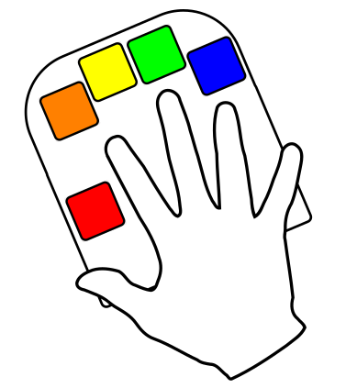
Left-hander’s Guide To The Keyboard

Hello Lefties!
Do you have a Quirkey and think “How do I use this thing?” Then you are reading the correct document.

If you do not have a Quirkey, it is probably a good idea to get one at this point, preferably a left-handed one.

You are looking for a plastic shell with six keys on it. A beginner’s Quirkey is slightly special in that each key is a different colour, but the operation is the same for all Quirkeys. If yours does not have coloured keys, use your imagination (or coloured pieces of sticky tape). Just leave it unplugged for now.

Five of these keys are arranged in the same pattern as the tips of your digits. One of them is at thumb level, but set slightly inside. It may be coloured black. This is called the “Command Key”.

Rule 1: Do not play with the Command Key.

The five keys under your digit tips are the ones you will be using to type letters, numbers, punctuation and so forth. As there are five keys, and five digits, there is no need to move your finger away from the key directly underneath it. Rest the heel your palm on the swell of the Quirkey and make yourself comfortable. Leaving your fingertips resting on the keys is fine, as long as you don’t click them just yet.
Rule 2: Your fingers do not move between keys.

Rule 2 is very important. Because neither your fingers or the keys go anywhere, you do not have to look around to see where things are. They’re right there where you left them. So once you have learned to use a Quirkey, you have also learned to touch type.

Plug It In
You’d better connect your Quirkey to the computer then. Put the Quirkey’s USB cable into the matching hole on the computer, and let your computer do whatever it does to detect a new keyboard. If your computer asks, tell it you have a standard US keyboard and no you don’t need to set up drivers or other languages thank you very much.

Sometimes computers take a few seconds longer than you would expect to recognize that the Quirkey is plugged in. We don’t know why. Computers are like that. But how do you know your Quirkey is worky?

Start some form of editing program on your computer. It doesn’t matter which one, just pick one you are familiar with. The Quirkey does not need any special setting up or fiddling about so it should work with all of them.

Are you ready to type something now? We can wait… Ok, now you’re ready we’ll start with the letter: e

This is the easiest letter. Press down gently with the pad of your index finger (that’s the one closest to your thumb) on the key under it until it goes ‘click!’
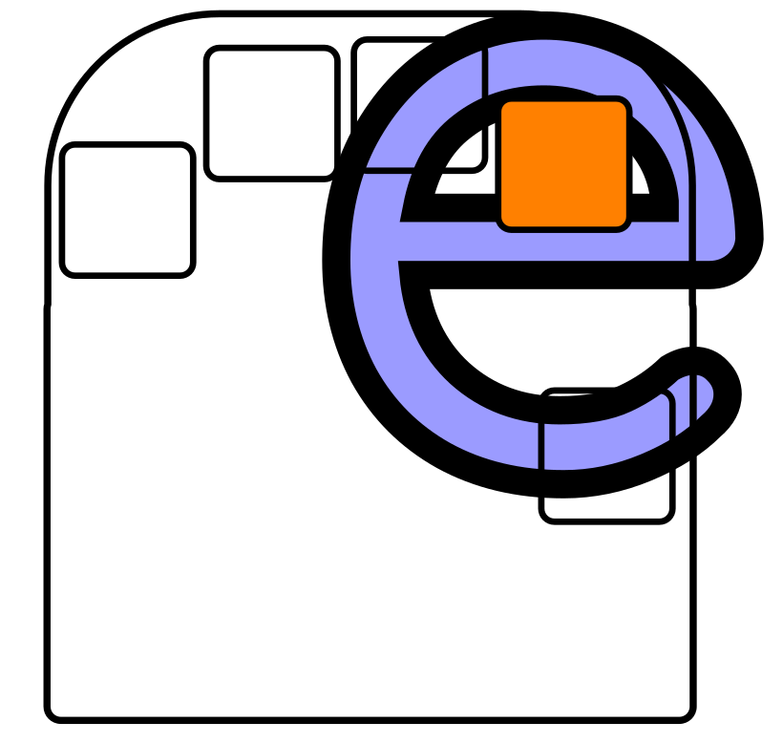

Note: Right-handers, you have not been forgotten. There is a ‘Beginners Guide’ for you too but these tutorial images are specially selected to work if you mirror them.

On a beginner’s Quirkey that will be coloured orange. Now you can lift your finger again. It should make a tinier click and an ‘e’ should appear on the screen. Do that a few times until you get the feel of it.

Now try pressing the key down, wait a second, then lift your finger. Notice how the ‘e’ only appears when you release the key? The Quirkey will only interpret your keys when you lift the last finger.

Rule 3: The Quirkey waits until you have lifted your fingers. There is no rush.
Now let’s try that on a letter that requires two keys: a

We’ve tried to represent this as the short horizontal line across the middle of a capital ‘A’ so:
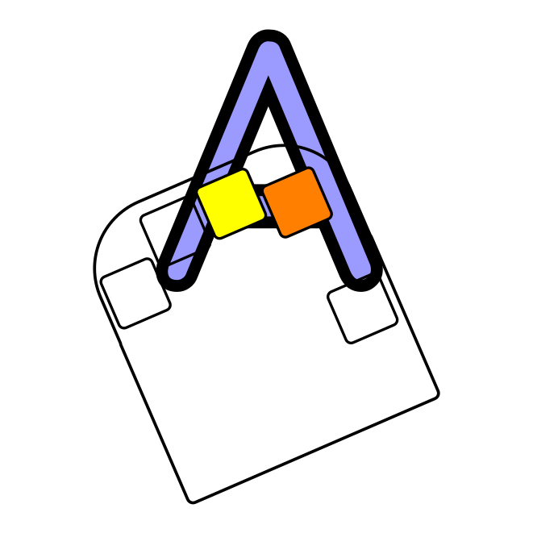
Hold down the index finger and middle finger keys at the same time – orange and yellow key if you’re playing in colour. Now lift the fingers up. No rush, remember. You should see ‘a’ appearing next to all your e’s. Now you can type aeaeae, which is an improvement.

NEWSFLASH - Getting Unstuck
There is a chance that by banging the wrong keys, your Quirkey keyboard will start doing things that you didn’t expect, like writing EVERYTHING IN UPPER CASE, or numb3r5 and $ymbols, or becoming a mouse. It’s nice to know it can do these things, and we will get there later.

For now though, should this happen to you, here is the recipe for getting unstuck:

1. Don’t panic.

2. Hold down all four finger keys at the same time. Let them go.

3. Hold down Both thumb keys at the same time. Let them go.

This will undo everything that the Quirkey might do. If your computer is still misbehaving, it’s not the Quirkey that’s doing it.

We now return you to your scheduled broadcast.

Time For A ‘P’
Enough of these vowels. Let’s have a consonant: p

This time we will exercise all your fingers and your thumb, just keep your thumb away from the Command Key! Ok, push down all the main five keys at once, and then lift your fingers back up. You have just p’d.

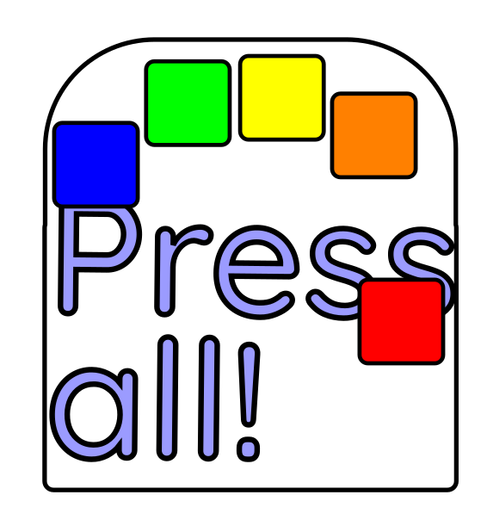

If you didn’t get a ‘p’ try again, just take it easy and make sure you have held all the keys down – it’s possible you missed one. Or two. See, it works.
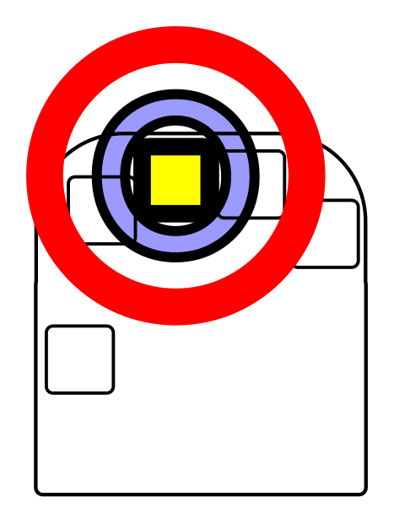
You can now type your first word: pea

Well, it probably looks more like eeeeeaaaeappea and you will want to know that you can add spaces by clicking just the thumb key – but Rule 1, don’t touch the Command Key!!!

Great, you can type ‘pea ape’ – so easy you can do it with your eyes closed. I bet you are itching to try out all the individual finger keys, probably with your eyes open again. Go on, get it out of your system. Start with the o right on the middle finger like the centre of a target. Have fun, see you in the next chapter.

The
The time has come to learn the most common word in the English language: the. We’ll start with the ‘T’ which uses the index and ring finger keys (orange and green if you’re typing on a rainbow Quirkey). We think it looks a bit like the line across the top of a capital ‘T’ like this:
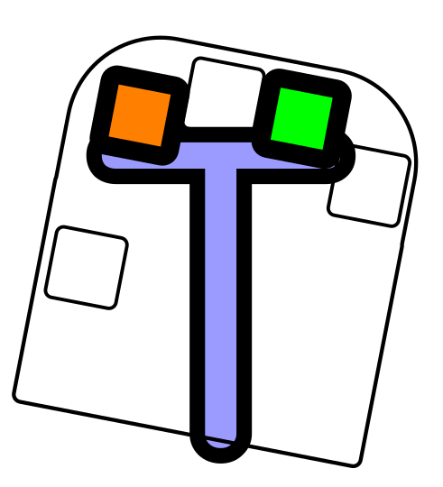
Your ‘T’ will be a lower case ‘t’ though, which is something we’ll fix in the next chapter so hold that thought. You can now type “potato” (or “eat a toe” which is mildly disturbing but progress of a sort).
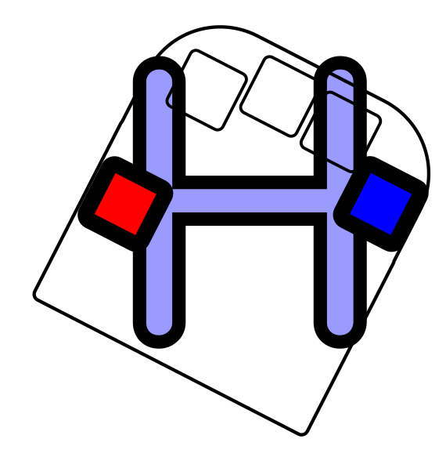
Now for ‘H’ which again has a line going right across the middle of it, but slightly lower down (red and blue for those with colours). So we picture it as this, with the thumb and little finger keys:
The ‘th’ sequence is worth learning to do quickly as they appear together a lot. Can you type “the potato” with your eyes closed? When you can, go to the next chapter and we’ll show you how to get into and out of trouble with Rule 1.

Breaking Rule 1
About that Command Key. It can do many things, and the reason you’ve been subtly discouraged from playing with it is that you also need to be able to undo those things. Let us start with the simplest thing it does.
You now have permission to click The Command Key. Once.
No smoke? Fire? Things from The Dungeon Dimensions? Good.
So what has happened then?
If you try typing a ‘T’ now you will get a ‘T’ not a ‘t’! Keep typing ‘he’ and you end up with ‘The’. So pressing the Command Key once will make the next letter a capital letter. Basically it does exactly the same as the shift key on your old keyboard.
But wait, there’s more. Let’s try that again, but first press the Command Key twice. Now type ‘the’. See? EVERYTHING IS IN CAPITALS. HELP! I’M STUCK IN CAPITALS HOW DO I GET OUT?
And that is why Rule 1.
You have locked in a shift. There are several other types of shift that the Command Key can get you into, but the way to clear them all is the same:
Press the thumb key and the Command Key at the same time. This can take a bit of getting used to, to be honest, but listen for both switches clicking and you’ll figure it out. At worst, you’ll accidentally type a space, so feel free to have at it several times. So, to summarize:
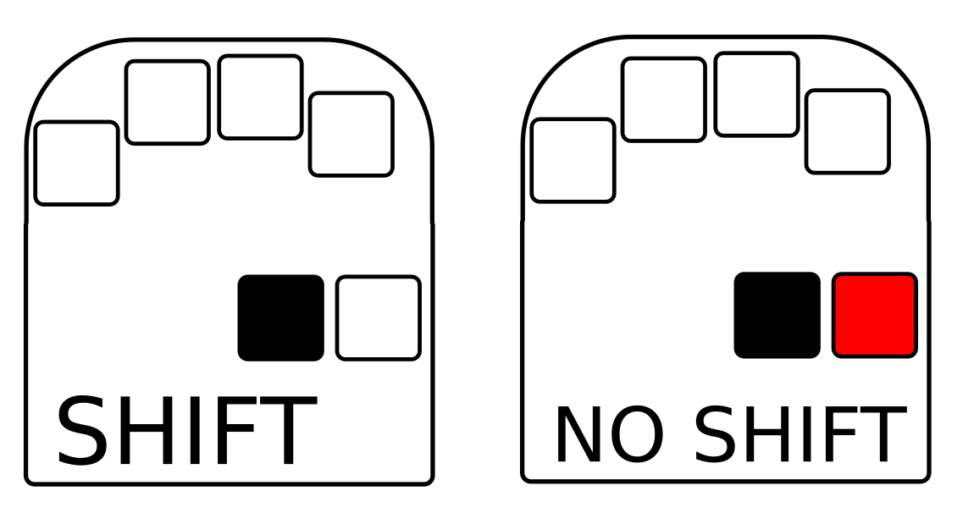
Now you can start a sentence with a capital letter. With that taken care of, and now we know how to get out of weird shift states that make the Quirkey do “funny things to my computer” we can let you loose on the rest of the alphabet, and some other common command combinations, like the Enter and Delete keys on the bottom row. Study the Delete key because you’ll likely be using it quite a bit as you learn to type all over again!
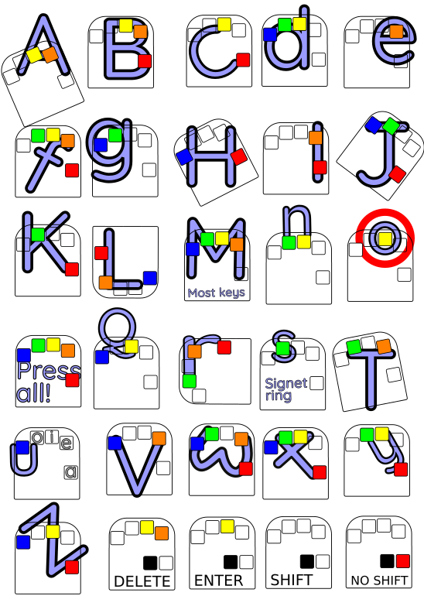
If you print this out and trim it to size, you can stick it on the desk next to your Quirkey. That keyboard in the way? Well, move it somewhere else, you might not be needing it for much longer anyway…

Getting To The Point .
What we need to be able to do now is to finish the sentence with a full stop, or as some countries say, a period.
As you have probably worked out by now, there are only 31 characters that can be typed by using combinations of five keys. The alphabet has 26, you’ve found the space character, that leaves us with 4 key combinations before we have to start using the more advanced “Command Key shifts” (spoiler alert: that’s in the next chapter). Those remaining 4 combinations have been used for the most common punctuation symbols:
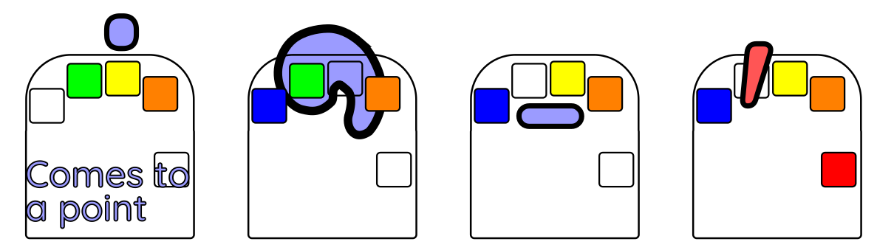
As well as the full stop we have a comma, hyphen and apostrophe. These are the last characters you have to learn for regular typing, so it’s worth the effort.
Quick note: If you have turned on Shift, your computer will think that you have pressed the shift key when you type .,-’ so will do exactly the same thing as your regular keyboard would do and come up with ><_”
So take the time to practice what you’ve learned. Once you can manage the alphabet – while only peeking a little bit anyway – you are ready to take on the next chapter where we will learn to count.

Counting On Command
Now you’ve got the hang of the Command Key for capitals and a few basic essentials, it’s time to take it to the next level: Numbers.
Trust me, learning to count on a Quirkey is a heck of a lot easier than learning all the letters of the alphabet!
To make things easy to remember, the command to turn on numbers is based on the letter ‘N’. What we do here is to use the Command-N combination, which is just like typing a regular ‘N’ but you also press the Command Key like this:
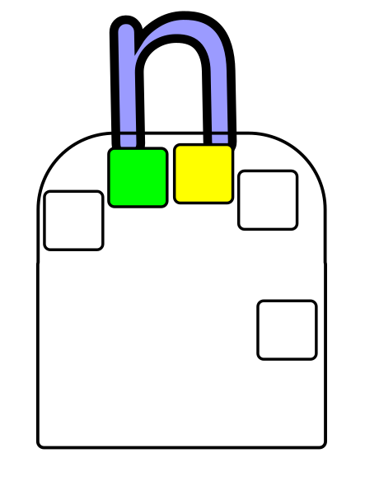
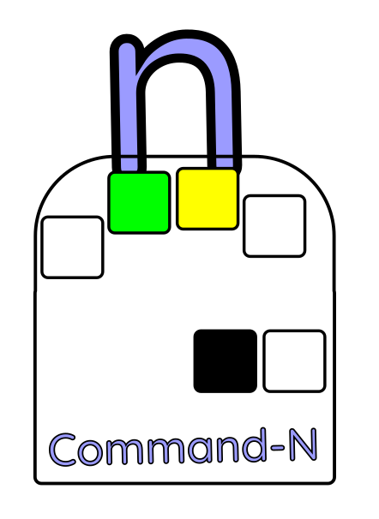
You have already discovered that use the Command Key to turn on Shift will only affect the next character. Pressing Command-N once does exactly the same thing.
Pressing Command-N twice will leave you in Number Shift until you hit the No Shift (that was the tricky both thumb keys at once manoeuvre, just to jog your memory).
So hit Command-N twice, and we’ll go back to the editor on your computer to try it out.
The first number we’ll do is zero. Why? Because it is the same key combination as ‘O’ and you know that one. Try it. Middle finger, remember.
Because you will often be typing spaces along with the numbers, the thumb key will still produce a space. For your convenience, other useful combinations like full stop, delete and enter also work just as they did before.
With Numeric Shift in operation, we have a whole new set of key combinations that we can use for punctuation and so forth. But for the moment we will concentrate on the rest of the numbers.
As the thumb is spoken for already, we have to start at number one with our index finger, which is how most people count anyway. Two is the thumb and index finger, and for number three we add in the middle finger and so on:
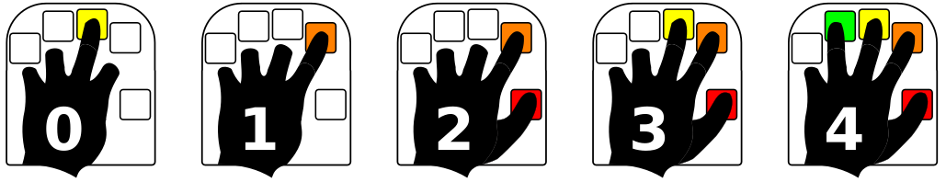
Now try it: 0123
Great, now everyone knows the code to my suitcase lock.
When we get to five, we run out of keys, so we just start counting on our fingers the other way like this:
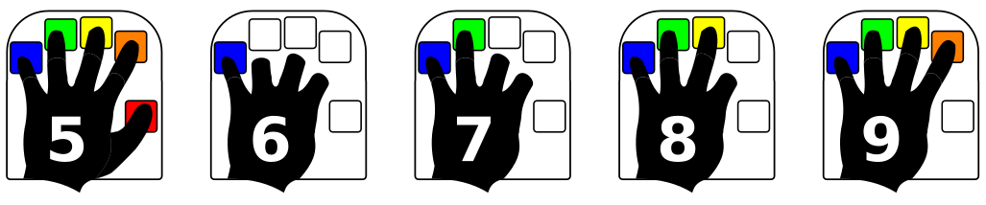
Note: Numeric Shift is not the same thing as the Num Lock key on your ordinary keyboard. As the Quirkey does not have a numeric keypad, the Num Lock is not really applicable. We’ll get to Pg Up, End, and cursor movement in a chapter or so.

Shifty Punctuation
While it’s called Numeric Shift, it should probably have been called Numbers And Symbols Shift. There are so many symbols, in fact, that we haven’t got room for them all on this handy cut-out-and-keep cheat sheet:
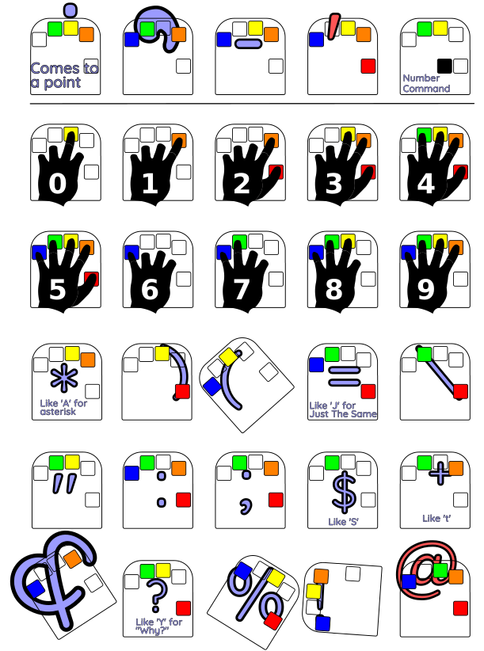
As for the others, you can find a full list at the back of this guide.
But, as the Quirkey behaves as a standard PC keyboard, the Shift key also works together with the Numeric Shift. This means that if you Shift the number one, just like on a standard keyboard, you get a ‘!’

Commanding The Quirkey
For those just wishing to type in some text, the manual so far has probably given you enough information to get on with things. The Quirkey though, can function as all the other keys on your standard keyboard. You know, the cursor arrows, PgUp, PgDn, function keys, tab, and the rest.
You’ve met some of these already: Enter and Delete for example. Command-D for Delete – pressing the Command Key together with the other two keys for the letter ‘D’. The “Tab” key is a new one for you: Command-T. All these represent a single key pressed, with no lingering after effects.
Some Commands put the keyboard into a different mode, allowing you to type a whole new range of characters instead of just letters. Command-N is one you’ve used in the previous chapter to switch into Numeric Mode.
Even on a standard keyboard there are a multitude of shift keys, control keys, alt keys and so forth that are needed to make computers do the things that they do. It’s a bit complicated. In fact if you’ve just been ploughing through this guide, your eyes may be glazing over at this point, so take a break and have a beverage of your choice.
Refreshed? Right, let’s plough on.
There are some things we do an awful lot on the computer, like deleting our mitsakes. We’ve tried to arrange these more common tasks so you can get to them quickly, like Command-D. The rest we have to get to by using cousins of Numeric Shift.
Let’s start with the easier, commonly used ones and leave the . Moving the cursor around the screen to edit text is a useful place to start.
Type in a couple of lines of text in your editor program, and try out Command-K. By now you should remember what keys to press for ‘K’, or at least have a copy of the cheat sheet to hand, so we’ll dispense with the keyboard diagrams for now. Every time you press Command-K the cursor moves bacK one character, exactly like it does when you press the left arrow cursor key on a standard keyboard.
So how do you think you’d move Forward? Yes, Command-F. BacK and Forth. You’ll be relieved to hear that all the movements left and right on a line are based on the same letters.

Larger movements Jump back and Zip forward. So to move the cursor up to the previous line we use Command-J, and to move down to the next line we use Command-Z. So to summarize with a picture:



Command
Jump back
Command  BacK |  | Command  Forth
Command
Zip forward

Extra Big Movements
Moving around one line or character at a time is something that you do on a regular basis when using the computer, so we put those actions in as Commands so you can get to them fairly quickly. However, there are only so many commands we can put on five keys, and so there is a different way to move by many lines or characters – don’t worry though, because we used the same letters to make it easier to remember.
Enter the ‘Extra Shift’ for extra big movement: Command-H. As with all shifts, you can hit it twice to lock it on, and clear it by pressing both Thumb Keys. With Extra Shift switched on, the letter ‘K’ will behave like the Home key, and take you to the beginning of a line. Try it out. We call this combination ‘Extra-K’.
In the same way ‘Extra-F’, ‘Extra-J’ and ‘Extra-Z’ take the place of End, PgUp and PgDn. This diagram should clear it up:

PgUp
Extra-Jump back
Home Extra-BacK |  | Extra-Forth End
Extra-Zip forward
PgDn

There are other useful keys in there, like Extra-E being the ESC key, and Extra-( giving a ‘[‘. A full list is given in the Quirkey Key Tables at the end of this document.

Functioning Function Keys And Control
Along the top of an old-fashioned PC keyboard are the function keys; F1, F2, F3 and so forth. Microsoft applications are particularly fond of using these, so we have added Command-L as a way to use them.
This works exactly the same way as Numeric Shift, but with ‘1’ giving you FI, F2 giving F2, and so forth. You can also hit Command-L twice to lock it on, and clear it with both Thumb Keys, but frankly we haven’t had an opportunity to use that capability!
Now, those old-fashioned keyboards have a limited supply of function keys, and so PC applications tend to add even more shortcuts using Shift-[function key] and Ctrl-[function key]. Well, the Quirkey’s Shift key works as expected – you can press it before or after using Control-L. But the “Ctrl” key? Yes, the Quirkey can do that as well.
Control Mode is achieved by typing Command-X, and as with the other modes you can hit it twice to lock it on, and hit both thumb keys to turn it off. On most systems Ctrl+direction moves in that direction by one word, and to make life easy, you don’t have to lock Control Mode on if you’re just moving word by word. You do have to turn it off though!

Note to Mac Users
Apple users may be going “What function keys?” In their infinite wisdom, Apple chose to make their keyboards differently to the rest of the world. They have named some of their keys differently, and in some cases use the same name for a different key! To avoid confusing the heck out of everyone here, the details are in the “What About Macs?” chapter.

What About Macs?
You have a Mac? Our condolences. They have labelled their keys in a very confusing way, but rest assured that the Quirkey can do them all. Here is the conversion table between Mac keyboard terms and PC keyboard terms:

Mac Key | Windows Key
Control | Ctrl
Option | Alt
Command (cloverleaf) | Windows
Delete | Backspace
Return | Enter

That “Windows” key is ironic. About the only time you really need it is when using a Mac! To access it use Extra+W
And just in case you were wondering, why yes. This manual was indeed typed in only using a Quirkey, both left- and right-handed versions.
This document is copyright 2024 by vik@diamondage.co.nz and is released under the terms of the GNU user-friendly GFDL 3.0 or later. Basically you can share it around to your heart’s content.

Quirkey Key Tables
This is the list of keys that can be produced with a Quirkey. Where it makes a difference, characters are shown without and with Shift for clarity.

Key | Numeric | Extra | Function
a A | * |  | F11
b B | 8 * |  | F8
c C | ( | [ {
d D | 3 # | DELETE | F3
e E | 1 ! | ESC | F1
f F | 4 $ | END | F4
g G | 7 & |  | F7
h H | - _
i I | 2 @ |  | F2
j J | = + | PG UP
k K | / ? | HOME
l L | #
m M | 9 ( |  | F9
n N | “ | \ |
o O | 0 ) |  | F10
p P | 5 % |  | F5
q Q | ) | ] }
r R | ; :
s S | $
t T | +
u U | 6 ^ |  | F6
v V | &
w W | : | WINDOWS
x X | ` ~
y Y | ?
z Z | % | PG DOWN
. > | . > |  | F12
, < | , <
- _ | !
‘ “ | @
SPACE | SPACE

Numeric Command-N
Extra Command-H
Function Command-V

Quirkey Command Functions

These Command functions are created from a Quirkey letter code that uses the Thumb Key, but when prefixed with Command- or Cmd- indicate that the Command Key is used in place of the Thumb Key (or in some cases in addition to all the other keys used for that letter).

For Command functions that shift into a different character set (like tapping the Command key twice to produce capital letters) pressing the Command sequence twice will "lock" that shift mode for all subsequent characters.

A few oddball functions will use both the Thumb and Command keys. The most frequent use is to press both at the same time to clear all current shift functions.

Shift modes may be stacked. For example, using Shift and Numeric Shift while
typing "-" will produce "_", and using Shift with Extra Shift while typing “[“ will produce “{“ much the way the original characters on a standard keyboard behave with Shift depressed.

Cmd Shift key (actual keyboard Shift key, but lockable)
Cmd-C Enter
Cmd-D Delete
Cmd-F Cursor right (Forward)
Cmd-H Extra Shift – extra large cursor movements
Cmd-I Insert
Cmd-J Cursor up (Actually Cmd-Y but mnemonic for “Jump back”)
Cmd-K Cursor left (bacK)
Cmd-L Function keys shift
Cmd-N Numeric shift (actually Cmd-Y but easier to remember)
Cmd-P Alt key shift (actual keyboard Left Alt)
Cmd-T Tab (actually Cmd-R but more mnemonic)
Cmd-X Command key shift (actual keyboard Ctrl)
Cmd-Z Cursor down (mnemonically at the bottom of the alphabet)

The Extra Shift
The Extra Shift is used primarily to emulate keys in the numeric/movement portion of a standard keyboard, as well as a few characters that seemed appropriate. Extra Shift will lock if pressed twice. It modifies the following character to perform as follows:
Extra-C [ (Note: similar to Numeric Shift generating a ‘(‘ character)
Extra-D DEL key (usually used for forward delete)
Extra-E ESC key
Extra-F END key (similar to Cmd-F used for right arrow)
Extra-J Page Up
Extra-V \
Extra-Q ] (Note: similar to Numeric Shift generating a ‘)’ character)
Extra-Z Page Down

Oddball Key Combinations and Mouse
Other than clearing the shifts, there are some oddball chords that use both the thumb keys simultaneously. Oddball-J is the ALTGR (Right Alt key) shift (which is needed to get to accented characters on some systems), and Oddball-I enters mouse mode. Mouse mode does not emulate all functions of a mouse, but Shift may be locked before entering mouse mode:
Right 1st finger
Left Pinkie
Up Index finger
Down Ring finger
Left button Thumb
Right button Command
Pressing all 4 finger keys will exit mouse mode. Mouse mode is not meant to be used constantly, only to rescue keyboard-only users when poorly-designed software insists users click with a mouse.

