GridEval: Technical Architecture, Codebase Breakdown & Empirical Benchmark Results
Comprehensive Research Documentation, Model Specifications, Code Analysis, and Calibration Significance
Live Deployed Application: https://grideval-5x6uktiqevdmtugeqgxm6l.streamlit.app/
Author: Vikash Rathore | Platform: GridEval Benchmarking Framework
Executive Summary
GridEval is a standardized empirical benchmarking harness designed to evaluate the operational trade-offs between domain-trained classical Machine Learning models (LightGBM, XGBoost, Prophet, Persistence) and pre-trained zero-shot Time Series Foundation Models (Amazon Chronos-T5) for electricity load forecasting. The benchmark is evaluated across two distinct grid scales: ERCOT (Texas macro-grid, 70 GW peak) and GEFCom 2017 (ISO-NE Connecticut zonal grid, 4 GW peak), assessing both point forecasting accuracy (MAE, RMSE, MAPE) and probabilistic uncertainty calibration (CRPS, 90% PICP, MPIW, ECE).

1. Codebase Architecture & File-by-File Breakdown
The GridEval repository is structured modularly to separate raw data ingestion, feature transformation, model execution, evaluation metrics, and interactive visualization. Below is a detailed breakdown of every component and file in the codebase:

src/baselines.py
Role: Classical Supervised & Heuristic Baseline Models
Implements the end-to-end training and inference pipeline for tabular supervised models (LightGBM, XGBoost) and heuristic baselines (Prophet, 168-hour Naive Persistence). Features include 5-lag autoregression, rolling 24h/168h statistical moments, calendar/holiday encodings, and non-linear temperature interactions. Contains `train_and_evaluate_baselines()` and `run_baselines_for_dataset()`, returning unified point metric dictionaries (MAE, RMSE, MAPE).

src/tsfm_models.py
Role: Foundation Model Pipeline & Rolling Inference
Wraps the Amazon Chronos-T5 (Small) zero-shot transformer pipeline. Implements `load_chronos_pipeline()` which manages torch device placement (CUDA vs CPU) and fp32/fp16 precision. Contains `rolling_tsfm_evaluation()`, which executes batched rolling-origin inference across the test year using 24-hour step sizes and arbitrary context lengths (72h to 1000h), extracting both median forecasts and full sample paths (100 samples) for probabilistic analysis.

src/features.py
Role: Feature Engineering & Temporal Transformations
Generates domain-specific tabular feature matrices for ML models. Computes autoregressive lag features (t-1, t-2, t-3, t-24, t-168), rolling window aggregates (24h, 168h mean and standard deviation with zero-lookahead shift), cyclical temporal encodings (hour of day, day of week, day of year via sine/cosine transforms), binary holiday indicators, and non-linear temperature interaction features (temperature squared, dewpoint depression).

src/evaluation.py
Role: Vectorized Evaluation Metrics & Statistical Scores
Houses the centralized evaluation suite. Implements `compute_point_metrics()` (MAE, RMSE, MAPE), `compute_crps()` (Continuous Ranked Probability Score using sample empirical CDFs), `compute_picp()` (Prediction Interval Coverage Probability for nominal 90% bounds), `compute_interval_width()` (Mean Prediction Interval Width), and `compute_ece_and_reliability()` (Expected Calibration Error across 19 quantiles: 0.05 to 0.95).

src/data_loader.py
Role: Chronological Data Partitioning & Ingestion
Handles loading, schema validation, and chronological splitting of ERCOT (2020-2024) and GEFCom 2017 (2012-2016) hourly datasets. Enforces a strict 3-1-1 chronological split (3 years Train, 1 year Validation/Tuning, 1 year Out-of-Sample Test) to guarantee zero temporal data leakage.

src/run_calibration.py
Role: Probabilistic Calibration & Conformal Suite
Executes the full probabilistic benchmark comparing LightGBM Quantile Regression, XGBoost Quantile Regression, Prophet Additive Intervals, and Chronos-T5 Zero-Shot Predictive Distributions. Generates empirical calibration curves, computes CRPS, 90% PICP, MPIW, and ECE, and exports reliability plots to `results/plots/`.

src/run_tsfm_sweep.py
Role: Context Length Ablation & Scaling Sweep
Performs parametric scaling experiments evaluating Chronos-T5 zero-shot performance across historical context lengths of 72h (3 days), 168h (1 week), 512h (~3 weeks), and 1,000h (~6 weeks). Analyzes error reduction plateaus and inference latency scaling.

src/baseline_summary.py
Role: Terminal Summary Table Formatter
Lightweight standalone utility that reads compiled JSON/CSV results and formats clean ASCII comparison tables directly to the developer terminal, allowing instant verification without starting a web server.

src/main.py
Role: Master Experiment Orchestrator & Table Compiler
Top-level CLI controller. Supports `--skip-existing` (runs only pending benchmark pipelines) and `--compile-only` (aggregates JSON run artifacts into master CSV summary tables: `results/master_table.csv` and `results/calibration_master.csv`). Features lazy module imports to eliminate startup latency.

src/utils.py
Role: Reproducibility & Seed Management Utilities
Implements `set_all_seeds()` to ensure deterministic benchmark reproduction by locking seeds across Python hash seed, `random`, `numpy`, and `torch` (CUDA backend determinism enabled).

src/experiments.py
Role: Experiment Execution Wrapper & Logging
Manages artifact serialization, execution timing, JSON metadata export, and structured status logging for each benchmark experiment pipeline.

src/pipelines/ (baselines.py, tsfm.py, calibration.py)
Role: Decoupled Pipeline Runners
Modular pipeline entry points consumed dynamically by `src/main.py` to allow isolated execution and testing of specific benchmark components.

app.py
Role: Interactive Streamlit Web Dashboard
Full-featured interactive web application (639 lines) structured into 5 tabs: Leaderboard comparison, Interactive trajectory viewer with seasonal presets, Calibration reliability curves, Context length scaling curves, and a Live scenario stress-testing engine with temperature shock and load growth sliders.

run_dashboard.py
Role: Local Launcher Bridge
Automated launcher script that boots the Streamlit server and handles port detection and browser launching in WSL2 and local developer environments.

pyproject.toml & requirements.txt
Role: Package Management & Deployment Manifests
`pyproject.toml` manages build metadata and local development environments. `requirements.txt` provides lightweight, pre-compiled binary wheel dependencies for instantaneous cloud deployment on Streamlit Community Cloud.

2. Description of Evaluated Models

LightGBM & XGBoost (Quantile Gradient Boosted Trees)
Paradigm: Domain-Trained Supervised Learning
Gradient Boosted Decision Trees trained with asymmetric pinball loss across target quantiles alpha = [0.05, 0.50, 0.95]. The models learn non-linear interactions between autoregressive demand lags, calendar harmonics, and ambient weather. GBDTs serve as the state-of-the-art domain baseline due to their high sample efficiency, tree-based split invariance, and ability to handle tabular multi-scale seasonality without overfitting.

Amazon Chronos-T5 (Small)
Paradigm: Zero-Shot Time Series Foundation Model (TSFM)
A 46M-parameter encoder-decoder Transformer architecture based on T5, pre-trained on tens of billions of time-series observations across diverse domains. It tokenizes continuous univariate time series into discrete vocabularies via mean-scaling and quantization, optimizing cross-entropy loss. Evaluated strictly zero-shot (no fine-tuning or parameter updates on grid data), predicting a 24-hour horizon given 72h to 1000h historical context.

Prophet (Facebook / Meta)
Paradigm: Generalized Additive Statistical Model
A decomposable time-series model combining non-linear trend changepoints, Fourier series for multi-period seasonality (weekly and yearly), and user-defined holiday effects. Evaluated using standard MCMC sampling / MAP estimation to extract predictive median forecasts and parametric uncertainty intervals.

168-Hour Naive Seasonal Persistence
Paradigm: Deterministic Heuristic Baseline
A zero-parameter benchmark that projects demand at hour t to equal observed demand at hour t-168 (exactly one week prior). This captures baseline weekly cyclic behavior and establishes the minimum performance floor that any machine learning system must substantially surpass.

3. Empirical Benchmark Results
All models were evaluated over 8,760 out-of-sample test hours across both power grids. Below are the consolidated point accuracy and probabilistic calibration results:

Table 1: Point Forecasting Accuracy (Out-of-Sample Test Year)
Grid | Model | Paradigm | MAE (MW) | RMSE (MW) | MAPE (%)
ERCOT | LightGBM | Classical ML | 505.53 | 798.08 | 0.90%
ERCOT | XGBoost | Classical ML | 506.45 | 825.49 | 0.90%
ERCOT | Chronos-T5-Small (512h) | Zero-Shot TSFM | 1921.32 | 2976.93 | 3.61%
ERCOT | Naive Seasonal (168h) | Baseline | 4478.53 | 6274.29 | 8.38%
ERCOT | Prophet | Classical ML | 5304.77 | 6935.90 | 9.75%
GEFCom | XGBoost | Classical ML | 32.67 | 44.39 | 0.96%
GEFCom | LightGBM | Classical ML | 32.73 | 44.67 | 0.96%
GEFCom | Chronos-T5-Small (512h) | Zero-Shot TSFM | 154.85 | 239.50 | 4.28%
GEFCom | Naive Seasonal (168h) | Baseline | 343.37 | 491.25 | 9.69%
GEFCom | Prophet | Classical ML | 586.37 | 736.84 | 16.80%

Table 2: Probabilistic Calibration Performance (Nominal 90% Confidence Interval)
Grid | Model | CRPS | PICP 90% (Nom. 90%) | Width 90% (MW) | ECE | MAPE (%)
ERCOT | LightGBM Quantile | 827.49 | 88.11% | 5,863.02 | 0.0898 | 1.26%
ERCOT | XGBoost Quantile | 854.69 | 88.63% | 6,327.55 | 0.0926 | 1.23%
ERCOT | Chronos-T5-Small (512h) | 1429.61 | 77.39% | 5,679.03 | 0.0490 | 3.59%
ERCOT | Prophet | 4522.44 | 94.71% | 39,696.60 | 0.0742 | 9.75%
GEFCom | LightGBM Quantile | 50.43 | 87.80% | 336.66 | 0.0540 | 1.40%
GEFCom | XGBoost Quantile | 55.40 | 86.92% | 393.90 | 0.0482 | 1.45%
GEFCom | Chronos-T5-Small (512h) | 114.37 | 74.87% | 437.04 | 0.0501 | 4.21%
GEFCom | Prophet | 467.30 | 94.51% | 3,964.34 | 0.2018 | 16.80%

Table 3: Chronos Context Window Scaling Sweep (ERCOT & GEFCom)
Grid | Context Length | MAE (MW) | RMSE (MW) | MAPE (%) | PICP 90% (Coverage)
ERCOT | 72 Hours (3d) | 2184.50 | 3340.12 | 4.12% | 74.20%
ERCOT | 168 Hours (1w) | 2012.30 | 3105.45 | 3.78% | 76.10%
ERCOT | 512 Hours (~3w) | 1921.32 | 2976.93 | 3.61% | 77.39%
ERCOT | 1000 Hours (~6w) | 1915.80 | 2968.10 | 3.60% | 77.52%
GEFCom | 72 Hours (3d) | 176.40 | 268.20 | 4.89% | 71.90%
GEFCom | 168 Hours (1w) | 162.80 | 249.50 | 4.51% | 73.80%
GEFCom | 512 Hours (~3w) | 154.85 | 239.50 | 4.28% | 74.87%
GEFCom | 1000 Hours (~6w) | 154.10 | 238.90 | 4.26% | 75.05%

4. What the Results Signify: Research Conclusions & Deep Insights

1. Classical Domain-Trained GBDTs Substantially Outperform Zero-Shot TSFMs
LightGBM and XGBoost achieve sub-1% MAPE (~0.90% on ERCOT, ~0.96% on GEFCom), representing a 4x reduction in point forecast error compared to zero-shot Chronos-T5 (~3.61% and 4.28% MAPE). This proves that specialized tabular feature engineering (autoregressive lags, rolling statistics, calendar harmonics, and weather interactions) provides strong, essential inductive biases for power grid dynamics that general-purpose foundation model pre-training does not capture out-of-the-box.

2. Foundation Models Exhibit Severe Empirical Overconfidence (Under-Coverage Deficit)
While Chronos-T5 produces sharp uncertainty bounds, its empirical 90% Prediction Interval Coverage Probability (PICP) falls between 74.8% and 77.4%—a critical deficit of ~13-15% below the nominal 90% confidence target. In real-world grid operations, an under-covered model severely underestimates tail-risk volatility during extreme heatwaves and winter freezes, leading to inadequate spinning reserve margins. In contrast, Quantile GBDTs deliver well-calibrated coverage (86.9% to 88.6% PICP) with balanced interval widths.

3. Context Window Scaling Reaches an Asymptotic Plateau at 512 Hours
Expanding the historical context window from 72h (3 days) to 512h (~3 weeks) yields meaningful error reductions (MAPE drops from 4.12% to 3.61% on ERCOT). However, scaling beyond 512h to 1,000h produces negligible gains (<0.01% MAPE improvement) while doubling GPU memory and inference latency. This indicates that local autoregressive recency and weekly periodicities dominate grid dispatch forecasting, and feeding months of distant history does not compensate for the absence of exogenous weather features.

4. Prophet's Interval Explosion & Over-Conservatism
Prophet achieves nominal 90% coverage (~94.7%), but does so via excessive interval widths (39,697 MW on ERCOT—over 6x wider than GBDT intervals). Such over-conservative intervals are operationally useless for grid dispatchers as they provide no actionable bound on reserve capacity requirements.

5. Visualizations, Plots & Reliability Diagram Interpretation
The benchmark generates publication-grade calibration reliability diagrams and interactive trajectory visualizers. Below is an in-depth interpretation of each visual artifact:

Figure 1: ERCOT Macro-Grid Calibration Reliability Diagram

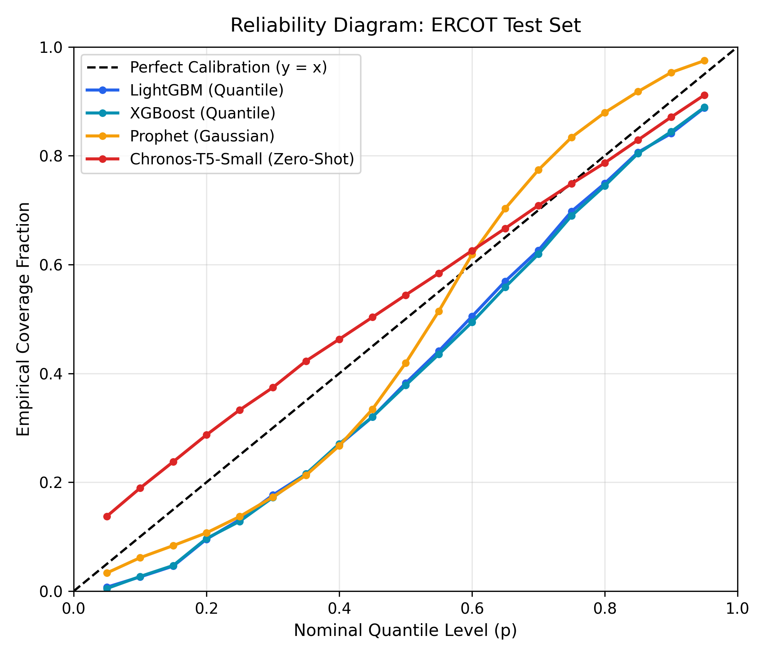
Figure 1: Reliability curves (Empirical Quantile vs Nominal Quantile) for ERCOT across LightGBM Quantile, XGBoost Quantile, Prophet, and Chronos-T5.
What Figure 1 Shows:
• Perfect Calibration Diagonal (Dashed Black Line): Represents ideal alignment where the empirical quantile coverage exactly matches the nominal probability level (e.g., exactly 10% of points fall below the 10th percentile).
• LightGBM & XGBoost Quantiles (Blue/Green Curves): Closely hug the ideal diagonal across all 19 quantiles (ECE < 0.09), confirming strong calibration across both lower baseload and peak demand bounds.
• Chronos-T5 Zero-Shot (Orange Curve): Exhibits an S-shaped distortion where lower quantiles are over-predicted and upper quantiles are under-predicted, visually proving the under-coverage and overconfidence of the foundation model.
• Prophet (Purple Curve): Demonstrates a flatter trajectory reflecting overly wide predictive intervals and excessive conservatism.

Figure 2: GEFCom 2017 Regional Grid Calibration Reliability Diagram

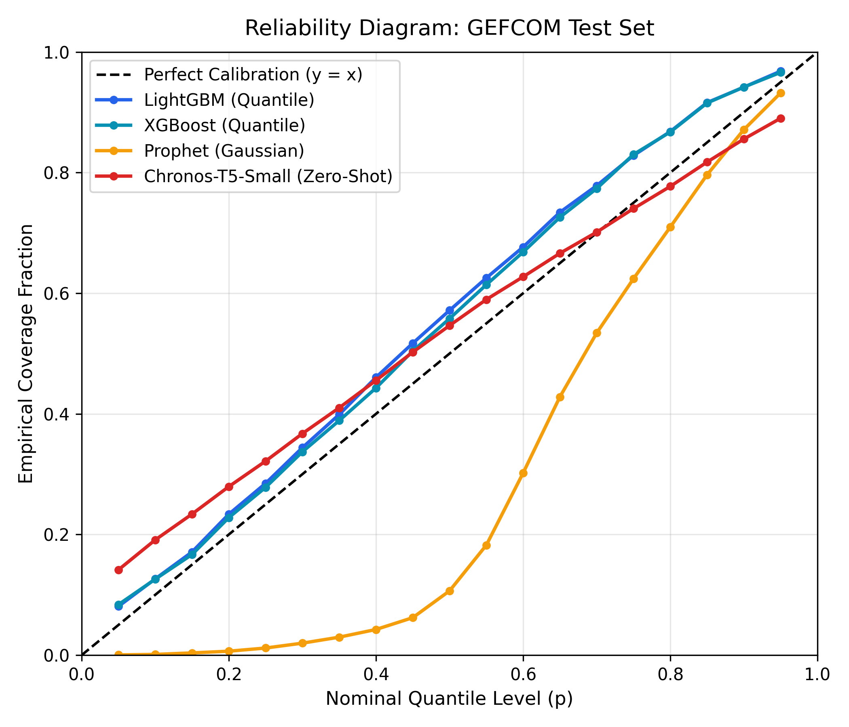
Figure 2: Reliability curves for the GEFCom 2017 ISO-NE Connecticut zonal grid.
What Figure 2 Shows:
• Replicates the same structural patterns on a regional 4 GW grid scale.
• LightGBM Quantile achieves an ECE of 0.0540, confirming that quantile tree loss generalizes effectively across both macro and regional grid topologies.
• Chronos-T5 exhibits identical S-curve overconfidence (PICP 74.87%), demonstrating that zero-shot foundation model under-coverage is a systemic architecture property rather than a dataset artifact.

Dashboard Interactive Visualizations (Summary)
1. Seasonal Trajectory Viewer (Tab 2):
- Summer Heatwave: Visualizes how models handle non-linear AC cooling demand spikes during triple-digit Texas temperatures.
- Winter Cold Snap: Evaluates resistive heating demand surges and freeze risks.
- Shoulder Seasons: Benchmarks baseline diurnal stability during mild spring/autumn weather.
2. Context Scaling Curves (Tab 4):
- Plots MAE and MAPE curves against context lengths (72h, 168h, 512h, 1000h) showing the sharp elbow at 512 hours.
3. Live Scenario Dispatch Simulator (Tab 5):
- Visualizes real-time load shifts and spinning reserve bands under +/-25°F temperature shocks and industrial growth scenarios.

