
B.M.S. COLLEGE OF ENGINEERING, BANGALORE-19
(Autonomous Institute, Affiliated to VTU)
Department of Computer Science and Engineering
CIE-1II
Course Code: 23CS4PCSED |  | Course Title: Software Engineering
Semester: IV |  | Maximum Marks: 40 | Date: 20/06/2026
Faculty Handling the Course: |  | Dr.LNR, SPS, LN, VS, SVA, PS, Dr.CR, MRP, Dr.BVK, Dr.EN, RSH, AG
Instructions:
- Scheme acts as a reference for valuators

PART-A
Total 5 Marks (No Choice)
No. | Question | CO-PO-BL | Marks
1 | Differentiate between Black-box testing and White-box testing with suitable applications and examples. | 2-2-4 | 5
Solution: Difference
Aspect | Black-Box Testing | White-Box Testing
Definition | Testing performed without knowledge of the internal code or program structure. | Testing performed with complete knowledge of the internal code and logic.
Focus | Functional requirements and outputs. | Internal logic, paths, conditions, and program structure.
 | No programming knowledge is required.
  Knowledge Required
  Programming knowledge is essential.
 | Usually performed by testers, QA engineers, or end users. | Usually performed by developers or test engineers.
  Tester
 | Requirements specification, user requirements, and functional documents. | Program design, source code, control flow, and data flow.
  Basis for Test Cases
 | To verify whether the software performs the required functions correctly. | To verify that all code paths and statements execute correctly.
  Objective
 | Equivalence Partitioning, Boundary Value Analysis, Cause-Effect Graphing | Statement Coverage, Branch Coverage, Path Coverage, Condition Testing.
  Techniques Used
  .
  Code Visibility
  Internal code is hidden.
  Internal code is visible.
 | Missing functions, incorrect outputs, interface errors. | Logic errors, coding errors, dead code, security vulnerabilities.
  Error Detection
 | System testing, Acceptance testing, Functional testing. | Unit testing, Integration testing.
  Testing Level

----------3 Marks Explaining with Applications and examples.
Black-Box Testing

Applications
- Functional testing
- System testing
- User acceptance testing
- Validation of software requirements

Example
Login System
White-Box Testing

Applications
- Unit testing
- Component testing
- Security testing
- Verification of algorithms

------Example
--------- 2 MARKS Snippet of a code

PART-B
Total 15 Marks (No Choice)
No. | Question | CO-PO-BL | Marks
2a | An e-commerce project experiences frequent requirement changes after coding begins. Identify the risks and apply suitable risk mitigation strategies to reduce project risk. | 2-2-3 | 5
Solution:
Risk | Description | Impact
Schedule Risk | Continuous requirement changes delay development activities. | Project completion may be postponed.
Cost Risk | Additional effort is required for redesign, coding, and testing. | Project budget may exceed estimates.
Technical Risk | New requirements may introduce complex technologies or integrations. | Increased technical difficulties and defects.
Quality Risk | Frequent modifications can introduce bugs and inconsistencies. | Reduced software reliability and customer satisfaction.
Scope Creep | Uncontrolled addition of features beyond the original scope. | Increased workload and resource consumption.
Maintenance Risk | Repeated changes make the system difficult to understand and maintain. | Higher maintenance costs.
Resource Risk | Developers spend more time reworking existing modules. | Reduced productivity and team morale.
…………….2.5 Marks
Risk mitigation properties:
Identified Risk | Mitigation Strategy
Schedule Delay | Incremental development, schedule buffers
Cost Overrun | Change control and impact analysis
Technical Complexity | Technical reviews and prototyping
Quality Problems | Continuous testing and code reviews
Scope Creep | Formal requirements management
Maintenance Difficulty | Configuration management and documentation
Resource Overload | Proper planning and resource allocation
…………….2.5 Marks
2b | Justify how practices of extreme programming fit into the principles of agile methods | 2-2-4 | 5
Solution:
XP and Agile Principles:
• Incremental development is supported through small, frequent system releases.
• Customer involvement means full-time customer engagement with the team.
• People not process through pair programming, collective ownership and a
process that avoids long working hours.
• Change supported through regular system releases.
• Maintaining simplicity through constant refactoring of code
--------2M

XP Supports Agile Values

1. Individuals and Interactions
- Pair programming and collective ownership encourage communication and collaboration.
- Team members work closely together to solve problems.

2. Working Software
- Small releases and continuous integration ensure that functional software is delivered frequently.
- Progress is measured through working software rather than documentation.

3. Customer Collaboration
- The on-site customer and planning game practices keep customers actively involved.
- Requirements can be refined based on customer feedback.

4. Responding to Change
- Refactoring, short iterations, and continuous feedback allow teams to adapt quickly to changing requirements.
- XP welcomes change even late in development.
-----------3M for explanation
2c | Differentiate between software inspection and software testing. Also identify the different roles and responsibilities in the inspection process. | 2-2-3 | 5
Solution:
Aspect | Software Inspection | Software Testing
Definition | A static verification technique where software artifacts (requirements, design, code) are examined to discover defects without executing the program. | A dynamic verification technique where the software is executed with test data to identify defects and failures.
Execution of Program | Not required. | Required.
Type of Activity | Static Verification. | Dynamic Verification and Validation.
Objective | To identify defects, omissions, inconsistencies, and non-compliance with standards. | To reveal failures and verify that the software meets its requirements.
Stage of Use | Can be applied early in the software process before implementation is complete. | Usually performed after implementation of a component or system.
Focus | Documents, designs, source code, and specifications. | Running software and observing its behavior.
Defects Found | Missing requirements, interface inconsistencies, logic errors, coding standard violations. | Functional errors, performance issues, runtime failures, and unexpected behavior.
Cost of Defect Detection | Lower, since defects are found early. | Higher if defects are found late in development.
Participants | Inspection team members. | Testers, developers, and users.
Output | List of identified defects and recommendations. | Test reports and defect reports.
------2.5 M differences
Roles in Inspection Process:
- Moderator: Organizes and controls the inspection.
- Author: Produces and corrects the work product.
- Reader: Guides the team through the document or code.
- Inspector: Identifies defects and inconsistencies.
- Recorder: Documents defects and recommendations.
----------2.5 explanation

PART- C
Total 20 Marks (Choice between question 3a & 3b, choice between question 4a & 4b)

3a | A software project contains the following tasks.  Analyze and design:  - Task Network  - Critical Path  - Timeline Chart | 3-3-5 | 4+6
  Task | Activity | Duration (Days) | Dependency
  T1 | Requirement Analysis | 2 | —
  T2 | UI Design | 3 | T1
  T3 | Database Design | 2 | T1
  T4 | Backend Coding | 4 | T2, T3
  T5 | Frontend Coding | 3 | T2
  T6 | Integration Testing | 2 | T4, T5
  T7 | Deployment | 1 | T6
Solution:
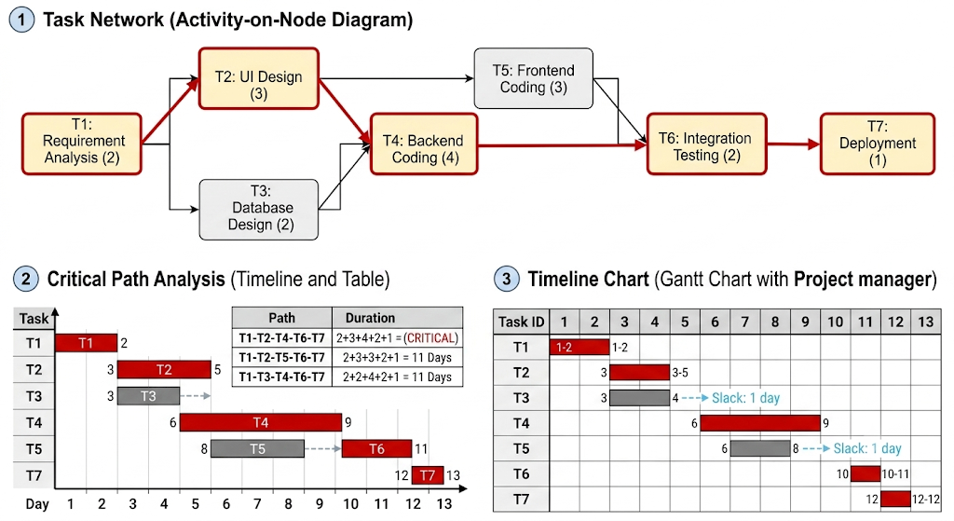
--------------Explanation: 4M
---------------Diagram:3M X 2= 6 M
OR
3b | Analyze the key strategies of clean-room approach to software development with a relevant diagram. | 3-3-4 | 4+6
Solution:
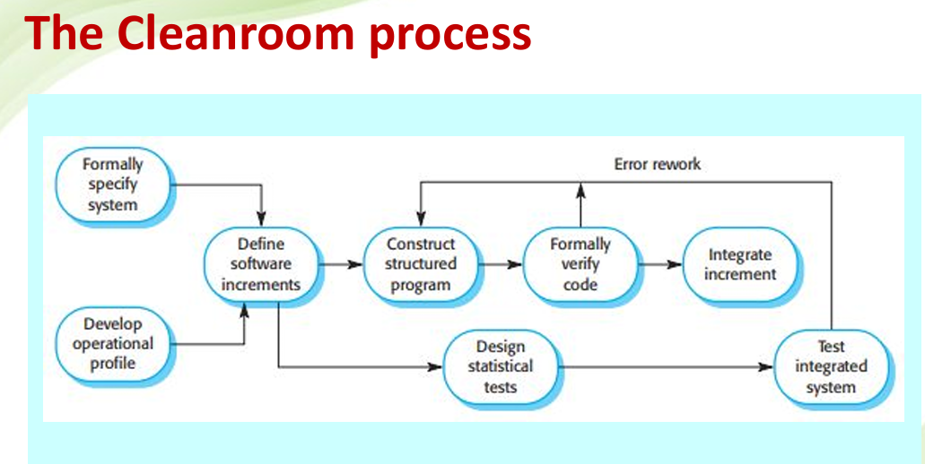
-------3 M for diagram
-------7 M for Explanation
4a | A government organization spends a significant portion of its IT budget on maintaining old software systems. To optimize expenditure, it intends to examine the legacy systems and decide which systems should be modernized and which should be removed. Analyze the factors that should be considered during legacy system assessment and recommend suitable evolution actions | 2-2-4 | 4+6
Solution:
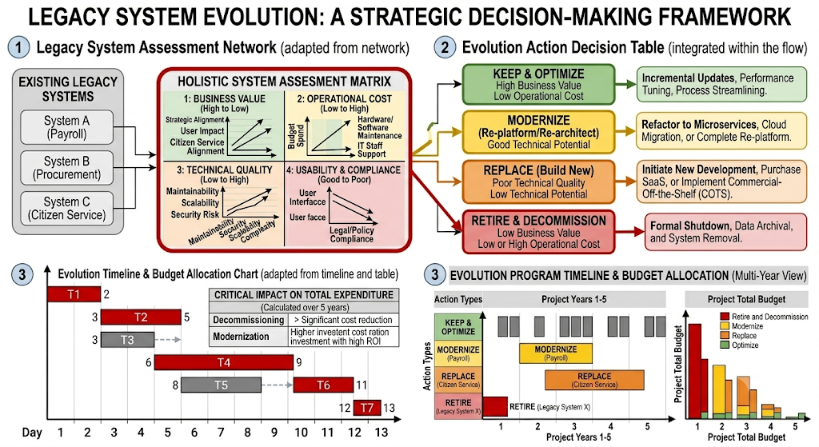
--------Diagram 4 Marks
---------Explanation 6 Marks

OR
4b | Analyze path testing approach of test case design by drawing a flow graph for  a binary search routine. Determine and write the different paths that are executed. | 2-2-4 | 4+6
Solution:
Flow graph for a binary search routine
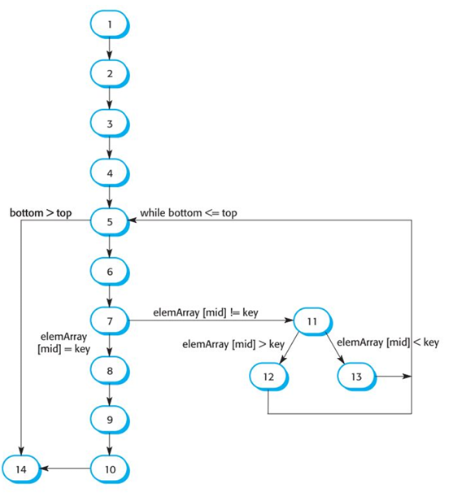
-------2 M for Diagram
--------2 M for Explanation
Different Paths
• 1, 2, 3, 4, 5, 6, 7, 8, 9, 10, 14
• 1, 2, 3, 4, 5, 14
• 1, 2, 3, 4, 5, 6, 7, 11, 12, 5, …
• 1, 2, 3, 4, 6, 7, 2, 11, 13, 5, …
• Test cases should be derived so that all
of these paths are executed
• A dynamic program analyser may be
used to check that paths have been
executed
------------6 M Different paths with Diagram

*** ALL THE BEST ***

