If there are no duplicated values in the column used by the ORDER BY clause, these functions return the same output.

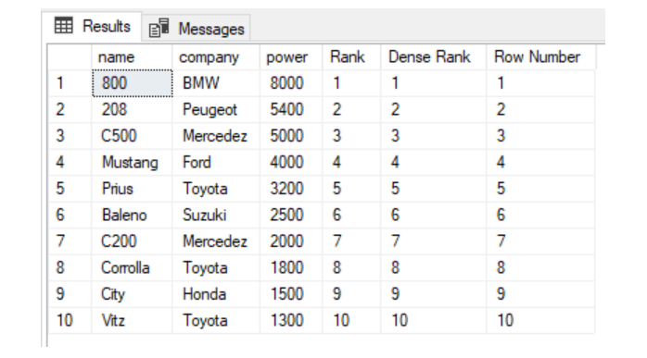

You can see that there are no duplicate values in the power column which is being used in the ORDER BY clause, therefore the output of the RANK, DENSE_RANK, and ROW_NUMBER functions are the same.

4A) 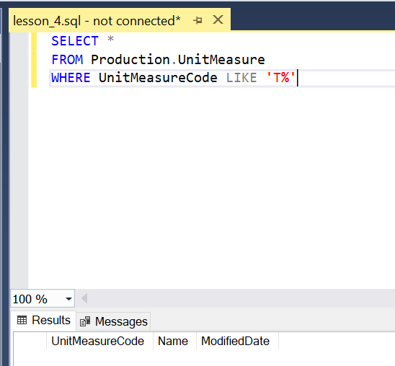

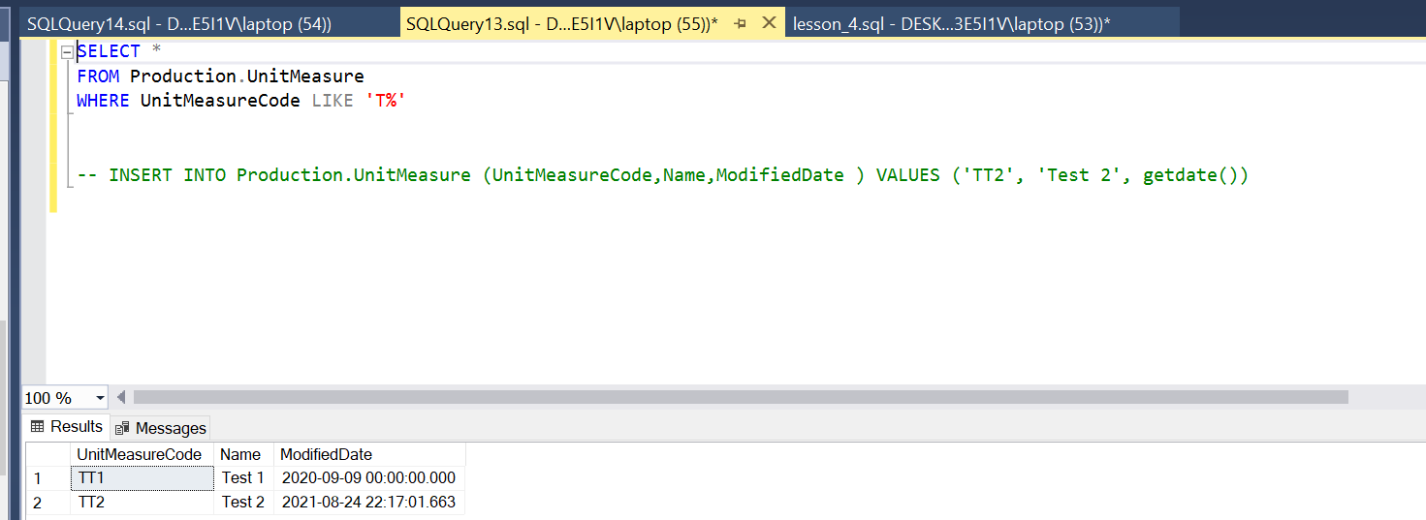

4b)

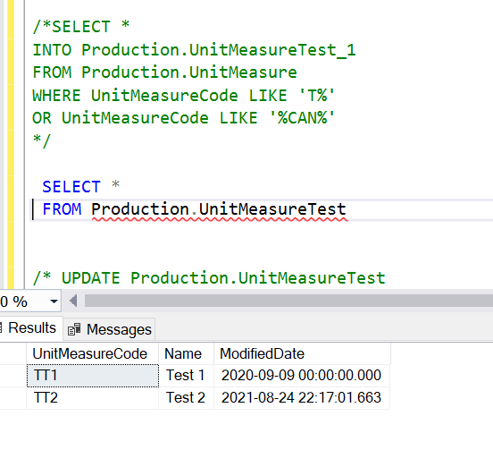

4c) 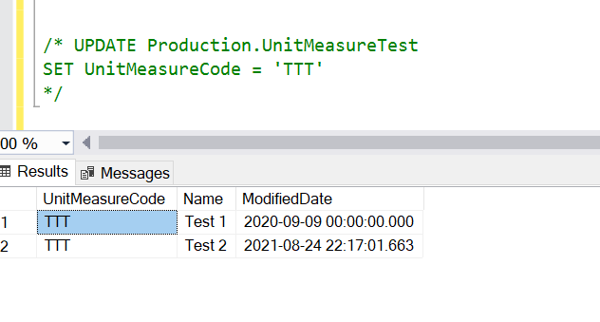

4D)

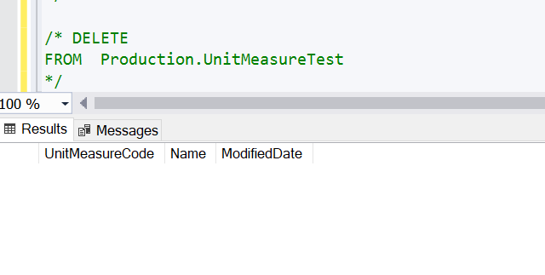

4E)1)

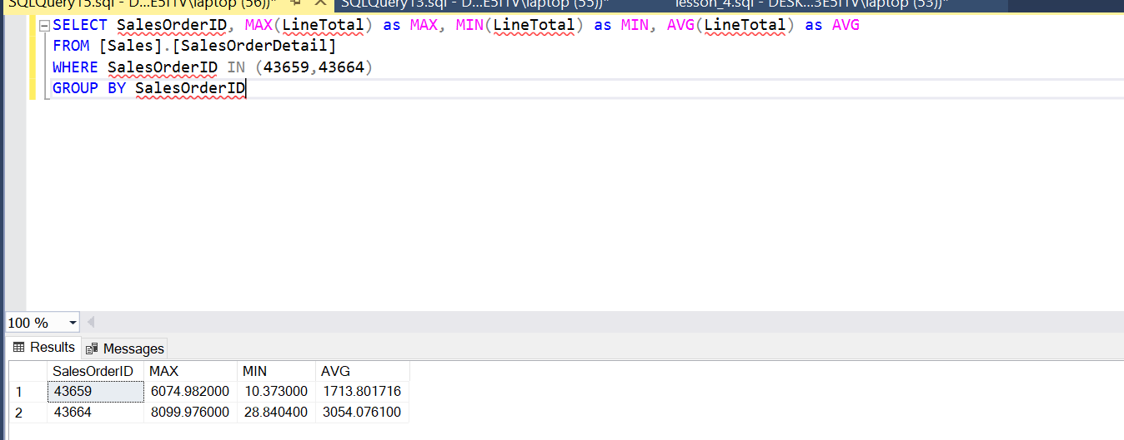

4E2) IT IS JUST FOR ME, DECIDED TO DO 2

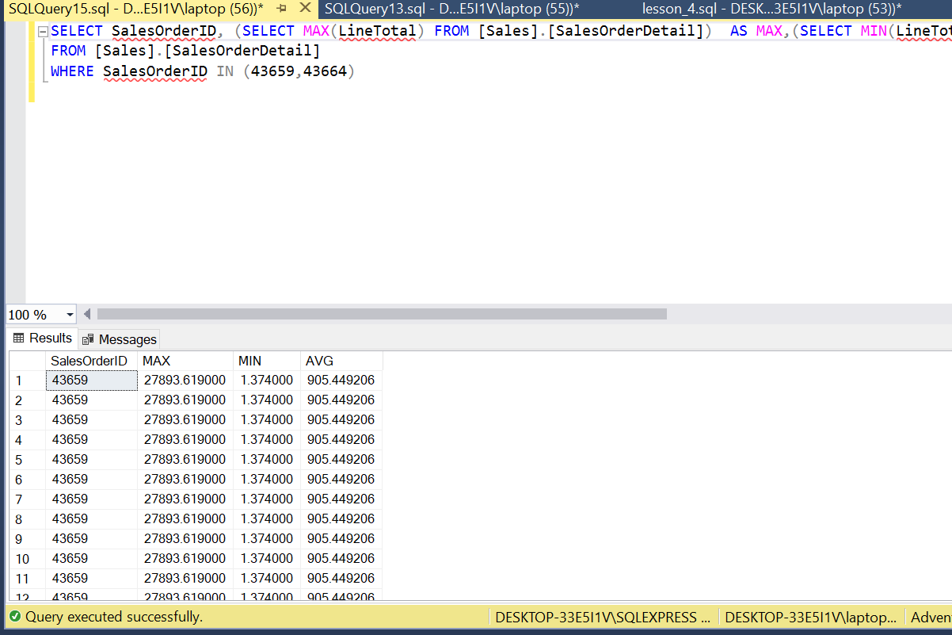

4F)

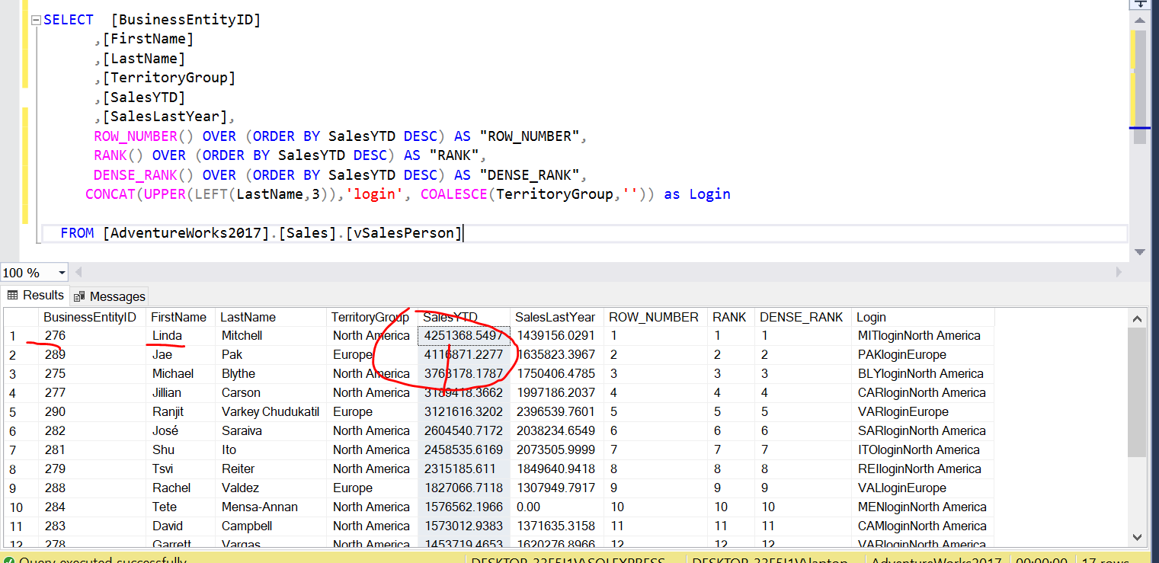

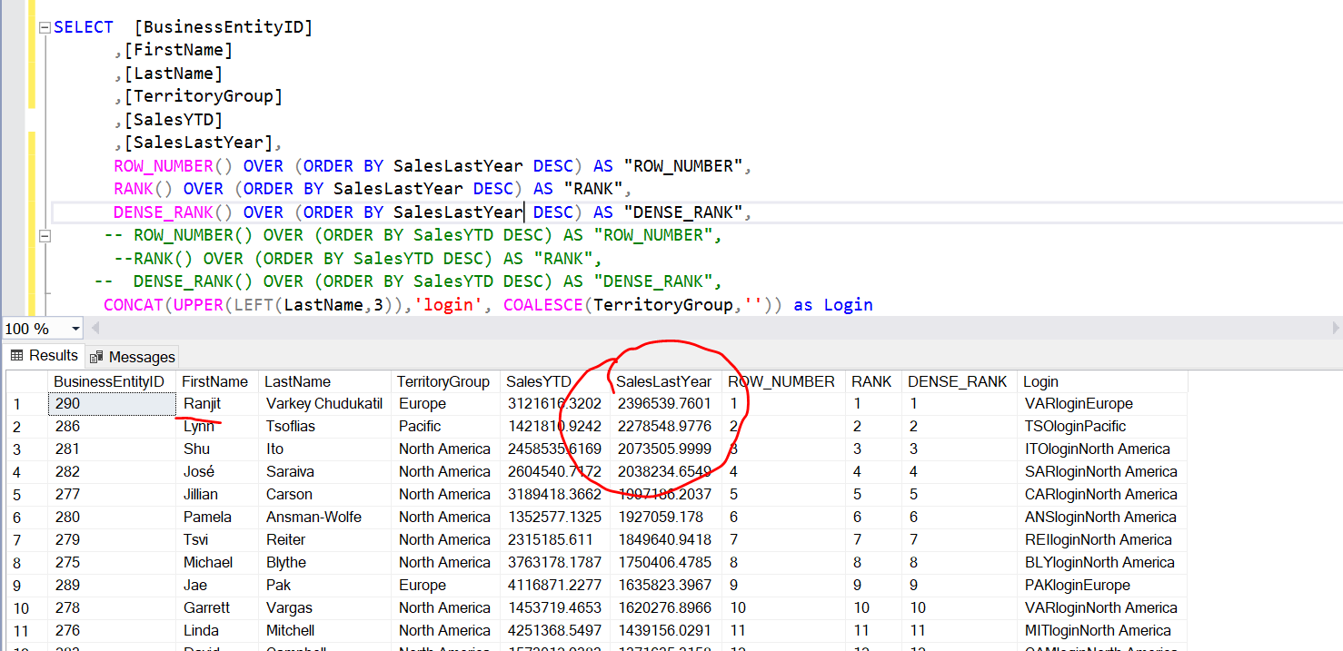

4 G)

SELECT CASE

WHEN Datename(dw, Dateadd(dd, -Datepart(dd, Getdate()) + 1, Getdate())) = 'Saturday' THEN Dateadd(dd, -Datepart(dd, Getdate()) + 3, Getdate())

WHEN Datename(dw, Dateadd(dd, -Datepart(dd, Getdate()) + 1, Getdate())) = 'Sunday' THEN Dateadd(dd, -Datepart(dd, Getdate()) + 2, Getdate())

ELSE Dateadd(dd, -Datepart(dd, Getdate()) + 1, Getdate())

END

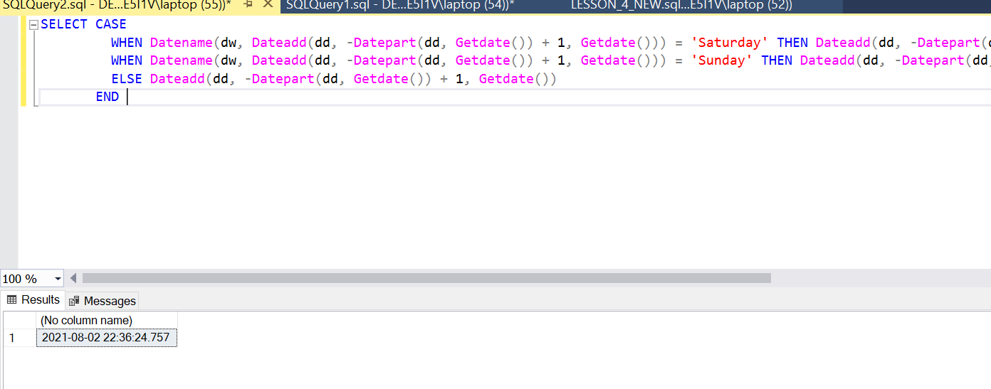

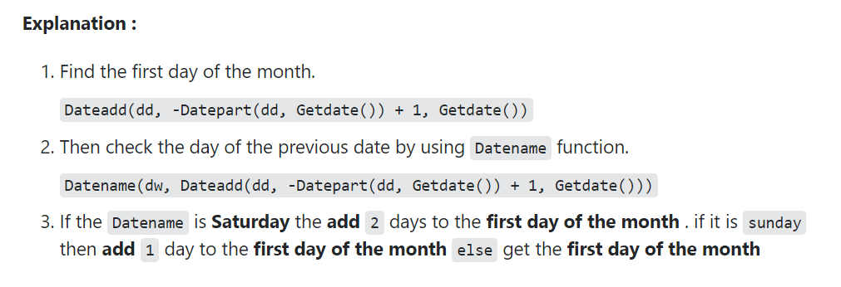

Not my code, but I like the idea of it and it is working!

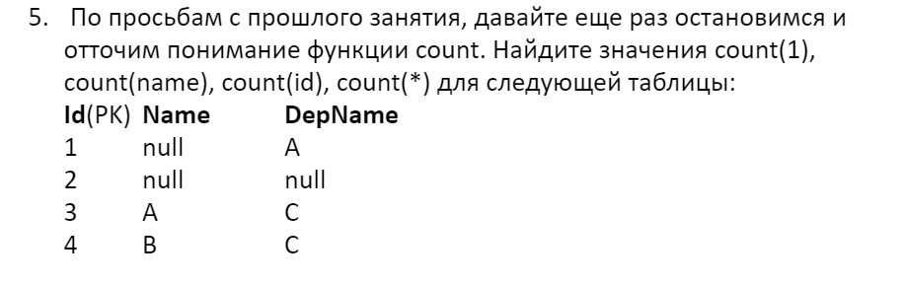

Count(1) count(name) count(id) count(*)

1. Null 1 1

1 null 1 1

1 1 1 1

1 1 1 1