Вначале я сделала (IN EXCEL) скрин с задания общей таблицы,ниже представляла 3NF

A)

I see a transitive relationship between cars(1-5) and first_name and last_name, so this is a 3-d type of normalization. I think that there is an error in cars 4 and 5 ,instead of the cars we see name and surname. And I have 2 assumptions, either there is a Null value, or there must be a car brand.

**3NF**

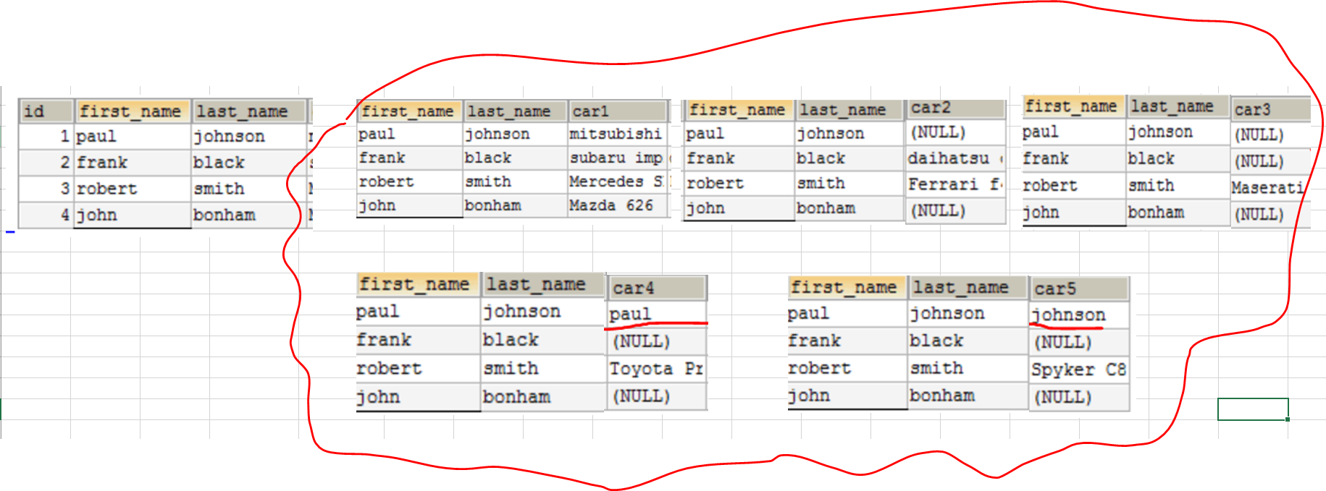

B) 1NF

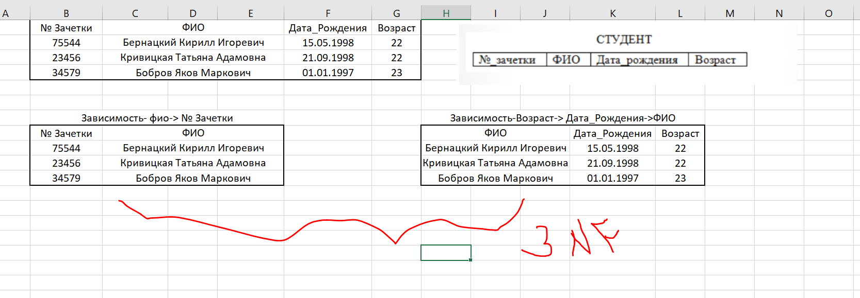

C) Despite the fact that the last column cars contains values separated by commas, but there is an id column and I see a transitive relationship between cars and first and last name: it means that normalization will be of type 3, (Cars-> first and last_name)

3NF

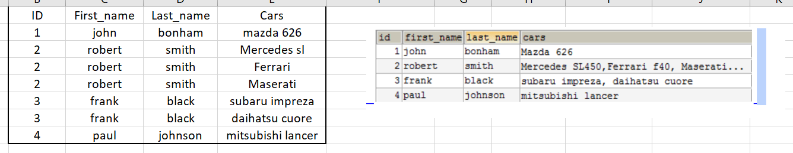

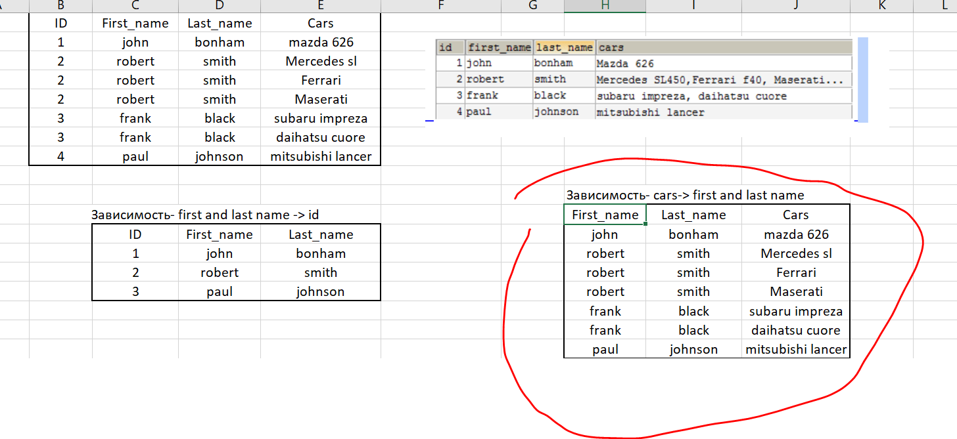

**D**) i see a transitive relationship between type and brand: Price->Type->Brand->Car_Id, so this is 3-d type of normalization. I also think that the price may depend not only on the brand , but also on the stores. Price->Store , **3 NF**

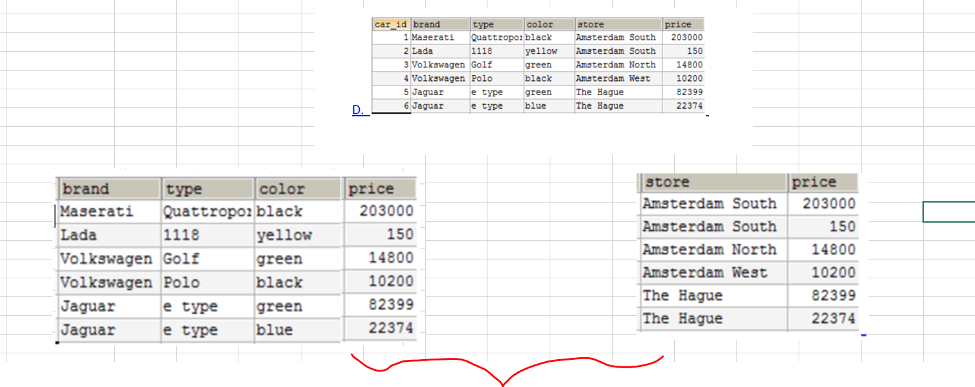

E) I don't see the transitive dependency in the table, so I think it is 2 NF.

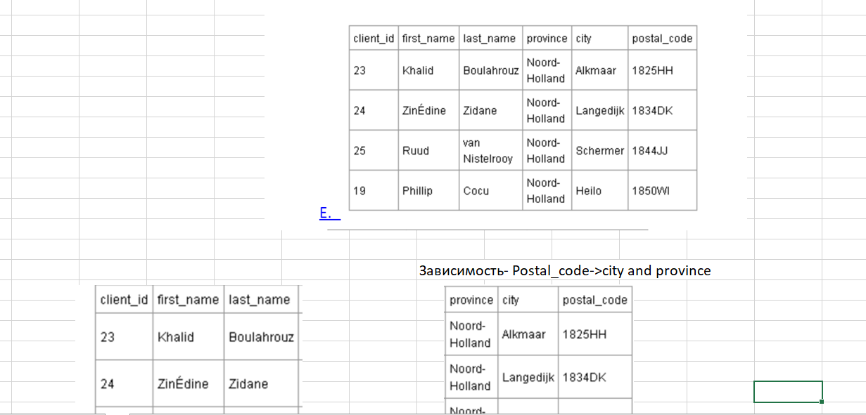

**f) I think it is 2 NF. , 2 last columns(они также исчисляемые) depend on order_number.** 