1. The first graph shows the average swim time for a swimmer at each age and type of swim.

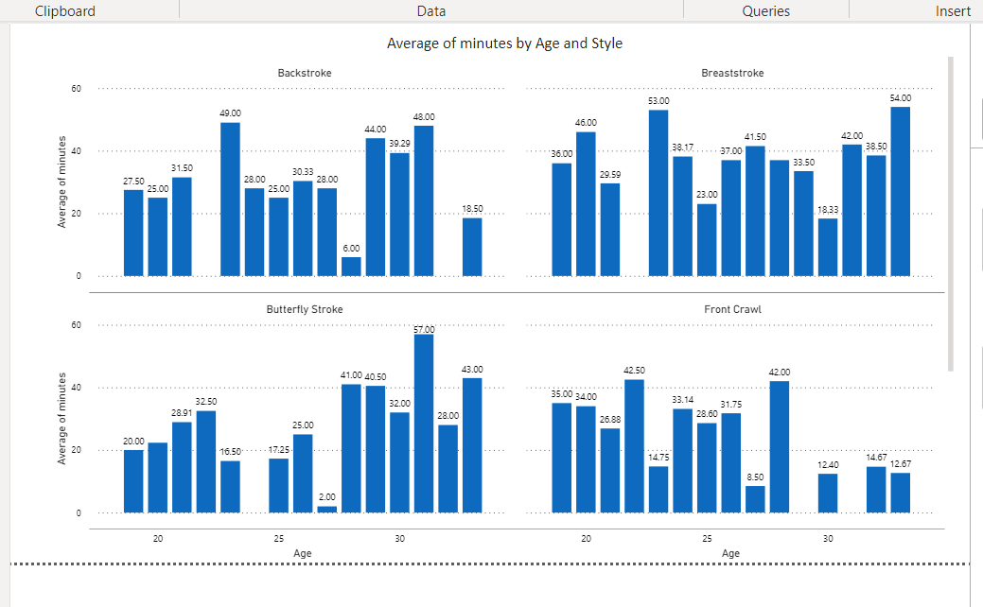

1. In the following graph, we can see the sponsor payments, sponsor name, sum of payments, date and competitionID in the table. Also, the pie chart filter shows, for example, where the sum of sponsors payments was more than 160k by countries. And the chart above shows the amount of sponsor payments by year.

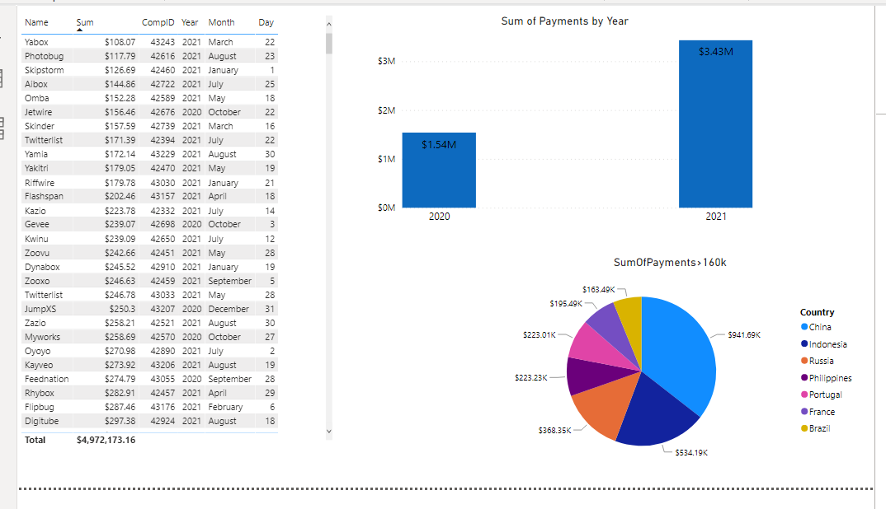

3. This graph shows how many competitions were in each country from our database. And there is a filter:countries where there were more than 45 competitions (as for example).

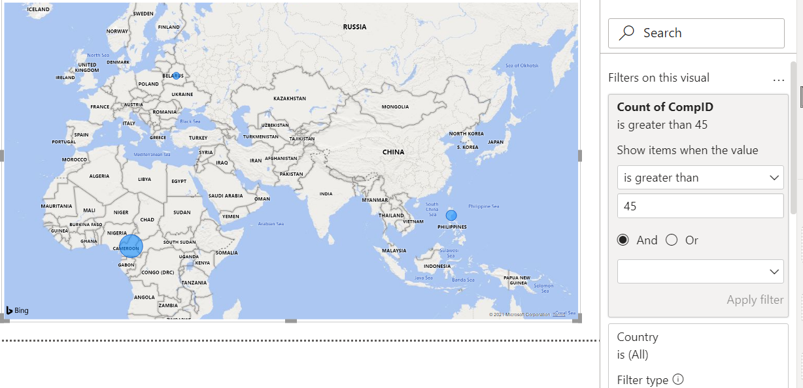

4.

The table shows data about the trainer. This graph shows how many competitions each coach has.

