Лабораторна робота №1
Тема: Принципи програмування. DRY, KISS, SOLID, YAGNI та ін.
Мета роботи: навчитися дотримуватися принципів програмування та обґрунтовувати їх.
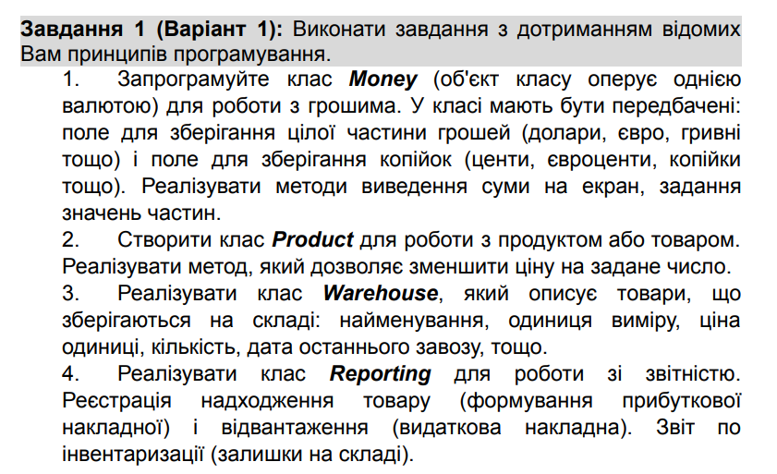
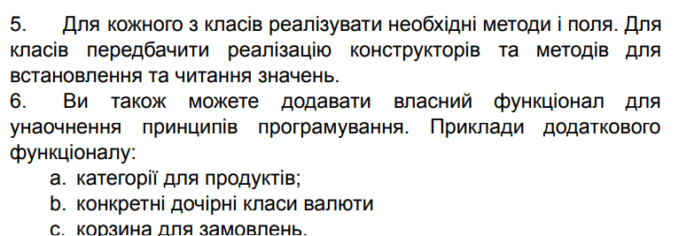

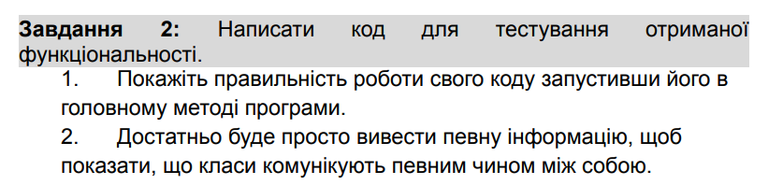
Лістинг коду
using System;
using System.Collections.Generic;

public interface IMoney
{
int WholePart { get; set; }
int FractionalPart { get; set; }
string Currency { get; set; }
string Display();
}

public class Money : IMoney
{
public int WholePart { get; set; }
public int FractionalPart { get; set; }
public string Currency { get; set; }

public Money(int wholePart, int fractionalPart, string currency)
{
WholePart = wholePart;
FractionalPart = fractionalPart;
Currency = currency;
}

public string Display()
{
return $"{WholePart}.{FractionalPart} {Currency}";
}
}

public class Category
{
public string Name { get; set; }
public string Description { get; set; }
public string Department { get; set; }

public Category(string name, string description, string department)
{
Name = name;
Description = description;
Department = department;
}
}

public class Product
{
public string Name { get; set; }
public IMoney Price { get; set; }
public Category Category { get; set; }
public string UnitOfMeasure { get; set; }
public int Quantity { get; set; }
public DateTime LastDeliveryDate { get; set; }

public Product(string name, IMoney price, Category category, string unitOfMeasure, int quantity, DateTime lastDeliveryDate)
{
Name = name;
Price = price;
Category = category;
UnitOfMeasure = unitOfMeasure;
Quantity = quantity;
LastDeliveryDate = lastDeliveryDate;
}

public void ReducePrice(int amount)
{
if (Price.WholePart < amount)
{
throw new Exception("The reduction amount cannot be greater than the product price.");
}
Price.WholePart -= amount;
}
}

public class Warehouse
{
private List<Product> Products { get; set; }

public Warehouse()
{
Products = new List<Product>();
}

public void AddProduct(Product product)
{
if (product == null)
{
throw new ArgumentNullException(nameof(product));
}
Products.Add(product);
}

public List<Product> GetProducts()
{
return Products;
}
}

public class ShoppingCart
{
private List<Product> Products { get; set; }

public ShoppingCart()
{
Products = new List<Product>();
}

public void AddProduct(Product product)
{
if (product == null)
{
throw new ArgumentNullException(nameof(product));
}
Products.Add(product);
}

public void RemoveProduct(Product product)
{
Products.Remove(product);
}

public IMoney TotalCost()
{
int totalWholePart = 0;
int totalFractionalPart = 0;
string currency = Products[0].Price.Currency;

foreach (var product in Products)
{
totalWholePart += product.Price.WholePart;
totalFractionalPart += product.Price.FractionalPart;
}

return new Money(totalWholePart, totalFractionalPart, currency);
}
}

public class Reporting
{
public Warehouse Warehouse { get; set; }

public Reporting(Warehouse warehouse)
{
Warehouse = warehouse;
}

public void RegisterProductReceipt(Product product, int quantity, string date)
{
Warehouse.AddProduct(product);
}

public void InventoryReport()
{
foreach (var product in Warehouse.GetProducts())
{
Console.WriteLine($"Product: {product.Name}, Price: {product.Price.Display()}, Category: {product.Category.Name}, Unit of Measure: {product.UnitOfMeasure}, Quantity: {product.Quantity}, Last Delivery Date: {product.LastDeliveryDate}");
}
}
}

class Program
{
static void Main(string[] args)
{
Console.WriteLine("Creating a new Money object...");
Money money1 = new Money(100, 50, "USD");
Money money2 = new Money(200, 25, "USD");
Money money3 = new Money(150, 75, "USD");
Console.WriteLine(money1.Display());

Console.WriteLine("Creating a new Category object...");
Category category1 = new Category("Fruit", "Edible item", "Food");
Category category2 = new Category("Vegetable", "Edible item", "Food");
Category category3 = new Category("Dairy", "Edible item", "Food");

Console.WriteLine("Creating new Product objects...");
Product product1 = new Product("Apple", money1, category1, "Kg", 200, DateTime.Now.AddDays(-10));
Product product2 = new Product("Milk", money2, category2, "Litre", 100, DateTime.Now.AddDays(-5));
Product product3 = new Product("Bread", money3, category3, "Piece", 150, DateTime.Now.AddDays(-2));

Console.WriteLine("Reducing product prices...");
product1.ReducePrice(10);
product2.ReducePrice(20);
product3.ReducePrice(15);
Console.WriteLine($"Product: {product1.Name}, Price: {product1.Price.Display()}, Category: {product1.Category.Name}");
Console.WriteLine($"Product: {product2.Name}, Price: {product2.Price.Display()}, Category: {product2.Category.Name}");
Console.WriteLine($"Product: {product3.Name}, Price: {product3.Price.Display()}, Category: {product3.Category.Name}");

Console.WriteLine("Creating a new Warehouse object...");
Warehouse warehouse = new Warehouse();

Console.WriteLine("Adding products to the warehouse...");
warehouse.AddProduct(product1);
warehouse.AddProduct(product2);
warehouse.AddProduct(product3);

Console.WriteLine("Creating a new Reporting object...");
Reporting reporting = new Reporting(warehouse);

Console.WriteLine("Registering product receipts...");
reporting.RegisterProductReceipt(product1, 10, "2024-03-05");
reporting.RegisterProductReceipt(product2, 20, "2024-03-06");
reporting.RegisterProductReceipt(product3, 15, "2024-03-07");

Console.WriteLine("Generating an inventory report...");
reporting.InventoryReport();

ShoppingCart shoppingCart = new ShoppingCart();

bool addingProducts = true;
while (addingProducts)
{
Console.WriteLine("Enter the name of the product you want to add to the cart (or 'stop' to finish):");
string productName = Console.ReadLine();

if (productName.ToLower() == "stop")
{
addingProducts = false;
}
else
{

Product productToAdd = warehouse.GetProducts().Find(p => p.Name == productName);

if (productToAdd != null)
{
shoppingCart.AddProduct(productToAdd);
Console.WriteLine($"Product '{productName}' has been added to the cart.");
}
else
{
Console.WriteLine($"Product with the name '{productName}' not found.");
}
}
}

Console.WriteLine("Displaying the total cost of the cart...");
Console.WriteLine(shoppingCart.TotalCost().Display());
}
}

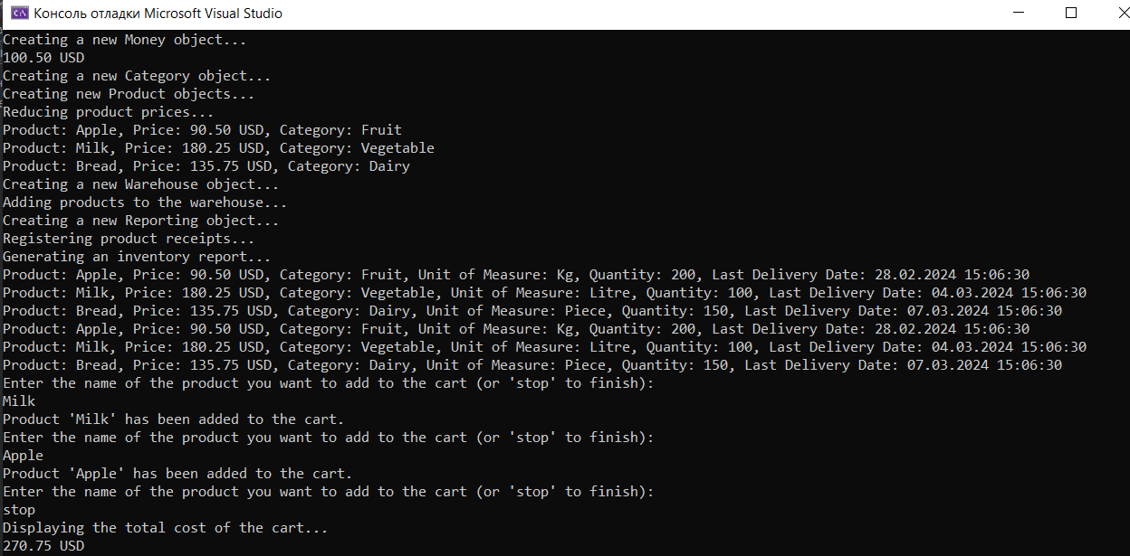
Рис.1.1.Результат виконання роботи
Висновок: в ході лабораторної роботи було розроблено систему управління товаром для магазину, використовуючи принципи SOLID, DRY, KISS та інші. Система включає класи для представлення грошових величин, категорій товарів, самого товару, складу, кошика для покупок та звітності. Завдяки цьому, система є гнучкою, масштабованою та легкою для розуміння та модифікації.

