Tomcat Server Setup

1. Download tomcat

<https://tomcat.apache.org/download-90.cgi>

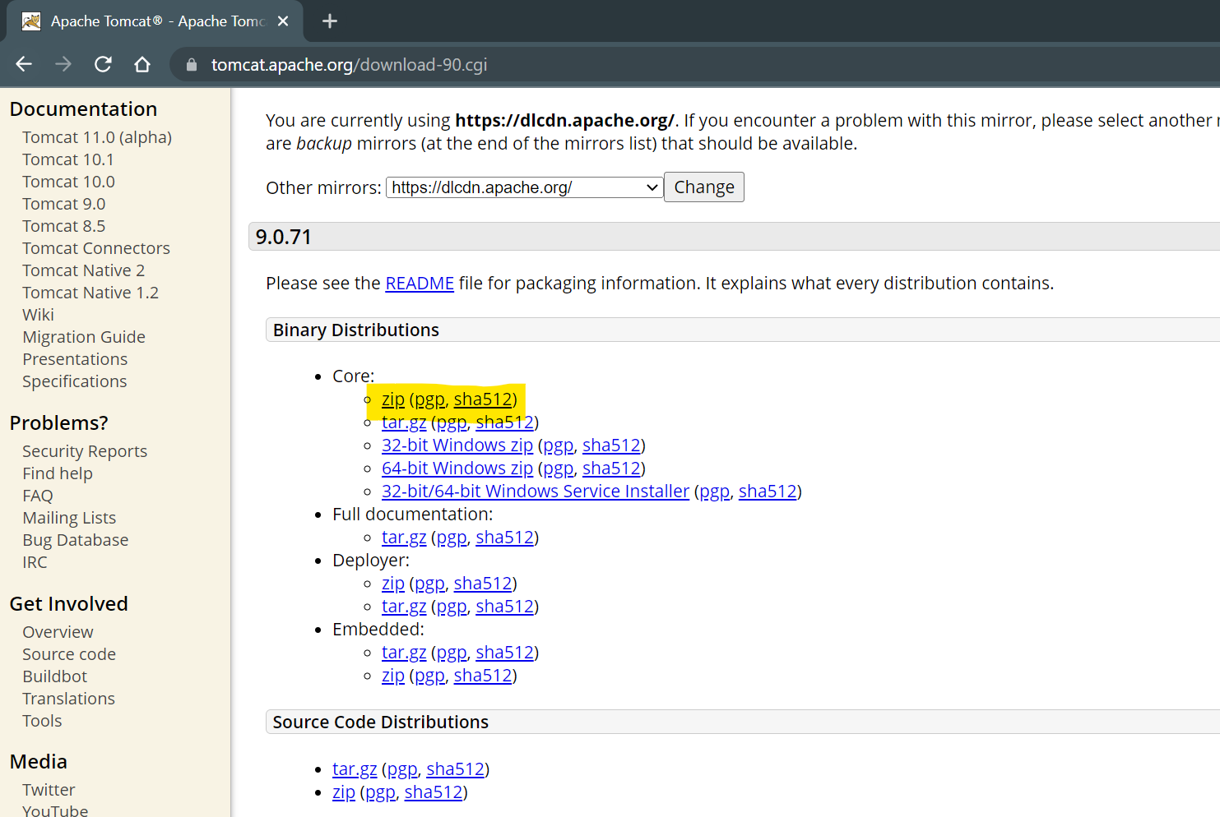

1. Copy and paste the zip file into specific location.
2. Extract the Zip File
3. Server Setup in Eclipse
   1. Set the “**JavaEE”** perspective
   2. Select “Servers” tab from the bottom for the window
   3. Click on the link to add new server.
   4. Expand “Apache” option from the list in the new window.
   5. Select a version which you downloaded
   6. Click on “Next”
   7. Browse and set the path of the location where you extracted the server zip file.
      1. Path of the parent folder of bin,lib, config etc.
   8. Click on Next and Finish

**Steps to create Web application**

1. Go “File” Menu -> “New” -> select “Dynamic Web Project”
2. Provide Name of the application and **make sure that Target Runtime** is selected
3. Click on “Next” -> click On “Next”
4. **Make sure that “generate Web.xml Deployment Descriptor” option is checked/selected**

Project Structure

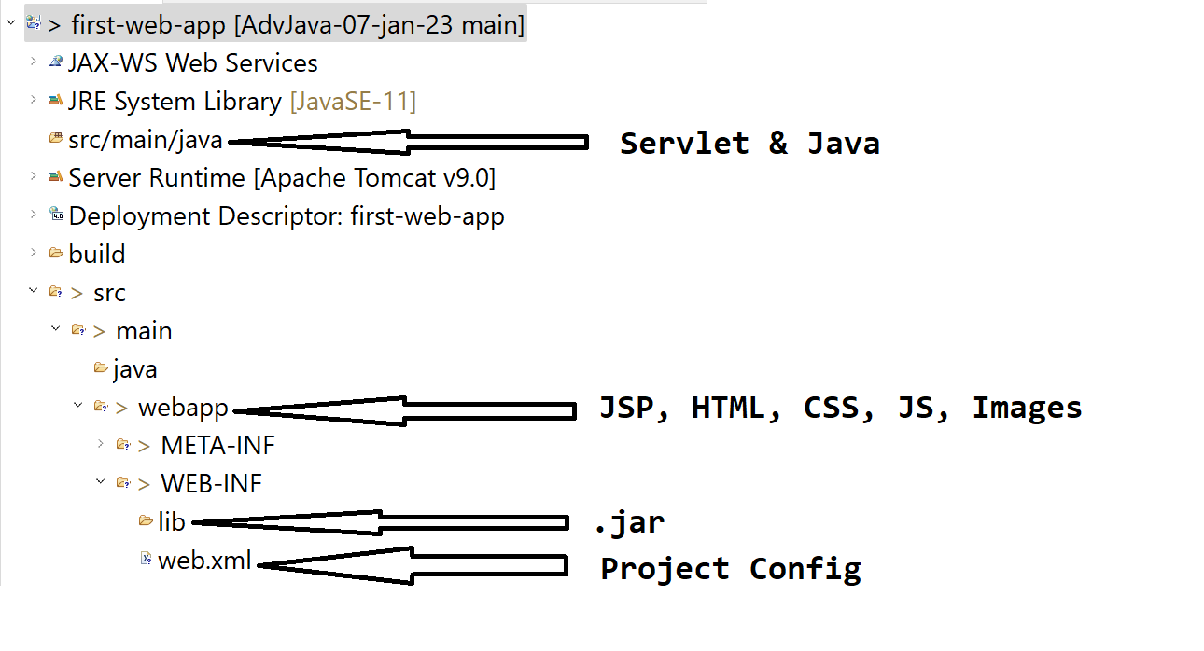

**Servlet**

1. Servlet is a java class.
2. In servlet main method us not used.
3. Servlet will be execute by the server (Servlet Container).
4. Servlet are execute and can be access by using URL.
5. Servlet are use to create dynamic web pages.
6. In the servlet you can use java code along with HTML (HTML in JAVA)
7. Servlet has to create inside src/main/java
8. Servlet are use to get request, process a request and generate the response

**Ways To Create Servlet**

1. Create java class and use Java EE APIs to create servlet
2. Implements Class with **Servlet interface**
3. Extends class with **GenericServlet abstract class**
4. Extends class with **HttpServlet abstract class**
5. Override the service method to work with request and repones.
6. Provide the URL for the servlet using @WebServlet annotation
   1. Use @WebServlet Annotation on class
   2. Provide the URL of the servlet which must be starts with “/”

**Steps to create servlet**

1. Right click on src/main/java ->”New” Option -> click on “servlet” option
2. Provide class name. -> click “Next”
3. You can edit URL or keep same -> Click “Next”
4. Select “service” check box from the method list -> click on “Finish”