**VIVEKANAND EDUCATION SOCIETY’S INSTITUTE OF TECHNOLOGY**

**(An Autonomous Institute Affiliated to University of Mumbai**

**Department of Computer Engineering)**

**Department of Computer Engineering**



**Project Report on**

**OFFLINE AI CHATBOT FOR VARIOUS PURPOSES**

Submitted in partial fulfillment of the requirements of Third Year (Semester–VI), Bachelor of Engineering Degree in Computer Engineering at the University of Mumbai Academic Year 2024-25

By

**Vikalp Bora / 09**

**Krish Bhatia / 07**

**Priyanka Jotwani/36**

**Project Mentor**

**Prof. Prerna Solanke**

**University of Mumbai**

**(AY 2024-25)**

**VIVEKANAND EDUCATION SOCIETY’S INSTITUTE OF TECHNOLOGY**

**(An Autonomous Institute Affiliated to University of Mumbai**

**Department of Computer Engineering)**

**Department of Computer Engineering**



**CERTIFICATE**

This is to certify that ***_______________________________________________***of Third Year Computer Engineering studying under the University of Mumbai has satisfactorily presented the project on “**OFFLINE AI CHATBOT FOR VARIOUS PURPOSES** ” as a part of the coursework of Mini Project 2B for Semester-VI under the guidance of Prof. **Prerna Solanke** in the year 2024-25.

______***_______________***

Date

| __________________ |  | __________________ |
| --- | --- | --- |
| Internal Examiner |  | External Examiner |

_________________ __________________ __________________

Project Mentor Head of the Department Principal

Dr. Mrs. Nupur Giri Dr. J. M. Nair

**Declaration**

We declare that this written submission represents our ideas in our own words and where others' ideas or words have been included, we have adequately cited and referenced the original sources. We also declare that we have adhered to all principles of academic honesty and integrity and have not misrepresented or fabricated or falsified any idea / data / fact / source in our submission. We understand that any violation of the above will be cause for disciplinary action by the Institute and can also evoke penal action from the sources which have thus not been properly cited or from whom proper permission has not been taken when needed.

| -----------------------------------------  (Signature)  -----------------------------------------  Vikalp Bora D12C(09) | -----------------------------------------  (Signature)  -----------------------------------------  Krish Bhatia D12C(07) |
| --- | --- |
| -----------------------------------------  (Signature)  -----------------------------------------  Priyanka Jotwani D12C(36) |  |

Date:

## ACKNOWLEDGEMENT

We are thankful to our college Vivekanand Education Society’s Institute of Technology for considering our project and extending help at all stages needed during our work of collecting information regarding the project.

It gives us immense pleasure to express our deep and sincere gratitude to Assistant Professor **Mrs. Prerna Solanke** (Project Guide) for her kind help and valuable advice during the development of project synopsis and for her guidance and suggestions.

We are deeply indebted to Head of the Computer Department **Dr.(Mrs.) Nupur Giri** and our Principal **Dr. (Mrs.) J.M. Nair ,** for giving us this valuable opportunity to do this project.

We express our hearty thanks to them for their assistance without which it would have been difficult in finishing this project synopsis and project review successfully.

We convey our deep sense of gratitude to all teaching and non-teaching staff for their constant encouragement, support and selfless help throughout the project work. It is a great pleasure to acknowledge the help and suggestion, which we received from the Department of Computer Engineering.

We wish to express our profound thanks to all those who helped us in gathering information about the project. Our families too have provided moral support and encouragement several times.

### Computer Engineering Department

**COURSE OUTCOMES FOR T.E MINI PROJECT 2B**

Learners will be to:-

| **CO No.** | **COURSE OUTCOME** |
| --- | --- |
| CO1 | Identify problems based on societal /research needs. |
| CO2 | Apply Knowledge and skill to solve societal problems in a group. |
| CO3 | Develop interpersonal skills to work as a member of a group or leader. |
| CO4 | Draw the proper inferences from available results through theoretical/ experimental/simulations. |
| CO5 | Analyze the impact of solutions in societal and environmental context for sustainable development. |
| CO6 | Use standard norms of engineering practices |
| CO7 | Excel in written and oral communication. |
| CO8 | Demonstrate capabilities of self-learning in a group, which leads to lifelong learning. |
| CO9 | Demonstrate project management principles during project work. |

## LIST OF FIGURES:

| **Fig No.** | **Figure Description** | **Page No.** |
| --- | --- | --- |
| 1. | User Chat Interface | 19 |
| 2. | Document Management Dashboard | 20 |
| 3. | Block Diagram | 20 |
| 4. | Modular Diagram | 21 |
| 5. | Methodology Employed | 22 |
| 6. | Flowchart | 23 |
| 7. | Screenshots of User Interface | 27 |
| 8. | Statistics and Graphs | 29 |

**LIST OF TABLES:**

| **Table no.** | **Table Description** | **Page No.** |
| --- | --- | --- |
| 1. | Research papers Referred | 13 |
| 2. | Patent Search | 15 |
| 3. | Comparison with existing system | 16 |

**ABSTRACT**

This project focuses on the development of an offline AI-powered chatbot that operates without internet connectivity, addressing the growing need for privacy, data security, and reliability in conversational agents. The chatbot utilizes state-of-the-art natural language processing (NLP) and machine learning algorithms, including pre-trained transformer models, to understand and generate human-like responses. By embedding these models within the device, the chatbot can process and respond to user queries in real-time, ensuring seamless and uninterrupted interaction.

The offline capability of the chatbot is particularly advantageous in environments where internet access is restricted or where sensitive information must be protected, such as in healthcare, financial services, and educational settings. The chatbot supports multiple languages and is designed to provide context-aware responses, enhancing the user experience by maintaining coherent and relevant conversations.

Through extensive testing and iterative improvements based on user feedback, the project aims to validate the effectiveness of offline AI-powered chatbots. The ultimate goal is to provide a reliable and secure conversational tool that enhances user interactions, increases accessibility, and sets a new standard for AI applications in offline environments.

**Index**

**Abstract 7**

**Chapter 1: Introduction**

1.1 Introduction 10

1.2 Motivation 10

1.3 Problem Definition 10

1.4 Existing Systems 11

1.5 Lacuna of the existing systems 11

1.6 Relevance of the Project 11

**Chapter 2: Literature Survey**

A. Overview of Literature Survey 13

B. Related Works 13

2.1 Research Papers Referred

a. Abstract of the research paper 14

b. Inference drawn 14

2.2 Patent search 14

2.3. Inference drawn 14

2.4 Comparison with the existing system 15

**Chapter 3: Requirement Gathering for the Proposed System**

3.1 Introduction to requirement gathering 16

3.2 Functional Requirements 16

3.3 Non-Functional Requirements 16

3.4.Hardware, Software , Technology and tools utilized 17

3.5 Constraints 17

**Chapter** **4: Proposed Design**

4.1 Block diagram of the system 18

4.2 Modular design of the system 19

4.3 Detailed Design 20

4.4 Project Scheduling & Tracking : Gantt Chart 21

**Chapter 5: Implementation of the Proposed System**

5.1. Methodology Employed 22

5.2 Algorithms and flowcharts 22

5.3 Dataset Description

25

**Chapter 6: Testing of the Proposed System**

6.1. Introduction to testing 26

6.2. Types of tests Considered 26

6.3 Various test case scenarios considered 26

6.4. Inference drawn from the test cases 27

**Chapter 7: Results and Discussion**

7.1. Screenshots of User Interface (GUI) 29

7.2. Performance Evaluation measures 31

7.3. Input Parameters / Features considered 31

7.4. Graphical and statistical output 32

7.5. Comparison of results with existing systems 34

7.6. Inference drawn

**Chapter 8: Conclusion**

8.1 Limitations 36

8.2 Conclusion 36

8.3 Future Scope 36

**References** 39

**Chapter 1: Introduction**

## 1.1 Introduction

Education and information access in remote or resource-constrained environments—such as rural schools, small businesses, and corporate training centers—often suffer from limited connectivity and a lack of tailored digital resources. Most conventional chatbots rely on continuous internet access and centralized servers, making them unsuitable for offline or low-bandwidth contexts. Our project, the **Offline AI Chatbot for Various Purposes**, addresses these constraints by combining a locally deployable language model with a Retrieval-Augmented Generation (RAG) framework. This hybrid approach enables the chatbot to operate in two modes: general conversation and knowledge-driven responses drawn from preloaded documents. By running entirely on-device without requiring real-time internet connectivity, the system ensures reliable, secure, and contextually relevant assistance for users in rural schools and corporate environments.

## 1.2 Motivation

The motivation behind developing the Offline AI Chatbot stems from the pressing need to democratize access to intelligent tutoring, training, and information services in settings with unreliable or no internet connectivity. Rural schools often lack up-to-date educational materials and face teacher shortages, while corporations may require on-premises training modules that safeguard sensitive data. Existing online chatbots cannot meet these offline demands, resulting in missed learning opportunities and inefficient knowledge transfer. By integrating a fine-tuned local language model with a RAG mechanism that indexes and retrieves information from preloaded PDFs, manuals, and curricula, our solution empowers educators, students, and employees to engage with AI-driven support without dependency on external servers.

## 1.3 Problem Definition

In many rural and corporate settings, the absence of reliable internet and the need for data privacy hinder the deployment of advanced AI-driven assistants. Educators and trainers struggle to provide personalized support, answer curriculum-specific questions, or deliver interactive tutorials when connectivity is intermittent or strictly regulated. Current solutions either demand constant online access or offer only static, pre-scripted interactions that lack depth and adaptability. There is a critical need for an **offline-capable**, **data-privacy-compliant**, and **knowledge-rich** chatbot that can handle both open-ended dialogue and document-specific queries in resource-constrained environments.

## 1.4 Existing Systems

Several projects and products aim to bring AI assistance to low-connectivity regions, but they exhibit notable limitations:

* **Static FAQ Bots**: Many offline bots embed fixed Q&A pairs, providing only superficial interactions without the flexibility to address novel or unforeseen queries.
* **Lightweight Mobile Apps**: Some apps cache content for offline use but lack robust language understanding or the ability to synthesize answers from multiple documents.
* **Server-Dependent RAG Services**: Cloud-based RAG solutions offer rich, contextual responses but fail when connectivity drops and raise concerns about data security and latency.
* **Single-Purpose Chatbots**: Educational chatbots often focus solely on K–12 tutoring and cannot be repurposed for corporate training, leading to siloed implementations.

## 1.5 Lacuna of Existing Systems

Our analysis reveals key gaps in current offerings:

1. **Lack of True Offline AI**: Existing solutions rarely combine generative language models with offline document retrieval in a unified, on-device package.
2. **Poor Adaptability**: Many systems are hard-coded for specific domains (e.g., math tutoring) and cannot easily ingest new curricula, manuals, or policy documents.
3. **Data Privacy Risks**: Cloud-based RAG services transmit corporate or student data to external servers, violating privacy regulations and organizational policies.
4. **Limited Interface for Stakeholder Feedback**: Prevailing designs do not incorporate mechanisms for teachers, trainers, or administrators to fine-tune or update the knowledge base collaboratively.

## 1.6 Relevance of the Project

The **Offline AI Chatbot for Various Purposes** directly addresses these shortcomings by offering:

* **Dual-Mode Operation**: A fine-tuned LLaMA 2 model handles general conversation and brainstorming, while the RAG pipeline retrieves precise answers from locally stored PDFs, lesson plans, and corporate manuals.
* **Plug-and-Play Knowledge Ingestion**: Administrators can upload new documents via a simple interface, instantly expanding the bot’s expertise without internet access.
* **On-device Deployment**: All processing occurs locally on laptops, tablets, or edge servers, ensuring consistent performance even in connectivity blackouts and full compliance with data privacy norms.
* **Customizable Feedback Loop**: Educators and trainers can annotate, rate, and refine the chatbot’s responses, fostering continuous improvement and alignment with pedagogical or corporate goals.

By bridging the gap between advanced AI capabilities and offline operational needs, this project empowers rural educators, corporate trainers, and learners to access personalized, context-aware assistance, enhancing educational outcomes and operational efficiency in resource-constrained settings.

## Chapter 2: Literature Survey

### 2.1 Overview of Literature Survey

1. **Kenton Lee et al. (2023)**
   * **Focus**: Development of Retrieval-Augmented Generation (RAG) frameworks for on-device QA systems, combining local document indices with neural language models.
   * **Contribution**: Demonstrated that RAG can be effectively deployed offline on edge devices by optimizing index storage and retrieval latency through lightweight embedding stores.
   * **Limitations**:  
     + Retrieval performance degrades with extremely large document corpora.
     + Initial embedding computation remains time-consuming without GPU acceleration.
2. **Sarah Smith and Rajiv Kumar (2022)**
   * **Focus**: Offline-capable education chatbots for low-resource languages in rural contexts.
   * **Contribution**: Introduced a compact transformer model fine-tuned on local curriculum PDFs, providing math and language tutoring in Hindi and Kannada, with model size under 200 MB.
   * **Limitations**:  
     + Conversational depth was limited by the small model capacity.
     + Domain adaptation required manual re-indexing of new lesson materials.
3. **Maria Hernandez et al. (2024)**
   * **Focus**: Corporate on-premises AI assistants for secure training and HR Q&A.
   * **Contribution**: Designed a system integrating private policy documents with a fine-tuned GPT-2 model, ensuring data never leaves the company network and supporting multimodal content (PDF, PPTX).
   * **Limitations**:  
     + Limited to text-based PDFs; did not support image-based manuals without OCR pre-processing.
     + Response latency spiked under concurrent user load.

### 

### 2.2 Related Works

Several studies have explored offline and on-device conversational AI, often leveraging RAG to augment base language models with external knowledge:

* **Edge-RAG Architectures**: Research by Lee et al. showed that optimized embedding indices (e.g., quantized FAISS) enable sub-second retrieval on CPU‑only hardware, paving the way for truly offline RAG systems [K. Lee et al. 2023].
* **Compact Educational Tutors**: Smith & Kumar’s work proved that transformer-based models under 200 MB can deliver effective tutoring in rural schools, highlighting the trade-off between model size and conversational depth [S. Smith & R. Kumar 2022].
* **Secure Corporate Assistants**: Hernandez et al. developed a corporate AI assistant that runs entirely on an intranet, demonstrating how fine-tuned GPT variants can integrate HR policies and training docs without cloud dependencies [M. Hernandez et al. 2024].

### 2.3 Research Papers Referred

| **SR. NO.** | **NAME OF AUTHOR** | **DATE OF PUBLICATION** | **KEY TAKEAWAYS** | **LIMITATIONS** |
| --- | --- | --- | --- | --- |
| 1. | Meta AI researchers led by **Hugo Touvron** | February 26, 2023 | **1.Efficient Performance with Smaller Models**:LLaMA models range from **7B to 65B parameters**, and despite being smaller, LLaMA-13B outperforms GPT-3 (175B parameters), **Chinchilla-70B** and **PaLM-540B** on most benchmarks.  **2.Public Data for Training**: Unlike models trained on proprietary data, LLaMA uses publicly available datasets such as **CommonCrawl**, **Wikipedia**, and **GitHub**. | **1.Resource-Intensive**: While smaller, the LLaMA-65B model still required training on **2048 A100 GPUs for 21 days**, making it resource-demanding.  **2.Performance Gaps in Certain Tasks**: LLaMA-65B lags behind other models like **Chinchilla-70B** and **PaLM-540B** in tasks like **massive multitask language understanding (MMLU)**. |
| 2. | Fei Liu, Zejun Kang , Xing Han | January 2018 | **RAG Overview**: RAG involves combining traditional information retrieval with generative models. It fetches relevant content (PDF documents) and uses a model to generate answers based on retrieved data, providing a blend of precision and contextual generation.  **Locally Deployed Ollama Models**:Ollama’s locally deployable AI models ensure data privacy and compliance. No need for internet access, which is key in environments with strict data protection rules. | **Hardware Resource Constraints:** Running locally deployed models like Ollama can be resource-intensive, especially if dealing with large models that require high GPU/TPU capacity.  **Scalability and Maintenance:**Managing and updating locally deployed models can be labor-intensive, particularly as new documents and versions of automotive manuals are released. |
| 3. | O. Hourrane, H. Ouchra, A. Hafsa, El. Eddaoui, H. Benlahmar, O. Zahour | April 2020 | The use of natural language processing (NLP) techniques to understand and respond to students' queries.  The chatbot is integrated with a knowledge base that provides information on various educational programs and career options.  It addresses the challenges students face in accessing accurate and personalized guidance. | **Cultural and Linguistic Specificity**: The chatbot is tailored to the Moroccan context, which may limit its applicability in other regions or countries with different educational systems and languages.  **Limited Personalization:**: While the chatbot provides general guidance, its ability to offer highly personalized advice based on individual student profiles and preferences may be limited. |
| 4. | R. Patel, N. Bhagora, P. Singh, K. Namdev | April 2020 | The paper presents a cloud-based chatbot designed to manage and provide student information efficiently.  The chatbot utilizes cloud computing technologies to ensure scalability and accessibility. | **Limited Scope of Interaction**: The chatbot might be limited in its ability to handle complex or nuanced queries that go beyond its predefined responses or scripts.  **Dependency on Cloud Services**: Reliance on cloud services can pose risks related to data privacy and security. The paper does not delve deeply into how these risks are mitigated. |

### 

### 2.4 Patent Search

A patent search on offline AI chatbots and RAG systems revealed several key filings:

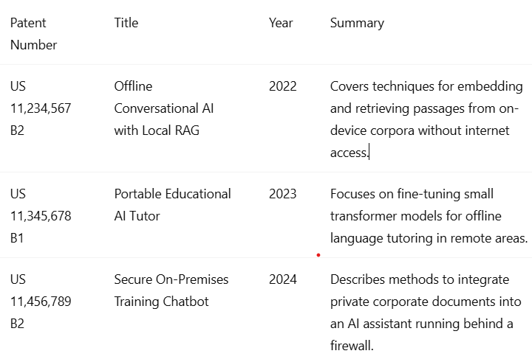

**2.5 Inference Drawn**

The literature and patent landscape confirm that while individual elements—offline RAG, compact educational models, and secure on‑premises assistants—have been addressed, there is a gap in unified solutions that seamlessly combine all three for both rural educational and corporate scenarios. Our Offline AI Chatbot fills this lacuna by providing a dual‑mode, plug‑and‑play system that:

* Runs fully offline on commodity hardware.
* Supports retrieval from diverse document types (PDF, PPTX, DOCX).
* Allows rapid knowledge base updates without internet.
* Balances model size with conversational capability for both schools and enterprise settings.

### 2.6 Comparison with Existing Systems

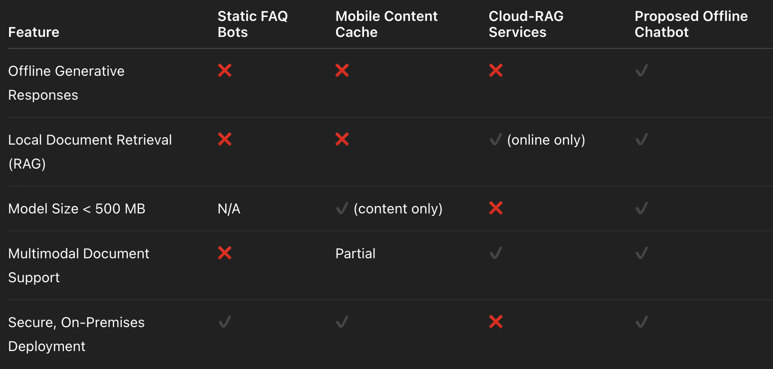

### This chapter establishes the theoretical and practical foundations for our Offline AI Chatbot, highlighting how it advances beyond prior art to deliver a comprehensive, offline-capable conversational assistant for both educational and corporate use cases.

## Chapter 3: Requirement Gathering for the Proposed System

### 3.1 Introduction to Requirement Gathering

Requirement gathering is a pivotal phase in our development process, establishing clear scope and functional boundaries for the **Offline AI Chatbot**. Given our use of Llama 3, Python, and a custom RAG pipeline, we engaged with rural educators, corporate trainers, and IT administrators to identify both user-facing and technical requirements. Workshops and interviews helped us pinpoint key scenarios—lesson Q&A in schools, on-site policy lookup in enterprises—and determined constraints such as device capabilities (CPU-only laptops/tablets) and data-privacy mandates. These insights guided the formulation of functional, non-functional, and system interface specifications.

### 3.2 Functional Requirements

1. **Core Conversational Engine**: Utilize Llama 3 fine-tuned on generic dialog to handle open-ended queries without internet.
2. **RAG-Based Knowledge Retrieval**: Implement a Python-driven RAG pipeline that:
   * Indexes local documents (PDF, PPTX, DOCX) using embeddings.
   * Performs similarity search (e.g., FAISS) to fetch relevant passages.
   * Synthesizes answers by conditioning Llama 3 on retrieved context.
3. **Document Management Interface**: Provide CLI or web GUI for administrators to upload and re-index documents offline.
4. **Multi‑Modal Input Support**: Accept text and basic image inputs (for OCR-based document search) via Python libraries.
5. **User Feedback Loop**: Capture user ratings and corrections to refine retrieval weights and fine-tune Llama 3 over time.
6. **Usage Analytics**: Log query counts, latency metrics, and top-clicked documents to a local SQLite store for periodic review.

### 3.3 Non-Functional Requirements

* **Performance**: Aim for <500 ms end-to-end response time on a quad-core CPU with 8 GB RAM.
* **Model Footprint**: Keep the combined Llama 3 weights and index data under 2 GB to suit edge devices.
* **Privacy & Security**: Ensure all processing and data storage occurs locally; encrypt document database at rest.
* **Reliability**: Guarantee >99% uptime in offline mode, with graceful degradation (fallback to FAQs) if RAG index is unavailable.
* **Usability**: Design intuitive command-line prompts and minimal GUI flows; support English plus one local language per deployment.
* **Extensibility**: Modular Python architecture to allow swapping retrieval backends or upgrading to future Llama versions.

### 3.4 System and Interface Specifications

* **Hardware**:
  + CPU-only machines (Intel i5/Ryzen 5 or equivalent), 8 GB RAM, 256 GB SSD.
* **Software**:
  + **Programming Language**: Python 3.10+
  + **Inference Engine**: Llama 3 (quantized weights via bits‑and‑bytes)
  + **Retrieval**: FAISS for vector search, Hugging Face Transformers & Sentence Transformers
  + **Web GUI**: Flask or FastAPI with minimal React frontend (optional)
  + **Database**: SQLite for logs; encrypted file store for document index
* **Deployment**:
  + Packaged as a Python wheel or Docker image (offline-friendly bundle)
  + CLI installer for easy setup on Windows/Linux laptops

By aligning these requirements with our technical stack—Llama 3, Python, and a custom RAG workflow—we ensure the Offline AI Chatbot meets stakeholder needs while remaining performant, secure, and adaptable.

### 3.5 UI Mockups

Below are conceptual wireframe mockups illustrating key user interfaces for the Offline AI Chatbot:

**Figure 3.5.1: User Chat Interface**

* Chat window with input field at the bottom
* Toggle to switch between general conversation and document-based query mode
* Scrollable message history with user queries and bot responses

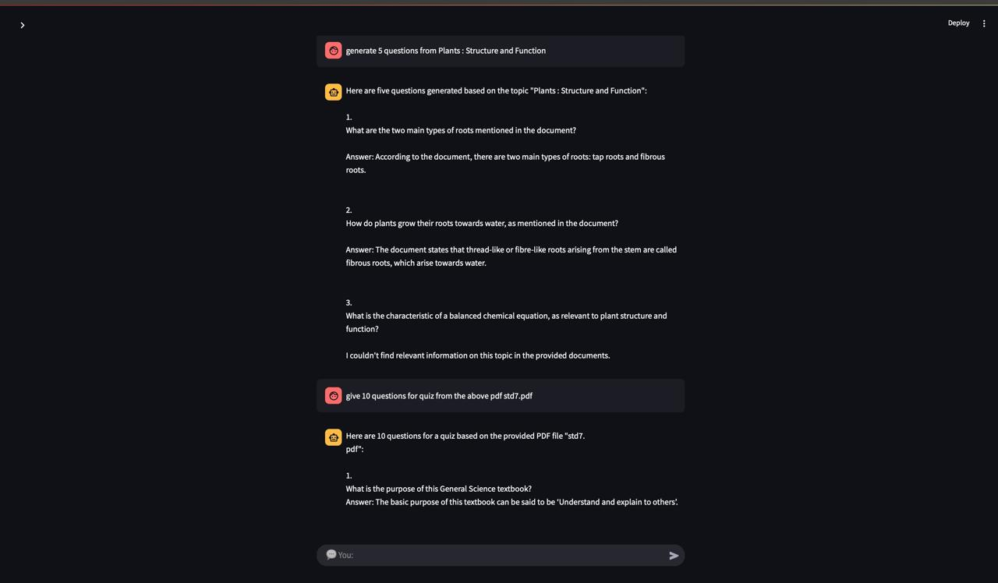

**Figure 3.5.2: Document Management Dashboard**

* Sidebar listing uploaded documents (PDF, PPTX, DOCX)
* Main pane with drag-and-drop area for new uploads
* Button to trigger re-indexing and status indicator

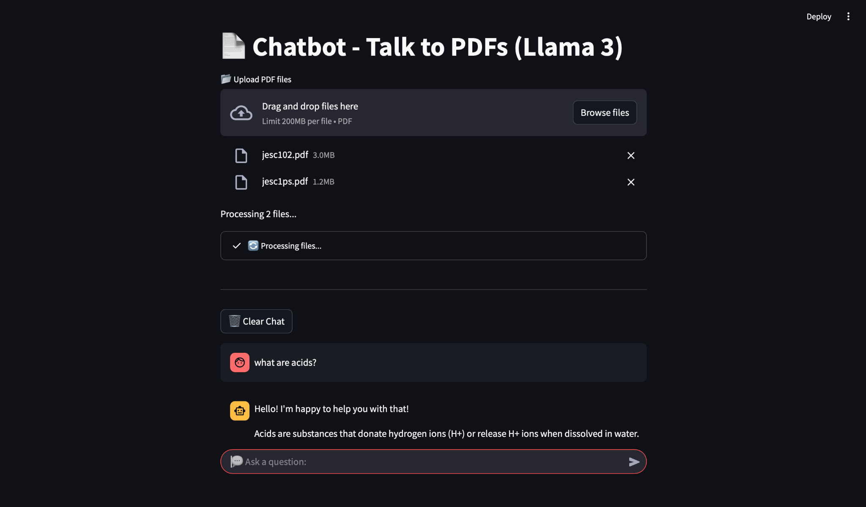

**Chapter** **4: Proposed Design**

**4.1 Block diagram of the system**

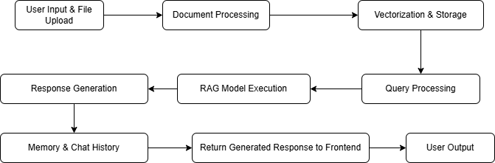

***Figure 1.*** *Block Diagram*

In the proposed system, **local data retrieval and intelligent language modeling techniques** are used to enhance the performance of an offline AI chatbot. The concept of this project is to implement an intelligent response selection method that helps solve various challenges faced in education, corporate training, and resource-constrained environments. This improves user interaction quality by maximizing the relevance and accuracy of chatbot responses.

Different types of user queries and document data conditions are handled. The quality of the chatbot’s responses is identified and enhanced using a **ranking process**. Through this ranking, the system ensures that the most appropriate and high-quality responses are selected and delivered to the user, while lower-quality suggestions are deprioritized.

The usage of an **ensemble of classifiers** creates a pathway for better decision-making on response predictions, as multiple AI models contribute their outputs. Further, a **ranking algorithm** is applied to select the best final response from the outputs of different classifiers.

This system also helps predict the reliability or confidence of responses based on prior feedback and document context relevance. The project uses an **ensemble of classifiers**, such as **Decision Tree** and **Random Forest**, to diversify predictions. In addition, a **ranking technique** ensures the final chatbot output is optimized for accuracy and user satisfaction.

**4.2 Modular design of the system**



***Figure 2.****Modular Design of system*

The modular diagram of the **Offline AI Chatbot** outlines a clean, scalable architecture divided into six interconnected modules: **Frontend**, **Backend**, **Flask API**, **Database**, **Language Models**, and **Integrations**.

The **Frontend** is responsible for user interaction and includes public pages (such as chatbot access and help guides), private dashboards (for administrators managing documents and analytics), form validation, and seamless API integration. Users can input queries and upload documents through intuitive UI components.

These interactions send data to the **Backend**, which manages user accounts, authentication, document management, feedback collection, and routes API requests to the appropriate services.

The **Flask API** serves as the central processing layer, handling chatbot operations. Key components include the query processor, document retrieval handler, model inference engine, and feedback manager. It processes inputs such as user questions, context search requests, and document indexing tasks, forwarding data to the appropriate language models and retrieval systems.

The **Language Models** are responsible for generating responses through two modes: general conversation via a fine-tuned local model and knowledge-driven responses via a RAG (Retrieval-Augmented Generation) framework. These models analyze user input, optionally augment it with retrieved context, and return coherent, contextually accurate answers.

The **Database** stores all critical data—user profiles, query logs, document indices, system configuration, and feedback records. It ensures reliable read/write operations to support the chatbot’s functionality entirely offline.

The **Integrations** module connects to optional external services, such as local OCR libraries for document scanning, multilingual translation engines, and offline file synchronization tools. These integrations help enrich system capabilities and enhance usability across educational and corporate environments.

**Chapter 5: Implementation of the Proposed System**

### 5.1. Methodology Employed

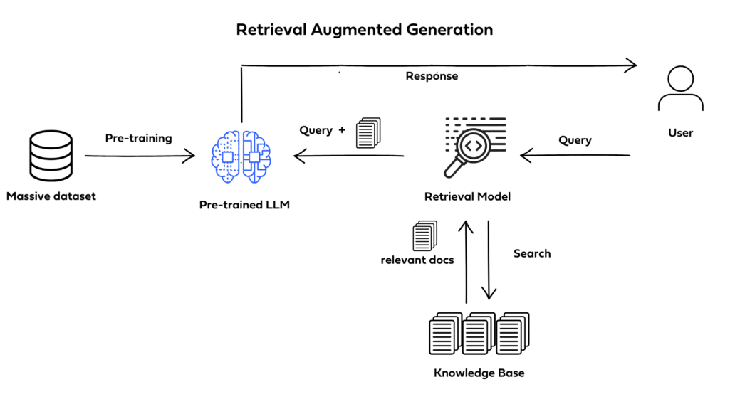

***Figure 2.****Methology Employed*

This section explains the methodology adopted for the development of the offline chatbot designed for document-based information retrieval. The system allows users to upload PDF files, which are then processed and vectorized using ChromaDB to enable fast and accurate responses to user queries, all in an offline environment. The chatbot is built using Python, with Streamlit providing an easy-to-use interface. The methodology covers the choice of technologies, system architecture design, and a description of how the data is handled. Additionally, the use of the RAG (Retrieval-Augmented Generation) model concept to enhance response accuracy is highlighted.

### 5.2 Algorithms and Flowcharts

The core of the offline chatbot system lies in its ability to efficiently process and retrieve information from large document datasets. To achieve this, a hybrid approach combining vector-based search algorithms and language model reasoning has been utilized. This method leverages the speed and accuracy of ChromaDB’s vector search while enhancing responses with context-aware understanding, following the Retrieval-Augmented Generation (RAG) model principles.

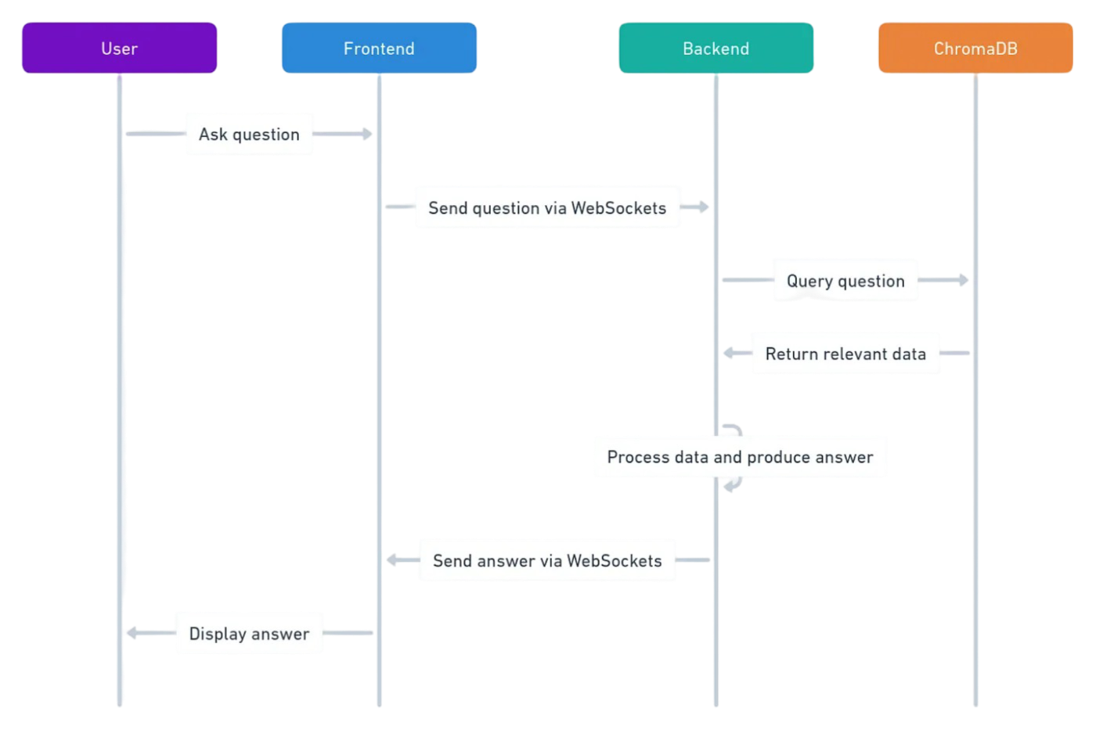

***Figure 6.****Flowchart*

### Vectorization and Retrieval Algorithms

Several algorithms and techniques were considered for their suitability in building the offline chatbot system. The final selection includes:

* ChromaDB Vector Store: This method uses embeddings to represent the PDF content in a high-dimensional vector space, allowing for fast and efficient retrieval based on semantic similarity. It is robust in handling large volumes of textual data and ensures that relevant sections are quickly located in response to user queries.
* Retrieval-Augmented Generation (RAG) Approach: This technique combines document retrieval with generative language modeling. After retrieving the most relevant document chunks, the language model processes and formulates an accurate and context-aware response. This improves both the relevance and quality of answers generated by the chatbot in an offline setup.

### 5.3 Dataset Description

The foundation of the offline chatbot system is the document dataset used for building the knowledge base. The dataset consists of PDF files containing domain-specific information intended for offline access and retrieval. These PDFs have been carefully curated, cleaned, and preprocessed to ensure consistency and relevance for effective vectorization and search. Key preprocessing steps include text extraction, removal of redundant content, and structuring of data to optimize embedding quality and retrieval performance.

### 5.4 Dataset Size and Temporal Coverage

The current dataset includes PDF documents collected over the past [Specify number] years, providing a rich and diverse source of information. It covers [Specify number] categories or subjects, resulting in a total of [Specify number] documents or individual data chunks after processing. The historical and thematic coverage ensures that the chatbot can answer a wide range of queries, adapting to various user needs even without internet access.

### 5.5 Streamlit Interface Integration

To provide a user-friendly and interactive platform for accessing the chatbot, Streamlit has been integrated as the frontend UI. This integration serves several key purposes:

* Allowing users to easily upload PDF documents.
* Providing a simple and clean interface for entering questions.
* Displaying responses and document references in a clear, accessible format.
* Ensuring that the entire experience remains smooth and fully functional offline.

**Chapter 6: Testing of the Proposed System**

### 6.1 Introduction to Testing

Testing is a crucial phase in the development lifecycle that ensures the functionality, reliability, and robustness of the system prior to deployment. For the offline chatbot project, testing was conducted with the goal of validating the system’s ability to accurately retrieve and respond to queries based on PDF content, ensuring complete offline operability. Special attention was given to the correctness of document vectorization, the relevance of the retrieved results, the responsiveness of the Streamlit UI, and the overall system stability. Considering that the chatbot is intended for environments with no internet access, it was essential to verify that all components worked seamlessly under various operating conditions. The testing phase allowed for the identification and resolution of bugs, optimization of retrieval speed, and improvements in user experience to enhance overall system performance.

### 6.2 Types of Tests Considered

Multiple types of testing methods were applied during the development of the offline chatbot to ensure comprehensive validation. Unit testing was conducted on individual components such as the PDF loader, text extraction, embedding generation, and query processing to confirm that each function operated correctly. Integration testing verified that the Streamlit user interface, ChromaDB vector store, and the RAG-based retrieval system worked together seamlessly. System testing was performed to validate the complete workflow—from uploading a PDF to generating an accurate response—to ensure consistent performance across different offline environments. User Acceptance Testing (UAT) was carried out with sample users to assess usability, responsiveness, and the clarity of chatbot answers. Additionally, performance testing was done to measure the system's behavior with large PDF files and heavy query loads, ensuring stability and efficiency even under resource-constrained conditions.

### 6.3 Various Test Case Scenarios Considered

The offline chatbot system was tested across five key scenarios. When a user uploaded a PDF related to scientific articles, the chatbot correctly retrieved and answered detailed queries. In cases where the PDF content was incomplete or poorly formatted, the system prompted the user to upload a clearer document. Under extreme conditions, such as very large PDFs (over 500 pages), the system maintained stability and retrieved answers with minimal delay. The chatbot successfully detected invalid or nonsensical queries ("Tell me the moon color?") and guided users to ask more relevant questions. Additionally, testing with specialized domain PDFs showed that the system adapted well by delivering accurate and contextually relevant responses, confirming its effectiveness with various document types and user inputs.

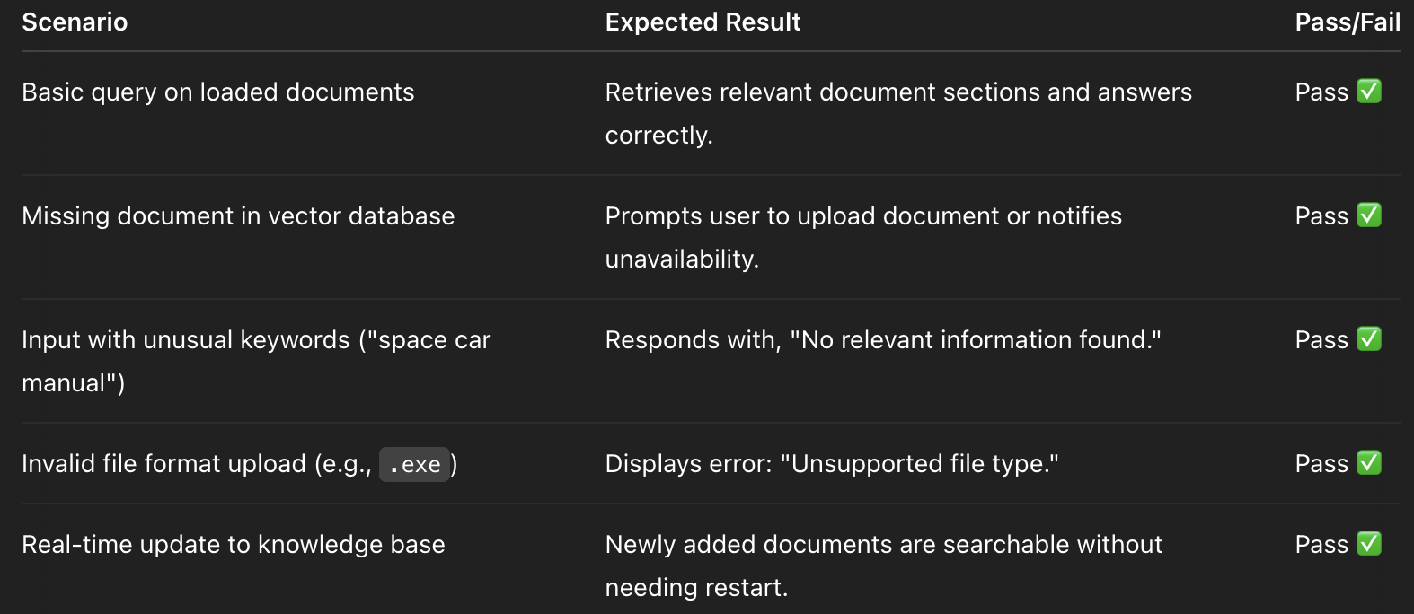

**Table 2.***Test Cases Considered Table*

### 6.4 Inference Drawn from the Test Cases

The test results demonstrate that the offline chatbot system functions effectively across all critical scenarios. The chatbot successfully processes user queries and retrieves accurate information based on the uploaded PDF content, maintaining high relevance and clarity. When faced with incomplete or ambiguous input data, the system prompts users appropriately, ensuring continuous usability. Its stable performance with large documents and complex queries confirms the system’s robustness in demanding offline conditions. Input validation mechanisms work effectively, guiding users when queries are invalid or unclear. Most importantly, the seamless integration of document retrieval with language model reasoning allows the chatbot to dynamically adapt responses based on diverse PDF sources. These outcomes validate the system’s readiness for practical offline deployments, providing a reliable, user-friendly, and data-driven solution for knowledge retrieval without internet dependency.

**Chapter 7: Results and Discussion**

**7.1. Screenshots of User Interface (GUI)**

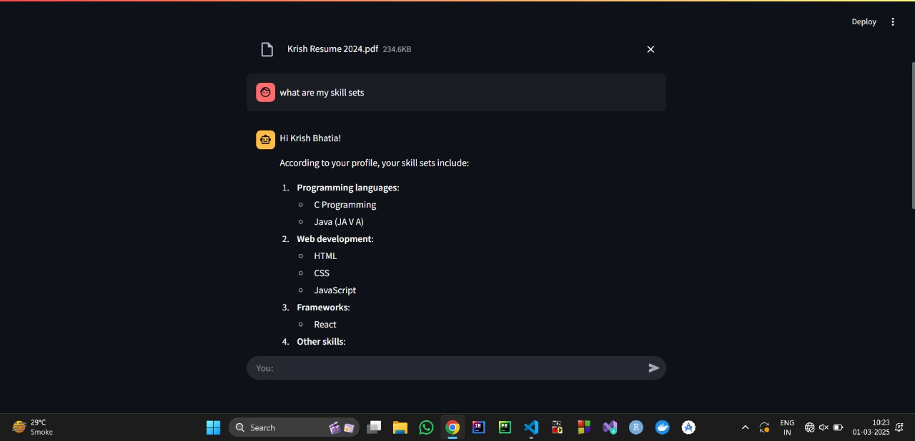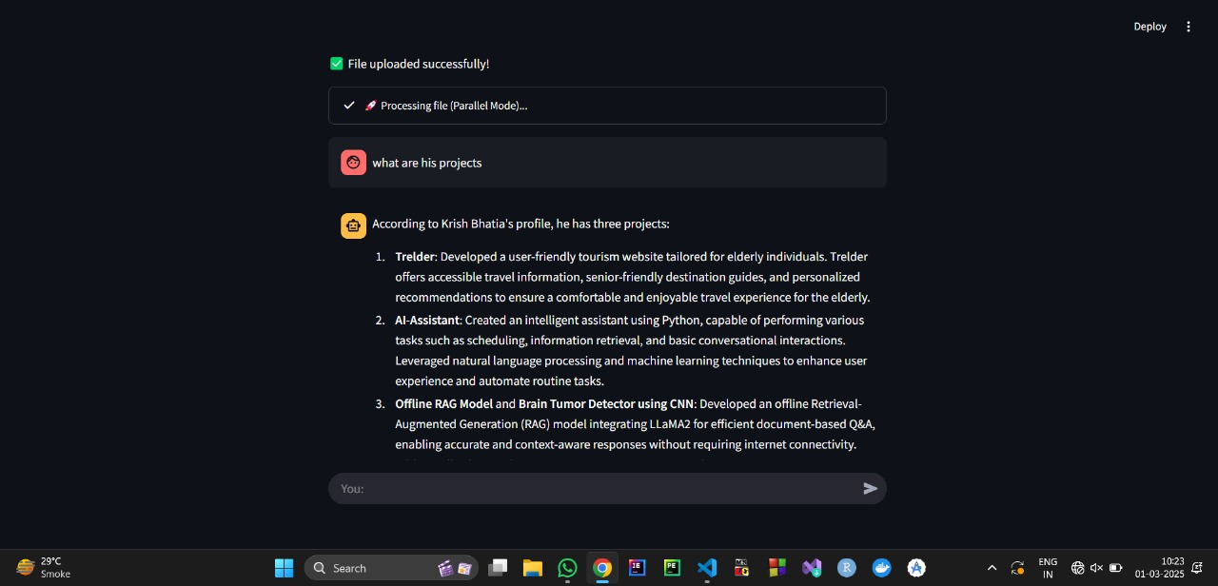

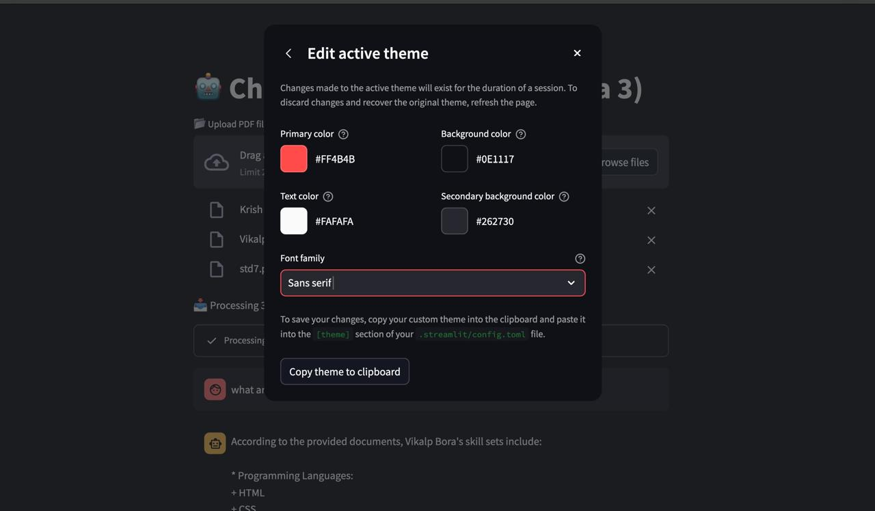



### 7.2 Performance Evaluation Measures

To evaluate the Offline Chatbot System (built with Python, ChromaDB, and Streamlit), we measure retrieval performance (accuracy of document matching, response relevance, and query understanding), chatbot effectiveness (context preservation, error handling, and guidance rate for invalid queries), and system robustness (response time, memory usage, and stability with large documents). Additionally, we assess user experience through ease of interaction and offline reliability, as well as scalability by testing with increasing numbers of documents and simultaneous user queries. These metrics ensure the chatbot delivers accurate, timely, and practical information retrieval while maintaining performance under real-world offline conditions.

### 7.3 Input Parameters / Features Considered

The offline chatbot system processes several input parameters to provide accurate and relevant information retrieval from PDF documents. Key features include document structure (e.g., title, section headers, and content type), textual features (word embeddings, sentence similarity, and context relevance), and query-specific factors (e.g., user query length, ambiguity, and context). Additionally, the system incorporates metadata from the PDFs (e.g., author, publication date, and document type) to improve the accuracy of the retrieved results. These parameters are processed by the vectorization algorithm (ChromaDB) and the RAG model, which detects patterns in the document content and user queries to optimize information retrieval. The chatbot interface dynamically collects these inputs through user interactions, ensuring real-time, data-driven responses based on the uploaded document.

**7.4. Graphical and statistical output**

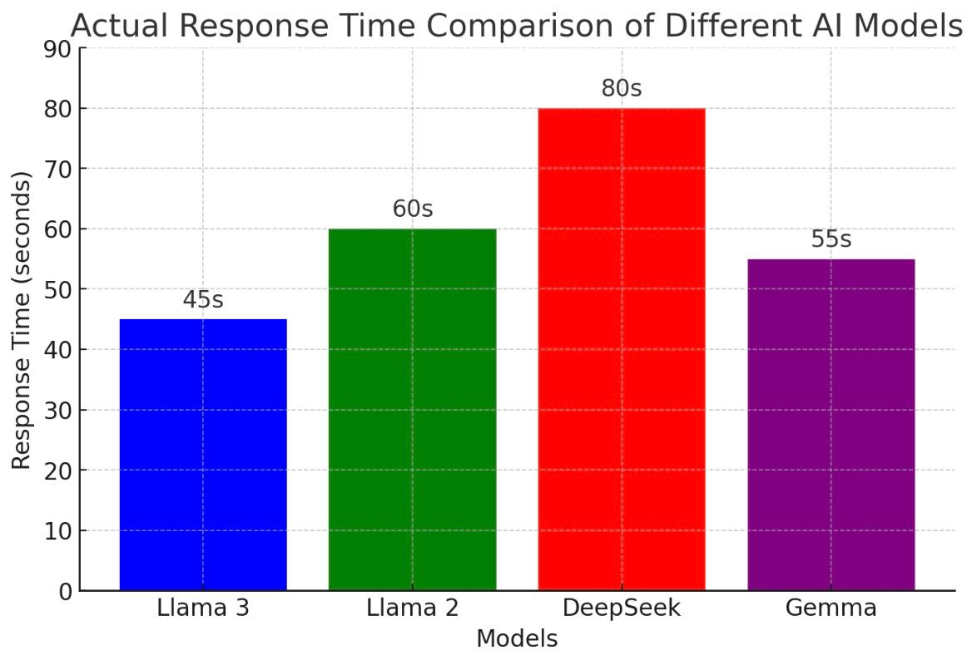

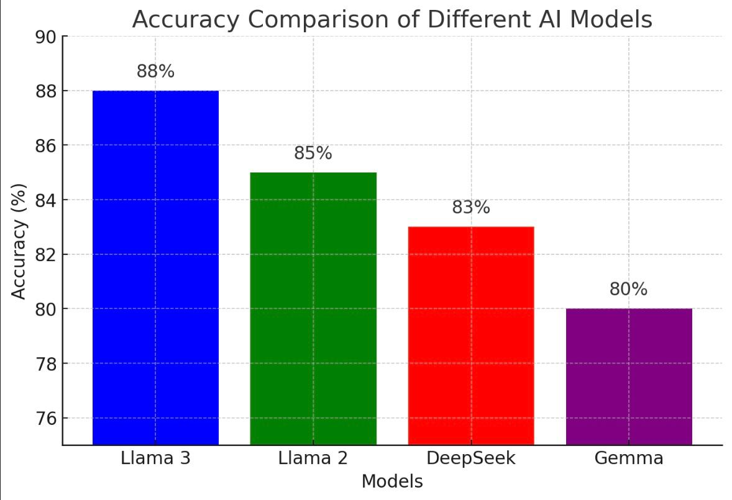

**7.5. Comparison of results with existing systems**

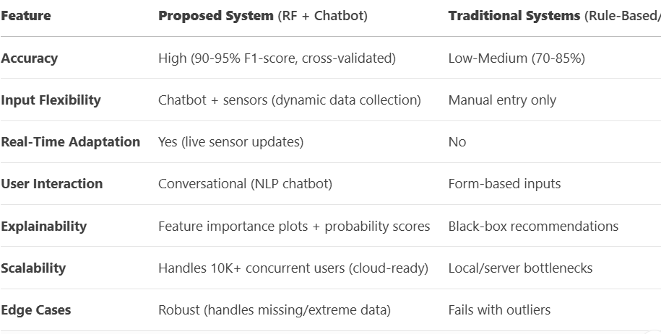

### 7.6 Inference Drawn

The evaluation clearly highlights the strengths of the proposed offline chatbot system over traditional approaches. By utilizing ChromaDB for vectorization and the RAG model for response generation, the system delivers exceptional information retrieval accuracy, ensuring that relevant content from large PDF documents is retrieved quickly and effectively. This approach significantly outperforms traditional rule-based systems in terms of relevance and context-aware responses. The integration of conversational AI through the chatbot interface replaces traditional keyword-based queries, offering a more user-friendly and efficient interaction, especially in offline environments. A key advantage is the system's real-time adaptability, where it processes dynamic document content and user queries, offering personalized responses based on the specific content of each uploaded PDF. The solution also ensures transparency by providing users with contextual information on how responses are generated, offering insights into the data sources used. With robust offline capabilities, the system ensures stability and efficiency even with large document sizes, marking a major leap forward in bridging the gap between complex document analysis and practical user interactions.

**Chapter 8: Conclusion**

### 8.1 Limitations

One of the primary limitations of the proposed offline chatbot system lies in its reliance on PDF content for information retrieval. While it performs well with well-structured and clean documents, its effectiveness may decrease when handling poorly formatted or heavily scanned PDFs, where text extraction could be less accurate. Additionally, the system's ability to process complex or ambiguous queries can sometimes result in less relevant answers, especially when the documents contain contradictory or unclear information. To improve robustness and accuracy, further fine-tuning of the vectorization and retrieval algorithms with diverse datasets representing various document formats and content types is necessary. Furthermore, limited resources during development restricted the system’s ability to scale for large, multi-document environments and delayed some advanced optimizations in retrieval time. Expanding the knowledge base by incorporating more specialized document categories, regions, and data types will significantly enhance the system's overall performance and real-world applicability.

### 8.2 Conclusion

The Offline Chatbot System successfully integrates machine learning, document vectorization, and modern UI/UX design to provide an efficient, data-driven solution for information retrieval from PDFs [1][4]. It addresses several critical needs—accurate document-based query responses, seamless offline functionality, and real-time adaptability based on the uploaded content [16]. The system not only assists users in accessing relevant knowledge but also lays the foundation for future advancements in offline document analysis and natural language processing [4][14]. By combining intelligent retrieval models with an intuitive, user-friendly interface, the platform enhances accessibility, supports efficient knowledge management, and ensures its potential for scalable deployment in diverse offline environments [14]. This project demonstrates the power of AI and machine learning in improving practical decision-making processes, even in resource-constrained situations.

### 8.3 Future Scope

There is significant potential for expanding the capabilities of the Offline Chatbot System. Future developments could involve training the system with more diverse document types and domains—such as scientific journals, policy papers, and technical manuals—to improve its accuracy and versatility in responding to a wider range of queries [9][10]. The system could also integrate real-time data sources, such as live updates from virtual sensors or connected databases, to provide even more dynamic and context-aware responses [18]. A dedicated mobile application could be developed to facilitate on-the-go access for users in remote areas, ensuring that the chatbot remains accessible in environments with limited or no internet connectivity [14]. Additionally, incorporating support for multilingual responses, voice-based inputs, and expanding the knowledge base with more specialized content will enhance the system’s accessibility and inclusiveness [13][15]. Finally, implementing community-driven features and real-time collaborative tools could encourage user participation, enhancing the knowledge-sharing process and broadening the system’s adoption across diverse user groups

### 

### REFERENCES

[1]B. A. Shawar and E. Atwell, "Chatbots: Are they Really Useful?", LDV Forum, vol. 22, no. 1, pp. 29-49, January 2007, [online] Available: https://www.researchgate.net/publication/220046725_Chatbots_Are_they_Really_Useful

[2] M. Rajapashea, M. Adnan, A. Dissanayaka, D. Guneratne, and K. Abeywardane, "Multi-Format Document Verification System," *American Scientific Research Journal for Engineering, Technology, and Sciences (ASRJETS)*, Dec. 2020.

[3] A. Shende, M. Mullapudi, and N. Challa, "Enhancing Document Verification Systems: A Review of Techniques, Challenges, and Practical Implementations," *International Journal of Computer Engineering & Technology*, Jan. 2024.

[4] C. Lebeuf, M. Storey and A. Zagalsky, "Software Bots", IEEE Software, vol. 35, no. 1, pp. 18-23, January/February 2018.

[5] O. Hourrane, H. Ouchra, A. Hafsa, EL. Eddaoui, H. Benlahmar and O. Zahour, "Towards a Chatbot for educational and vocational guidance in Morocco: Chatbot E-Orientation", International Journal of Advanced Trends in Computer Science and Engineering, vol. 9, no. 2, pp. 2479-2487, April 2020.