**4th SEMESTER SUBJECT**

**SOFTWARE PROJECT**

**of**

**B.Tech. Computer Engineering**

**Topic: Online Cloth Shopping**

| **Prepared by:** | **Prepared by:** |
| --- | --- |
| **Name: Bharad Raj Jitendrabhai** | **Name: Chauhan Shyam Hiteshbhai** |
| **ID: 21CEUBS106** | **ID: 21CEUOS005** |
| **Roll No: CE009** | **Roll No: CE017** |
| **Batch: A1** | **Batch: A1** |
| **Computer Engineering,** | **Computer Engineering,** |
| **Dharmsinh Desai University** | **Dharmsinh Desai University** |

Dharmsinh Desai University

Year 2022-23

**PROJECT DESCRIPTION:**

The Clothing websites are used to do shopping for clothes online. First and main object of this is to make shopping interactive and it will be easy to use. There are many functionalities to achieve these goals. It will make the selection of clothes easy. There are functions to get proper clothes for you. There are sections of gender wise shopping of clothes. In every item there are details of all the things of that product which you need to know. In that same page option to see all products similar to that. There are functions to make your dream wardrobe and you can order from there directly. There is an option of a cart for ordering many items together. There is an option to create your wishlist. And from there you can add that product to cart and then order the product.

**GitHub Link:**

[**https://github.com/Shyam023/R-S-cloth-store.git**](https://github.com/Shyam023/R-S-cloth-store.git)

**Screenshot of Website :**

1. **User Registration :**

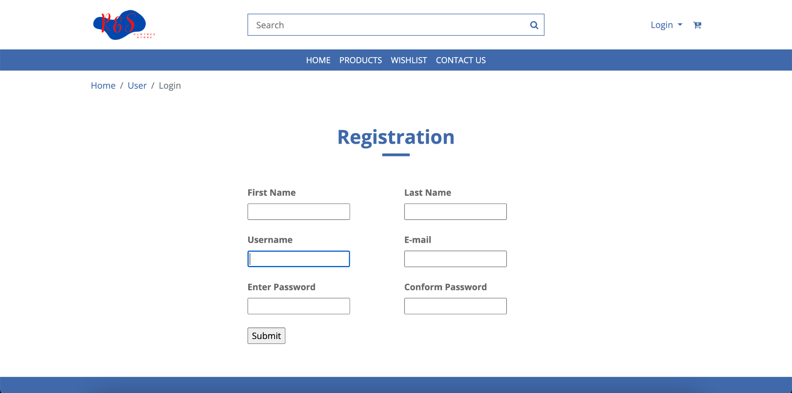

1. **User Login :**

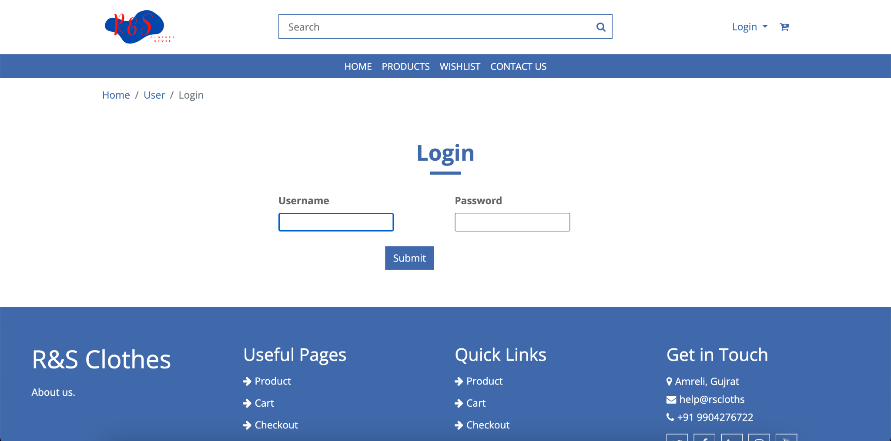

1. **User Home Page :**

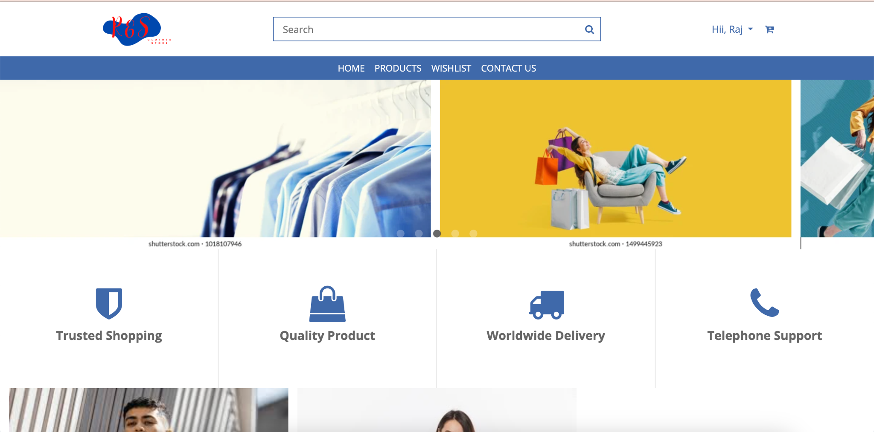

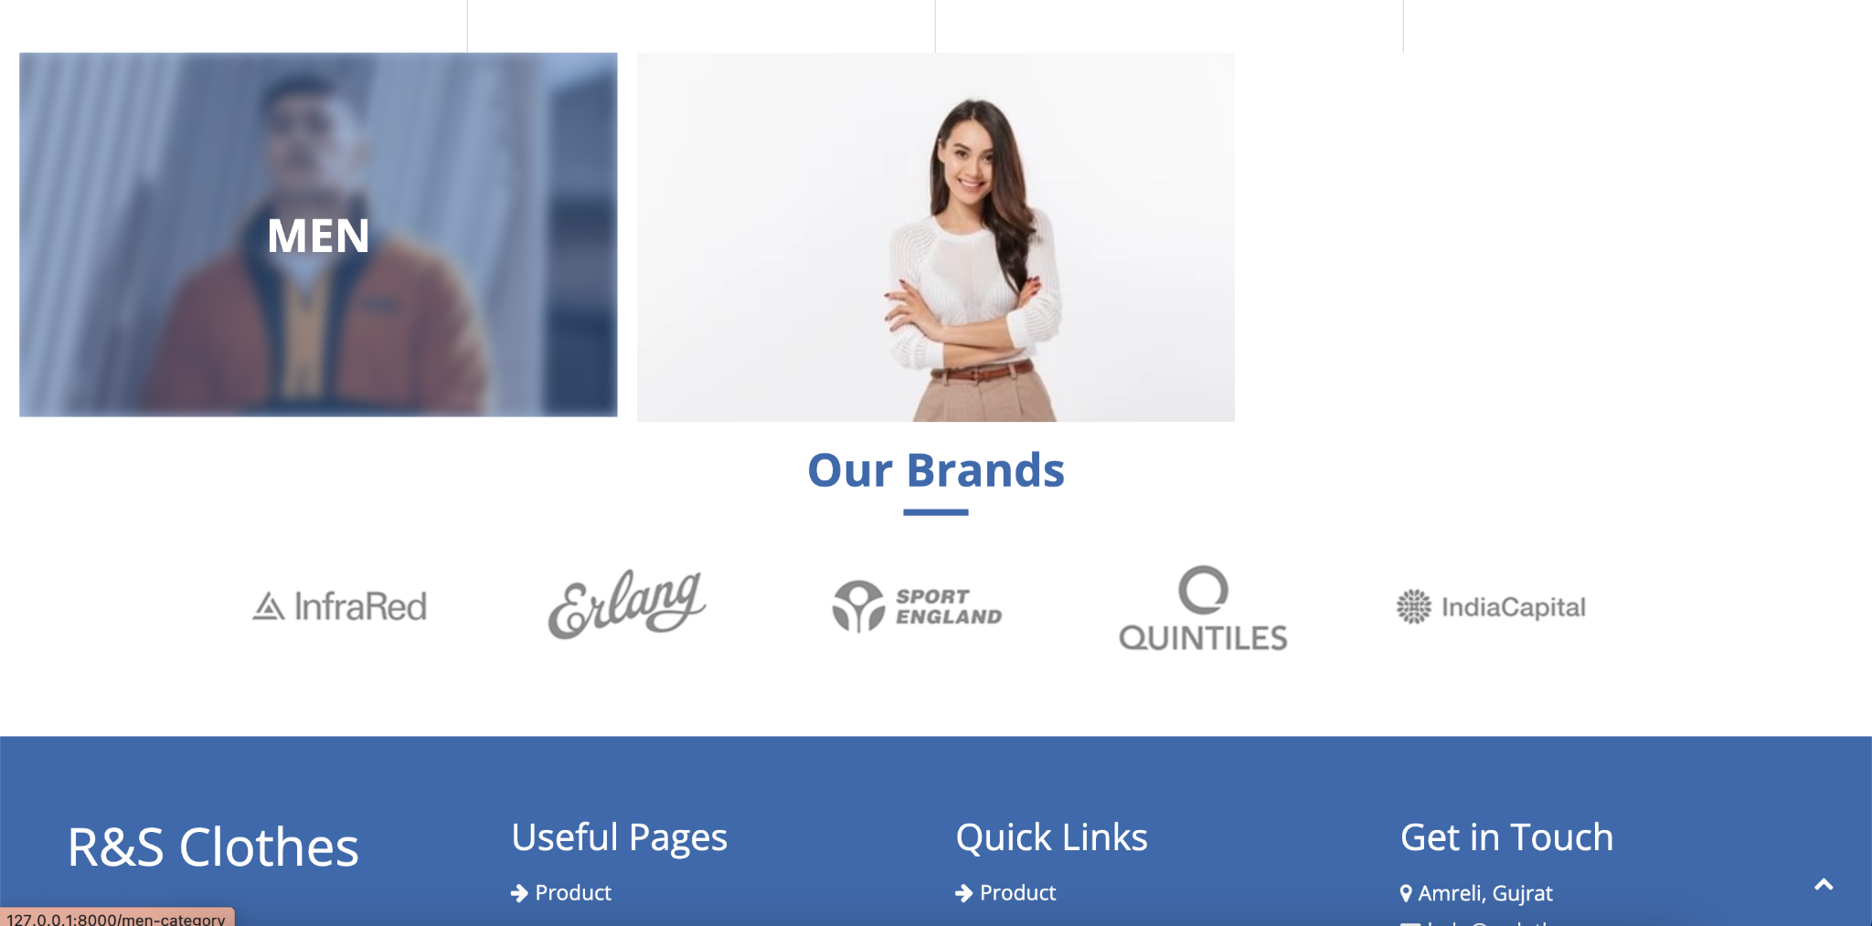

1. **Product List :**

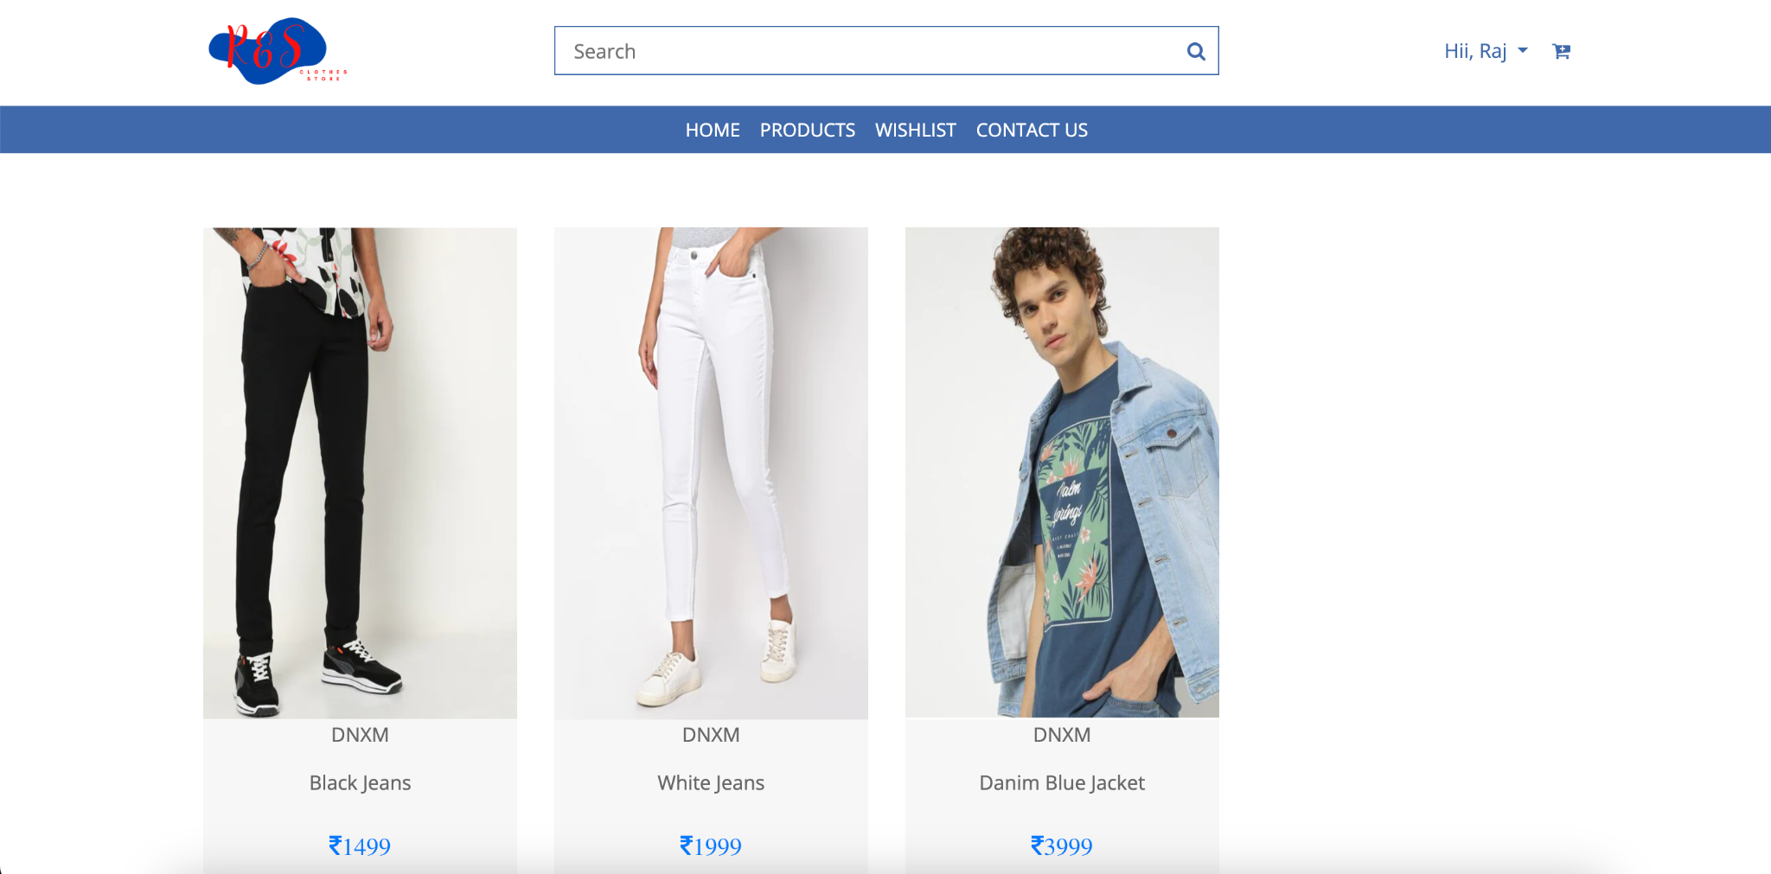

1. **Product Cart and Wishlist Option :**

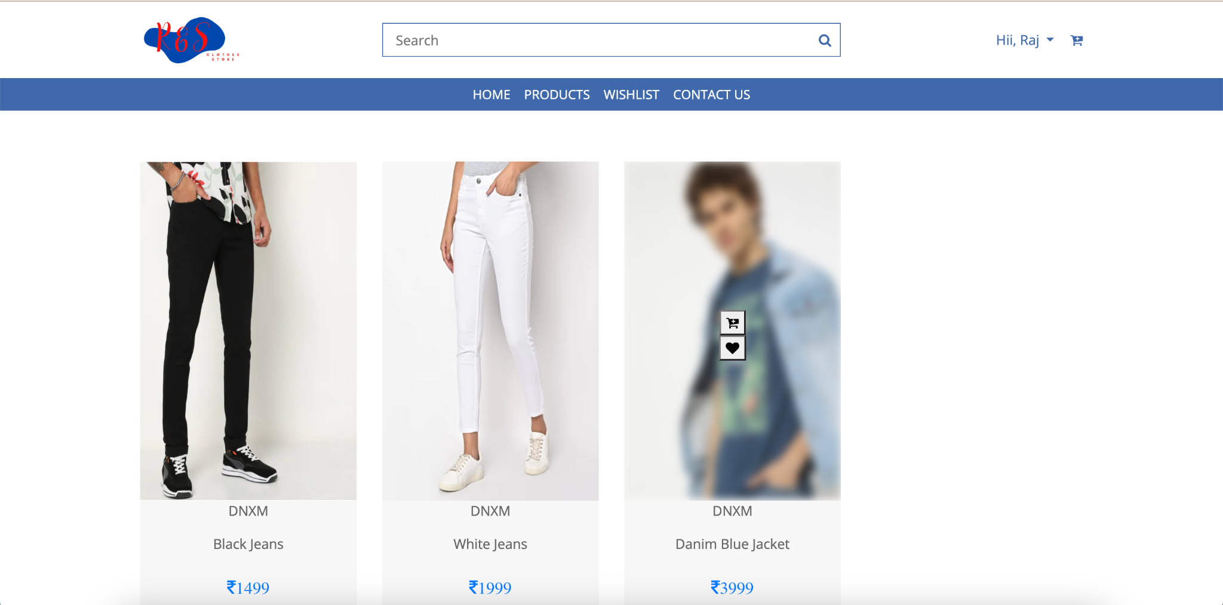

1. **User Wishlist :**

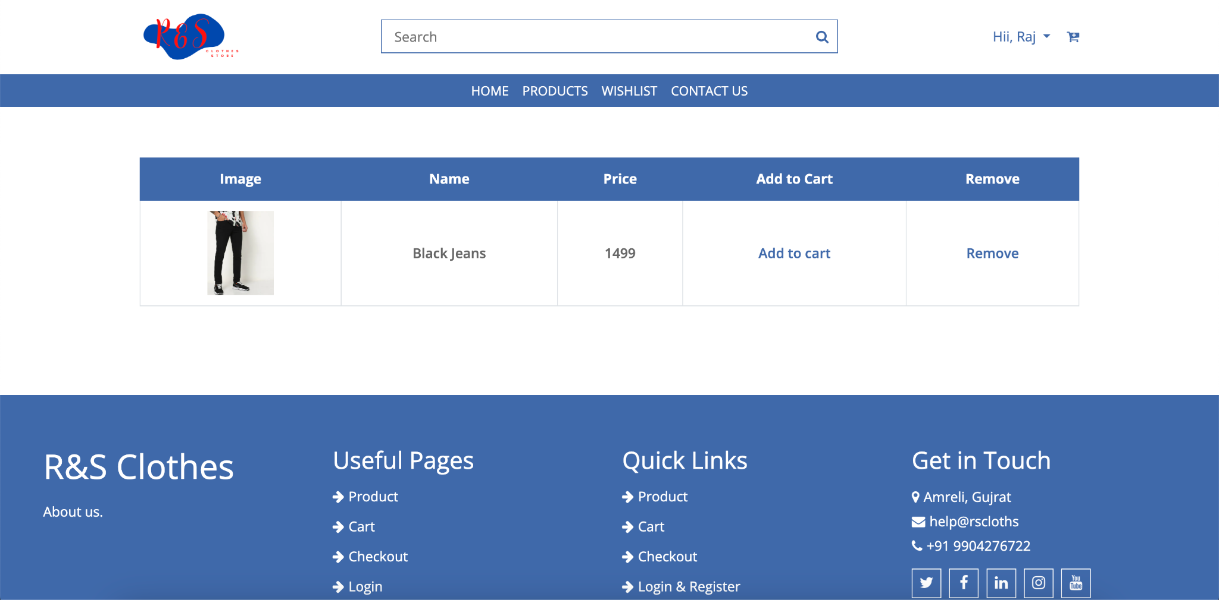

1. **User Cart and Checkout Option :**

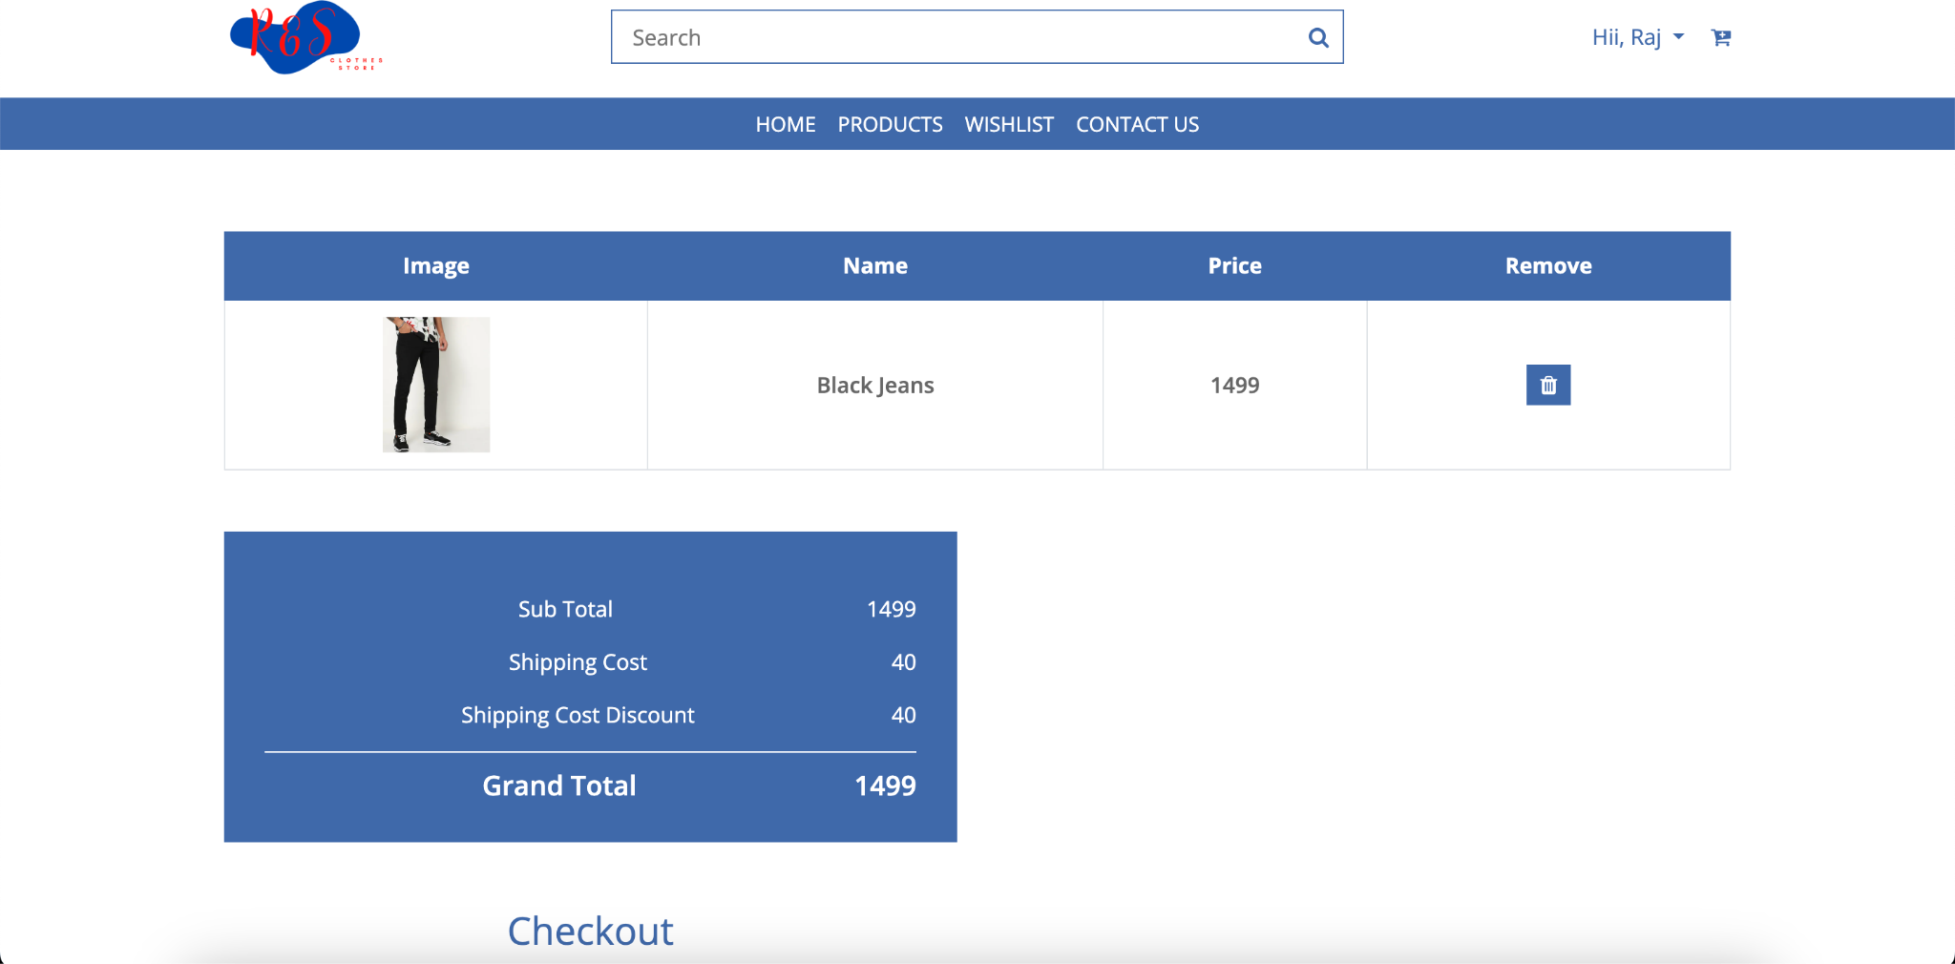

1. **Dashboard :**

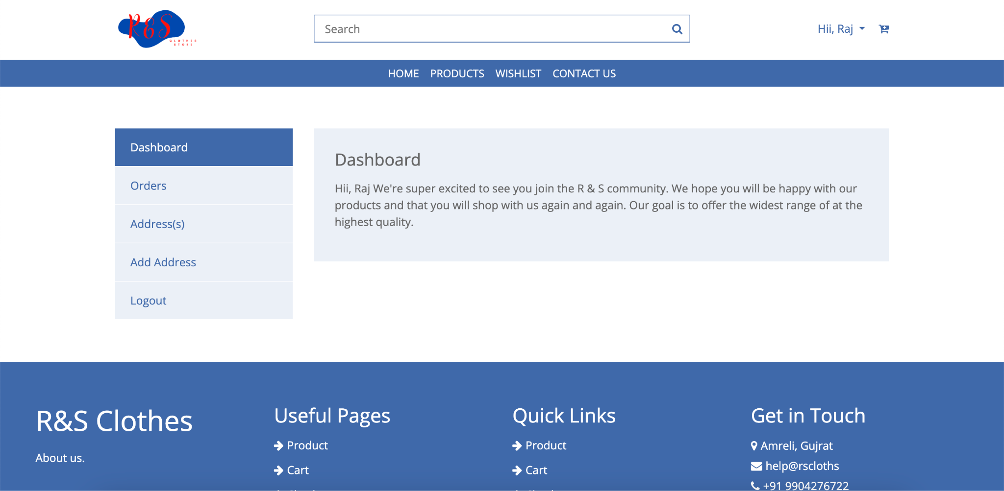

1. **User Order details:**

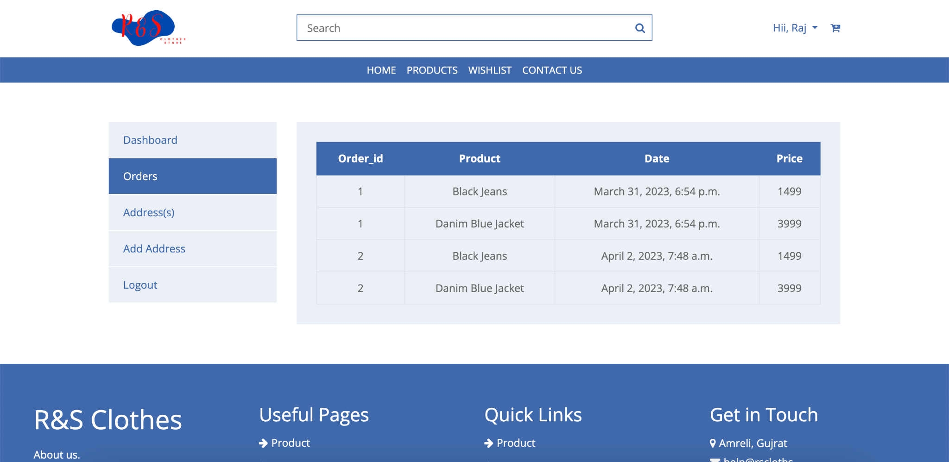

1. **User all Address List:**

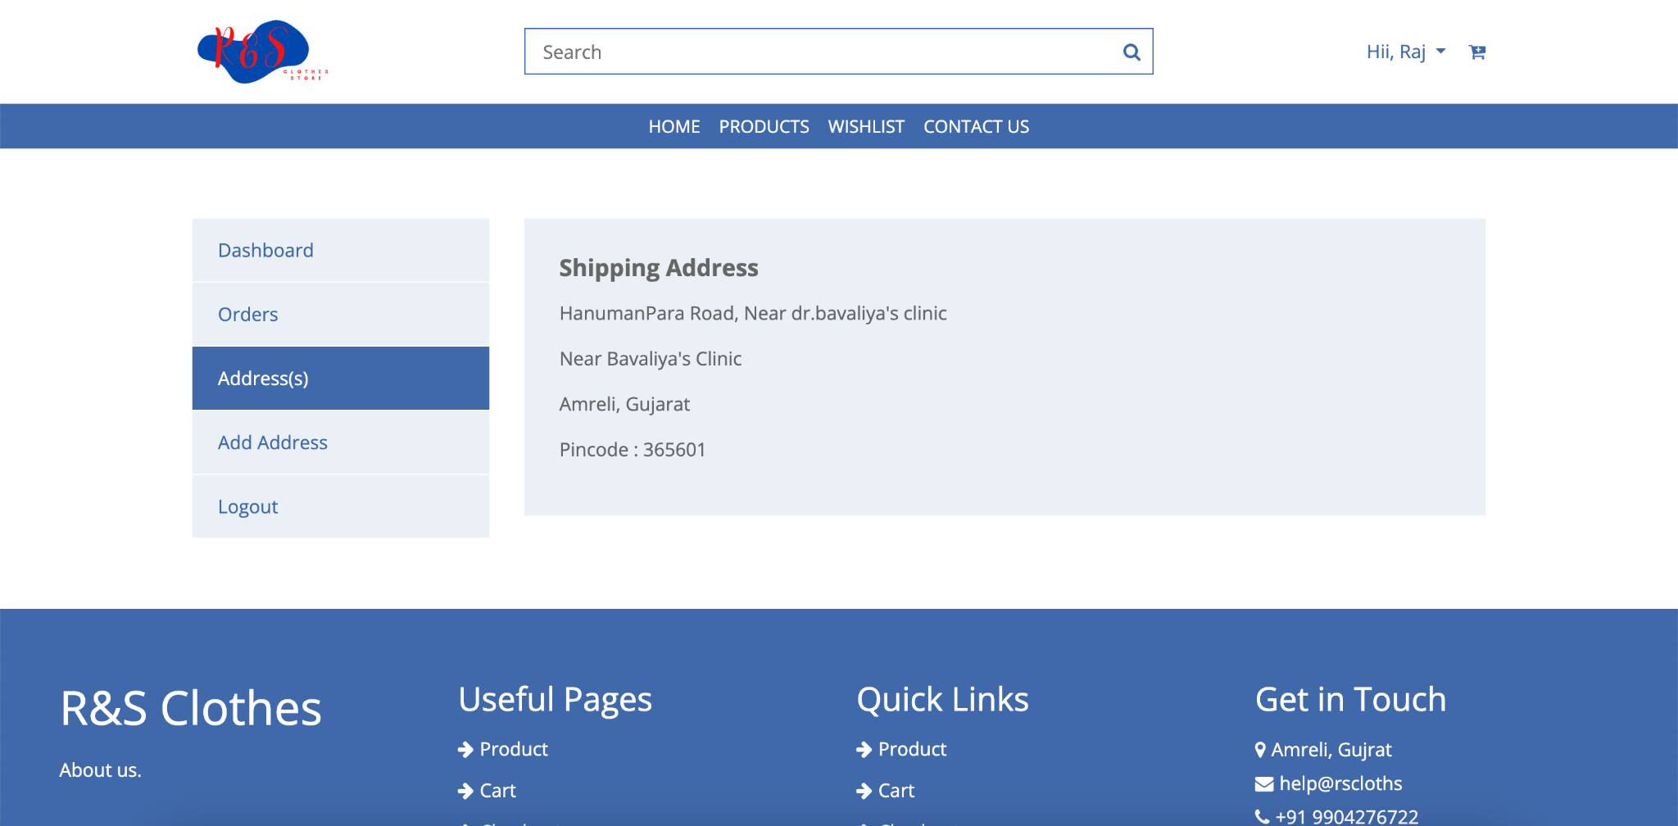

1. **User Add Address :**

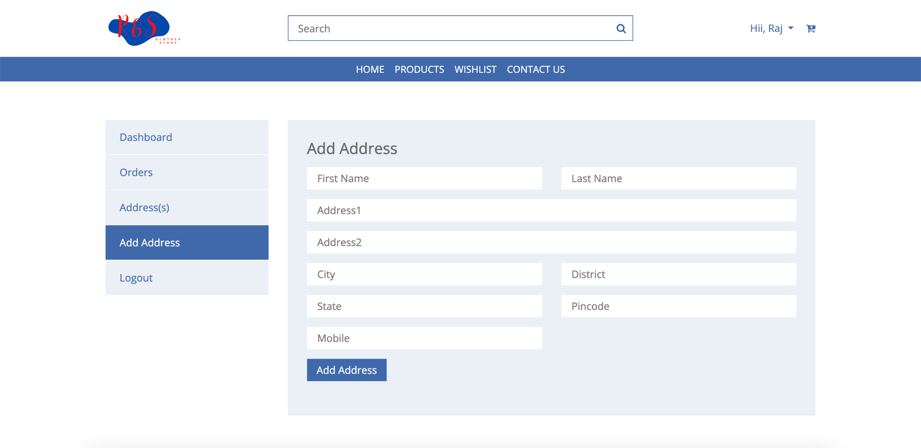

1. **Retailer Login:**



1. **Retailer Registration :**

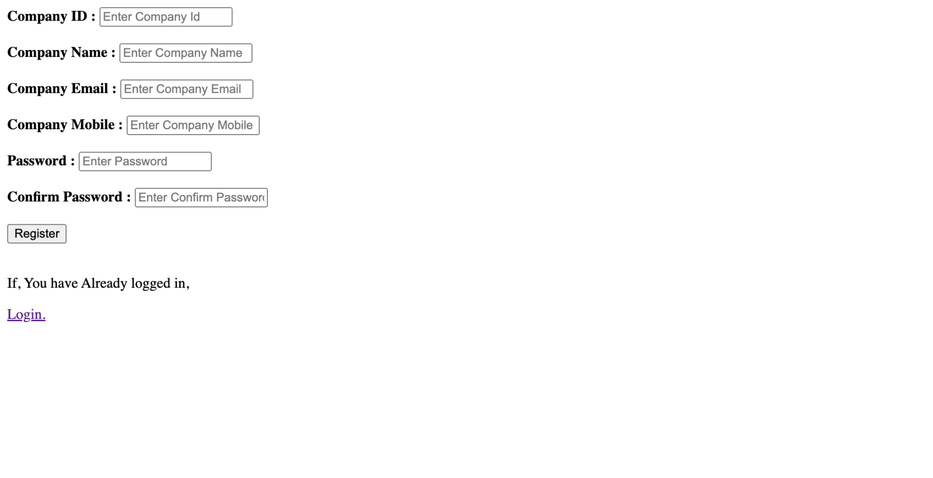

1. **Retailer Add Product :**

