CAPITAL
IN MOTION
Indian Startup Funding Analysis | 2015–2020
A management-ready review of investment patterns, source-data reliability, and the actions required to make the reporting decision-ready.
THE VERIFIED BASELINE
RECORDS | DISCLOSED AMOUNTS | DISCLOSED FUNDING | FUNDING DISCLOSURE RATE
3,044 | 2,073 | $38.14B | 68.1%

Prepared from the supplied cleaned CSV, cleaning notebook, business problem statement, SQL query documentation, and three Power BI screenshots.
Evidence standard: figures in the analysis are independently recalculated from the supplied cleaned CSV. SQL execution, end-to-end re-execution of the notebook, and DAX validation in Power BI Desktop were not available for this review.

01 | EXECUTIVE READOUT
The capital story is concentrated — but the dataset needs stronger controls
The data supports a useful directional view of disclosed startup funding. It does not yet support unqualified market-wide trend claims or definitive individual-investor rankings.
Verified finding | Evidence from supplied cleaned CSV | Business meaning
Disclosed funding totals $38.14B | 2,073 of 3,044 records have numeric Amount_USD; sum = $38.144B | Funding totals reflect disclosed values only, not all funding raised.
Private Equity is the largest funding-type bucket | $27.23B; 71.4% of disclosed amount | Reported funding is dominated by one stage/type classification.
Five highest-funding city labels dominate | $32.02B; 84.0% of disclosed funding | Geographic concentration is high; normalize locations before using it for expansion decisions.
Mean deal size is far above the median | Average $18.40M vs median $1.75M (10.5×) | A small number of large rounds materially influence averages.
Source coverage thins sharply after 2016 | 993 records in 2016; 111 in 2019; 7 in January 2020 | The record-count decline cannot be interpreted as market decline without coverage completeness evidence.

Recommended management stance
Use this work as a descriptive funding landscape and a data-quality baseline. Before it becomes a capital-allocation tool, validate the $3.9B largest recorded deal, consolidate category taxonomies, normalize investor identities, build a complete month calendar, and reconcile Power BI totals to the CSV.

What was and was not validated
- Passed: direct recalculation of core totals, year/city/stage summaries, missing-amount rates, deal-size distribution, and duplicate count from the supplied cleaned CSV.
- Not independently executed: Python cleaning notebook (raw input CSV was not supplied), MySQL queries (no database connection), and Power BI DAX/visual calculations (screenshots reviewed only).

02 | BUSINESS PROBLEM
Business problem and analytical scope
Original problem statement retained from the supplied brief.
“Analyze Indian startup funding data from 2015 to 2020 to uncover trends in investment activity, looking at which industries, cities, and funding stages attracted the most capital over time, and who the key investors were.”

Six core questions
ID | Business question | Analytical approach
01 | How has total funding trended over time, both in deal count and dollar amount, month-over-month and year-over-year? | Year/month sums; record count vs disclosed-amount count; growth only where period coverage is comparable.
02 | Which industries received the most funding, and how has that shifted over time? | Funding by industry; explicit label normalization and before/after taxonomy checks.
03 | Which cities are the biggest startup hubs by funding volume? | Funding by city label; isolate Indian city records and reconcile geography fields.
04 | How is funding distributed across funding stages, from Seed and Series A/B/C through Private Equity and Debt? | Funding-type distribution using Investment_Type_Clean; show value and deal counts.
05 | Who are the top investors, by number of deals and by total amount invested? | Current strings are not reliable individual-investor entities until multi-name cells are normalized.
06 | What is the average and median deal size, and how does it vary by industry or stage? | Average and median of disclosed numeric amounts; segment by industry/stage with outlier context.

Scope boundaries
- Dataset period is 2 January 2015 to 13 January 2020. The supplied file contains January-only data for 2020 (7 records).
- The source labels Amount_USD as USD. Currency metadata was not independently verified.
- Findings describe the supplied dataset; they do not establish complete Indian market coverage or causal explanations for funding movements.

03 | DATA AUDIT
A useful cleaned table, with material coverage and taxonomy limits
The supplied cleaned CSV contains 3,044 records and 12 columns. Category placeholders are filled, but missing funding amounts remain null by design.
Audit item | Recalculated result | Status / implication
Rows / columns | 3,044 / 12 | Reconciled directly to CSV.
Date range | 2015-01-02 to 2020-01-13 | 2020 contains only seven records, all in January.
Numeric funding amount | 2,073 disclosed; 971 missing (31.9%) | Missing is not zero; totals and average/median use disclosed numeric amounts.
Disclosed funding total | $38.1439B | Recalculated as sum(Amount_USD). Currency still as labeled by source.
Average / median | $18.40M / $1.75M | Mean is 10.5× median; investigate outliers.
Exact duplicate rows | 0 | No exact duplicates in the supplied cleaned CSV.
Unique startup-name strings | 2,457 | At least one Startup Name value is URL-like and needs review.
Distinct industry labels | 822 | Long tail and near-duplicates; the sector ranking changes after taxonomy cleanup.
Distinct city labels | 73 | Includes Unknown, country/state values, and foreign locations; screenshot City Count is not reconciled to this raw-label count.
Distinct investor strings | 2,364 | Not equivalent to individual investors; some cells contain multiple names.

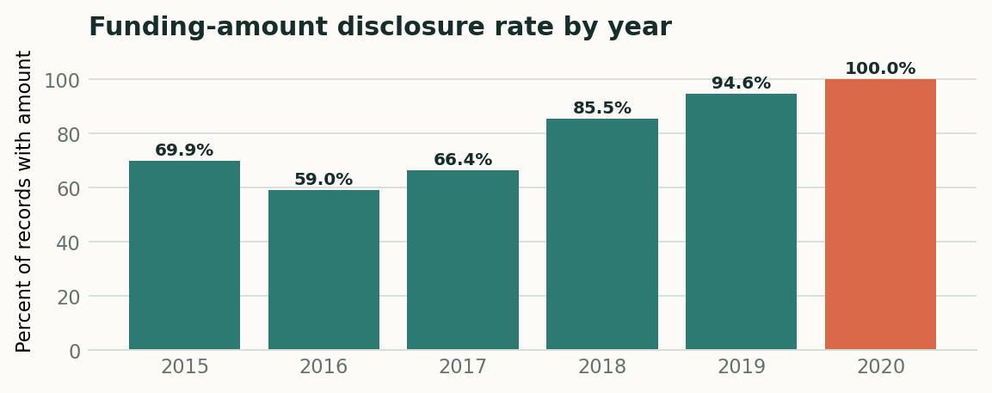
Disclosure rate = records with numeric Amount_USD / all records. The 2020 value is based on only seven January records.
Cleaning notebook review: it describes repair of eight malformed date strings, amount parsing, city standardization, funding-type standardization, investor casing/alias normalization, replacement of missing categorical values with “Unknown”, and removal of 0 exact duplicates. The notebook’s stored outputs report 0 unparseable dates. The raw source CSV referenced by the notebook was not supplied, so those before/after steps could not be re-executed independently.

04 | METHOD AND CONTROLS
Calculation rules and technical validation
The cleaned CSV was loaded independently and core metrics were recalculated. SQL and Power BI execution are marked as untested where a runtime was not supplied.

Calculation definitions
Metric | Definition used in this report | Important interpretation
Deal records | COUNT(rows) = 3,044 | Includes records whose funding amount is undisclosed.
Disclosed deal records | COUNT(Amount_USD) = 2,073 | Counts numeric amount values, excluding nulls.
Total disclosed funding | SUM(Amount_USD) = $38.1439B | Does not estimate missing/undisclosed capital.
Average disclosed deal size | AVERAGE(Amount_USD) = $18.40M | Sensitive to very large recorded rounds.
Median disclosed deal size | MEDIAN(Amount_USD) = $1.75M | Better represents the central disclosed deal than the mean in this skewed distribution.
Funding disclosure rate | 2,073 / 3,044 = 68.1% | A data-coverage KPI, not a funding success rate.
City concentration | Top five exact cleaned city labels / total funding = 83.95% | Location mapping and geographic filtering affect the result.

Python notebook review
- Notebook structure and stored outputs were reviewed. Key cleaning steps include date repair, numeric conversion of Indian digit-grouped amount strings, category normalization, missing categorical placeholders, and duplicate checks.
- The notebook uses machine-specific Windows paths and reads raw_startup_funding.csv. That raw file was not included; full end-to-end notebook execution was therefore not tested. The cleaned CSV was independently analyzed in Python.

SQL query review
- The SQL PDF covers yearly/monthly totals, YoY/MoM funding growth, cumulative funding, industry/city/stage breakdowns, investor-string ranks, mean/median deal size, and additional segment queries.
- MoM query risk: the dataset has no 2019-03 group. A LAG over existing YearMonth rows may compare 2019-04 to 2019-02 unless a complete calendar-month spine is joined and missing months are handled explicitly.
- Investor SQL groups by Investors_Name text. Multi-name cells are treated as a single string; this is not an individual-investor leaderboard.
- YoY on 2020 is not comparable to full years: it reflects only seven January records. Use a like-for-like January-to-January comparison or exclude 2020 from full-year growth.
Testing status: SQL syntax/results were not executed in MySQL; DAX and visual interactions were not executed in Power BI Desktop. The three supplied Power BI screenshots were visually inspected.

05 | FUNDING ACTIVITY
Recorded funding peaks in 2017; record coverage drops sharply after 2016
The values below are calculated from the supplied CSV. The pattern should be described as funding recorded in this file—not a definitive market trajectory—until source coverage is established.
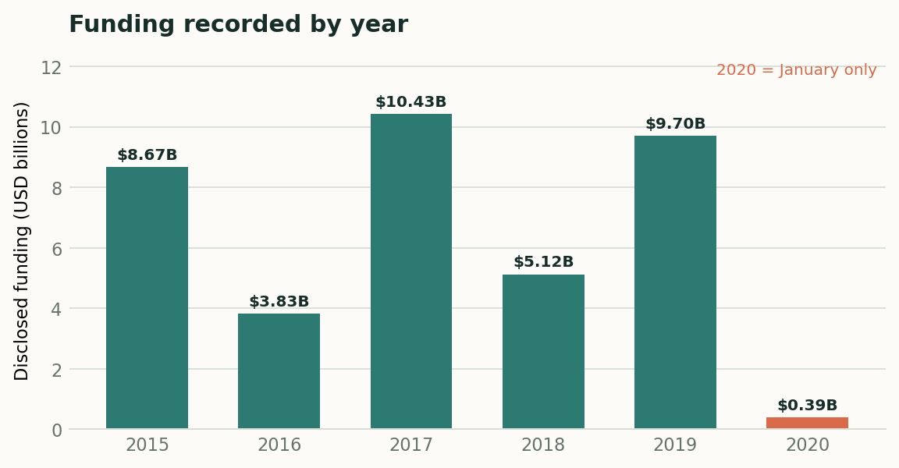
Annual sum of disclosed Amount_USD. 2020 contains January-only data and is not a full-year comparator.
Year | Records | Amounts disclosed | Funding total | YoY change* | Disclosure rate
2015 | 936 | 654 | $8.673B | — | 69.9%
2016 | 993 | 586 | $3.828B | -55.9% | 59.0%
2017 | 687 | 456 | $10.429B | +172.4% | 66.4%
2018 | 310 | 265 | $5.122B | -50.9% | 85.5%
2019 | 111 | 105 | $9.701B | +89.4% | 94.6%
2020 | 7 | 7 | $0.390B | -96.0% | 100.0%

*2020 YoY change is shown only to document the mechanical calculation (-96.0%); it must not be interpreted as a full-year funding decline because the file has only January 2020 records.

What the data supports
- 2017 has the highest annual disclosed total at $10.43B; 2015 is $8.67B, 2019 is $9.70B, and 2018 is $5.12B.
- 2016 has the largest record count (993). Later observed counts fall to 687 in 2017, 310 in 2018, 111 in 2019, and 7 in January 2020. This coverage pattern is a reason to verify collection completeness before market-level interpretation.
- The largest observed funding month is 2019-08 at $4.53B across 17 records, including 16 numeric amounts. This is driven by a $3.9B recorded round and requires source-level verification.
- The dataset contains no YearMonth row for 2019-03. A strict month-over-month series should include the missing month as missing/zero by a documented rule rather than silently skipping it.

06 | INDUSTRY MIX
Industry rankings are sensitive to inconsistent labels
The raw Industry field has 822 distinct strings. A limited case/punctuation normalization was applied to exact e-commerce label variants for this finding; it is not a full sector taxonomy.
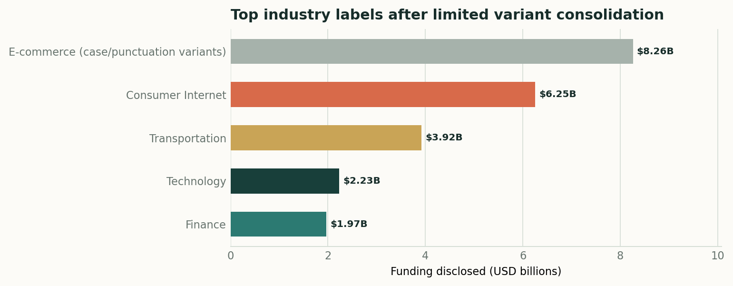
For the E-commerce bar, exact labels that normalize to “ecommerce” after lowercasing and removing punctuation are merged. Subtypes such as marketplace or M-commerce are not included in that group.
Industry grouping / label | Records | Disclosed funding | Analytical note
E-commerce exact label variants | 299 | $8.26B | 299 records across six case/punctuation variants; this grouping changes the ranking.
Consumer Internet | 941 | $6.25B | Largest single raw label; 941 records.
Transportation | 4 | $3.92B | Only 4 records; dominated by the $3.9B Rapido record, a material outlier to verify.
Technology | 478 | $2.23B | Exact raw label only.
Finance | 62 | $1.97B | Exact raw label only.
Unknown | 171 | $1.23B | Unknown should remain visible as a data-quality category.

Implication
Do not publish a definitive industry leaderboard until a controlled taxonomy maps spelling/case variants and semantically related labels (for example, e-commerce, marketplace, and M-commerce) into documented canonical categories. Keep the raw label alongside the canonical label for auditability.

07 | GEOGRAPHY
Five city labels account for 84.0% of disclosed funding
City totals are aggregated as they appear in the cleaned CSV. The city field still includes foreign locations, country/state labels, and “Unknown”, so geography should be standardized before operational use.
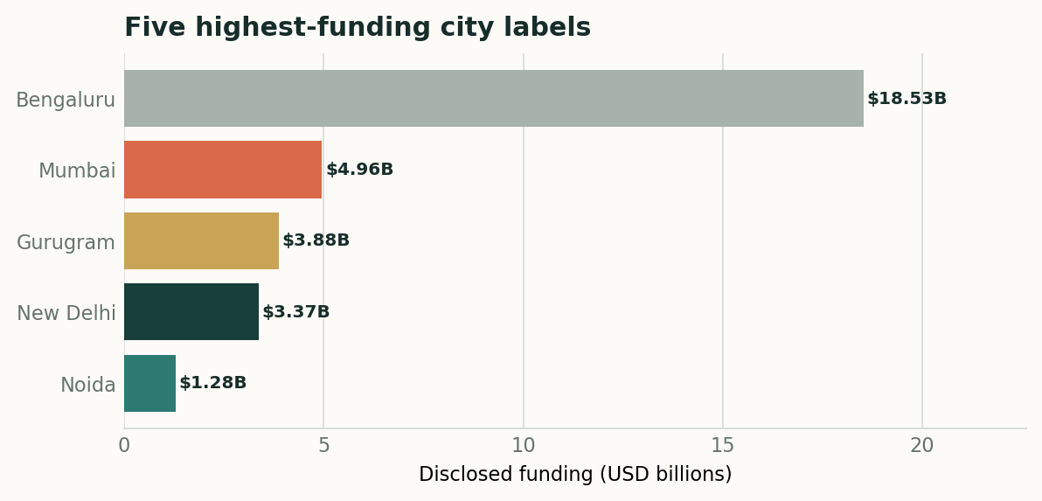
Top five city labels ranked by sum of numeric Amount_USD.
City label | Records | Records with numeric amount | Funding | Share of total
Bengaluru | 850 | 592 | $18.533B | 48.6%
Mumbai | 573 | 407 | $4.959B | 13.0%
Gurugram | 342 | 244 | $3.878B | 10.2%
New Delhi | 463 | 271 | $3.371B | 8.8%
Noida | 94 | 57 | $1.283B | 3.4%

Key geographic insight
Bengaluru contributes $18.53B, or 48.6% of disclosed funding in this file. The top five city labels contribute $32.02B (84.0%). This is strong concentration in the observed data, but not a census of the entire Indian startup ecosystem.

Required geography controls
- Separate City, State/Region, and Country fields. Treat “India”, “US/USA”, state names (for example, Haryana or Karnataka), and foreign cities as distinct data-quality cases rather than city geographies.
- Preserve the source City field; create an auditable City_Canonical and a Geography_Status field (India city / foreign city / country-state / unknown / ambiguous).
- Use a city bar chart as the default; use a map only after geocoding and country matching are verified.

08 | STAGE & DEAL SIZE
Private Equity dominates value; averages are skewed by large rounds
Stage results use the supplied Investment_Type_Clean column. This avoids mixing it silently with the separate Power BI “Funding Stage” grouping.
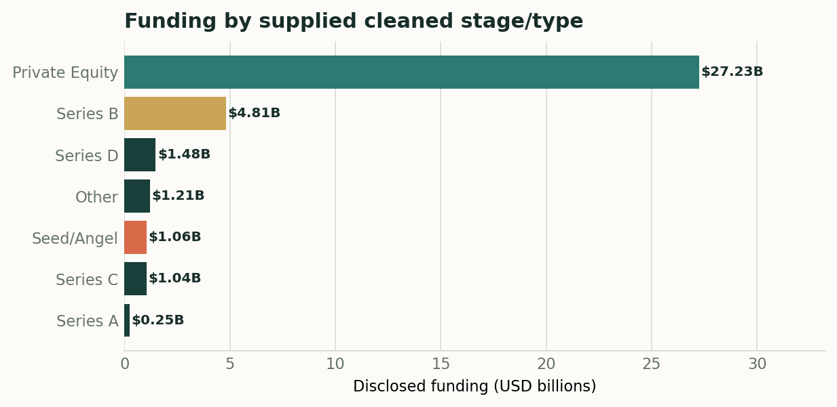
Top seven Investment_Type_Clean categories by disclosed funding; sums exclude rows with blank Amount_USD.
Investment type | Records | Disclosed records | Funding | Funding share | Average / median
Private Equity | 1,362 | 1,077 | $27.235B | 71.4% | $25.29M / $6.00M
Series B | 21 | 21 | $4.805B | 12.6% | $228.82M / $15.80M
Series D | 12 | 12 | $1.482B | 3.9% | $123.48M / $65.00M
Other | 12 | 11 | $1.205B | 3.2% | $109.58M / $6.24M
Seed/Angel | 1,542 | 864 | $1.056B | 2.8% | $1.22M / $0.37M
Series C | 14 | 14 | $1.045B | 2.7% | $74.62M / $50.00M
Series A | 33 | 30 | $0.248B | 0.6% | $8.25M / $3.45M

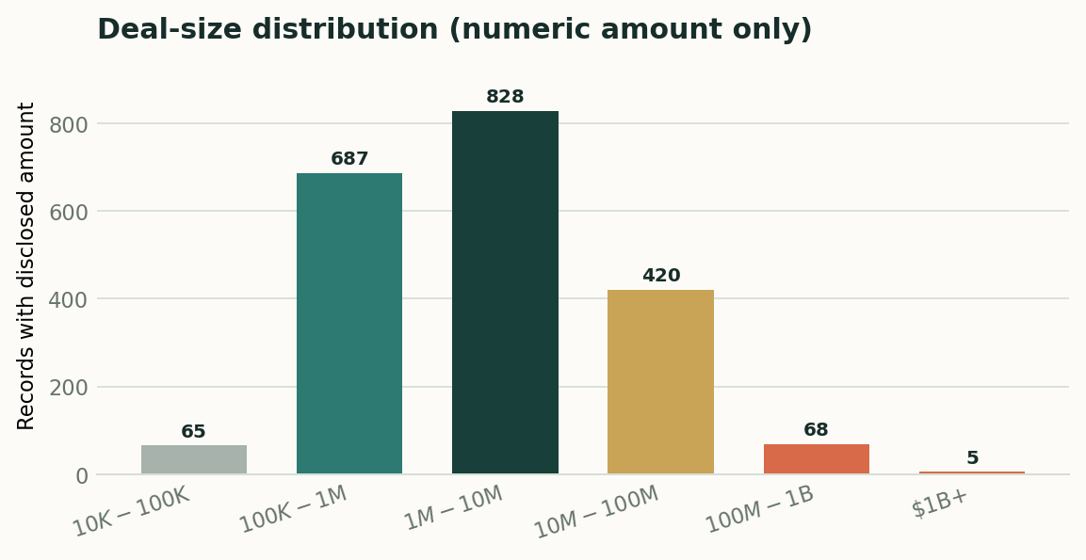
Counts include only records with numeric funding amounts. No disclosed numeric amounts are below $10K in this export.

Distribution and outlier interpretation
- Mean disclosed deal size is $18.40M, versus a median of $1.75M; the mean is 10.5× the median. Use medians alongside averages when comparing typical deal sizes.
- The top ten funding records sum to $13.27B (34.8% of total disclosed funding). The largest single record is $3.90B for Rapido Bike Taxi on 2019-08-27, recorded as Series B. Verify this record and source currency before treating it as a market fact.
- Seed/Angel has the largest record count (1,542) but only $1.06B in disclosed funding; Private Equity has 1,362 records and $27.23B. Counts and capital volume tell different stories.

09 | INVESTORS & SQL LOGIC
The current investor field does not yet support a defensible individual-investor leaderboard
Investor name strings are normalized for casing/spacing in the notebook, but a number of rows still contain multiple names in a single text cell.
Indicator | Observed value | Interpretation
Distinct investor strings | 2,364 | Not the count of unique individual investors.
Rows labeled Unknown | 24 | Unknown investor attribution should remain visible.
Rows labeled Undisclosed Investor(s) | 115 | Do not mix with named-investor ranking.
Rows with multi-name strings | 1,447 | A row may list multiple investors separated by commas, “and”, or ampersands.

Why the current SQL ranking can mislead
The supplied SQL examples group by Investors_Name and sum the full Amount_USD for each exact string. Where a cell contains several co-investors, the total is attributed to the group string, not individually to each investor. Splitting the string and assigning the full amount to each person would double-count capital unless the business rule explicitly calls for exposure rather than exclusive attribution.

Recommended investor model
- Create a stable Funding_Round_ID for each record and an Investor dimension with canonical name, alias, and entity type (named / undisclosed / group).
- Create a FundingRoundInvestor bridge table to represent multi-investor relationships. Choose and document a funding attribution rule (full exposure per co-investor vs allocated shares); do not mix the two definitions.
- Show two separate rankings: deal involvement count and attributed/exposure amount, each clearly labeled. Keep Unknown and Undisclosed as explicit categories in the full view.

SQL execution review
- The SQL PDF covers all six problem questions plus extra analyses (largest rounds, repeated fundraising, subverticals, city-industry pairs, and yearly startup/investor strings).
- MoM query needs a complete month calendar because 2019-03 has no row. The stored LAG-by-existing-month approach may skip a month and compare non-adjacent months.
- Power BI screenshot review found at least one investor table whose displayed row order is not descending by Total Funding, and some city totals do not reconcile to direct CSV aggregation. Confirm filters, sort settings, and refresh status before final submission.

APPENDIX A | POWER BI SCREENSHOT
Executive Overview
User-supplied screenshot; visual inspection only. These images are included as implementation evidence, not as a replacement for CSV-based calculations.
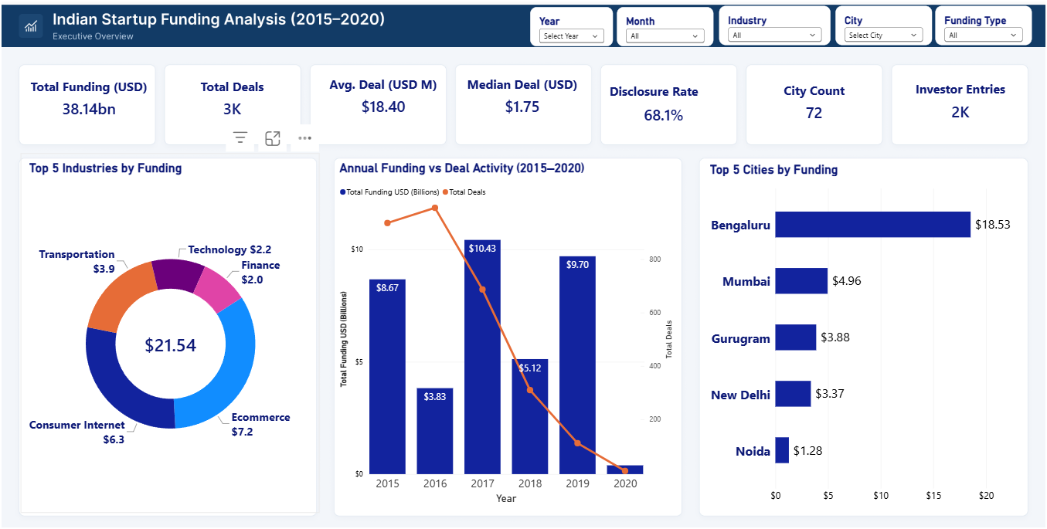
Visual review: the total disclosed funding shown is consistent with the CSV (approximately $38.14B). The City Count displayed as 72 is not reconciled to the 73 distinct raw City labels in the supplied CSV; industry group totals also depend on an undocumented mapping.
Validation rule: after refresh, reconcile the cards and tables to the cleaned CSV under the same filter context. Record the intended measure definition (all records vs disclosed records), aggregation grain, and category mappings on the dashboard or in documentation.

APPENDIX B | POWER BI SCREENSHOT
Industry, City & Investor Analysis
User-supplied screenshot; visual inspection only. These images are included as implementation evidence, not as a replacement for CSV-based calculations.
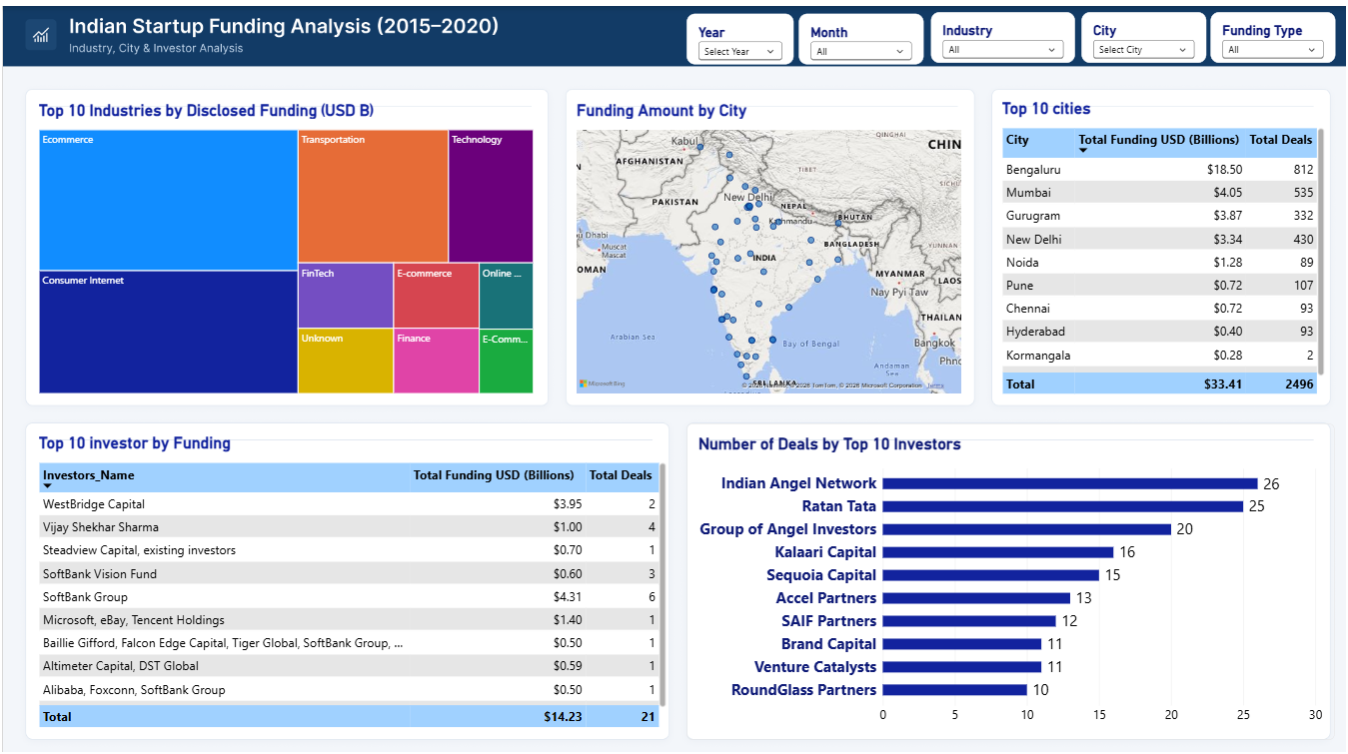
Visual review: the dashboard contains city map, Top 10 city table, industry treemap, and investor views. Some table city totals (for example, Mumbai) differ from direct aggregation of the supplied CSV. The investor table also requires sorting by funding descending and entity-level attribution controls.
Validation rule: after refresh, reconcile the cards and tables to the cleaned CSV under the same filter context. Record the intended measure definition (all records vs disclosed records), aggregation grain, and category mappings on the dashboard or in documentation.

APPENDIX C | POWER BI SCREENSHOT
Funding Stage & Deal Size Analysis
User-supplied screenshot; visual inspection only. These images are included as implementation evidence, not as a replacement for CSV-based calculations.
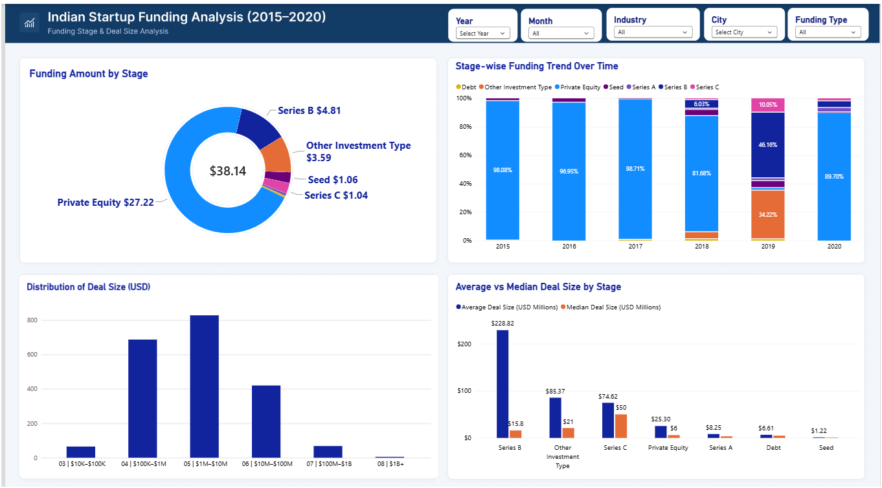
Visual review: the layout shows stage funding, year composition, deal-size bands, and average/median by stage. Its ad hoc Funding Stage mapping differs from Investment_Type_Clean, so document the mapping and reconcile chart values. Deal-size categories use numeric prefixes to force sort order; do not remove those sort keys without replacing the sort logic.
Validation rule: after refresh, reconcile the cards and tables to the cleaned CSV under the same filter context. Record the intended measure definition (all records vs disclosed records), aggregation grain, and category mappings on the dashboard or in documentation.

10 | RECOMMENDATIONS
Five actions to make the analysis decision-ready
Prioritize controls that affect financial totals and rankings before polishing additional visuals.
Priority | Action | What to do
P0 · Before submission | Reconcile dashboard to CSV | Refresh the Power BI model from the exact cleaned CSV. Reconcile total funding ($38.1439B), 3,044 records, 2,073 numeric amounts, and disclosure rate (68.1%). Investigate the City Count and city-table discrepancies.
P0 · Before decision use | Validate the $3.9B recorded round | Verify the Rapido Bike Taxi / Transportation / Series B record against a trusted source and confirm currency/units. Keep it flagged until confirmed; do not silently drop it.
P1 · 1 week | Standardize industry taxonomy | Map 822 raw labels to a governed canonical industry field. Begin with exact case/punctuation variants and review semantic groupings such as e-commerce, marketplace, and M-commerce with a documented dictionary.
P1 · 1 week | Normalize city geography | Create canonical city, state, country and geography-status fields. Preserve raw city strings; only classify foreign, state-only, country-only, and unknown records into “Other” in a dedicated India-focused view.
P1 · 1–2 weeks | Build investor dimension + bridge | Normalize aliases and model each named investor separately. Define co-investor funding attribution before ranking totals. Preserve Unknown and Undisclosed as explicit values.
P2 · 1–2 weeks | Make trends period-safe | Join a complete calendar-month spine for MoM. Treat missing 2019-03 explicitly. Avoid full-year 2020 comparisons; use Jan-to-Jan if a like-for-like check is needed.
P2 · Ongoing | Automate QA checks | Run row count, disclosure rate, duplicate count, source-date coverage, unknown taxonomy rate, amount outlier checks, and Power BI-to-CSV reconciliation on every refresh.

Business use after controls
Once these checks pass, use the report to monitor disclosed capital concentration by year, stage, industry, and city; use median deal size alongside average; and use investor insights only after co-investor identity and attribution rules are formalized.

11 | IMPLEMENTATION ROADMAP
A practical 30-day path from descriptive report to governed insight
The roadmap below is proposed; it is not a claim that the actions have already been implemented.
Timing | Workstream | Deliverable | Exit criterion
Days 0–2 | Reconciliation | Metric audit across CSV and Power BI | Total funding, record count, disclosed records, city totals, stage totals agree under identical filters.
Days 0–2 | Outlier review | Source confirmation for $3.9B recorded round | Amount/currency/date/classification confirmed or explicitly excluded with documented rationale.
Week 1 | Industry + geography | Canonical mapping dictionary and audit columns | Every raw label maps to canonical label or an approved Unknown/Other status.
Week 1–2 | Investor model | Investor dimension + funding-round bridge | Multi-name records represented without hidden double counting; ranking definition approved.
Week 2 | Time series | Complete month calendar + safe growth measures | MoM uses adjacent months; 2020 reported as partial year or like-for-like period.
Week 3–4 | BI QA and release | Power BI validation checklist, updated screenshots, report notes | Slicers, tooltip, sorts, top-N filters, caveats, and all KPI totals tested.

Monitoring scorecard
Metric | Current baseline | Monitoring purpose
Total disclosed funding | $38.144B | Detect refresh or filter-context drift.
Record count | 3,044 | Detect unexpected row loss or expansion.
Disclosed amount records | 2,073 (68.1%) | Track amount availability without treating missing as zero.
Missing amount records | 971 (31.9%) | Track data completeness.
Exact duplicate rows | 0 | Catch repeated records.
Amount outlier control | Max = $3.90B | Review extremes and source units.
Month coverage | Missing row: 2019-03 | Prevent unsafe MoM comparisons.

12 | QUALITY ASSURANCE
Evidence register, limitations, and conclusion
This report distinguishes recalculated facts from screenshot observations, notebook outputs, and queries that could not be executed.
Finding / check | Source | Verification status | Implication
Core totals: 3,044 rows; 2,073 amount values; $38.1439B sum | cleaned_startup_funding(1).csv; direct pandas calculations | PASS — recalculated | Use as disclosed funding baseline.
Mean $18.40M / median $1.75M | cleaned_startup_funding(1).csv; direct pandas calculations | PASS — recalculated | Use median with mean because of skew/outliers.
2015–2020 date range; 2020 has 7 January rows | cleaned CSV; Date and Year fields | PASS — recalculated | Do not interpret 2020 as a full-year total.
Notebook claims 8 malformed dates fixed, 0 unparseable | startup_funding_cleaning(1).ipynb stored outputs and methodology | REVIEWED, not re-executed | Raw CSV was not supplied; full cleaning run cannot be reproduced here.
SQL queries and outputs | sql_queries(2).pdf | REVIEWED; MySQL execution NOT TESTED | Query behavior may differ in a live database; month-gap and investor-string issues identified.
Power BI visuals and DAX | Three user-supplied screenshots | VISUAL REVIEW ONLY | Some values/filters need reconciliation; DAX was not executed independently.
Currency is USD | Amount_USD column and problem materials | SOURCE-LABEL ONLY | Currency/FX basis not independently verified.
Industry and investor leaderboards | Cleaned CSV fields | PARTIAL / taxonomy-sensitive | Canonical mapping and investor entity model needed before definitive ranking.

Limitations
- The raw source CSV referenced by the cleaning notebook was not supplied. Raw-versus-cleaned changes could not be independently reconciled from the source file.
- MySQL was not connected; SQL results are not certified as execution-tested. The supplied SQL document includes screenshots of outputs rather than a live database environment.
- Power BI Desktop execution was not available. Visuals and screenshots were reviewed, but DAX, relationship behavior, interactions, and filter propagation were not independently executed.
- Funding amounts are treated as USD because the supplied column is named Amount_USD; this label has not been externally verified. Missing amounts are excluded from amount-based statistics.
- The apparent record-count decline and annual funding change may reflect source coverage changes, not underlying market contraction. The maximum $3.9B record requires source-level confirmation.

Conclusion
The supplied data presents a high-concentration funding picture: disclosed capital is led by Private Equity, clustered in a small set of city labels, and heavily influenced by a handful of very large rounds. The strongest next step is not another visual; it is governance of the input categories, the outlier record, investor entities, and time-period completeness. Once those controls are in place, the three-page Power BI report can become a more defensible management monitoring tool.

Source inventory
- Business scope: problem_statement(3).pdf, page 1.
- Dataset: cleaned_startup_funding(1).csv (3,044 rows × 12 columns).
- Cleaning and stored outputs: startup_funding_cleaning(1).ipynb; SQL query design and example outputs: sql_queries(2).pdf (12 pages); Power BI evidence: three supplied screenshots (Pages 1–3).

