**Vikaral Kumar**

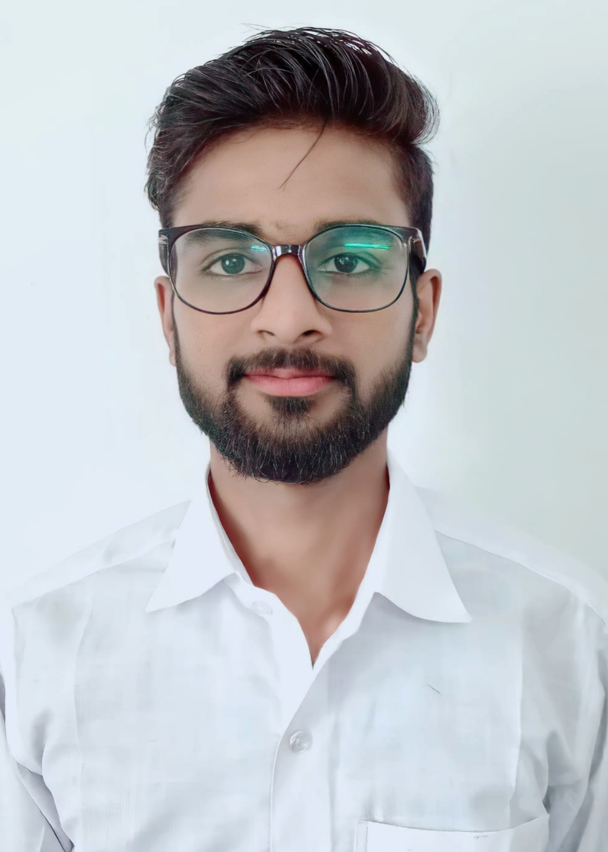

Add - Vill+post-Dibhiyan, Sasaram Bihar (821107)

[reyanshraja31@gmail.com](mailto:reyanshraja31@gmail.com)

Mo. +91 6202653428

3th year B.E Computer Science student at Dhanalakshmi Srinivasan College Of Engineering And Technology Which is Affiliated to **Anna University** with excellent academic record and keen interest and practical exposure in the field of information security and technology .

|  |
| --- |
| **Education** |

B.E , Computer Science & Engineering (Currently Pursuing , 5th  sem) 2020-2024

Dhanalaksmi Srinivsan College Of Engineering

And Technology (ANNA UNIVERSITY), CGPA – 8.025/10

12th (Senior Secondary Examination) 2020

BSEB Board Patna , 75%

10th (Secondary Examination) 2018

BSEB Board Patna , 63.8%

|  |
| --- |
| **Technical Skills** |

* Programming Languages – Java,Kotlin,Python
* Web Technologies – HTML, CSS, JavaScript
* Ms word,Excel,PowerPoint

|  |
| --- |
| **Internships** |

**Android App Development inern ,Internshala Aug-Oct’27**   
Worked on the frontend and backend development framework. I did a project on college notes and books provider app ,where we utilize the knowledge.

**Cloud Computing intern, Veranda|Edureka Oct- Going on**

I am doing cloud computing intern on online from Edureka and now we learned about Amazon Web Services(AWS).

|  |
| --- |
| **Trainings & Workshops** |

* 12 weaks CAD (Certified App development) on online Intenshsala.
* Attended one weak certified html course certification on Skillup.
* Attended one weak Fundamental of Ethical hacking certified course on Udemy.

|  |
| --- |
| **Extra-curricular Activities** |

* Have undergone 3 month of KYP(kushal Yuva Program) based on computer knowledge.
* Hobbies include reading sci-fi novels, learning new technology, and writing.

|  |
| --- |
| **Additional information** |

* Language – English and Hindi
* Quick learner
* Good communication skills.