# C:\Users\Invertis\Desktop\c5d8bf04c4b57afbfecc93118f30db7b.jpg

# NITIN KUMAR

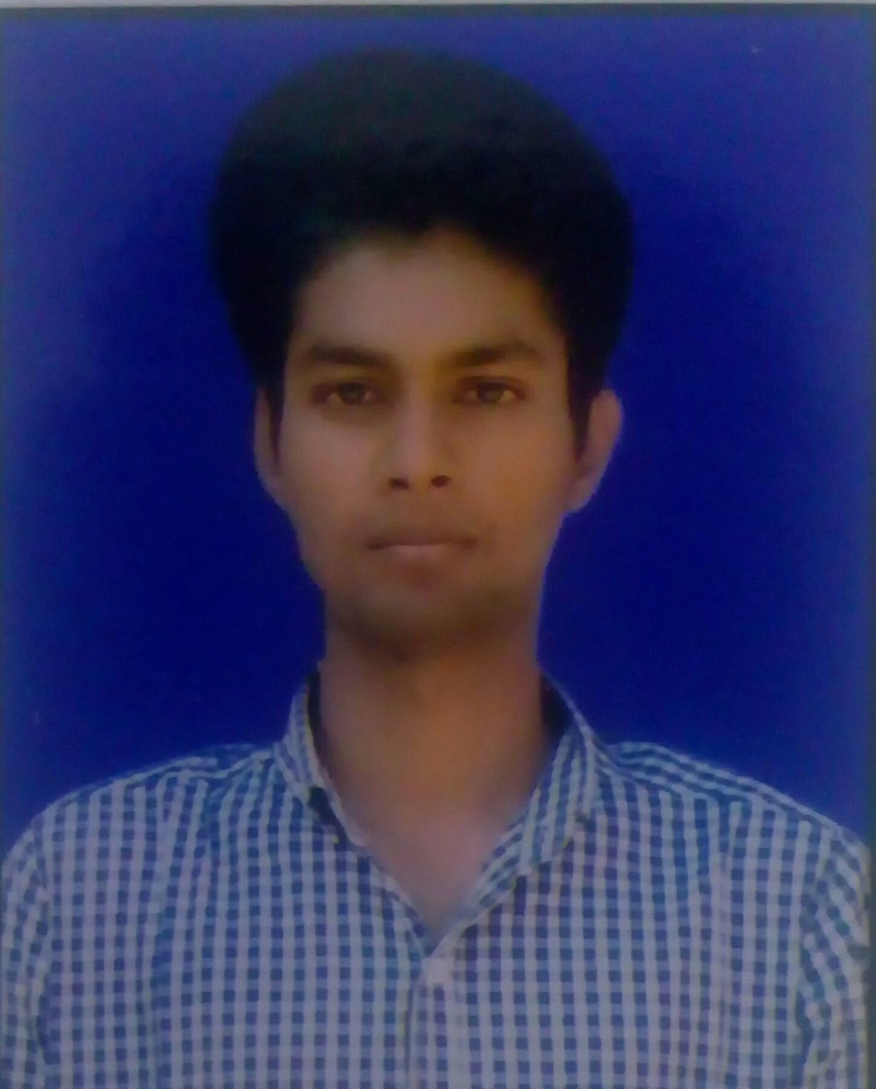

# Email id: nitinsharma47020@gmail.com

# Mobile No: 8755339437

# 

**CAREER OBJECTIVE**

Looking for a challenging and task oriented position in an organization which demands the best of my professional ability in terms of managerial and analytical skills and helps me in broadening and enhancing my current skill and knowledge and to be involved as a part of a team that dynamically works towards the growth of the organization and reach the top with determination, dedication and hard work.

**PROFESSIONAL QUALIFICATION**

|  |  |  |  |
| --- | --- | --- | --- |
| **COURSEonal interests:shments:** | **BOARD/ UNIVERSITY** | **PERCENTAGE/CGPA** | **YEAR OF PASSING** |
| **BCA** | **MJPRU** | **65.56** | **2023** |
| **MCA** | **Invertis University** | **-** | **Appearing** |

**EDUCATIONAL QUALIFICATION**

* **12th** from Bharat inter college, Bhojipura Bareilly in 2018.
* **10th** from Bharat inter college, Bhojipura Bareilly in 2016.

**­­­­**

**SOFTWARE SKILLS**

* **HTML, CSS, JAVASCRIPT**
* MS Office, Excel, PowerPoint.

**STRENGTHS**

* Highly confident and innovative in the area of expertise.
* Swift in learning and implementing new topics and techniques.
* Determined to learn with practical approach.
* Good communication skills and managing skills.

**FIELDS OF INTEREST**

* Web Development.

**LIGUISTIC PROFICIENCY**

* English
* Hindi

**PERSONAL INFORMATION**

**Nationality**  Indian

**Date of Birth** 28-06-2002

**Gender** Male

**Marital Status** Single

**Permanent Address** Bareilly

**Hobbies** Listen Songs and Acting.

Date: Monday, January 13, 2025

Place: Bareilly