AI-Powered Interview Evaluation & Resume Analysis System
Final Year Project Report
Department of Information Science and Engineering

Abstract
This project is an AI-powered recruitment support system that automates resume analysis, verifies candidate identity, generates role-based interview questions, evaluates performance, and produces structured hiring reports. It reduces recruiter workload and improves fairness, speed, and data-driven decision making.

Problem Statement
Recruiters often spend a large amount of time manually reviewing resumes and interview results. Many existing systems do not verify candidate identity before starting the assessment, which creates the risk of fake participation. This project solves these problems using automation, AI-based analysis, and secure verification.

Objectives
The main objectives are to upload and analyze resumes automatically, match candidate skills with job requirements, verify candidate identity using ID card and face matching, generate interview questions, evaluate interviews, and produce efficient recruitment reports.

System Features
The system includes resume upload, job matching, candidate verification, interview generation, AI evaluation, ranking dashboard, and downloadable reports.

Project Home Page

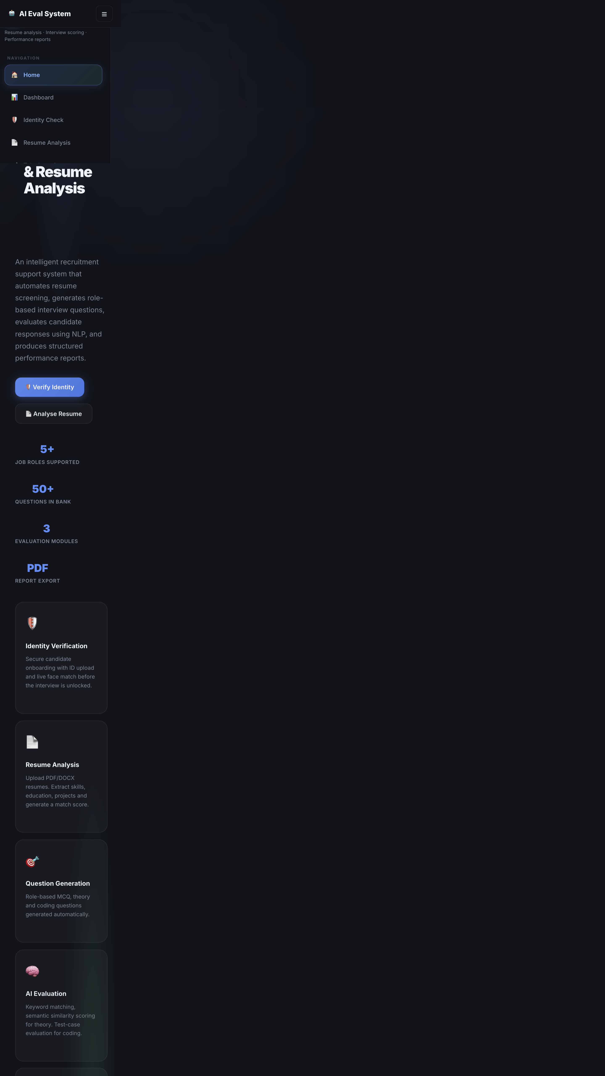

Candidate Login Page



Verification Page



Resume Analysis Page



Interview Page



Recruiter Dashboard



Reports Page



System Architecture
The project uses a modular architecture with a frontend interface, backend APIs, AI processing engine, and database for managing users, resumes, interviews, and reports. The candidate and recruiter workflows are separated for clear role-based access.

Identity Verification
Before the interview begins, the candidate is required to upload an ID card and capture a live face image. The system compares the face with the ID to confirm identity before allowing access to the assessment.

Resume Analysis
The system extracts key details from uploaded resumes such as education, skills, work experience, projects, and certifications. These details are compared against the job description to compute a match score.

Interview Evaluation
The candidate answers role-based questions that may include MCQ, theory, and coding tasks. The system evaluates the performance and creates a detailed score report.

Results
The final output includes candidate ranking, evaluation score, skills summary, and recruiter-ready reports. This improves hiring speed, fairness, and decision quality.

Conclusion
This project demonstrates a complete AI-powered recruitment support system with secure identity verification, resume analysis, interview evaluation, and structured reporting. It is suitable as a real-world final-year project and can be extended further with better AI models and live interview analytics.

