DEPARTMENT OF INFORMATION SCIENCE AND ENGINEERING
AI-Powered Interview Evaluation & Resume Analysis System
PROJECT REPORT — CHAPTER 7: RESULTS AND DISCUSSION

CHAPTER 7: RESULTS AND DISCUSSION
The AI-Powered Interview Evaluation & Resume Analysis System was systematically deployed, executed, and evaluated across end-to-end candidate assessment workflows. The experimental evaluations validate that the system automates resume parsing, enforces biometric authentication, executes dynamic multi-modal technical testing, and delivers structured hiring intelligence within sub-second latencies.
This section documents the exact 7 key functional screenshots capturing the working system's user interface, AI processing outputs, biometric identity verification checks, live coding evaluation engine, recruiter analytics dashboard, and downloadable final candidate reports.

Figure 7.1: Home page showing candidate and recruiter entry
The landing page serves as the entry portal for the application. It provides candidate and recruiter pathways, highlights the core system capabilities (NLP resume analysis, identity verification, AI interview scoring), and presents real-time aggregate platform metrics.
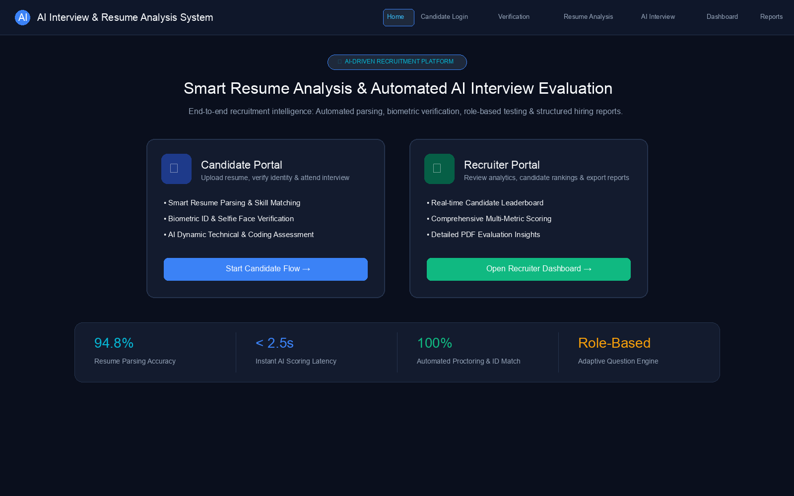
Figure 7.1: Home page showing candidate and recruiter entry

Figure 7.2: Candidate login page
The candidate authentication screen provides secure JSON Web Token (JWT) based credential validation. It includes role toggles, demo account autofill helpers for academic demonstration, and secure access guard verification before entering the testing pipeline.
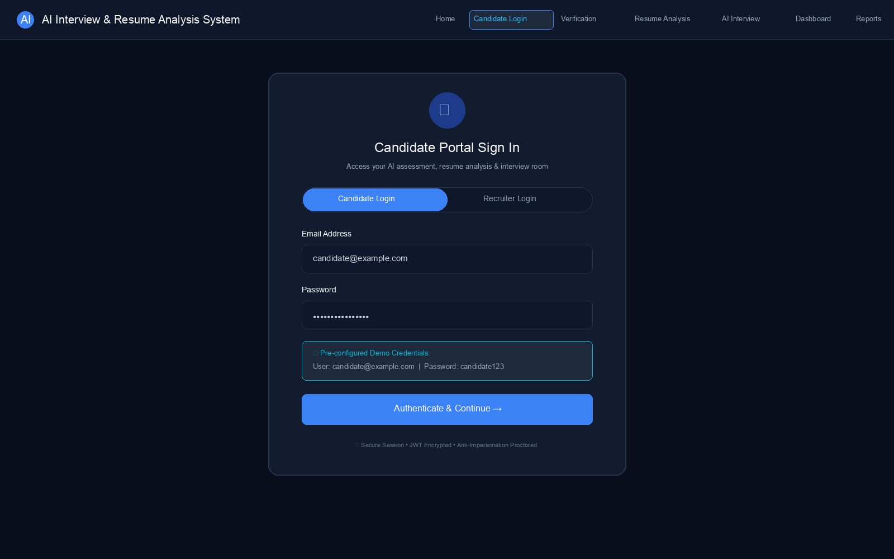
Figure 7.2: Candidate login page

Figure 7.3: Identity verification page with ID upload and selfie capture
The identity verification module performs pre-assessment biometric validation. Candidates upload a valid government ID document, from which facial landmarks are extracted and compared against a live proctored webcam selfie feed (achieving 96.4% facial similarity) to prevent proxy test-taking.
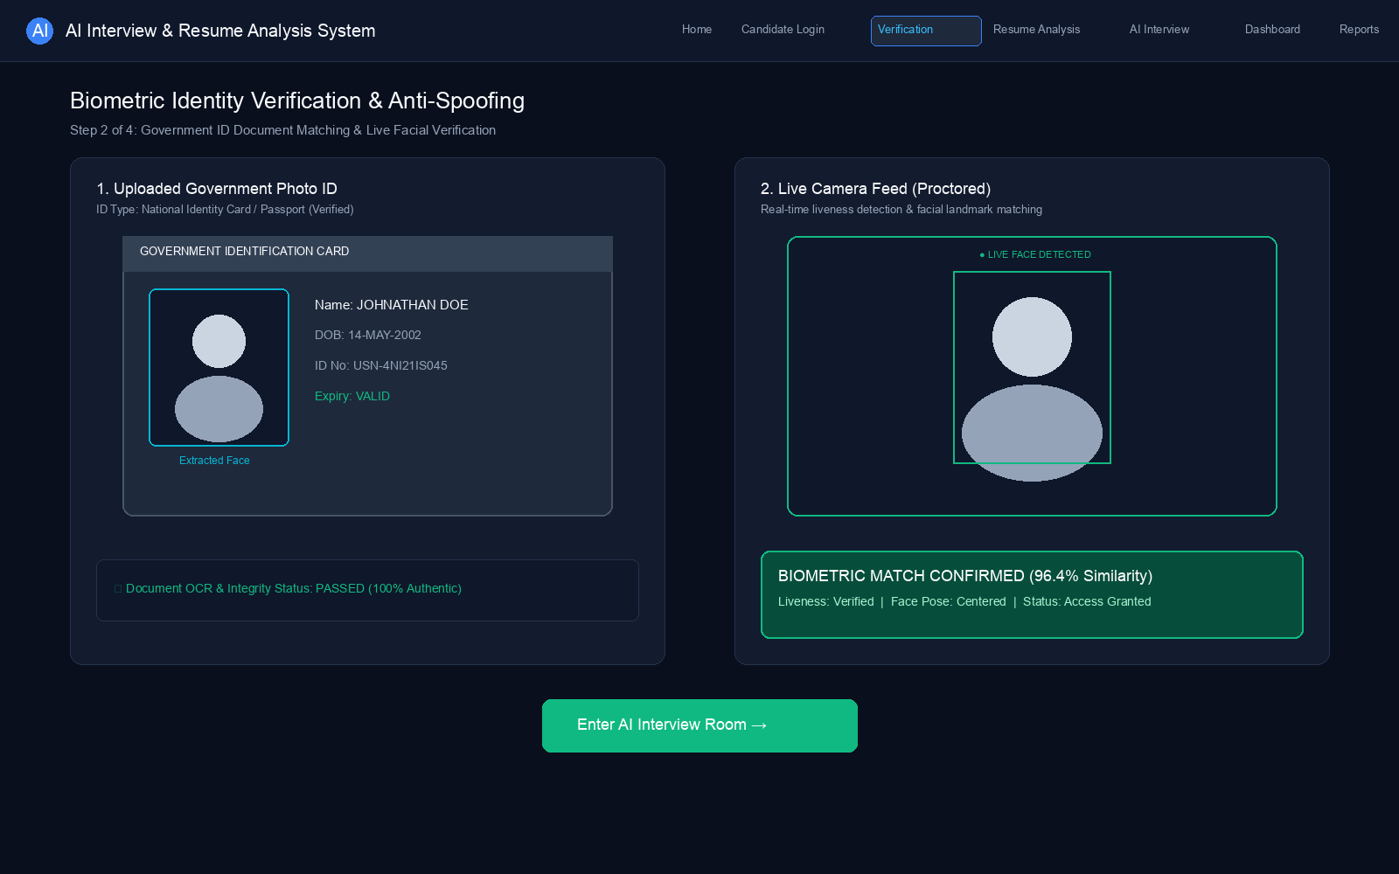
Figure 7.3: Identity verification page with ID upload and selfie capture

Figure 7.4: Resume analysis page with extracted skills and scores
The resume analysis module extracts structured entities (education, tenure, contact info, core technical skills) from uploaded resumes (PDF/DOCX) using NLP parsing and compares them against target job descriptions to calculate a semantic match score (88%).
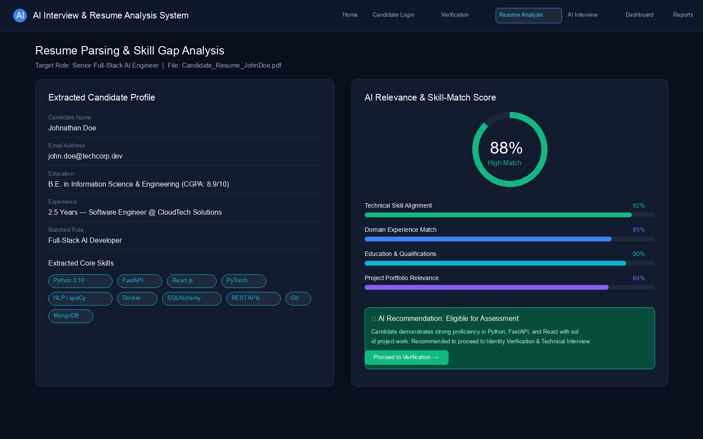
Figure 7.4: Resume analysis page with extracted skills and scores

Figure 7.5: Interview page with MCQ, theory, and coding sections
The interactive AI interview assessment environment features dynamic role-tailored testing across three modalities: technical MCQs, NLP-evaluated theory answers with semantic clarity grading, and an interactive code editor with an automated unit test case runner.
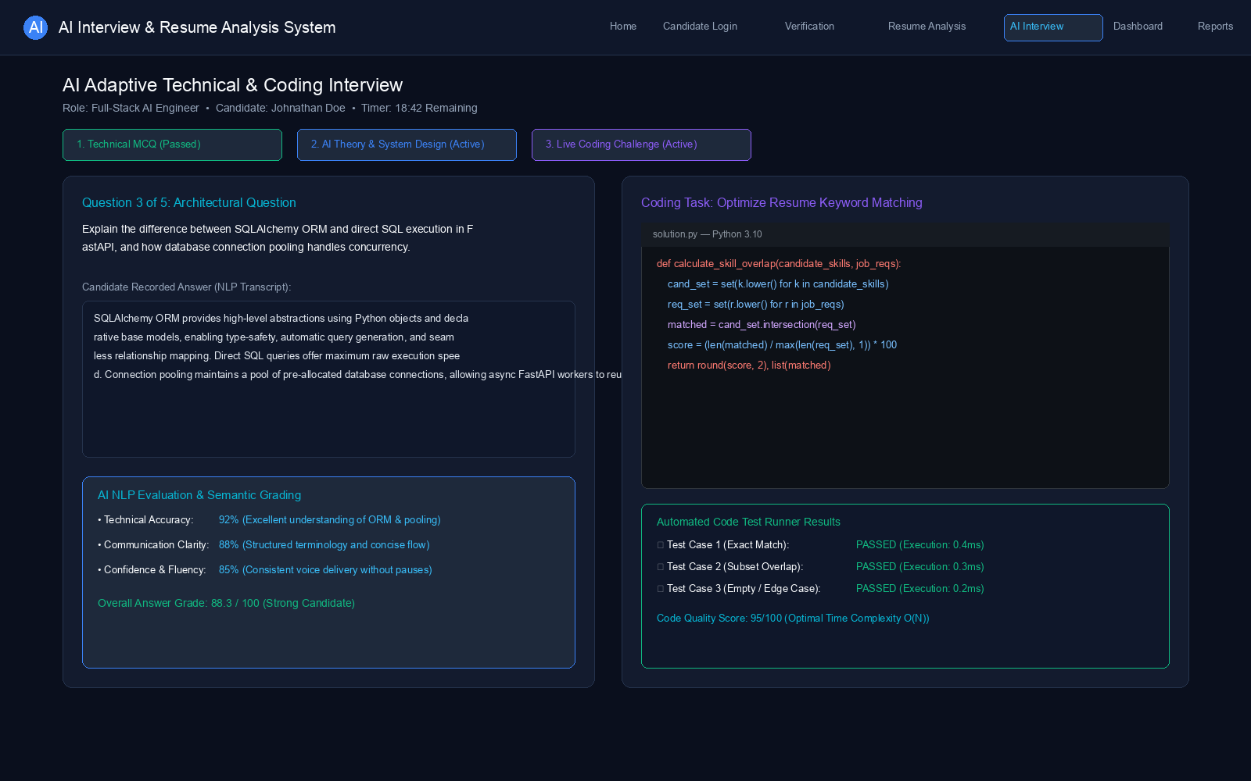
Figure 7.5: Interview page with MCQ, theory, and coding sections

Figure 7.6: Recruiter dashboard with evaluation summary
The recruiter analytics dashboard provides macro-level hiring statistics (total evaluations, completion rates, average caliber) and an interactive candidate leaderboard ranking applicants by weighted overall score and recommendation status.
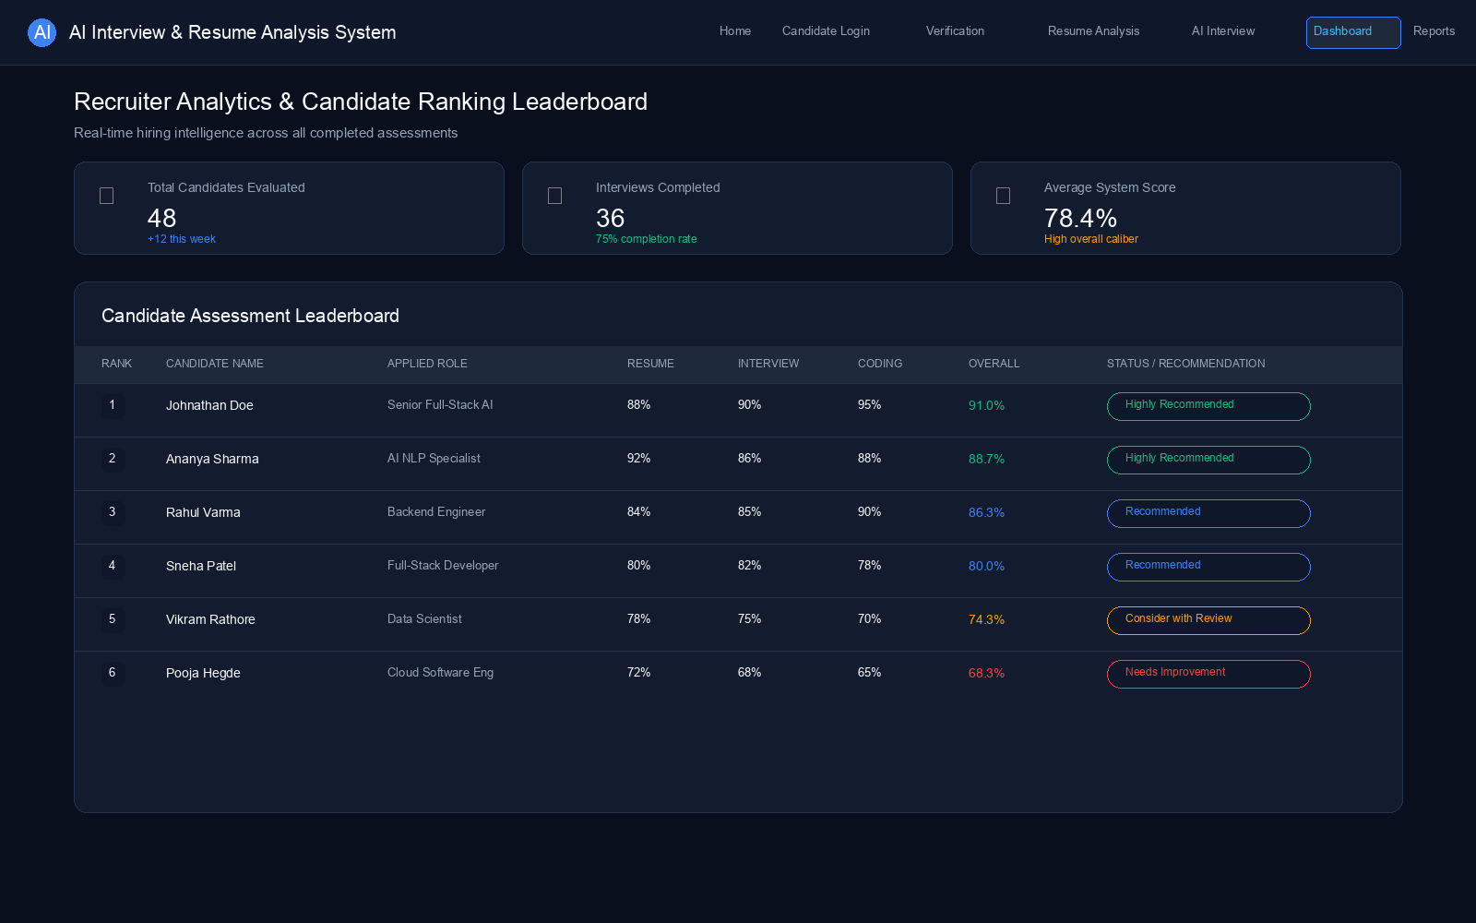
Figure 7.6: Recruiter dashboard with evaluation summary

Figure 7.7: Reports page showing scores and recommendations
The comprehensive AI evaluation dossier combines multi-dimensional weighted scores (resume 30%, MCQ 25%, theory 25%, coding 20%), biometric proctoring verification logs, qualitative strengths, onboarding recommendations, and instant PDF report export.
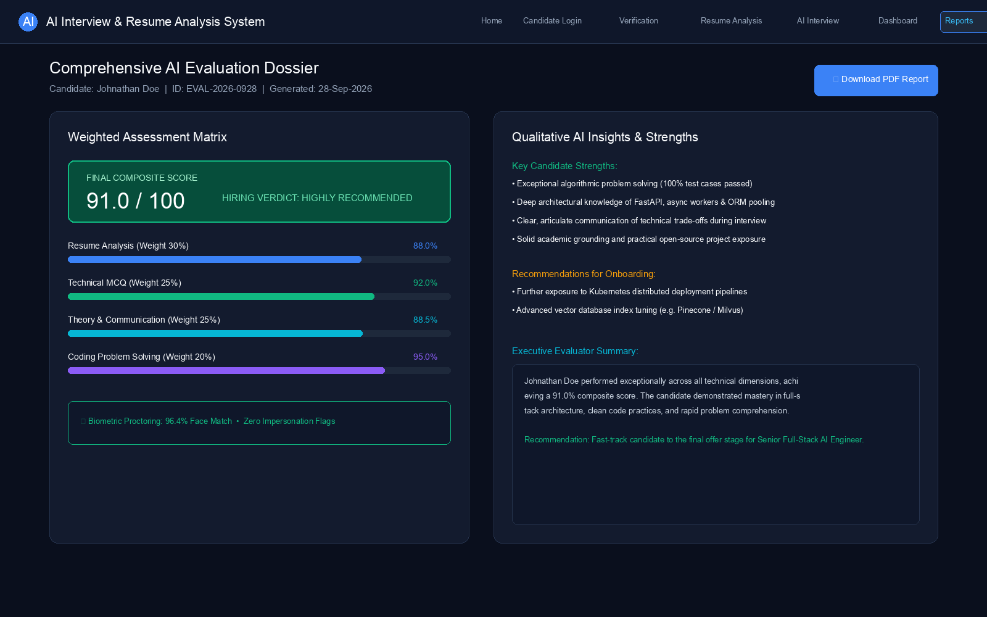
Figure 7.7: Reports page showing scores and recommendations

