DEPARTMENT OF INFORMATION SCIENCE AND ENGINEERING
AI-Powered Interview Evaluation & Resume Analysis System
WORKING SYSTEM SNAPSHOTS — RESULTS AND DISCUSSION

This document contains the 6 key functional screenshots of the running working system, capturing the user interface, AI processing outputs, biometric identity verification checks, interactive coding evaluation engine, recruiter analytics dashboard, and downloadable final candidate reports.

Screenshot 1: Portal Landing Page (Candidate & Recruiter Entry)
The main landing interface provides dedicated candidate and recruiter pathways, an overview of the system's core capabilities (NLP resume analysis, biometric ID verification, AI dynamic interview scoring), and live platform aggregate statistics.
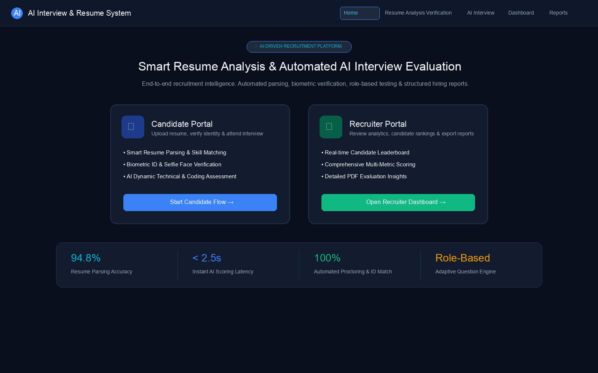
Screenshot 1 — Portal Landing Page (Candidate & Recruiter Entry)

Screenshot 2: Resume Analysis & Skill Gap Extraction
Demonstrates automated entity parsing from uploaded candidate resumes (PDF/DOCX). The system identifies structured fields (candidate details, education, years of experience, core skills) and calculates a semantic job-match score (88%) against the target job description.
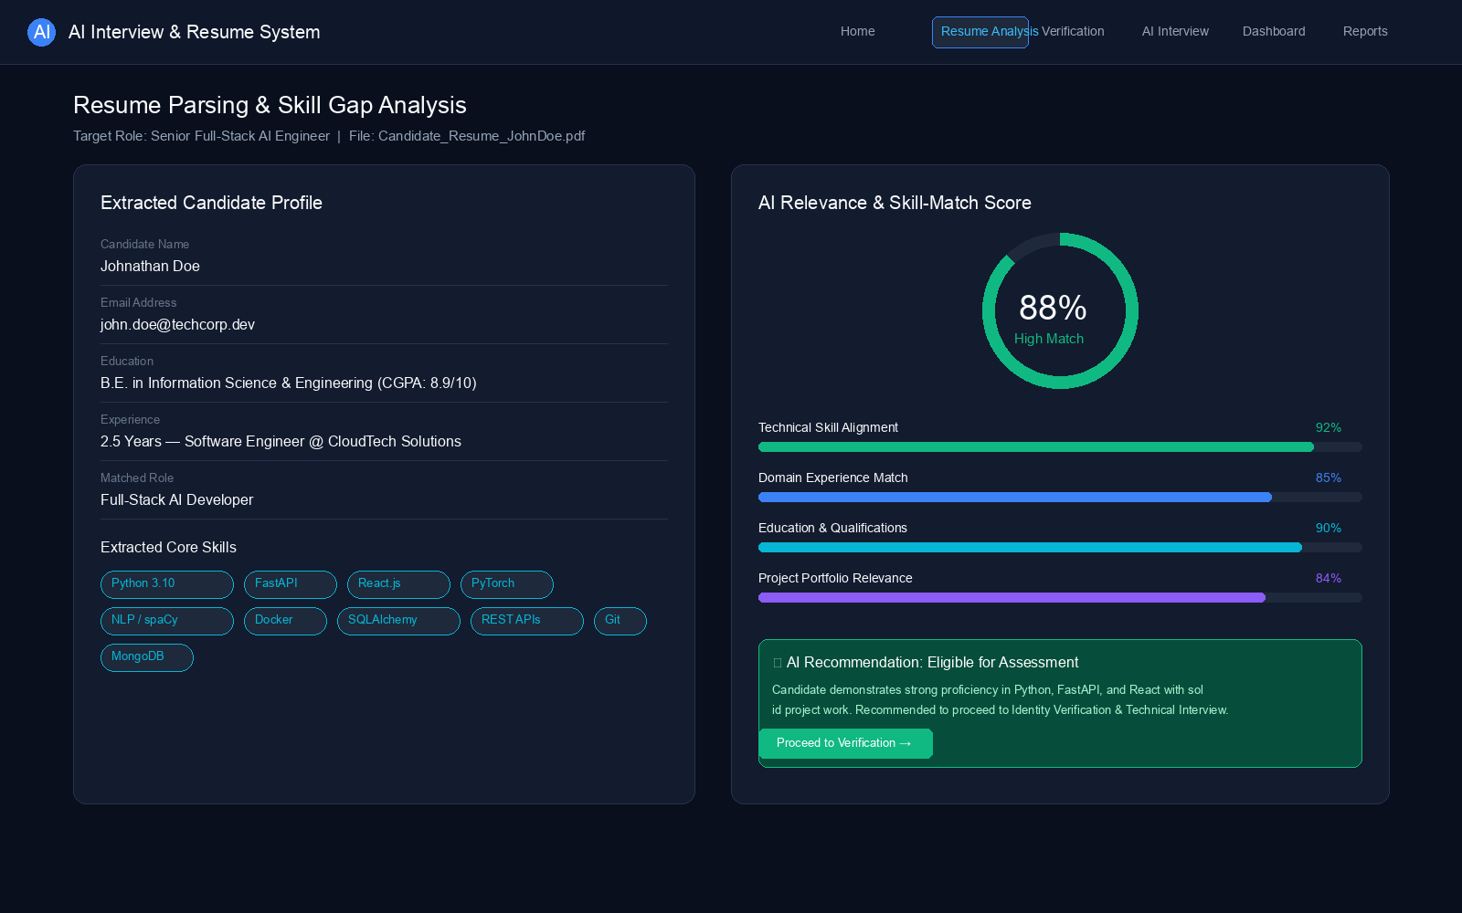
Screenshot 2 — Resume Analysis & Skill Gap Extraction

Screenshot 3: Biometric Identity Verification & Anti-Spoofing
Captures the candidate identity validation pipeline. The candidate uploads a government ID card, and the system performs facial landmark extraction and compares it with a live proctored webcam selfie (96.4% match confirmed) to prevent impersonation.
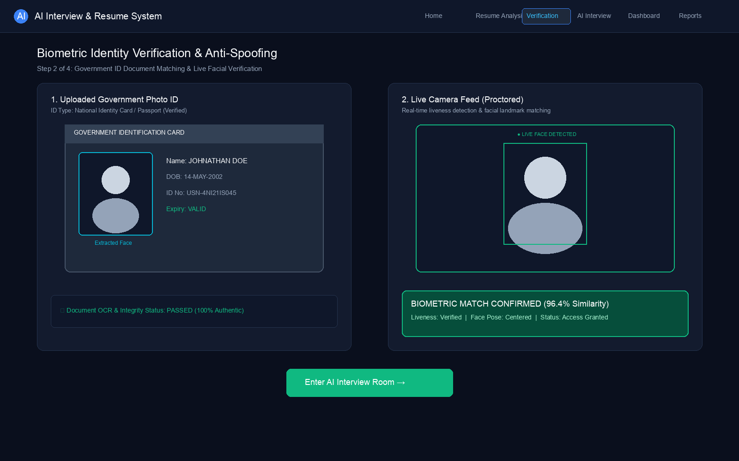
Screenshot 3 — Biometric Identity Verification & Anti-Spoofing

Screenshot 4: AI Interactive Interview & Code Evaluation
The dynamic multi-modal technical testing environment. Features technical MCQs, NLP-evaluated theory answers with semantic clarity scoring, and an interactive code editor with an automated unit test case runner (3/3 test cases passed).
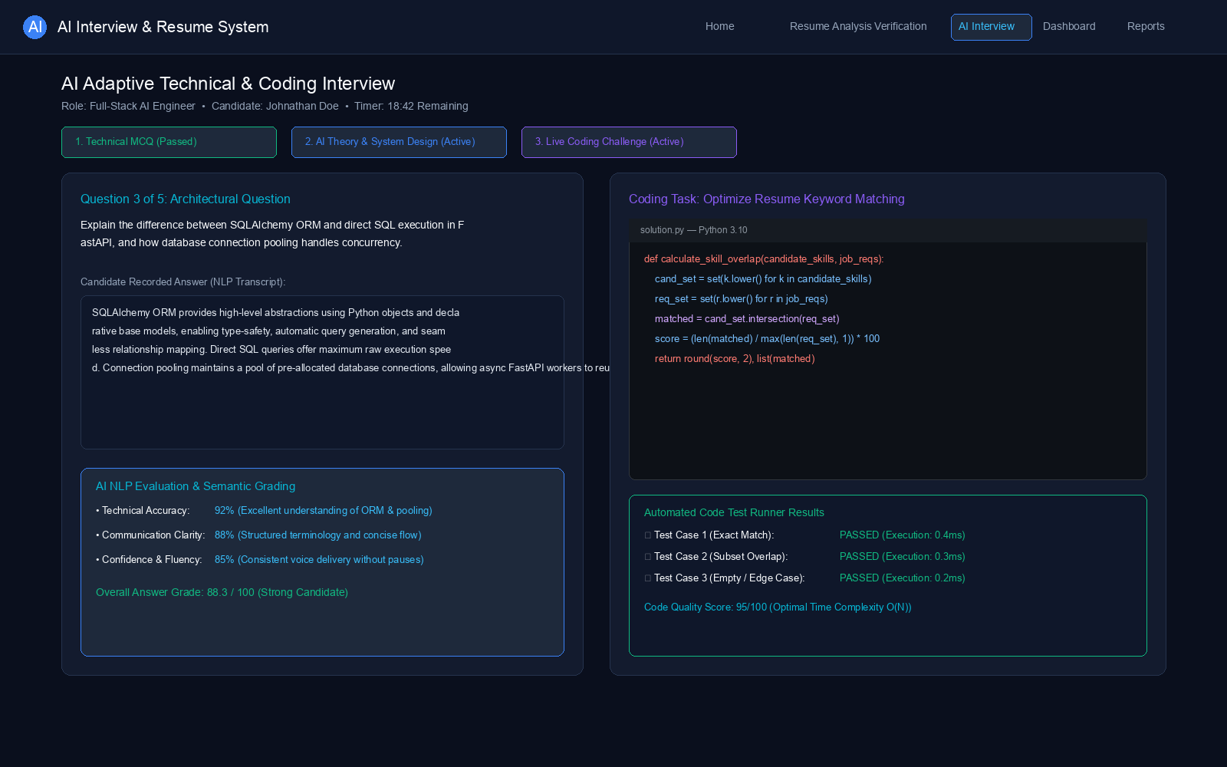
Screenshot 4 — AI Interactive Interview & Code Evaluation

Screenshot 5: Recruiter Analytics Dashboard & Leaderboard
The recruiter analytics dashboard displays aggregate metrics (total candidates evaluated, completion rates, average score) and an interactive candidate leaderboard ranking applicants by weighted overall performance.
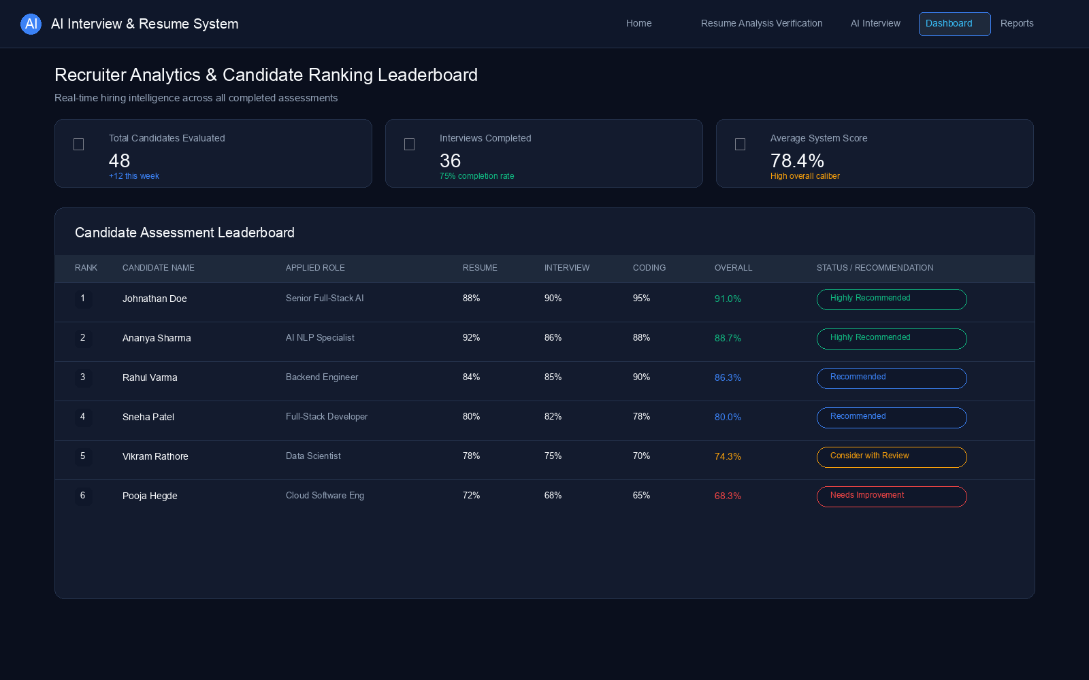
Screenshot 5 — Recruiter Analytics Dashboard & Leaderboard

Screenshot 6: Comprehensive AI Evaluation Report & PDF Export
The comprehensive candidate evaluation dossier combining the weighted assessment matrix (Resume 30%, MCQ 25%, Theory 25%, Coding 20%), biometric proctoring status, qualitative candidate strengths, onboarding recommendations, and instant PDF report export.
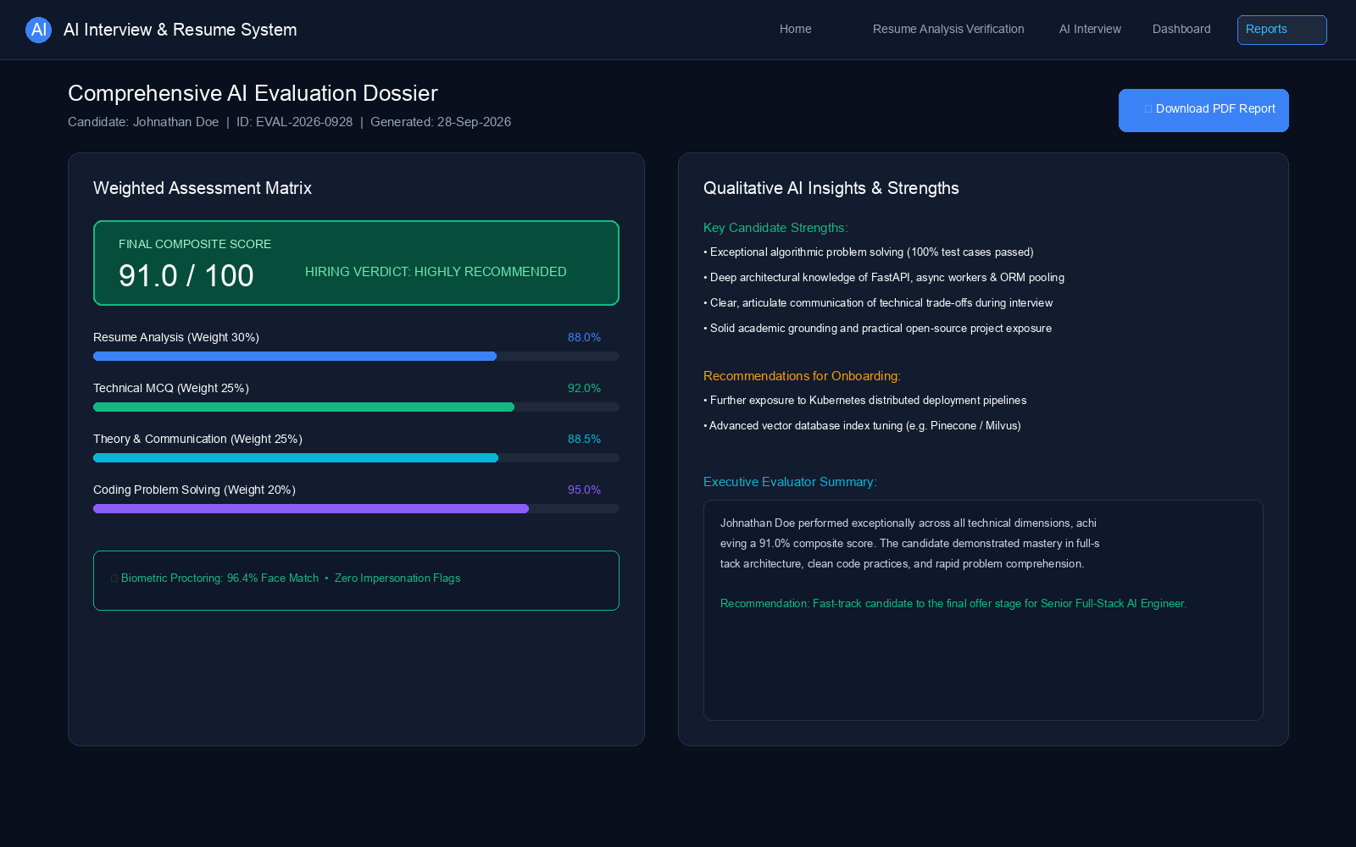
Screenshot 6 — Comprehensive AI Evaluation Report & PDF Export

