2025
PortSwigger Labs
Task Twelve
Vikas S Menon

Contents

- SQL injection 3
- Cross-site scripting 6
- Cross-site request forgery (CSRF) 8
- Cross-origin resource sharing (CORS) 10
- Server-side request forgery (SSRF) 11
- OS command injection 12
- Server-side template injection 13
- Path traversal 14
- Access control vulnerabilities 15
- Authentication 18
- Insecure deserialization 20
- File upload vulnerabilities 21

SQL injection

- SQL injection vulnerability in WHERE clause allowing retrieval of hidden data

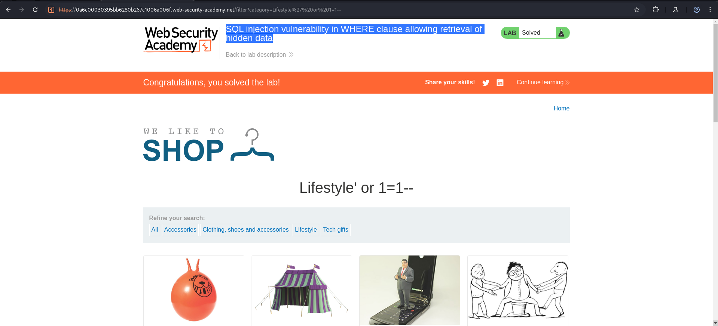

- SQL injection vulnerability allowing login bypass

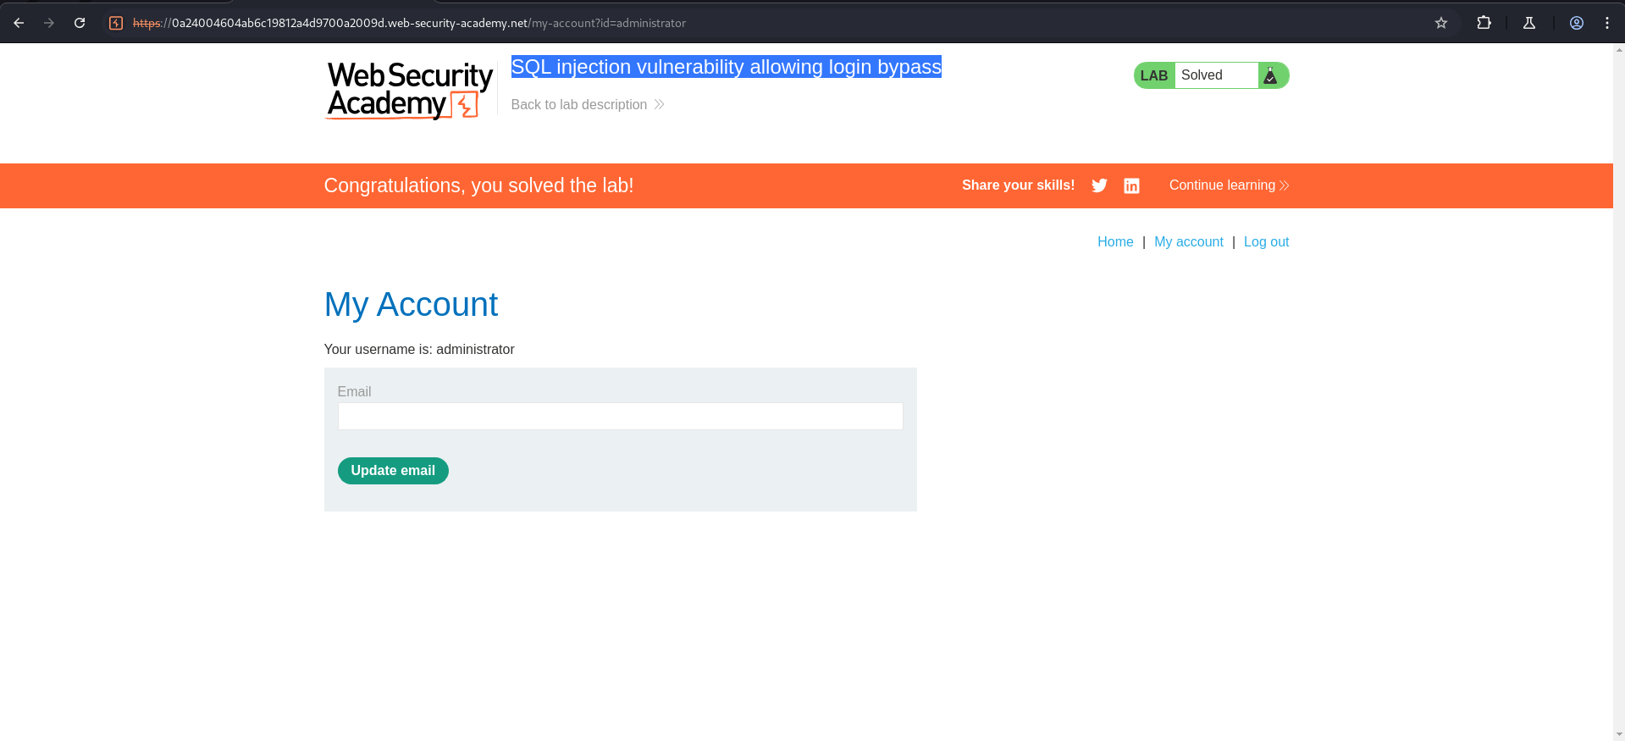

- SQL injection UNION attack, determining the number of columns returned by the query

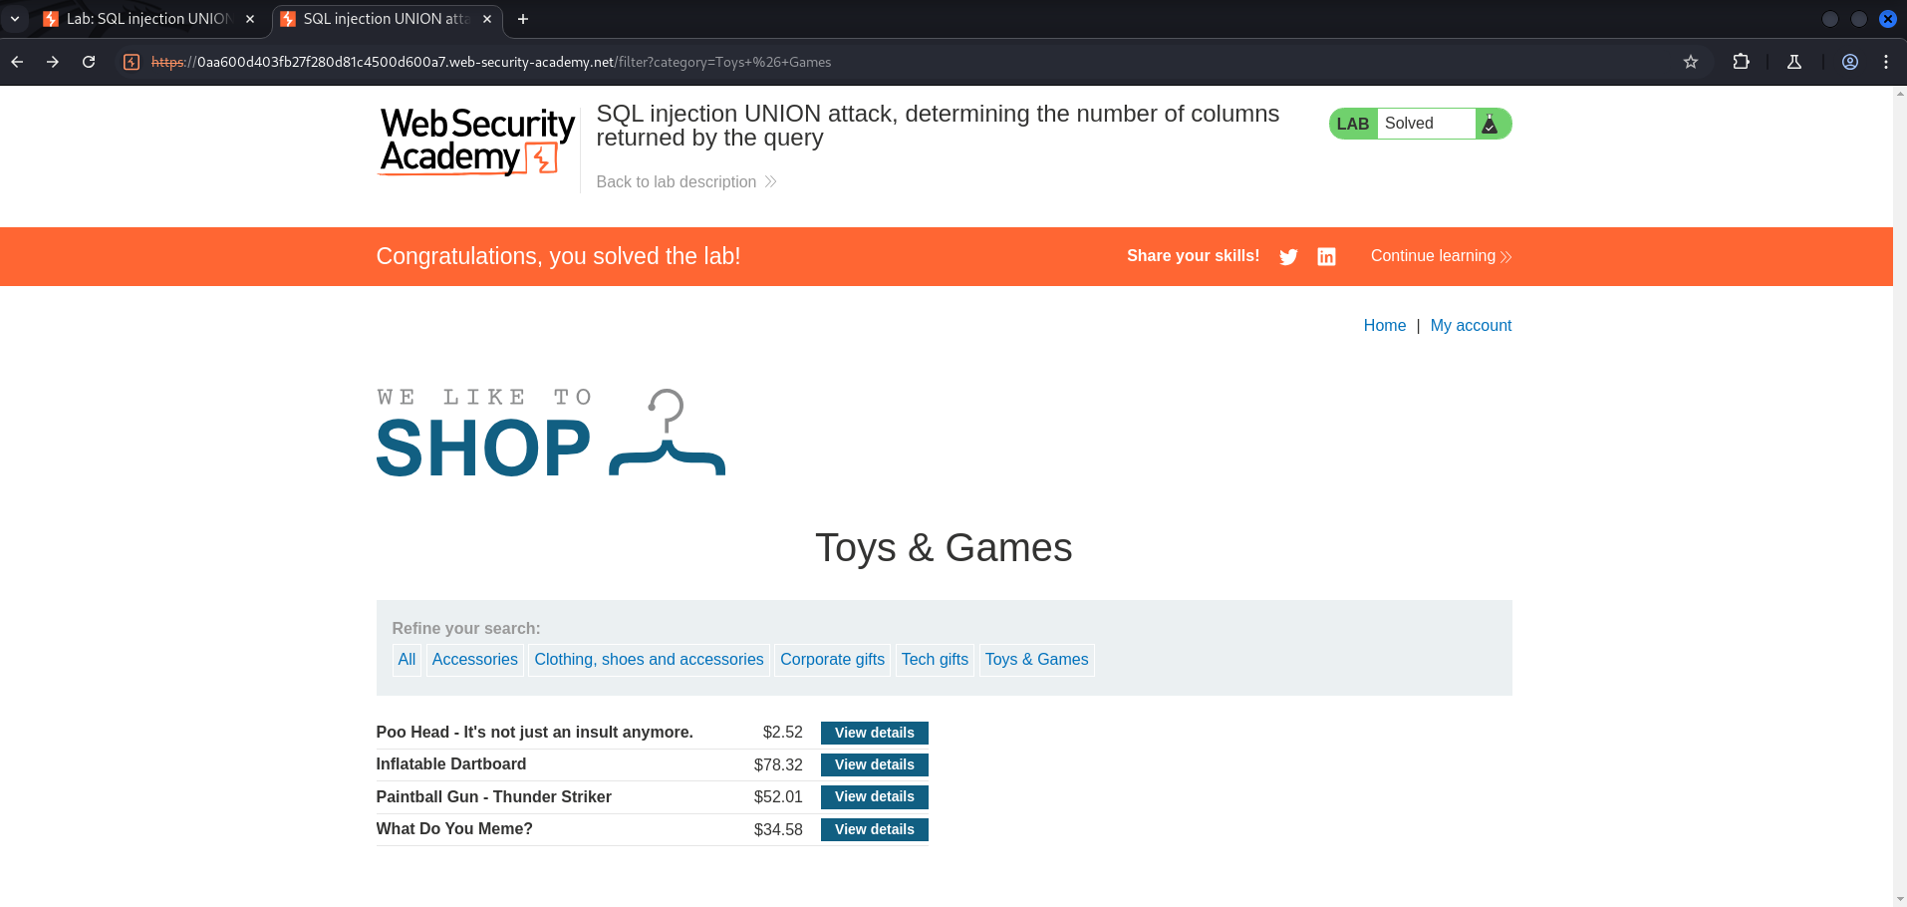

- SQL injection UNION attack, finding a column containing text

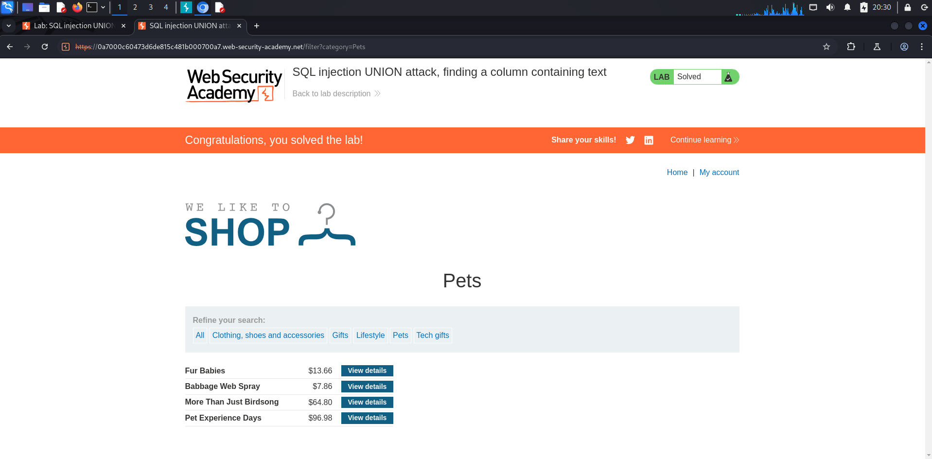

- SQL injection UNION attack, retrieving data from other tables

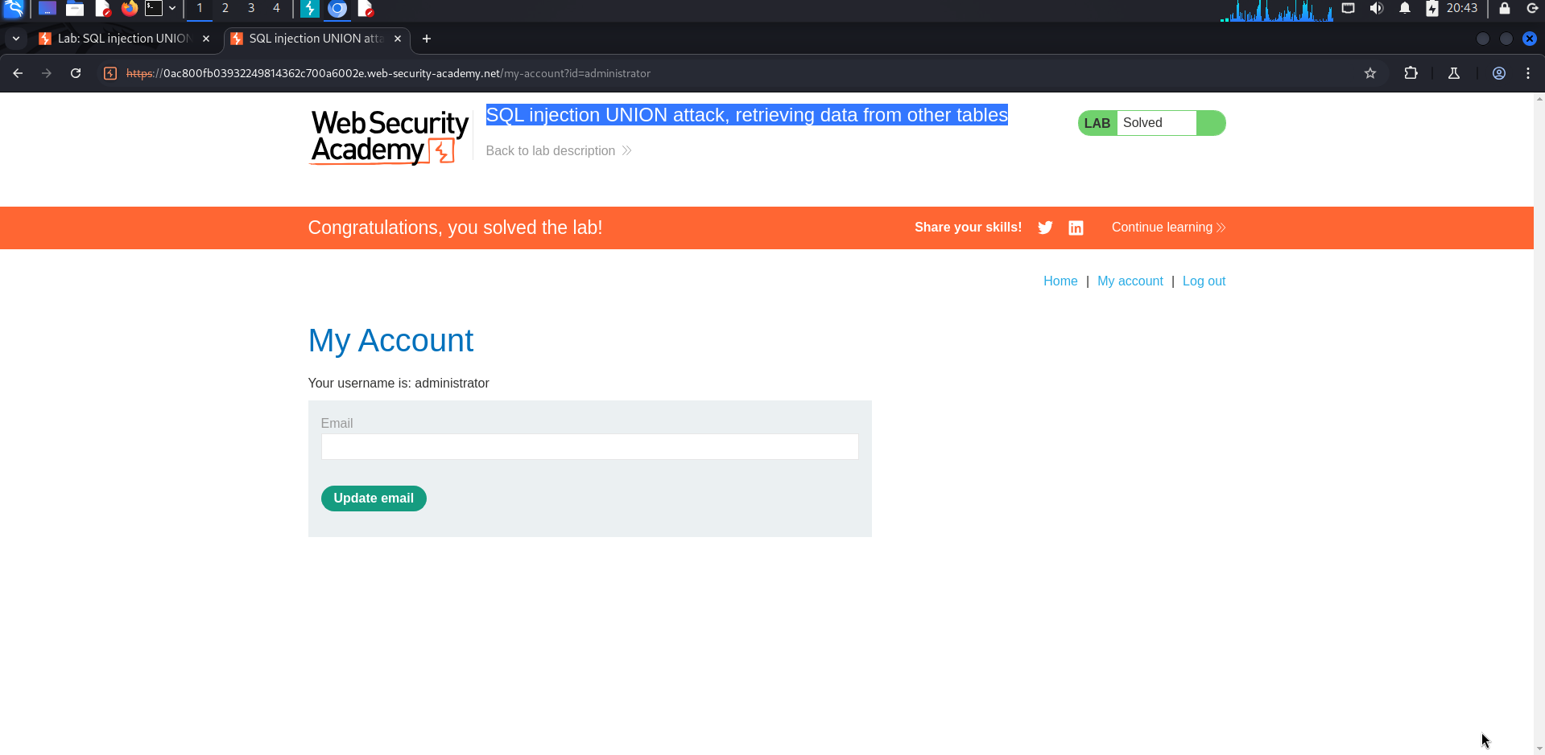

Cross-site scripting

- Reflected XSS into HTML context with nothing encoded

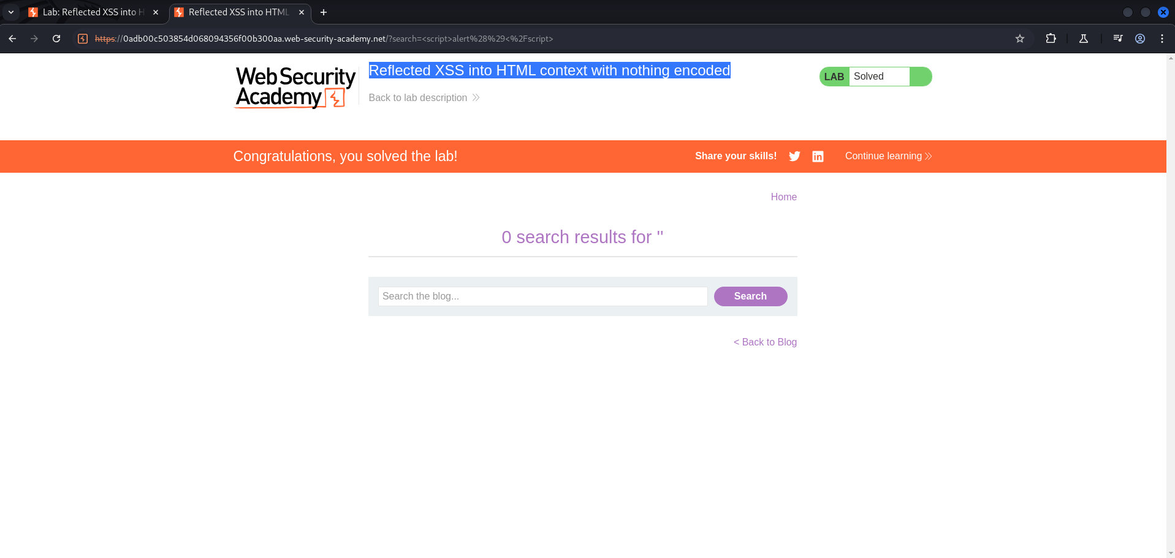

- Stored XSS into HTML context with nothing encoded

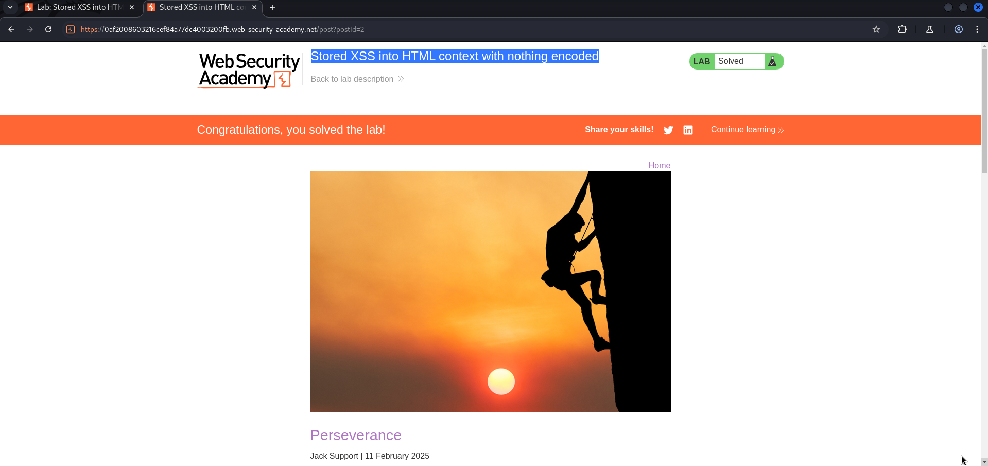

- DOM XSS in document.write sink using source location.search

- DOM XSS in innerHTML sink using source location.search

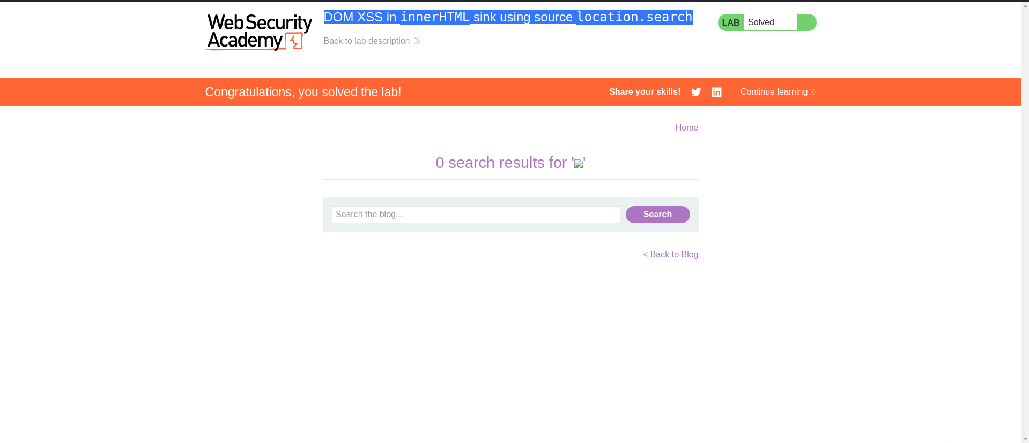

Cross-site request forgery (CSRF)

- CSRF vulnerability with no defenses

- CSRF where token validation depends on request method

- CSRF where token validation depends on token being present

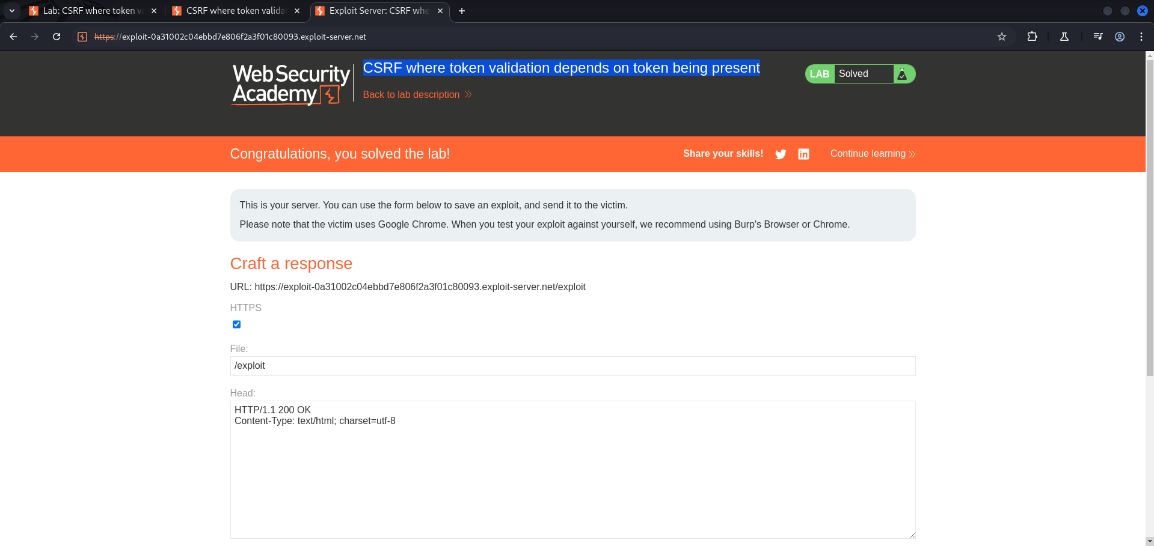

Cross-origin resource sharing (CORS)

- CORS vulnerability with basic origin reflection

Server-side request forgery (SSRF)

- Basic SSRF against the local server

- Basic SSRF against another back-end system

OS command injection

- OS command injection, simple case

- Blind OS command injection with time delays

Server-side template injection

- Basic server-side template injection


- Basic server-side template injection (code context)

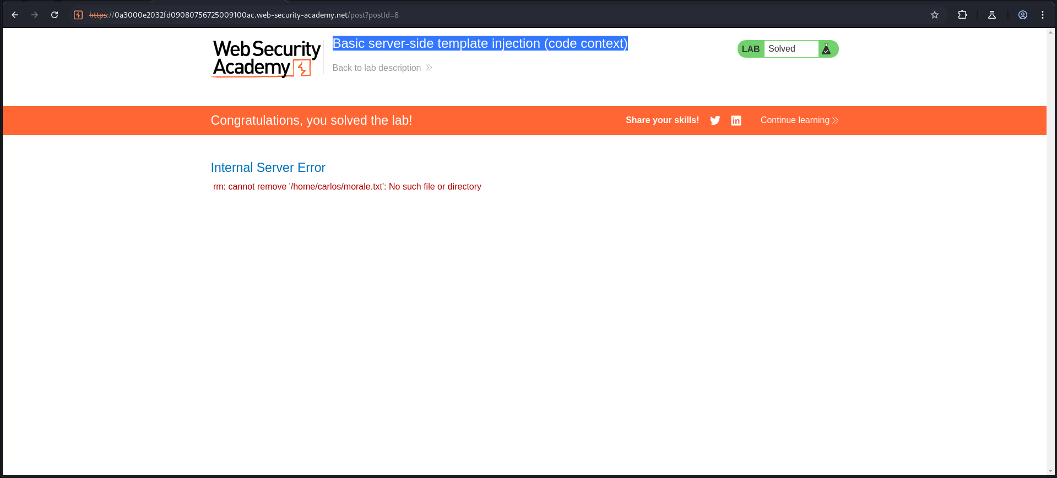

Path traversal

- File path traversal, simple case



Access control vulnerabilities

- Unprotected admin functionality

- Unprotected admin functionality with unpredictable URL

- User role controlled by request parameter

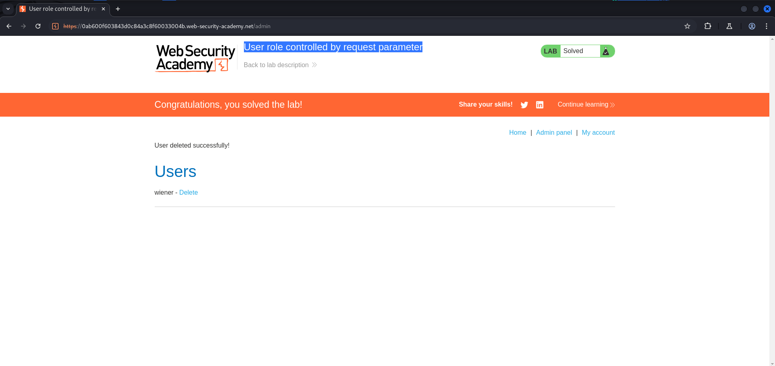

- User role can be modified in user profile

- User ID controlled by request parameter with password disclosure

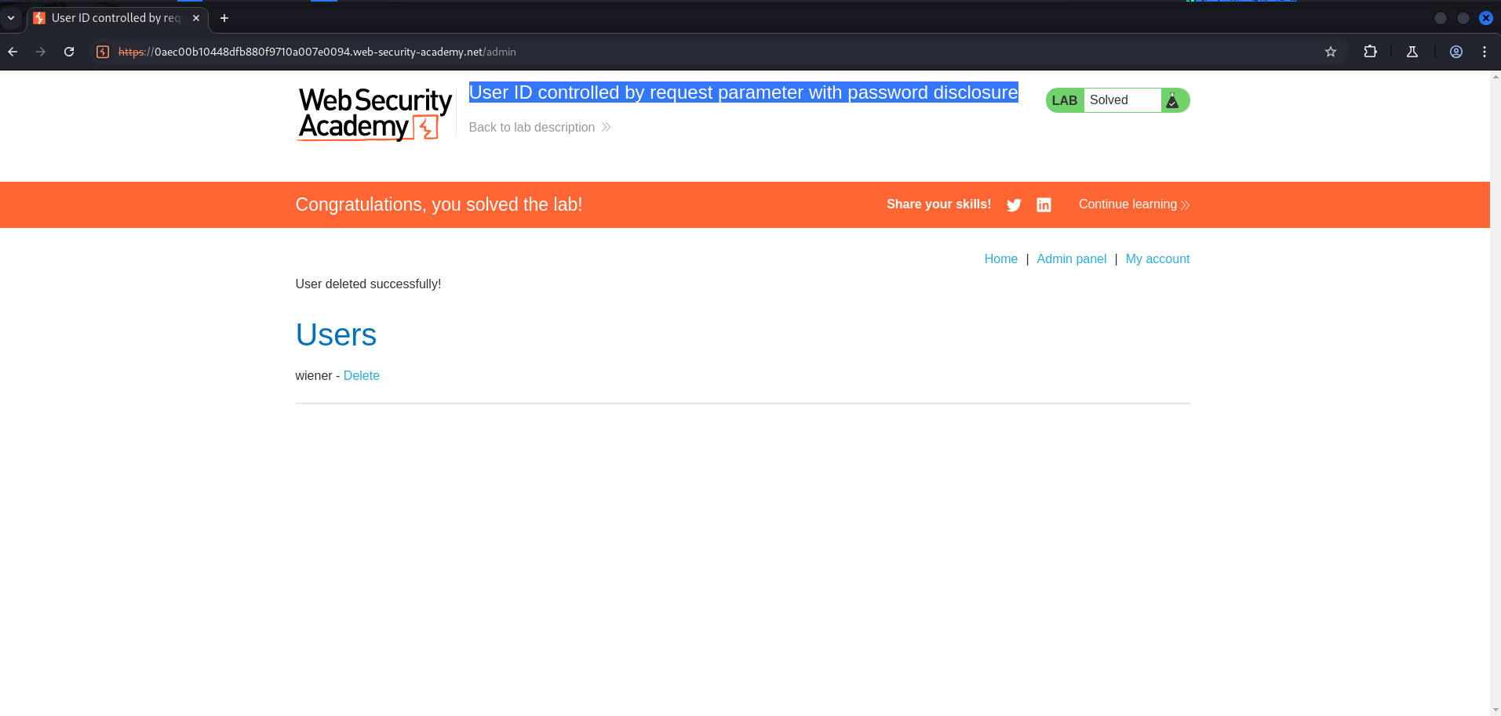

Authentication

- Username enumeration via different responses

- 2FA simple bypass

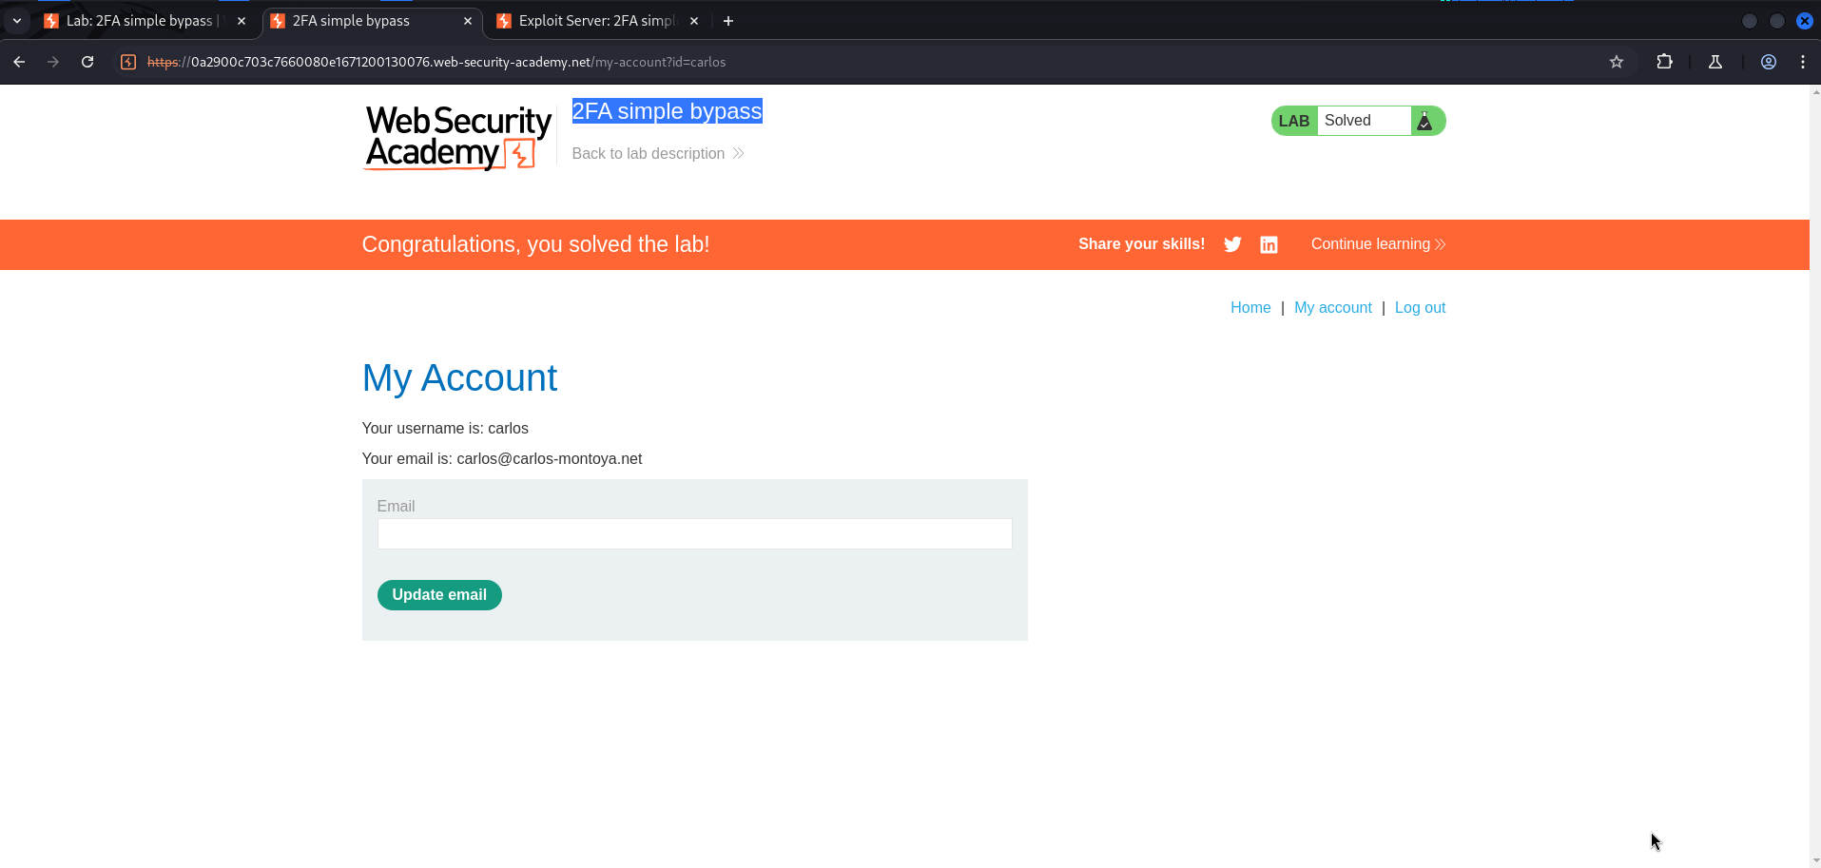

- Password reset broken logic

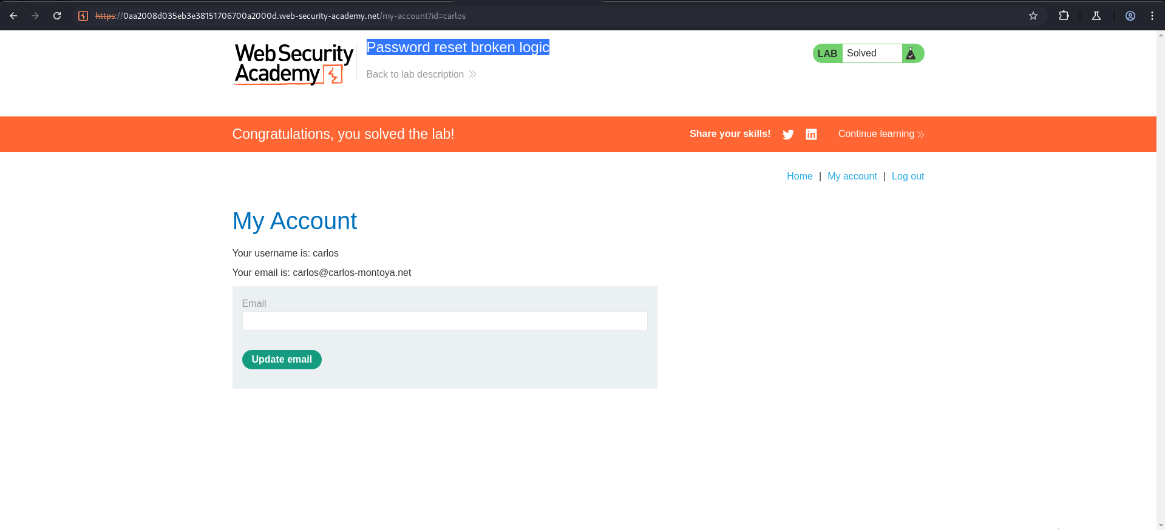

Insecure deserialization

- Modifying serialized objects

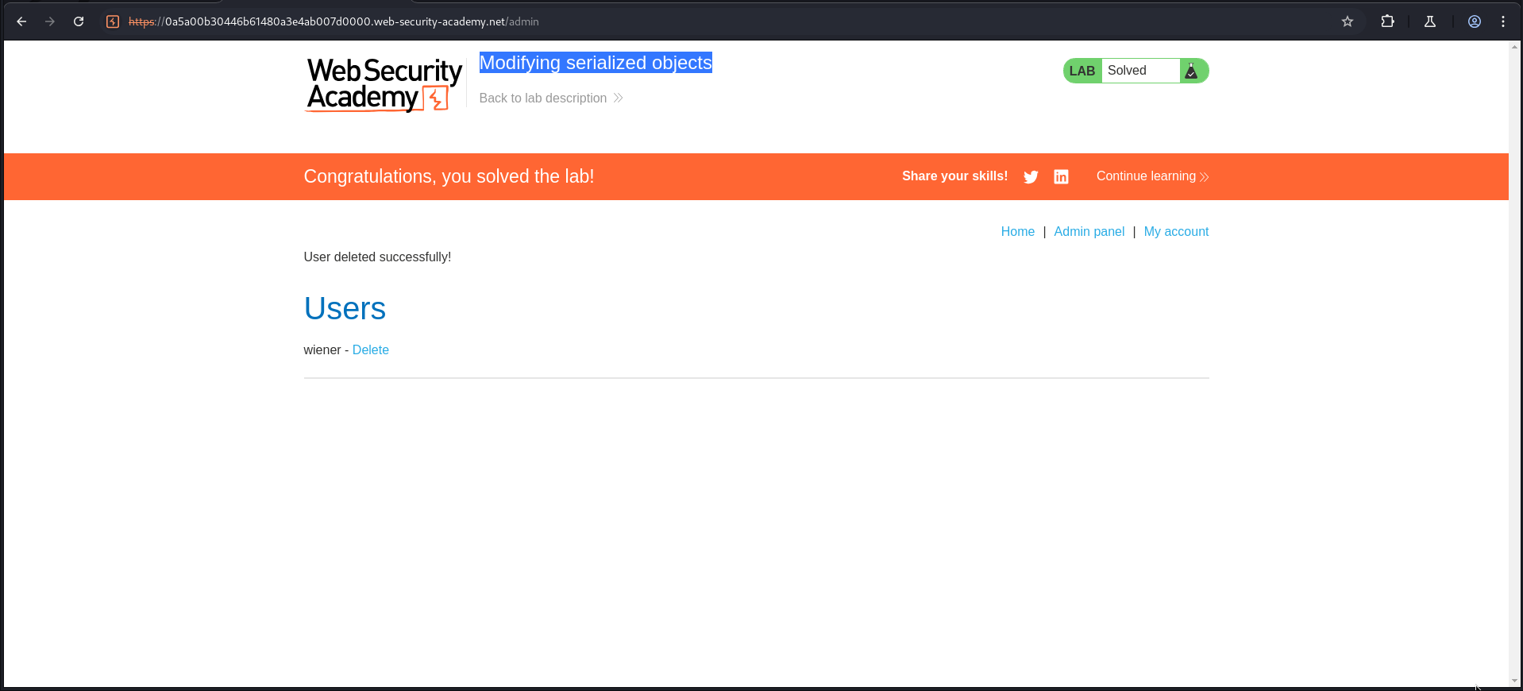

File upload vulnerabilities

- Remote code execution via web shell upload

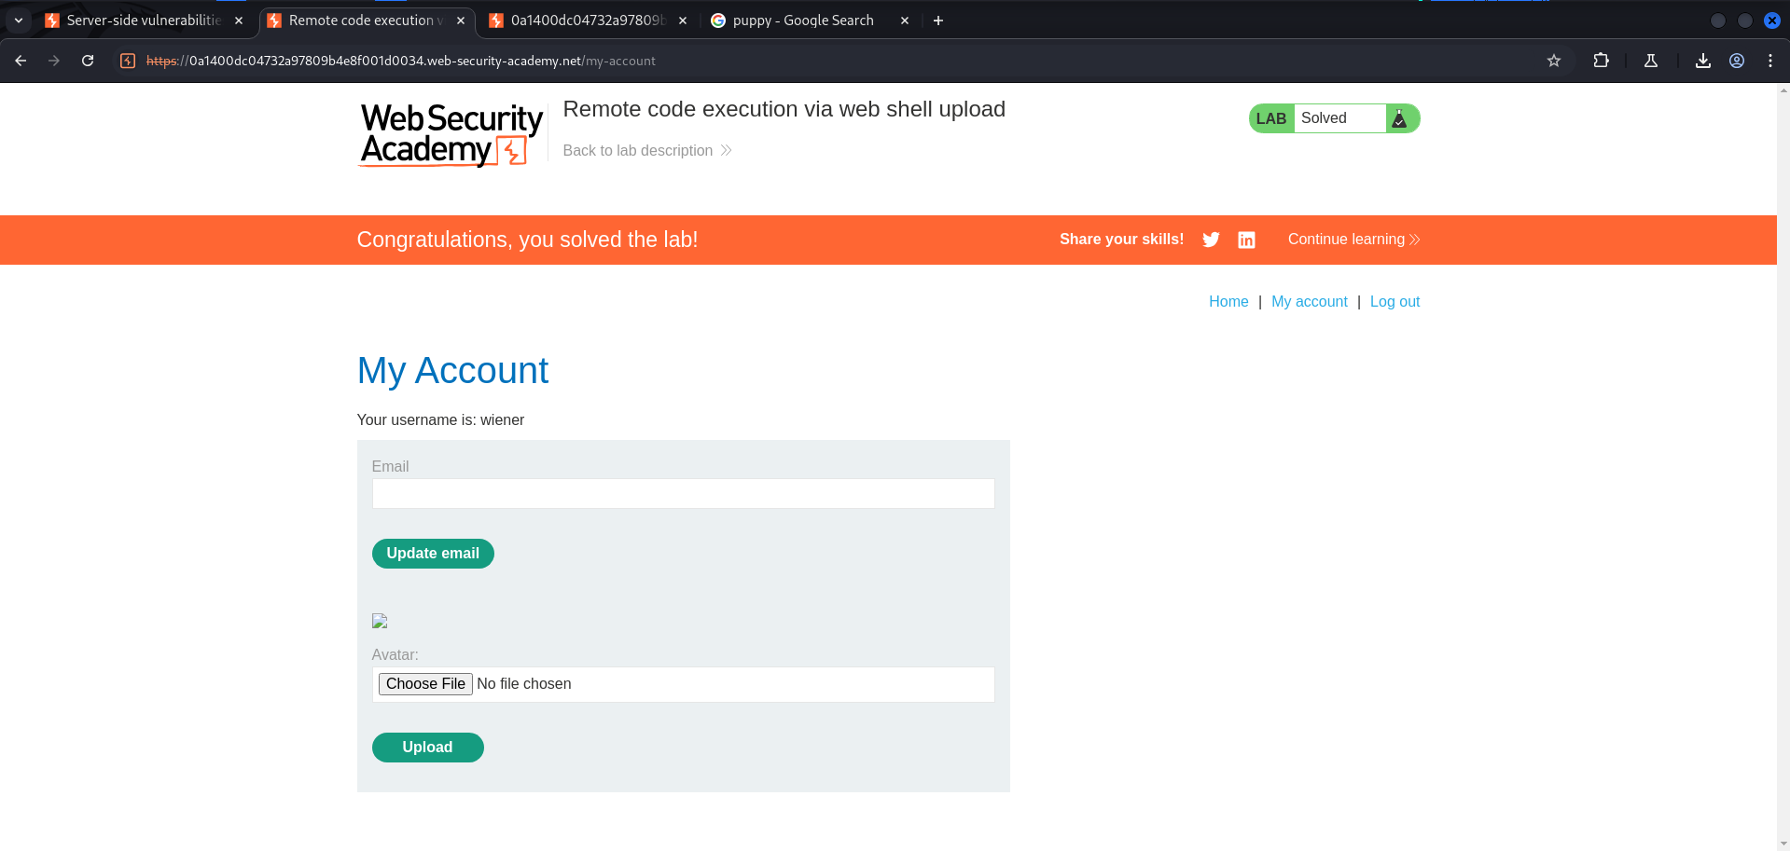

- Web shell upload via Content-Type restriction bypass

