Module: Synthetic Material Behavior Generation
1. Input Feature Space (Independent Variables)
These five columns represent the controlled variables in the laboratory or workshop.
Column Name | Units | Range | Physical Significance
Fe_pct | % | 65.0 – 75.0 | The iron matrix; serves as the base of the alloy.
Cr_pct | % | 15.0 – 20.0 | Chromium; increases corrosion resistance and solid-solution strength.
Ni_pct | % | 8.0 – 12.0 | Nickel; stabilizes austenite and improves toughness/ductility.
Weld_V | Volts | 10.0 – 15.0 | Arc Voltage; determines heat input ($Q = V \cdot I / v$).
Repair_Cycle | Count | 0, 1, 2 | Number of times the weld was ground out and re-welded.

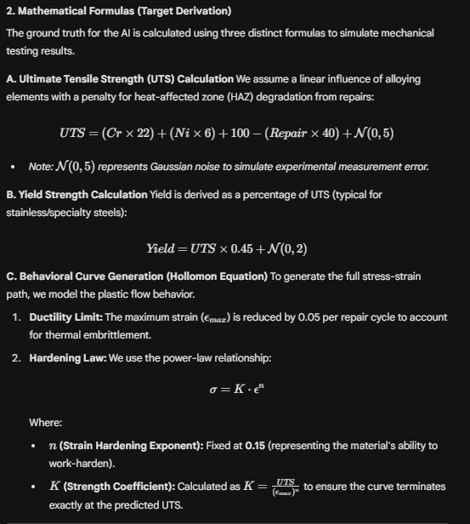
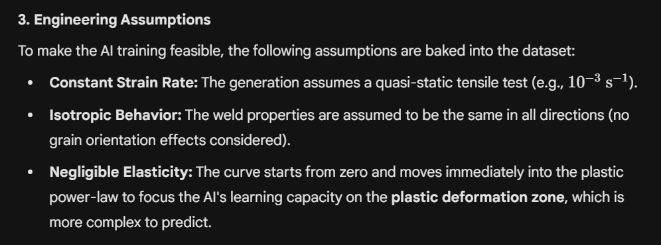
4. Dataset Architecture (Final Columns)
The final .csv file contains the following structure for every sample:
- Inputs: Fe_pct, Cr_pct, Ni_pct, Weld_V, Repair_Cycle
- Point Targets: Yield_MPa, UTS_MPa
- Vector Targets: * Stress_Curve: A JSON string containing 100 float values of Stress.
  - Strain_Curve: A JSON string containing 100 float values of Strain.
Technical Documentation: Step 2
Module 2 : Multi-Task Learning (MTL) Neural Network
1. Structural Design
The architecture is a Multi-Output Deep Neural Network. It utilizes a "Shared Backbone" to extract fundamental metallurgical features, which then feed into three specialized "Task Heads."
2. The Shared Backbone (Feature Extraction)
The first two layers are shared across all tasks. This forces the model to find a common mathematical representation of the alloy’s state.
- Input Layer: 5 neurons (matching the input features: Fe, Cr, Ni, V, Repair).
- Hidden Layer 1: 64 neurons + ReLU Activation.
- Hidden Layer 2: 128 neurons + ReLU Activation.
- Regularization: Batch Normalization (1D). This layer is critical for stabilizing the 128-neuron output before it splits, ensuring that the gradient flow is balanced between the high-magnitude Stress values and low-magnitude Strain values.

3. Specialized Output Heads
Once the backbone has "encoded" the alloy chemistry and process parameters, the network splits into three parallel paths:

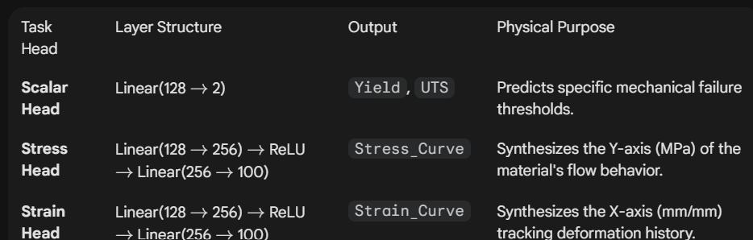
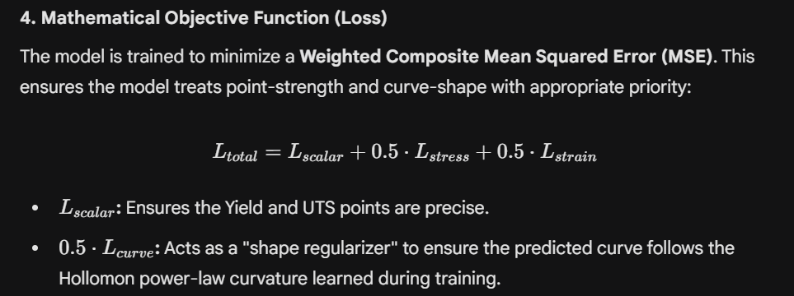
5. Training Parameters
- Optimizer: Adam (Adaptive Moment Estimation) with a learning rate of $0.001$.
- Batch Size: 16 (Small batches are used to allow the model to generalize better on specialized alloy samples).
- Epochs: 150 (Sufficient for the backbone to map the chemistry-to-strength non-linearities).

Technical Documentation: Step 4
Module: Inference and Behavioral Visualization
1. Objective
To provide a non-destructive method for evaluating the mechanical integrity of a specific alloy composition under varying repair conditions. This module serves as a "Virtual Tensile Test."
2. The Prediction Pipeline
To get a visualization, the system performs a three-step data transformation:
- Normalization: The raw alloy inputs (e.g., $Cr=17.5\%$) are transformed via the StandardScaler to match the model’s internal distribution.
- Forward Pass: The scaled inputs are fed into the VSSC_MaterialAI model. The backbone extracts features, and the three heads simultaneously generate the Yield/UTS scalars and the 100-point Stress/Strain vectors.
- Vector Reconstruction: The output tensors are converted into NumPy arrays for plotting

3. Using the Prediction Script
The user defines an alloy "Profile" using the following parameters:
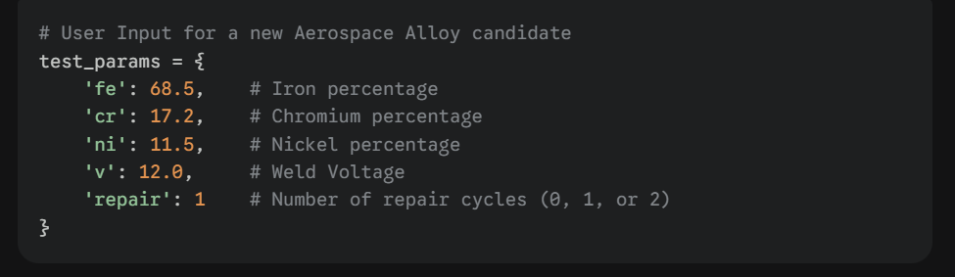
4. Interpreting the Visualization
The resulting plot provides three critical engineering insights:
- Elastic-Plastic Transition: The curve shows how the alloy transitions from its initial loading to permanent deformation.
- Peak Load (UTS): A horizontal dashed line indicates the maximum stress the alloy can withstand.
- Ductility Envelope (Fracture Point): A vertical dashed line marks the predicted point of failure. If the repair cycle is high, this line will shift to the left, indicating a loss of toughness.

Engineering Significance for VSSC
By using this visualization tool, engineers can:
- Screen Materials: Test 100 different chemical combinations in seconds without casting or machining a single physical sample.
- Assess Repair Risk: Quantify the exact drop in ductility when a component undergoes its second repair ($R2$) versus its first ($R1$).
- Optimize Heat Input: Adjust the Weld_V parameter in the prediction script to see how voltage variations might affect the final mechanical flow of the weld.
Final Documentation Summary
You now have a complete 4-part document:
- Step 1: Data Generation (Physics/Formulas)
- Step 2: Architecture (Shared Backbone/Multi-Head)
- Step 3: Training (Optimizer/Loss Weighting)
- Step 4: Prediction & Visualization (Usage/Interpretation)

