Central university of Haryana
Department of Computer Science & Engineering
(Village Jant-Pali, Mahendergarh, Haryana-123031)



Data Structures and Algorithms Lab
(BT CS 304)

Submitted by :- Submitted to :-
Vikas Singh Prof. Anant R. Bara
Roll No: 241504 (Assistant Professor)
Btech (CSE) 2nd year Department of CSE



S.No. | TITLE | PAGE No.
1 | Recursive generation of Fibonacci series up to N terms. | 3
2 | Recursive computation of factorial for a given number. | 4
3 | Program to insert, delete, and traverse elements in a one-dimensional array. | 5 - 7
4 | Program to implement binary search in a sorted array. | 8 - 9
5 | Program to implement Bubble Sort and display intermediate passes. | 10 - 11
6 | Program to implement Insertion Sort. | 12 - 13
7 | Program to implement Merge Sort using recursion. | 14 - 15
8 | Program to calculate address of an element in a 2D array using row-major and column-major formulas. | 16 - 17
9 | Program to implement stack using arrays with push, pop, peek, and display operations. | 18 – 20
10 | Program to implement stack using linked list with dynamic memory allocation. | 21 - 23
11 | Program to implement queue using arrays with enqueue, dequeue, peek, and display. | 24 - 26
12 | Program to implement queue using linked list with dynamic memory allocation. | 27 - 29
13 | Program to implement queue using two stacks. | 30 - 32
14 | Program to create a singly linked list and perform insertion at beginning, middle, and end. | 33 - 36
15 | Program to delete a node from a singly linked list by value or position. | 37 - 40
16 | Program to create a binary tree using array representation. | 41 - 42
17 | Program to perform preorder, inorder, and postorder traversal of a binary tree. | 43 - 44
18 | Program to build a max heap and perform heapify operation. | 45 - 46
19 | Program to represent a graph using adjacency matrix. | 47 - 48
20 | Program to perform Breadth-First Search (BFS) traversal of a graph. | 49 - 50

Program 1: Recursive generation of Fibonacci series up to N terms.
Solution: // Author: [Vikas Singh 241504]
#include <iostream>
using namespace std;
// Recursive Fibonacci series
int RecursiveFibbonacci(int n)
{
if (n == 0) return 0;
if (n == 1) return 0;
return RecursiveFibbonacci(n - 1) + RecursiveFibbonacci(n - 2);
}
// Main Function
int main()
{
int n;
cout << "Enter the number of terms: ";
cin >> n;
cout << "Fibonacci Series: ";
// Loop to print the series up to n terms
for (int i = 0; i < n; i++)
{
cout << RecursiveFibbonacci(i) << " ";
}
cout << endl;
return 0;
}
Output:
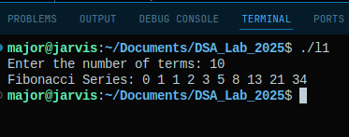

GitHub Link: https://github.com/Vikas-Singh-0897/DSA_Practical_2025/blob/main/Lab1.cpp

Program 2: Recursive computation of factorial for a given number.
Solution: // Author: [Vikas Singh 241504]
#include <iostream>
using namespace std;
// Recursive Fibonacci series
long long factorial(int n)
{
if (n <= 1) return 1;
else return n * factorial(n - 1);
}
// Main Function
int main()
{
int number;
cout << "Enter a positive integer: ";
cin >> number;

if (number < 0) {
cout << "Error: Factorial of a negative number doesn't exist." << endl;
}
else{
cout << "Factorial of " << number << " is: " << factorial(number) << endl;
}
return 0;
}
Output:
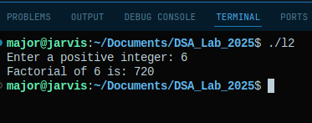

GitHub Link: https://github.com/Vikas-Singh-0897/DSA_Practical_2025/blob/main/Lab2.cpp

Program 3: Program to insert, delete, and traverse elements in a one-dimensional array.
Solution: // Author: [Vikas Singh 241504]
#include <iostream>
using namespace std;
// Define maximum capacity of the array
const int MAX_SIZE = 100;
// Global variables
int arr[MAX_SIZE];
int currentSize = 0;
// Traverse Function
void traverse(){
if (currentSize == 0){
cout << "Array is empty." << endl;
return;
}
cout << "Current Array Elements: ";
for (int i = 0; i < currentSize; i++){
cout << arr[i] << " ";
}
cout << endl;
}
// Insertion Function
void insertElement(int value, int position){
if (currentSize >= MAX_SIZE){
cout << "Error: Array is full (Overflow)." << endl;
return;
}
if (position < 0 || position > currentSize + 1){
cout << "Error: Invalid position!" << endl;
return;
}
for (int i = currentSize; i >= position; i--){
arr[i] = arr[i - 1];
}
arr[position - 1] = value;
currentSize++;
cout << "Element inserted successfully!" << endl;
}
// Deletion Function
void deleteElement(int position){
if (currentSize == 0){
cout << "Error: Array is empty (Underflow)." << endl;
return;
}
if (position < 1 || position > currentSize){
cout << "Error: Invalid position!" << endl;
return;
}
for (int i = position - 1; i < currentSize - 1; i++){
arr[i] = arr[i + 1];
}
currentSize--;
cout << "Element deleted successfully!" << endl;
}
// Main Function
int main(){
int choice, value, position;
cout << "Enter initial number of elements (max " << MAX_SIZE << "): ";
cin >> currentSize;
cout << "Enter " << currentSize << " elements: ";
for (int i = 0; i < currentSize; i++){
cin >> arr[i];
}
do{
cout << "\n--- ARRAY OPERATIONS MENU ---" << endl;
cout << "1. Traverse (Display)\n
2. Insert Element\n
3. Delete Element\n
4. Exit" << endl;
cout << "Enter your choice: ";
cin >> choice;
switch (choice){
case 1:
traverse();
break;
case 2:
cout << "Enter value to insert: ";
cin >> value;
cout << "Enter position (1 to " << currentSize + 1 << "): ";
cin >> position;
insertElement(value, position);
break;
case 3:
cout << "Enter position to delete (1 to " << currentSize << "): ";
cin >> position;
deleteElement(position);
break;
case 4:
cout << "Exiting program..." << endl;
break;
default:
cout << "Invalid choice! Try again." << endl;
}
} while (choice != 4);
return 0;
}
Output:
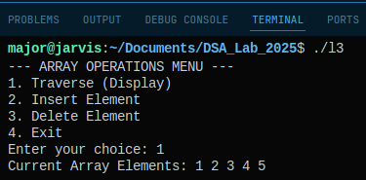
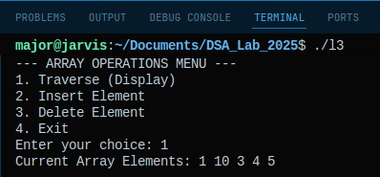
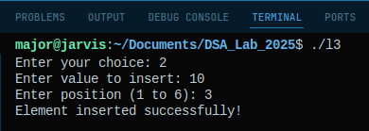
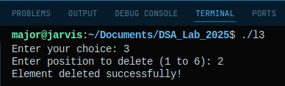

Github Link: https://github.com/Vikas-Singh-0897/DSA_Practical_2025/blob/main/Lab3.cpp

Program 4: Program to implement binary search in a sorted array.
Solution: // Author: [Vikas Singh 241504]
#include <iostream>
using namespace std;
// Binary Search Funcion
int binarySearch(int arr[], int size, int target){
int low = 0;
int high = size - 1;
while (low <= high){

int mid = low + (high - low) / 2;

if (arr[mid] == target){
return mid;
}
if (arr[mid] < target){
low = mid + 1;
}
else{
high = mid - 1;
}
}
return -1;
}
// Mian Function
int main(){
int n, target;
cout << "Enter the number of elements: ";
cin >> n;

int arr[n];

cout << "Enter " << n << " sorted elements (e.g., 10 20 30): ";
for (int i = 0; i < n; i++){
cin >> arr[i];
}

cout << "Enter the value to search: ";
cin >> target;
int result = binarySearch(arr, n, target);

if (result != -1){
cout << "Element found at index " << result << endl;
}
else{
cout << "Element not found in the array." << endl;
}

return 0;
}
Output:
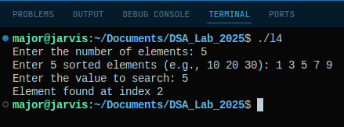

Github Link: https://github.com/Vikas-Singh-0897/DSA_Practical_2025/blob/main/Lab4.cpp

Program 5: Program to implement Bubble Sort and display intermediate passes.
Solution: // Author: [Vikas Singh 241504]
#include <iostream>
using namespace std;
// Print function
void printArray(int arr[], int size){
for (int i = 0; i < size; i++){
cout << arr[i] << " ";
}
cout << endl;
}
// Bubble Sort Function
void bubbleSort(int arr[], int n){
bool swapped;
for (int i = 0; i < n - 1; i++){
swapped = false;
for (int j = 0; j < n - i - 1; j++){
if (arr[j] > arr[j + 1]){
int temp = arr[j];
arr[j] = arr[j + 1];
arr[j + 1] = temp;
swapped = true;
}
}

if (swapped == false) return;

cout << "After Pass " << i + 1 << ": ";
printArray(arr, n);
}
}
// Main Function
int main(){
int n;
cout << "Enter number of elements: ";
cin >> n;

int arr[n];
cout << "Enter the elements: ";
for (int i = 0; i < n; i++){
cin >> arr[i];
}

cout << "\nOriginal Array: ";
printArray(arr, n);
cout << "---------------------------------" << endl;

bubbleSort(arr, n);

cout << "---------------------------------" << endl;
cout << "Final Sorted Array: ";
printArray(arr, n);

return 0;
}
Output:
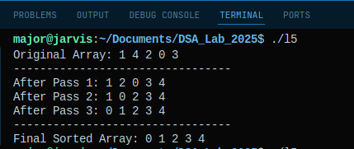

Github Link: https://github.com/Vikas-Singh-0897/DSA_Practical_2025/blob/main/Lab5.cpp

Program 6: Program to implement Insertion Sort.
Solution: // Author: [Vikas Singh 241504]
#include <iostream>
using namespace std;
// Print Function
void printArray(int arr[], int size){
for (int i = 0; i < size; i++){
cout << arr[i] << " ";
}
cout << endl;
}
// Insertion Sort Function
void insertionSort(int arr[], int n){
int key, j;

for (int i = 1; i < n; i++){
key = arr[i];
j = i - 1;

while ( j >= 0 && arr[j] > key ){
arr[j + 1] = arr[j];
j = j - 1;
}

arr[j + 1] = key;
cout << "After inserting " << key << ": ";
printArray(arr, n);
}
}
// Main Function
int main(){
int n;
cout << "Enter number of elements: ";
cin >> n;

int arr[n];
cout << "Enter the elements: ";
for (int i = 0; i < n; i++){
cin >> arr[i];
}

cout << "\nOriginal Array: ";
printArray(arr, n);
cout << "---------------------------------" << endl;
insertionSort(arr, n);
cout << "---------------------------------" << endl;
cout << "Final Sorted Array: ";
printArray(arr, n);

return 0;
}
Output:
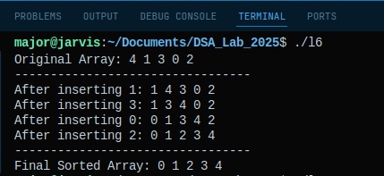

Github Link: https://github.com/Vikas-Singh-0897/DSA_Practical_2025/blob/main/Lab6.cpp

Program 7: Program to implement Merge Sort using recursion.
Solution: // Author: [Vikas Singh 241504]
#include <iostream>
using namespace std;
// Merge Function
void merge(int arr[], int left, int mid, int right){
int i, j, k;
int n1 = mid - left + 1;
int n2 = right – mid;
// Create temporary arrays
int leftArray[n1], rightArray[n2];
for (i = 0; i < n1; i++){
leftArray[i] = arr[left + i];
}
for (j = 0; j < n2; j++){
rightArray[j] = arr[mid + 1 + j];
}
i = j = 0; k = left;
while ( i < n1 && j < n2 ){
if ( leftArray[i] <= rightArray[j] ){
arr[k] = leftArray[i];
i++;
} else{
arr[k] = rightArray[j];
j++;
} k++;
}
while (i < n1){
arr[k] = leftArray[i];
i++, k++;
}
while (j < n2) {
arr[k] = rightArray[j];
j++, k++;
}
}
// Recursive Merge Sort Function
void mergeSort(int arr[], int left, int right){
if (left < right){
int mid = left + (right - left) / 2;
mergeSort(arr, left, mid);
mergeSort(arr, mid + 1, right);
merge(arr, left, mid, right);
}
}
// Print Function
void printArray(int arr[], int size){
for (int i = 0; i < size; i++)
cout << arr[i] << " ";
cout << endl;
}
// Main Function
int main(){
int n; int arr[n];
cout << "Enter number of elements: ";
cin >> n;
cout << "Enter elements: ";
for (int i = 0; i < n; i++){
cin >> arr[i];
}
cout << "Original Array: ";
printArray(arr, n);
mergeSort(arr, 0, n - 1);
cout << "Sorted Array: ";
printArray(arr, n);
return 0;
}
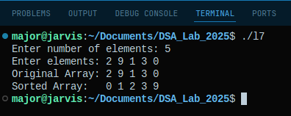
Output:

Github Link: https://github.com/Vikas-Singh-0897/DSA_Practical_2025/blob/main/Lab7.cpp
Program 8: Program to calculate address of an element in a 2D array using row-major and column-major formulas.
Solution: // Author: [Vikas Singh 241504]
#include <iostream>
using namespace std;
// Main Function
int main(){
long baseAddress;
int rows, cols, i, j, elementSize;

// Input 2D Array
cout << "--- 2D Array Address Calculator ---" << endl;
cout << "Enter Base Address (e.g., 1000): ";
cin >> baseAddress;

cout << "Enter total Rows (M) and Columns (N): ";
cin >> rows >> cols;
cout << "Enter size of one element in bytes (e.g., 4 for int): ";
cin >> elementSize;

// Input Target Coordinate (i,j)
cout << "\nEnter the row index (i) to find: ";
cin >> i;
cout << "Enter the column index (j) to find: ";
cin >> j;

// Check
if (i >= rows || j >= cols || i < 0 || j < 0){
cout << "Error: Indices out of bounds!" << endl;
return 1;
}

long rowMajorAddr = baseAddress + elementSize * ((i * cols) + j);
long colMajorAddr = baseAddress + elementSize * ((j * rows) + i);

cout << "\n---------------------------------" << endl;
cout << "Element coordinates: arr[" << i << "][" << j << "]" << endl;
cout << "---------------------------------" << endl;

cout << "Row-Major Address: " << rowMajorAddr << endl;
cout << "Column-Major Address: " << colMajorAddr << endl;
cout << "---------------------------------" << endl;

return 0;
}

Output:
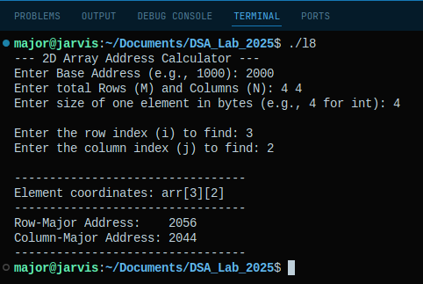

Github Link: https://github.com/Vikas-Singh-0897/DSA_Practical_2025/blob/main/Lab8.cpp

Program 9: Program to implement stack using arrays with push, pop, peek, and display operations.
Solution: // Author: [Vikas Singh 241504]
#include <iostream>
using namespace std;
// Size Defination
#define MAX 100
// Stack class
class Stack{
int top;
int arr[MAX];
public:
// Constructor
Stack(){
top = -1;
}
// Push Function
void push(int x){
if (top >= MAX - 1){
cout << "Error: Stack Overflow! Cannot add more elements." << endl;
return;
}
arr[++top] = x;
cout << x << " pushed into stack." << endl;
}
// Pop Function
void pop(){
if (top < 0){
cout << "Error: Stack Underflow! Stack is empty." << endl;
return;
}
int x = arr[top--];
cout << x << " popped from stack." << endl;
}
// Peek Function
void peek(){
if (top < 0){
cout << "Stack is Empty." << endl;
return;
}
cout << "Top element is: " << arr[top] << endl;
}
// Display Function
void display(){
if (top < 0){
cout << "Stack is Empty." << endl;
return;
}
cout << "Stack elements: ";
for (int i = top; i >= 0; i--){
cout << arr[i] << " ";
}
cout << endl;
}
};
// Main Function
int main(){
Stack s;
int choice, value;
do{
cout << "\n--- STACK OPERATIONS ---" << endl;
cout << "1. Push" << endl;
cout << "2. Pop" << endl;
cout << "3. Peek (Top)" << endl;
cout << "4. Display" << endl;
cout << "5. Exit" << endl;
cout << "Enter choice: ";
cin >> choice;

switch (choice){
case 1:
cout << "Enter value to push: ";
cin >> value;
s.push(value);
break;
case 2:
s.pop();
break;
case 3:
s.peek();
break;
case 4:
s.display();
break;
case 5:
cout << "Exiting..." << endl;
break;
default:
cout << "Invalid Choice!" << endl;
}
} while (choice != 5);

return 0;
}
Output:
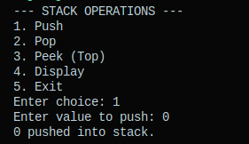
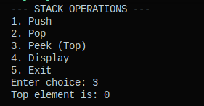

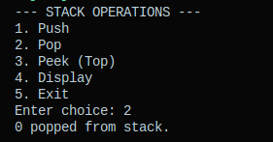
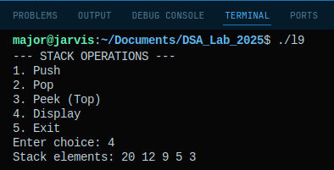

Github Link: https://github.com/Vikas-Singh-0897/DSA_Practical_2025/blob/main/Lab9.cpp

Program 10: Program to implement stack using linked list with dynamic memory allocation.
Solution: // Author: [Vikas Singh 241504]
#include <iostream>
using namespace std;
// Node Structure
struct Node{
int data;
Node *next;
};
// Stack class
class Stack{
private:
Node *top;
public:
// Constructor
Stack(){
top = NULL;
}
// Push Function
void push(int value){
Node *newNode = new Node();
newNode->data = value;
newNode->next = top;
top = newNode;
cout << value << " pushed to stack." << endl;
}
// Pop Function
void pop(){
if (top == NULL){
cout << "Error: Stack Underflow (Empty)." << endl;
return;
}
Node *temp = top;
top = top->next;
cout << temp->data << " popped from stack." << endl;
delete temp;
}
// Peek Function
void peek(){
if (top == NULL){
cout << "Stack is Empty." << endl;
return;
}
cout << "Top element is: " << top->data << endl;
}
// Display Function
void display(){
if (top == NULL){
cout << "Stack is Empty." << endl;
return;
}
Node *temp = top;
cout << "Stack: ";
while (temp != NULL){
cout << temp->data << " -> ";
temp = temp->next;
}
cout << "NULL" << endl;
}
};
// Main Function
int main()
{
Stack s;
int choice, val;
do{
cout << "\n--- DYNAMIC STACK MENU ---" << endl;
cout << "1. Push" << endl;
cout << "2. Pop" << endl;
cout << "3. Peek" << endl;
cout << "4. Display" << endl;
cout << "5. Exit" << endl;
cout << "Enter choice: ";
cin >> choice;
switch (choice){
case 1:
cout << "Enter value: ";
cin >> val;
s.push(val);
break;
case 2:
s.pop();
break;
case 3:
s.peek();
break;
case 4:
s.display();
break;
case 5:
cout << "Exiting..." << endl;
break;
default: cout << "Invalid choice." << endl;
}
} while (choice != 5);
return 0;
}
Output:

Github Link: https://github.com/Vikas-Singh-0897/DSA_Practical_2025/blob/main/Lab10.cpp

Program 11: Program to implement queue using arrays with enqueue, dequeue, peek, and display Operations.
Solution: // Author: [Vikas Singh 241504]
#include <iostream>
using namespace std;
// Maximum capacity of the queue
#define MAX 100
// Queue Class
class Queue{
int arr[MAX];
int front;
int rear;
public:
// Constructor
Queue(){
front = rear = -1;
}
// Enqueue Function
void enqueue(int value){
if (rear == MAX - 1){
cout << "Error: Queue Overflow! (Queue is full)" << endl;
return;
}
if (front == -1){
front = 0;
}
arr[++rear] = value;
cout << value << " enqueued into queue." << endl;
}
// Dequeue Function
void dequeue(){
if (front == -1 || front > rear){
cout << "Error: Queue Underflow! (Queue is empty)" << endl;
return;
}
cout << arr[front] << " dequeued from queue." << endl;
front++;
if (front > rear){
front = rear = -1;
}
}
// Peek Function
void peek(){
if (front == -1 || front > rear){
cout << "Queue is Empty." << endl;
return;
}
cout << "Front element is: " << arr[front] << endl;
}
// Display Function
void display(){
if (front == -1 || front > rear){
cout << "Queue is Empty." << endl;
return;
}
cout << "Queue elements: ";
for (int i = front; i <= rear; i++){
cout << arr[i] << " ";
}
cout << endl;
}
};
// Main Function
int main(){
Queue q;
int choice, value;
do{
cout << "\n--- QUEUE OPERATIONS ---" << endl;
cout << "1. Enqueue (Insert)" << endl;
cout << "2. Dequeue (Delete)" << endl;
cout << "3. Peek (Front)" << endl;
cout << "4. Display" << endl;
cout << "5. Exit" << endl;
cout << "Enter choice: ";
cin >> choice;
switch (choice){
case 1:
cout << "Enter value to enqueue: ";
cin >> value;
q.enqueue(value);
break;
case 2:
q.dequeue();
break;
case 3:
q.peek();
break;
case 4:
q.display();
break;
case 5:
cout << "Exiting..." << endl;
break;
default: cout << "Invalid choice!" << endl;
}
} while (choice != 5);
return 0;
}
Output:
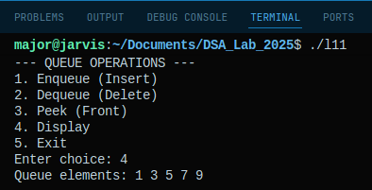
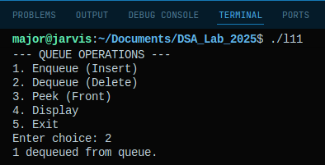

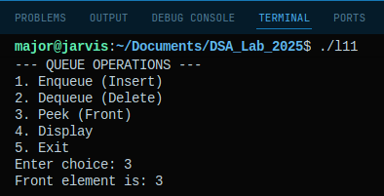
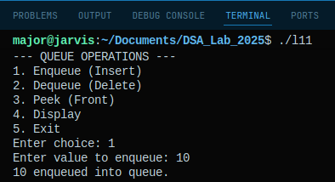

Github Link: https://github.com/Vikas-Singh-0897/DSA_Practical_2025/blob/main/Lab11.cpp

Program 12: Program to implement queue using linked list with dynamic memory allocation.
Solution: // Author: [Vikas Singh 241504]
#include <iostream>
using namespace std;
// Node Structure
struct Node{
int data;
Node *next;
};
// Queue class
class Queue{
private:
Node *front, *rear;
public:
// Constructor
Queue(){
front = rear = NULL;
}
// Enqueue function
void enqueue(int value){
Node *newNode = new Node();
if (!newNode){
cout << "Heap Overflow! Cannot allocate memory." << endl;
return;
}
newNode->data = value;
newNode->next = NULL;
if (front == NULL){
front = rear = newNode;
} else {
rear->next = newNode;
rear = newNode;
}
cout << value << " enqueued to queue." << endl;
}
// Dequeue function
void dequeue(){
if (front == NULL){
cout << "Error: Queue Underflow (Empty)." << endl;
return;
}
Node *temp = front;
cout << front->data << " dequeued from queue." << endl;
front = front->next;
if (front == NULL){
rear = NULL;
} delete temp;
}
// Peek function
void peek(){
if (front == NULL){
cout << "Queue is Empty." << endl;
return;
}
cout << "Front element is: " << front->data << endl;
}
// Display function
void display(){
if (front == NULL) {
cout << "Queue is Empty." << endl;
return;
}
Node *temp = front;
cout << "Queue: ";
while (temp != NULL){
cout << temp->data << " -> ";
temp = temp->next;
}
cout << "NULL" << endl;
}
};
// Main function
int main(){
Queue q;
int choice, val;
do{
cout << "\n--- LINKED LIST QUEUE MENU ---" << endl;
cout << "1. Enqueue" << endl;
cout << "2. Dequeue" << endl;
cout << "3. Peek" << endl;
cout << "4. Display" << endl;
cout << "5. Exit" << endl;
cout << "Enter choice: ";
cin >> choice;
switch (choice){
case 1: cout << "Enter value: ";
cin >> val;
q.enqueue(val);
break;
case 2: q.dequeue();
break;
case 3: q.peek();
break;
case 4: q.display();
break;
case 5: cout << "Exiting..." << endl; break;
default: cout << "Invalid choice." << endl;
}
} while (choice != 5);
return 0;
}
Output:

Github Link: https://github.com/Vikas-Singh-0897/DSA_Practical_2025/blob/main/Lab12.cpp
Program 13: Program to implement queue using two stacks
Solution: // Author: [Vikas Singh 241504]
#include <iostream>
#include <stack>
using namespace std;
// Queue using Stack class
class QueueUsingStacks{
private:
stack<int> inputStack;
stack<int> outputStack;
public:
// Enqueue Function
void enqueue(int x){
inputStack.push(x);
cout << x << " enqueued." << endl;
}
// Dequeue Function
void dequeue(){
if ( outputStack.empty() && inputStack.empty() ){
cout << "Error: Queue Underflow (Empty)." << endl;
return;
}
if (outputStack.empty()){
while (!inputStack.empty()){
outputStack.push(inputStack.top());
inputStack.pop();
}
}
int val = outputStack.top();
outputStack.pop();
cout << val << " dequeued." << endl;
}
// Peek Function
void peek(){
if (outputStack.empty() && inputStack.empty()){
cout << "Queue is Empty." << endl;
return;
}
if (outputStack.empty()){
while (!inputStack.empty()){
outputStack.push(inputStack.top());
inputStack.pop();
}
}
cout << "Front element: " << outputStack.top() << endl;
}
// Is Empty Function
bool isEmpty(){
return inputStack.empty() && outputStack.empty();
}
};
// Main Function
int main(){
QueueUsingStacks q;
int choice, val;

do{
cout << "\n--- QUEUE VIA STACKS MENU ---" << endl;
cout << "1. Enqueue" << endl;
cout << "2. Dequeue" << endl;
cout << "3. Peek" << endl;
cout << "4. Exit" << endl;
cout << "Enter choice: ";
cin >> choice;

switch (choice){
case 1:
cout << "Enter value: ";
cin >> val;
q.enqueue(val);
break;
case 2:
q.dequeue();
break;
case 3:
q.peek();
break;
case 4:
cout << "Exiting..." << endl;
break;
default:
cout << "Invalid choice." << endl;
}
} while (choice != 4);
return 0;
}
Output:

Github Link: https://github.com/Vikas-Singh-0897/DSA_Practical_2025/blob/main/Lab13.cpp

Program 14: Program to create a singly linked list and perform insertion at beginning, middle, and end.
Solution: // Author: [Vikas Singh 241504]
#include <iostream>
using namespace std;
// Node Structure
struct Node{
int data;
Node *next;
};
// Linked List class
class LinkedList{
private:
Node *head;
public:
// Constructor
LinkedList(){
head = NULL;
}
// Insert Function
void insertAtBeginning(int value){
Node *newNode = new Node();
newNode->data = value;
newNode->next = head;
head = newNode;
cout << "Inserted " << value << " at the beginning." << endl;
}
// Insert at the End function
void insertAtEnd(int value){
Node *newNode = new Node();
newNode->data = value;
newNode->next = NULL;
if (head == NULL){
head = newNode;
cout << "Inserted " << value << " as the first element." << endl;
return;
}
Node *temp = head;
while (temp->next != NULL){
temp = temp->next;
}
temp->next = newNode;
cout << "Inserted " << value << " at the end." << endl;
}
// Insert at any Position
void insertAtPosition(int value, int position){
if (position < 1){
cout << "Invalid position!" << endl;
return;
}
if (position == 1){
insertAtBeginning(value);
return;
}
Node *newNode = new Node();
newNode->data = value;
Node *temp = head;
for (int i = 1; i < position - 1; i++){
if (temp == NULL){
cout << "Position out of bounds." << endl;
return;
}
temp = temp->next;
}
if (temp == NULL){
cout << "Position out of bounds." << endl;
return;
}
newNode->next = temp->next;
temp->next = newNode;
cout << "Inserted " << value << " at position " << position << "." << endl;
}
// Display Function
void display()
{
if (head == NULL){
cout << "List is Empty." << endl;
return;
}
Node *temp = head;
cout << "Current List: ";
while (temp != NULL){
cout << temp->data << " -> ";
temp = temp->next;
}
cout << "NULL" << endl;
}
};
// Main function
int main(){
LinkedList list;
int choice, value, pos;
do{
cout << "\n--- LINKED LIST MENU ---" << endl;
cout << "1. Insert at Beginning" << endl;
cout << "2. Insert at End" << endl;
cout << "3. Insert at Position (Middle)" << endl;
cout << "4. Display" << endl;
cout << "5. Exit" << endl;
cout << "Enter your choice: ";
cin >> choice;

switch (choice){
case 1:
cout << "Enter value: ";
cin >> value;
list.insertAtBeginning(value);
break;
case 2:
cout << "Enter value: ";
cin >> value;
list.insertAtEnd(value);
break;
case 3:
cout << "Enter value: ";
cin >> value;
cout << "Enter position: ";
cin >> pos;
list.insertAtPosition(value, pos);
break;
case 4:
list.display();
break;
case 5:
cout << "Exiting..." << endl;
break;
default: cout << "Invalid choice." << endl;
}
} while (choice != 5);
return 0;
}
Output:

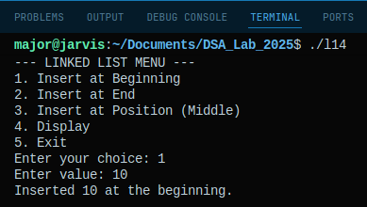
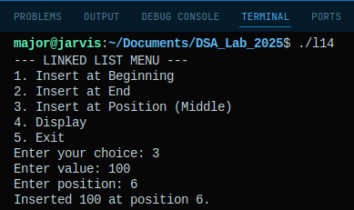
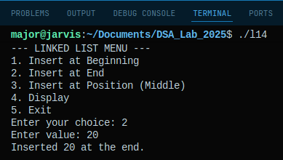
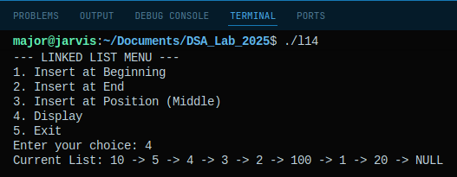
Github Link: https://github.com/Vikas-Singh-0897/DSA_Practical_2025/blob/main/Lab14.cpp

Program 15: Program to delete a node from a singly linked list by value or position.
Solution: // Author: [Vikas Singh 241504]
#include <iostream>
using namespace std;
// Node Structure
struct Node{
int data;
Node *next;
};
// Linked List Class
class LinkedList{
private:
Node *head;
public:
// Constructor
LinkedList(){
head = NULL;
}
// Insert Function
void insertAtBeginning(int value){
Node *newNode = new Node();
newNode->data = value;
newNode->next = head;
head = newNode;
}
// Display Function
void display(){
if (head == NULL){
cout << "List is Empty." << endl;
return;
}
Node *temp = head;
cout << "Current List: ";
while (temp != NULL){
cout << temp->data << " -> ";
temp = temp->next;
}
cout << "NULL" << endl;
}
// Delete by value function
void deleteByValue(int value){
if (head == NULL){
cout << "List is empty. Nothing to delete." << endl;
return;
}
if (head->data == value){
Node *toDelete = head;
head = head->next;
delete toDelete;
cout << "Deleted value " << value << "." << endl;
return;
}
Node *temp = head;
while (temp->next != NULL && temp->next->data != value){
temp = temp->next;
}
if (temp->next == NULL){
cout << "Value " << value << " not found in the list." << endl;
return;
}
Node *toDelete = temp->next;
temp->next = toDelete->next;
delete toDelete;
cout << "Deleted value " << value << "." << endl;
}
// Delete by position function
void deleteByPosition(int position){
if (head == NULL){
cout << "List is empty." << endl;
return;
}
if (position < 1){
cout << "Invalid position." << endl;
return;
}
if (position == 1){
Node *toDelete = head;
head = head->next;
delete toDelete;
return;
}
Node *temp = head;
for (int i = 1; i < position - 1; i++){
if (temp == NULL || temp->next == NULL){
cout << "Position out of bounds." << endl;
return;
}
temp = temp->next;
}
if (temp->next == NULL){
cout << "Position out of bounds." << endl;
return;
}
Node *toDelete = temp->next;
temp->next = toDelete->next;
delete toDelete;
}
};
// Main Function
int main(){
LinkedList list;
int choice, val, pos;
do{
cout << "\n--- DELETION MENU ---" << endl;
list.display();
cout << "1. Delete by Value" << endl;
cout << "2. Delete by Position" << endl;
cout << "3. Add Element (Append)" << endl;
cout << "4. Exit" << endl;
cout << "Choice: ";
cin >> choice;
switch (choice){
case 1:
cout << "Enter value to delete: ";
cin >> val;
list.deleteByValue(val);
break;
case 2:
cout << "Enter position to delete (1-based): ";
cin >> pos;
list.deleteByPosition(pos);
break;
case 3:
cout << "Enter value to add: ";
cin >> val;
list. insertAtBeginning(val);
break;
case 4:
cout << "Exiting..." << endl;
break;
default: cout << "Invalid choice." << endl;
}
} while (choice != 4);
return 0;
}
Output:

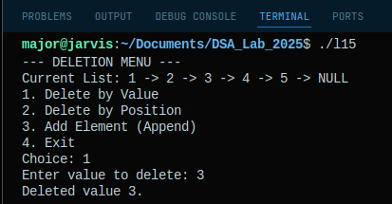
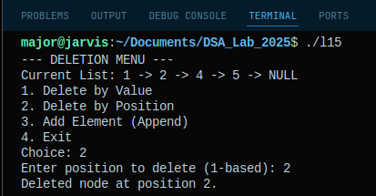
Github Link: https://github.com/Vikas-Singh-0897/DSA_Practical_2025/blob/main/Lab15.cpp

Program 16: Program to create a binary tree using array representation.
Solution: // Author: [Vikas Singh 241504]
#include <iostream>
using namespace std;
// Maximum size of array for tree
const int MAX = 100;
// Insert Node
void insertNode(int tree[], int index, int value){
if (index >= MAX){
cout << "Insertion failed! Index out of range.\n";
return;
}
tree[index] = value;
}
// Print Tree
void printTree(int tree[], int size){
cout << "Binary Tree (Array Representation): ";
for (int i = 0; i < size; i++){
cout << tree[i] << " ";
}
cout << endl;
}
// Creat Tree
void createTree(int tree[], int size){
for (int i = 0; i < size; i++){
int value;
cout << "Enter value for node at index " << i << ": ";
cin >> value;
insertNode(tree, i, value);
}
}
// Main Function
int main(){
int tree[MAX];

for (int i = 0; i < MAX; i++){
tree[i] = -1;
}
int n;
cout << "Enter number of nodes to insert in binary tree: ";
cin >> n;

createTree(tree, n);
printTree(tree, n);

return 0;
}
Output:
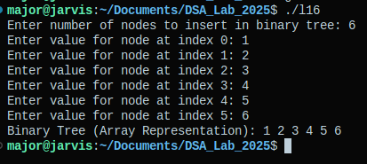

Github Link: https://github.com/Vikas-Singh-0897/DSA_Practical_2025/blob/main/Lab16.cpp

Program 17: Program to perform preorder, inorder, and postorder traversal of a binary tree.
Solution: // Author: [Vikas Singh 241504]
#include <iostream>
using namespace std;
// Node Structure
struct Node{
int data;
Node *left;
Node *right;
};
// Create Node Function
Node *createNode(int value){
Node *newNode = new Node();
newNode->data = value;
newNode->left = NULL;
newNode->right = NULL;
return newNode;
}
// PreOrder Traversal Function
void preorder(Node *root){
if (root == NULL) return;
cout << root->data << " ";
preorder(root->left);
preorder(root->right);
}
// Inorder Traversal Function
void inorder(Node *root){
if (root == NULL) return;
inorder(root->left);
cout << root->data << " ";
inorder(root->right);
}
// Postorder Traversal Function
void postorder(Node *root){
if (root == NULL) return;
postorder(root->left);
postorder(root->right);
cout << root->data << " ";
}
// Main Function
int main(){
Node *root = createNode(1);
root->left = createNode(2);
root->right = createNode(3);
root->left->left = createNode(4);
root->left->right = createNode(5);
cout << "Binary Tree Traversals:" << endl;
cout << "-----------------------" << endl;
cout << "Preorder (Root-L-R): ";
preorder(root);
cout << endl;
cout << "Inorder (L-Root-R): ";
inorder(root);
cout << endl;
cout << "Postorder (L-R-Root): ";
postorder(root);
cout << endl;
return 0;
}
Output:
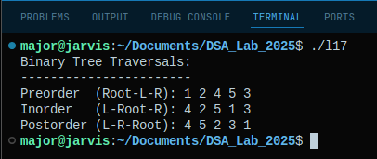

Github Link: https://github.com/Vikas-Singh-0897/DSA_Practical_2025/blob/main/Lab17.cpp

Program 18: Program to build a max heap and perform heapify operation.
Solution: // Author: [Vikas Singh 241504]
#include <iostream>
using namespace std;
// Heapify function
void heapify(int arr[], int n, int i){
int largest = i;
int left = 2 * i + 1;
int right = 2 * i + 2;

if (left < n && arr[left] > arr[largest]){
largest = left;
}
if (right < n && arr[right] > arr[largest]){
largest = right;
}
if (largest != i){
swap(arr[i], arr[largest]);
heapify(arr, n, largest);
}
}
// Max heap from Array
void buildMaxHeap(int arr[], int n){
for (int i = n / 2 - 1; i >= 0; i--){
heapify(arr, n, i);
}
}
// Print Array function
void printArray(int arr[], int n){
for (int i = 0; i < n; ++i)
cout << arr[i] << " ";
cout << "\n";
}
// Main Function
int main(){
int arr[] = {4, 10, 3, 5, 1};
int n = sizeof(arr) / sizeof(arr[0]);

cout << "Original Array: ";
printArray(arr, n);

buildMaxHeap(arr, n);

cout << "Max Heap Constructed: ";
printArray(arr, n);

return 0;
}
Output:
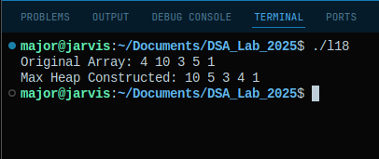
Github Link: https://github.com/Vikas-Singh-0897/DSA_Practical_2025/blob/main/Lab18.cpp

Program 19: Program to represent a graph using adjacency matrix.
Solution: // Author: [Vikas Singh 241504]
#include <iostream>
using namespace std;
// Maximum number of vertices
#define MAX 20
// Graph class
class Graph{
private:
int adjMatrix[MAX][MAX];
int numVertices;
public:
// Constructor
Graph(int vertices){
numVertices = vertices;
for (int i = 0; i < numVertices; i++){
for (int j = 0; j < numVertices; j++){
adjMatrix[i][j] = 0;
}
}
}
// Function to add an edge
void addEdge(int i, int j){
if (i >= numVertices || j >= numVertices || i < 0 || j < 0){
cout << "Invalid Vertex Index!" << endl;
return;
}
adjMatrix[i][j] = 1;
adjMatrix[j][i] = 1;
}
// Function to remove an edge
void removeEdge(int i, int j){
if (i >= numVertices || j >= numVertices || i < 0 || j < 0)
return;
adjMatrix[i][j] = 0;
adjMatrix[j][i] = 0;
}
// Function to display the matrix
void display(){
cout << "\n--- Adjacency Matrix ---" << endl;
cout << " ";
for (int i = 0; i < numVertices; i++)
cout << i << " ";
cout << endl;
for (int i = 0; i < numVertices; i++){
cout << i << ": ";
for (int j = 0; j < numVertices; j++){
cout << adjMatrix[i][j] << " ";
}
cout << endl;
}
}
};
// Main Function
int main(){
int v = 4;
Graph g(v);
g.addEdge(0, 1);
g.addEdge(0, 2);
g.addEdge(1, 2);
g.addEdge(2, 3);
g.display();
cout << "\nRemoving edge between 1 and 2..." << endl;
g.removeEdge(1, 2);
g.display();
return 0;
}
Output:
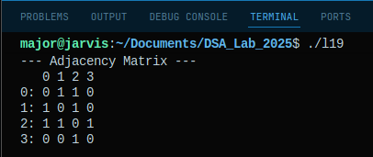

Github Link: https://github.com/Vikas-Singh-0897/DSA_Practical_2025/blob/main/Lab19.cpp
Program 20: Program to perform Breadth-First Search (BFS) traversal of a graph.
Solution: // Author: [Vikas Singh 241504]
#include <iostream>
#include <queue>
using namespace std;
// Node Structure
struct Node {
int data;
Node* left;
Node* right;

Node(int val) {
data = val;
left = nullptr;
right = nullptr;
}
};
// BFS Function
void bfsTraversal(Node* root) {
if (root == nullptr) {
return;
}
queue<Node*> q;
q.push(root);
while (!q.empty()) {
Node* current = q.front();
q.pop();
cout << current->data << " ";
if (current->left != nullptr) {
q.push(current->left);
}
if (current->right != nullptr) {
q.push(current->right);
}
}
}
// Main Function
int main() {
Node* root = new Node(1);
root->left = new Node(2);
root->right = new Node(3);
root->left->left = new Node(4);
root->left->right = new Node(5);

cout << "BFS (Level Order) Traversal: ";
bfsTraversal(root);
cout << endl;

return 0;
}
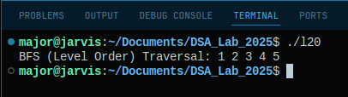
Output:
Github Link: https://github.com/Vikas-Singh-0897/DSA_Practical_2025/blob/main/Lab20.cpp

