Name – Vikas Srivastava
Topic – SQL Assignment : 11
Batch - DATACOM+5G Dev
Batch Id - 25SUB4505
User Id – 55984
Email Id – vikas200027@gmail.com
------------------------------------------------------------------------------------------------------------------------------------------------------------------
Assignment 11: Compose SQL statements to BEGIN a transaction, INSERT a new record into the 'orders' table, COMMIT the transaction, then UPDATE the 'products' table, and ROLLBACK the transaction.
Solution :
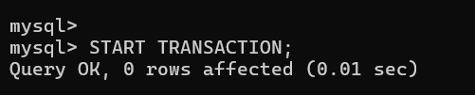
1.
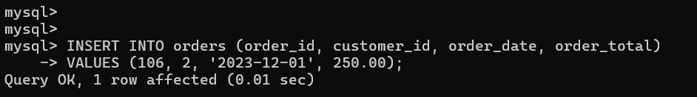
2.
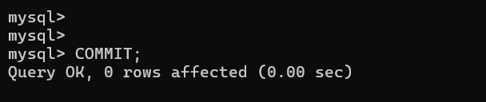
3.
4.
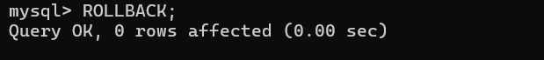
5.

