Name – Vikas Srivastava
Topic – SQL Assignment : 09
Batch - DATACOM+5G Dev
Batch Id - 25SUB4505
User Id – 55984
Email Id – vikas200027@gmail.com
-------------------------------------------------------------------------------------------------------------------------------------------------------------------
Assignment 9: Craft a query using an INNER JOIN to combine 'orders' and 'customers' tables for customers in a specified region, and a LEFT JOIN to display all customers including those without orders.
Solution :
- Create a Order Table.
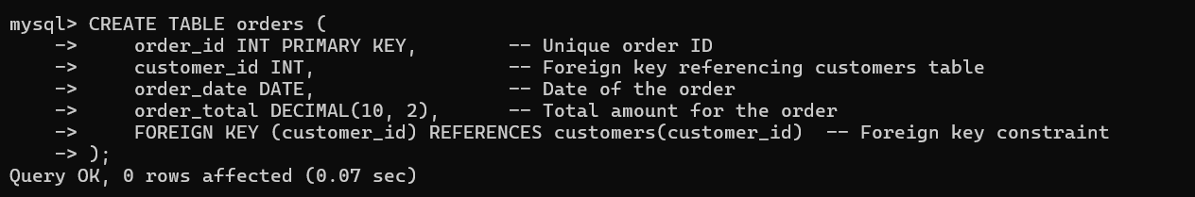
1.
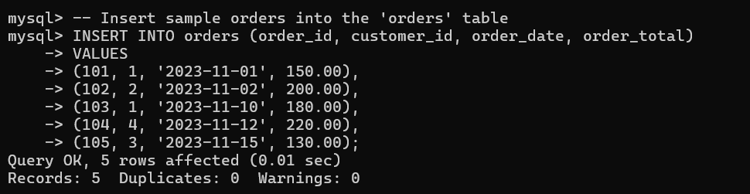
2.
- Using an INNER JOIN to combine 'orders' and 'customers' tables for customers in a specified region.
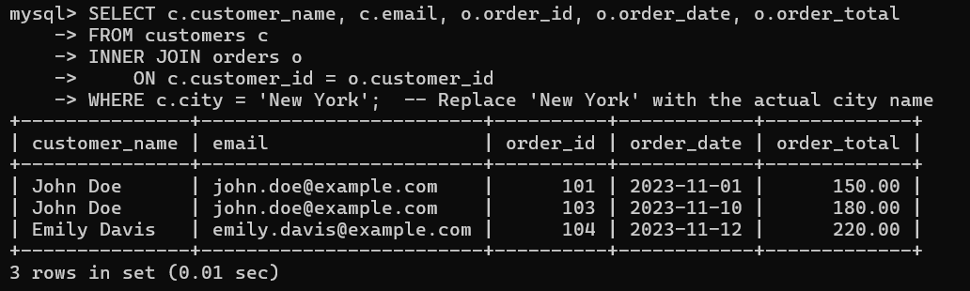
3.
- LEFT JOIN to display all customers including those without orders.
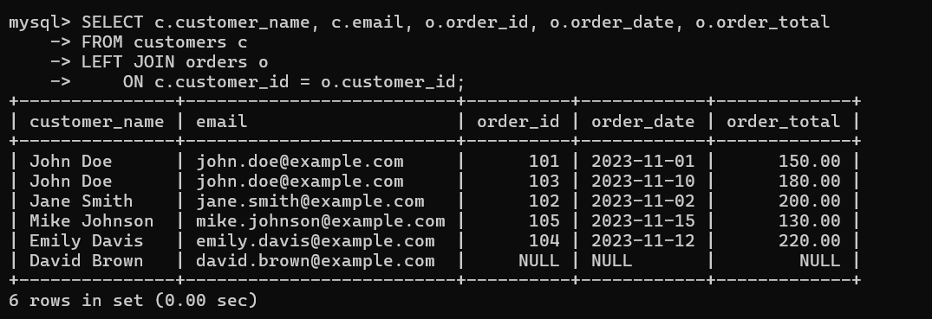
4.

