Name – Vikas Srivastava
Topic – Shell Script Assignment : 02
Batch - DATACOM+5G Dev
Batch Id - 25SUB4505
User Id – 55984
Email Id – vikas200027@gmail.com
-------------------------------------------------------------------------------------------------------------------------------------------------------------------
Assignment 2: Write a script that reads numbers from the user until they enter '0'. The script should also print whether each number is odd or even.
Solution :
Code :
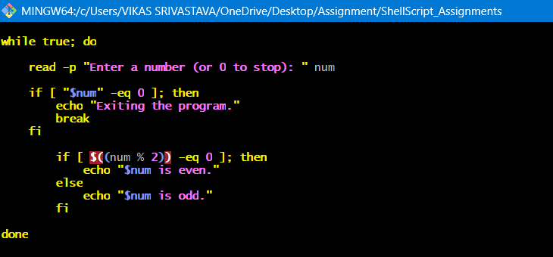
Output :
