Name – Vikas Srivastava
Topic – Shell Script Assignment : 03
Batch - DATACOM+5G Dev
Batch Id - 25SUB4505
User Id – 55984
Email Id – vikas200027@gmail.com
-------------------------------------------------------------------------------------------------------------------------------------------------------------------
Assignment 3: Create a function that takes a filename as an argument and prints the number of lines in the file. Call this function from your script with different filenames.
Solution :
Code :
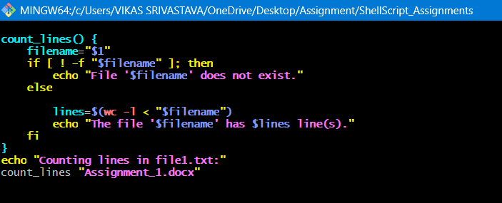
Output :
