Name – Vikas Srivastava
Topic – Shell Script Assignment : 04
Batch - DATACOM+5G Dev
Batch Id - 25SUB4505
User Id – 55984
Email Id – vikas200027@gmail.com
-------------------------------------------------------------------------------------------------------------------------------------------------------------------
Assignment 4: Write a script that creates a directory named TestDir and inside it, creates ten files named File1.txt, File2.txt, ... File10.txt. Each file should contain its filename as its content (e.g., File1.txt contains "File1.txt").
Solution :
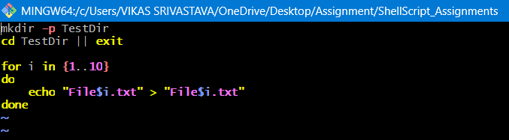
1.
2.
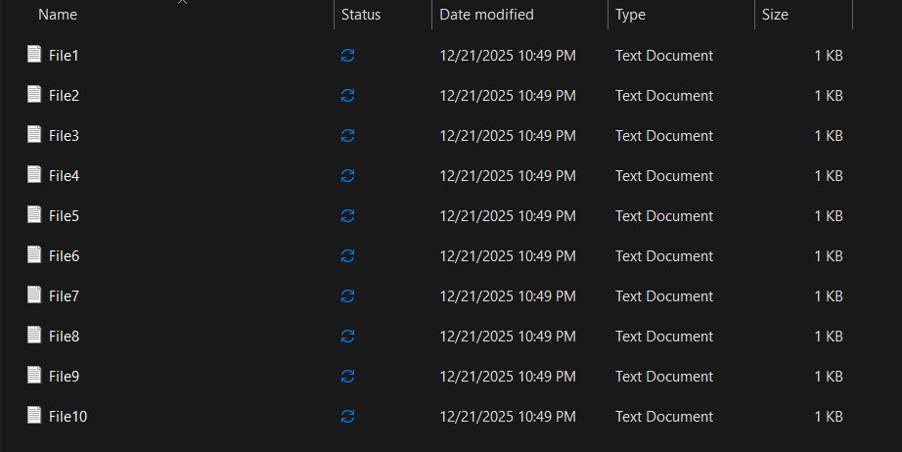
3.
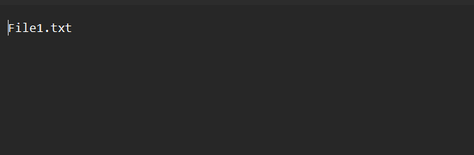
4.

