Name – Vikas Srivastava
Topic – Shell Script Assignment : 05
Batch - DATACOM+5G Dev
Batch Id - 25SUB4505
User Id – 55984
Email Id – vikas200027@gmail.com
-------------------------------------------------------------------------------------------------------------------------------------------------------------------
Assignment 5: Modify the script to handle errors, such as the directory already existing or lacking permissions to create files.
Add a debugging mode that prints additional information when enabled.
Solution :
Code :
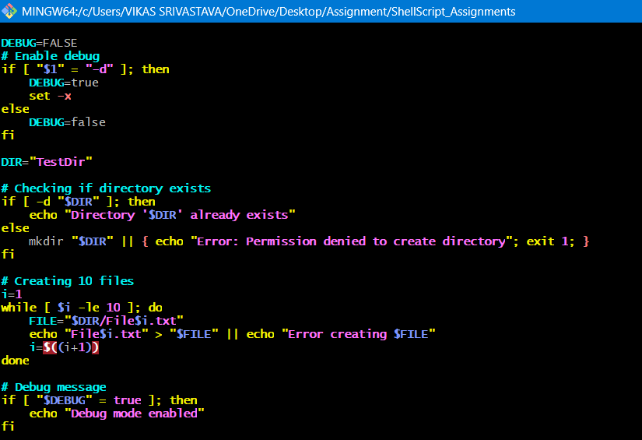
Output:

