Name – Vikas Srivastava
Topic – Shell Script Assignment : 06
Batch - DATACOM+5G Dev
Batch Id - 25SUB4505
User Id – 55984
Email Id – vikas200027@gmail.com
-------------------------------------------------------------------------------------------------------------------------------------------------------------------
Assignment 6: Given a sample log file, write a script using grep to extract all lines containing "ERROR". Use awk to print the date, time, and error message of each extracted line.
Data Processing with sed
Solution :
Code :
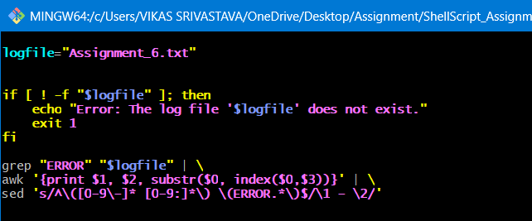
Output :
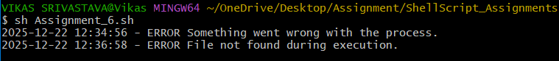
1.

