Name – Vikas Srivastava
Topic – Shell Script Assignment : 07
Batch - DATACOM+5G Dev
Batch Id - 25SUB4505
User Id – 55984
Email Id – vikas200027@gmail.com
-------------------------------------------------------------------------------------------------------------------------------------------------------------------
Assignment 7: Create a script that takes a text file and replaces all occurrences of "old_text" with "new_text". Use sed to perform this operation and output the result to a new file.
Solution :
Create a file :
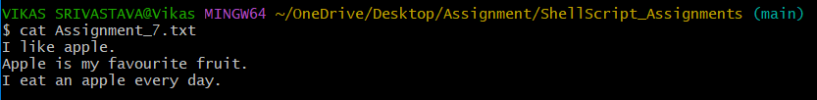
Code :
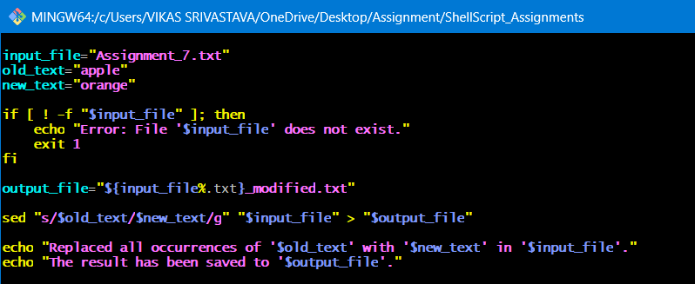
Output :
