Name – Vikas Srivastava
Topic – Git/Github Assignment : 03
Batch - DATACOM+5G Dev
Batch Id - 25SUB4505
User Id – 55984
Email Id – vikas200027@gmail.com
-------------------------------------------------------------------------------------------------------------------------------------------------------------------
Assignment 3: Feature Branches and Hotfixes
Create a 'hotfix' branch to fix an issue in the main code. Merge the 'hotfix' branch into 'main' ensuring that the issue is resolved.
Solution : Follow these steps :
1. Open the command prompt or Git Bash and navigate to the Git repository.
2. Make sure you are on the main branch:
- git checkout main
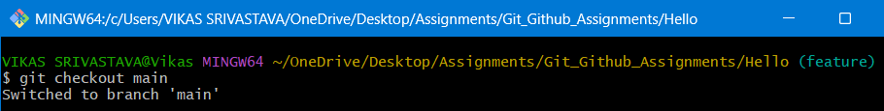
3. Create a new branch named feature using:
- git branch hotfix
4. Switch to the hotfix branch:
- git checkout hotfix
5. Fix the issue by editing an existing file or correcting the code.
6. Add the fixed files to the staging area:
- git add.
7. commit the fix:
- git commit -m "Fixed files"
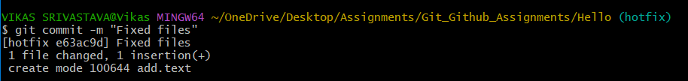
8. Switch back to main branch:
- git checkout main
9. Merge the hotfix branch into main:
- git merge hotfix
