Name – Vikas Srivastava
Topic – Git/Github Assignment 1
Batch - DATACOM+5G Dev
Batch Id - 25SUB4505
User Id – 55984
Email Id – vikas200027@gmail.com
---------------------------------------------------------------------------------------------------------------------------------------------------
Assignment 2: Design a database schema for a library system, including tables, fields, and constraints like NOT NULL, UNIQUE, and CHECK. Include primary and foreign keys to establish relationships between tables.
Solution :
1. Create a Database :
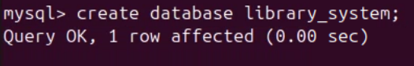
2. Use that database :
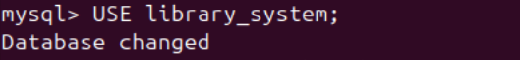
3. Create table : Including tables, fields, and constraints like NOT NULL, UNIQUE, and CHECK.
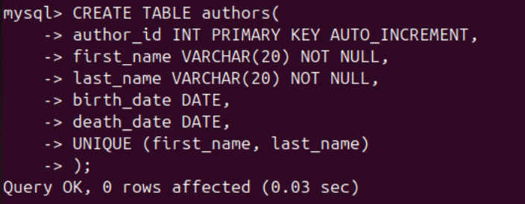
1.
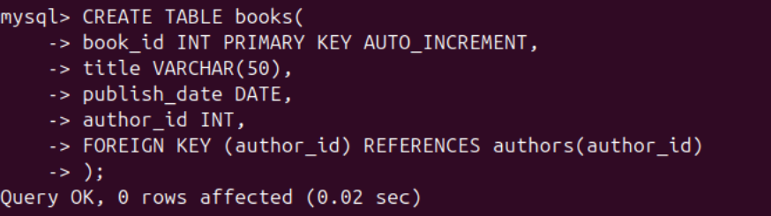
2.
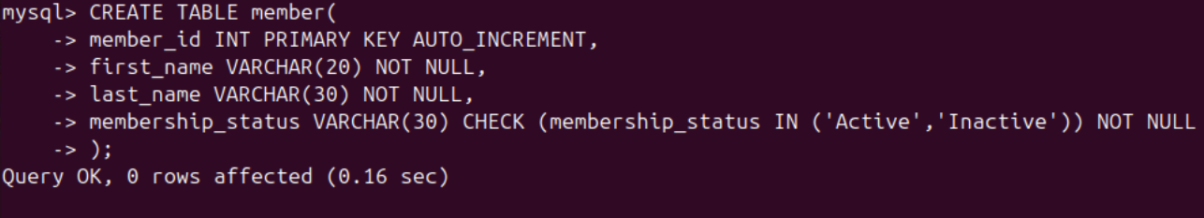
3.

